March 3, 2021

###########

#####################

COMPONENT 3

A LEVEL COMPUTER SCIENCE PROGRAMMING PROJECT

Contents

Analysis 5

Short Introduction and Problem Description 5

Is the problem solvable? 5

Features that Allow for Computational Methods 5

Amenability to a Computational Approach 6

Who would use it? 7

Stakeholders and Potential Clients 7

Stakeholders’ Needs 8

The Final Client 8

Has this been done before? 9

Research into Already Existing Solutions 9

Online Revision PDFs 9

Generated GCSE Questions Based on Input Parameters on a Website 10

A website Containing a List of GCSE Questions to answer 12

Revision Guides and Revision Workbooks 14

How Existing Solutions Affect the Approach 16

What is essential for this to work? 18

Essential Features 18

Additional Features 19

Rejected Features 19

Is it going to be limited in any way? 20

It Will Not Support Every Possible Specification 20

It Will Not Support Any Networking Functionality. 20

It Will Not Work on Smartphones or Tablets 20

Is there any required software or hardware? 20

Needs a User to Have a Working Desktop or Laptop Computer 20

Needs a Java Virtual Machine (JVM) 20

What are the success criteria? 21

Design 22

Problem Decomposition 22

Main Menu UI and Initialisation 23

Question Generation 23

Topic Selection and Question Selection 23

Algebra Interpretation 23

Post-Generation Functionality 24

Visualisation and Feedback 24

Data Saving and Handling 24

User Interface 25

Necessary Algorithms 26

Overview 26

Principal Subroutines Pseudocode 28

JavaScript Object Notation Storage Format 31

Specification Data Storage Format 31

User Data Storage Format 32

Historic Data Storage Format 33

Solution Structure 34

Key Technicalities – Variables, Data Structures and Classes 36

Variables, Input Sanitisation and Validation 36

Packages and Classes 38

Usability Features 39

Post-Development Data and Concluding Notes 41

Implementation 43

Iteration #1 44

Design and Outline 44

Programming and Implementation 45

Code and Justification 45

Prototypes 48

Testing, Problem Rectification and Client Feedback 49

Evidence of Testing and Test Results 49

Problems and Remedies 51

Evaluation of Development Iteration 51

Iteration #2 52

Design and Outline 52

Programming and Implementation 54

Code and Justification 55

Prototypes 64

Testing, Problem Rectification and Client Feedback 65

Evidence of Testing and Test Results 65

Problems and Remedies 67

Evaluation of Development Iteration 67

Iteration #3 68

Design and Outline 68

Programming and Implementation 72

Code and Justification 72

Prototypes 94

Testing, Problem Rectification and Client Feedback 94

Evidence of Testing and Test Results 94

Problems and Remedies 96

Evaluation of Development Iteration 97

Iteration #4 98

Design and Outline 98

Programming and Implementation 102

Code and Justification 102

Prototypes 111

Testing, Problem Rectification and Client Feedback 111

Evidence of Testing and Test Results 111

Problems and Remedies 115

Evaluation of Development Iteration 116

Iteration #5 117

Design and Outline 117

Programming and Implementation 121

Code and Justification 121

Prototypes 137

Testing, Problem Rectification and Client Feedback 138

Evidence of Testing and Test Results 138

Problems and Remedies 141

Evaluation of Development Iteration 143

Iteration #6 144

Design and Outline 144

Programming and Implementation 146

Code and Justification 146

Prototypes 160

Testing, Problem Rectification and Client Feedback 160

Evidence of Testing and Test Results 160

Problems and Remedies 162

Evaluation of Development Iteration 164

Evaluation 165

Post Development Testing and Testing to Inform Evaluation 165

Functionality Testing 165

Robustness Testing 180

RGB Colour Input Validation and Sanitisation 180

Window Creator Buttons for Graphs and Reading Frames 181

Usability Testing 189

Testing Session Results 189

Addressing Usability Concerns 189

Analysis of Success 198

Successful Usability Features 198

Limitations of the Working Solution 200

Maintenance of the Working Solution 201

Summary and Conclusion 201

Bibliography 202

# Analysis

## Short Introduction and Problem Description

This section aims to analyse the problem of a **dynamic mathematics revision aid** (referred to as “the problem” from now on). The problem itself is that students in any year group and any tier of education find it hard to revise mathematics effectively because mathematics is not a subject where information can just be rote learnt. The following sections will explore different solution possibilities to this problem. It will describe its key characteristics and features, stakeholders, approaches, limitations, and suitability for computational methods.

## Is the problem solvable?

### Features that Allow for Computational Methods

A mathematics revision question generator has many aspects which are suitable to be solved by computational methods. The following list aims to identify them:

1. Mathematics, by principles, relies on numbers – as do computers. This means that many of the features of a question generator will be simple to interpret, manipulate and store as they are all based on numbers. Interpreting algebra will require the use of regular expressions - a common feature in most programming languages.
2. The problem will lend itself to decomposition, the practice of breaking down the problem into smaller, more easily solvable components. It can be separated into multiple sections such as topics, performance/statistics, question generation, etc. This will provide a much easier mode of navigation, but also ease of implementation.
3. The problem also lends itself to abstraction – the concept and practice of removing extra detail and interpreting mathematical concepts in purely computational and numerical form. Details such as the text format in the questions, the format of user input and text fonts can all be omitted when carrying out the implementation of the solution.
4. Since generation of questions will have to be random and unpredictable – to aid revision and practice of mathematical methods without knowing what to do from the start – the use of pseudorandom number distributions will be required. This is very easily solvable by maths libraries available to programming languages and development environments.
5. During the question generation process, heuristics can be implemented to not generate questions on what the user is already good at, and conversely, generate more questions on what they historically score low marks on. This will help end-users improve, as they are practicing areas of improvement more.
6. Results of questions and tests will need to be dynamically displayed and stored. Computers allow for this by using Graphical User Interfaces (GUI) and databases – which are easy to manipulate through programming languages and computer systems.
7. Correct answers will need to be calculated to validate the user’s own proposed solution. This can be easily done by computers programmed to carry out arithmetic and algebra, therefore not wasting the user’s time in calculating the possibly faulty “correct” answers by themselves.
8. Topics will need to be organised and browsed by the user. This is done by responsive GUIs with multiple windows (as mentioned above) and makes getting started in revising much quicker and easier.

### Amenability to a Computational Approach

This problem is very suitable to a computational approach, above other approaches due to the reasons outlined below.

Computers provide facilities to store results – such as those of questions and tests – in a very efficient and secure way. This is better than other approaches such as thinking up one’s own questions, completing them and writing down the result on a piece of paper, or an excel spreadsheet. This is because papers can get damaged or misplaced. Handwriting will also not be an issue because a computer screen will display the results instead. Excel spreadsheet files can get messy and hard to organise, taking away time from revising.

Computers provide facilities to display mathematical notation such as formulas and graphs very accurately. For graph plotting and interpreting exercises, this is vastly superior to drawing graphs by hand. Formulas and complex symbols get drawn by the computer, which removes any confusion caused by faulty handwriting. The same can be said for geometrical displays – such as triangles and circles.

Worksheets are another alternative approach to revising mathematics. This has issues however. A worksheet only has a set number of questions of a set kind. Once they’re filled, they cannot be re-used. Computers solve this by simply erasing the memory storing the questions and generates a new set on command by the user. On-top of this being quicker and easier, it is also more environmentally friendly, as less paper is being used.

Revision guides and books are similar to worksheets, however they also contain certain features to make revising easier and more productive, such as: tick boxes to track what the reader is good at; images to illustrate concepts; and summary questions at the end of each topic. A computational approach is better than those, because the computer can work out how adept the user is at certain topics (by the use of statistics and machine learning algorithms), removing the need for the user to manually do that. On-top of images, videos and animated illustrations can also be included in a computational approach – something that books cannot do.

Interactivity, such as clicking on formulas to learn more about them or external links to webpages with extra information are also only possible with a computational approach to the problem. Textbooks, worksheets, flashcards or anything else of the sort cannot do that.

Since computers store results digitally, they can offer much more accurate and quicker progress tracking. This will help in revision since the user gets automatic feedback on where they are going wrong, right after completing the exercises or tests.

## Who would use it?

The problem will need a group of users to aid in designing it, testing it, and finally using it. The nature of this problem applies to a large range of people, mainly students, but also teachers and other smaller groups of people within education.

### Stakeholders and Potential Clients

The main group of stakeholders for the solution is students who are studying in secondary education – especially students in Key Stage 3 (KS3) or Key Stage 4 (KS4). They are just beginning on learning the foundations of algebra and other principal topics within mathematics, which are crucial to their success in later studies. They have the time, but they do not yet necessarily have the needs nor know-how on how to revise mathematics effectively. The solution should build a good foundation and demonstrate what effective mathematics revision is like because it focuses purely on the questions. Thus, ensuring that these topics are covered thoroughly, efficiently and interactively is of great importance. If they can utilise the solution and spend their time learning about exactly what they need to know, and not waste time doing anything else such as navigating the user interface or choosing questions (because the computer manages that for them), then that will result in greater success for them within the long term.

Students in KS3 may use the solution for practicing current skills, learning new topics, revising for tests and/or revisiting mathematical methods. Their needs are to score high grades in exams and gain a better understanding of mathematics – and by practicing mathematics through questions generated randomly but still suited to their own needs, they can do that in the most efficient way possible. They will be used extensively when doing evaluative testing at the end of each design cycle.

Heads of mathematics departments within secondary schools, especially those who teach KS3 or KS4 might be interested in the solution because it gives their students a better tool for revising and practicing mathematics than what they themselves have available – i.e., books or worksheets. They run the department and manage all of the department’s resources. This solution may be an alternative that requires less funding to have, which is something they might consider. They will not directly use the proposed solution, however they will be the ones authorising the use of it within the department and within lesson, so their opinion will also matter greatly when ensuring quality and specification accuracy.

Teachers who teach KS3 or KS4 will also find an interest in the solution to the problem because: They may use it for illustrating new mathematical concepts to their students through example questions in lesson; setting homework questions to do for their students; or even potentially practicing their own skills with it if the need arises. They can also use it to track the progress of their students by regularly asking for statistics on their results. This will help them teach their students more about the things they struggle with. Teachers will play a key role in testing the solution to ensure it maintains mathematical accuracy but also ease of use.

Sixth Formers who are studying A-levels will also find this useful as the solution may help them practice higher level questions which are tailored to their needs. It also allows them to review foundations of mathematics which they may have forgotten earlier in their education. They will not use it as extensively as the lower year groups because they have more important A-level work to focus on, however as a quick practice of foundations, it can be useful if used during free moments – e.g., at home or as a warmup for their own revision. They too will be used in the testing process of the solution because their opinion and thoughts are as valid as the other stakeholders. Their input will be considered when bug-fixing and doing small tweaks to aesthetics.

### Stakeholders’ Needs

Their needs are to have a solution that interactively, smartly and efficiently generates questions to solve using mathematical methods. They need it to be clear and easy to use, along with being mathematically accurate and understandable.

An interview with a group of year 7s obtained the following key requirements:

1. They would like some kind of leader board to compare scores with classmates.
2. They would like a suggestions tab to list topics of improvement by rank.
3. They would like the colour scheme to remain primary and secondary, but be configurable.
4. They would like the ability to change the background to some kind of image.
5. They would like the questions to be displayed in list format.
6. They would like a pop-up hint to aid when getting a question wrong.
7. They would like example “model answer” questions to explain the topic in very brief terms before doing questions on them to serve as a reminder/memory refresher.
8. They would like formulas in example questions to be clickable to show further information about them.
9. They would like videos displayed within the program itself to explain topics they may need to revise more.

An interview with a maths teacher at the same school attained the following needs:

1. Questions should have different levels, e.g., for linear equations, one-step, two-step, equations with x on both sides, etc.
2. Questions topics should be listed by all appropriate tiers, e.g., for KS3, only topics and then subtopics, but for KS4, foundation/higher first, then topics, and then subtopics.
3. A “model answer” should be included somewhere to refresh their memory before practice.

### The Final Client

The client for this solution to the problem will be a mathematics teacher who teaches year 7 for most of their time. They would like to find a more interactable and easier way of revising and practicing mathematics at the lower level. This means their opinion will be the most valuable throughout development and their needs will be the greatest priority to address. They will be referred to as “the client” from this point onwards.

## Has this been done before?

This section aims to explore what has already been accomplished and/or produced in the field of mathematics revision aids.

### Research into Already Existing Solutions

#### Online Revision PDFs

One of the revision solutions that currently exists for 11+ students are PDF files that someone can print from the internet. They include printed notes on the times tables, geometrical definitions, formula definitions, conversion charts and many more pages on various foundation level topics [1]. The website quotes *“parents who have used these on long journeys during the holidays, stuck on their notice boards, stuck on the fridge with a fridge magnet”*. This as a revision aid is functional, however it only serves as a reference and/or fact reminder about mathematics (as implied by the quote), and does not allow practice of actual mathematical skills. This is not suitable to a computational approach as a stand-alone idea; however, it is possible to integrate it into the problem’s solution by having formula or definition reminders as pop-ups whenever a question is answered incorrectly, or as some kind of flashcard-like game. Below is an illustration of one of these revision aids.



[Fig. 1] Revision Aid 3 – elevenplusexams.com

#### Generated GCSE Questions Based on Input Parameters on a Website

A website [2] generates questions to answer based on a range of input parameters. It provides the answer by simply clicking on the question. Below is a series of screenshots of the webpage and most of its features.

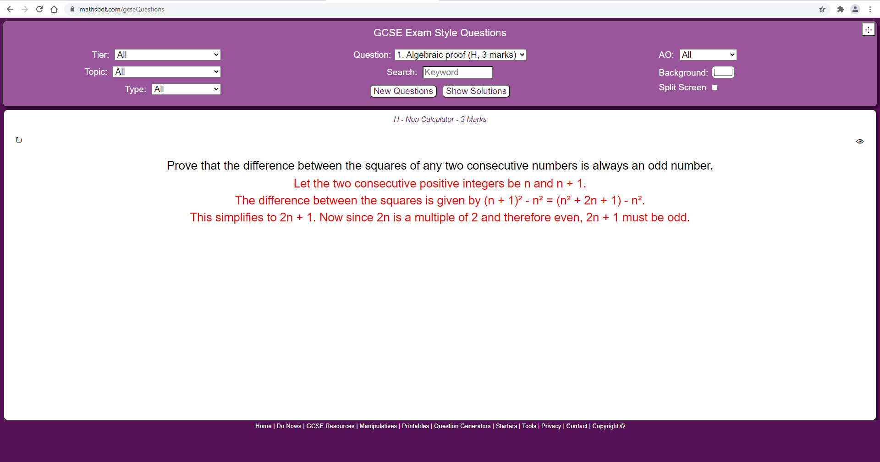

[Fig. 2] mathsbot.com – the web application discussed.

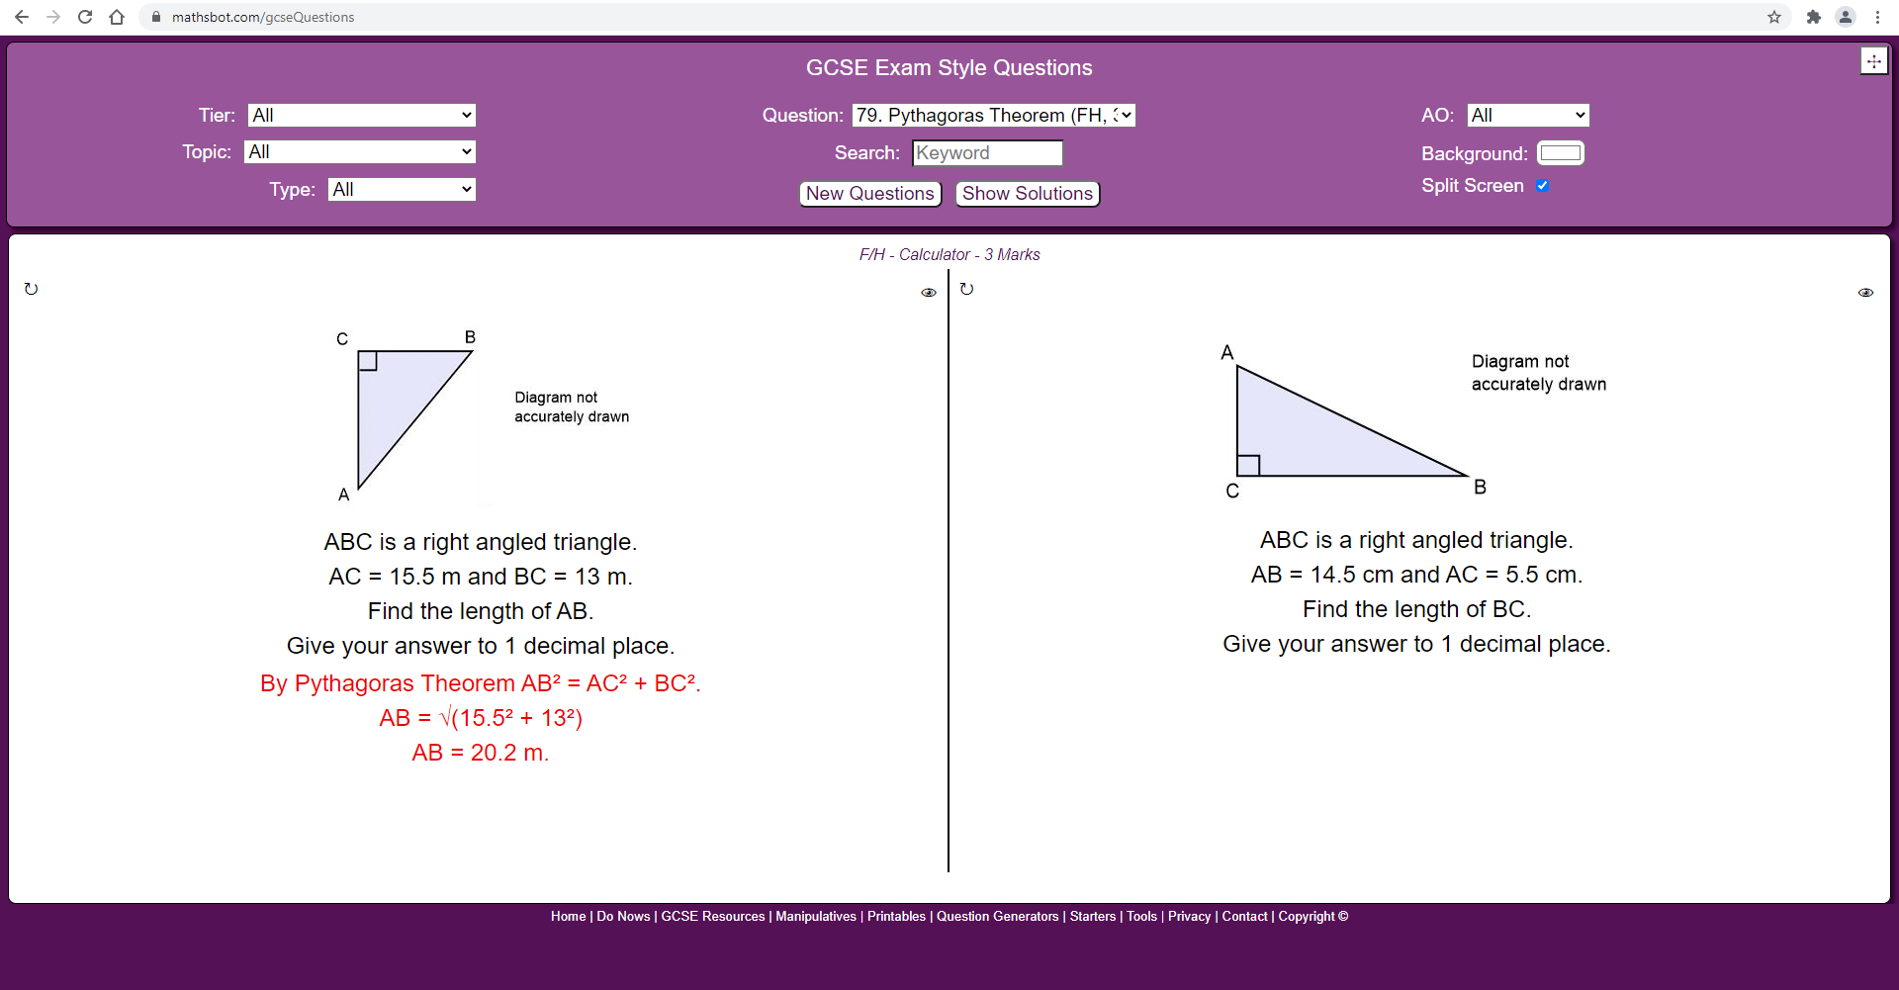

[Fig. 3] mathsbot.com – showcasing the split screen and answer display. Minimalist UI design.

This approach to mathematics revision has a number of advantageous and disadvantageous features within it that the solution *could* use within implementation:

1. **Separates questions based on education tier, topic, exam type, question type and even keywords within the question.** 
   1. *This is a good feature and should be included in the solution because it allows the user to fully customise their own revision experience and allows them to cherry-pick questions that they struggle with the most or want the most practice with. It allows them to target very specific parts about the syllabus they are on.*
2. **It displays the question as it would appear in the exam, giving how many marks it is worth and gives adequate space for workings out if the user is on a touchscreen device. The answer is clearly displayed if clicked on and laid out clearly and comprehensively.**
   1. *This feature should be included because it allows them to practice exam technique and get used to knowing how many marks a question typically of that kind is worth. It also helps the user practice laying out their work to exam standard because the model answers show exactly what is and isn’t sufficient for gaining marks.*
3. **Allows the same question to be regenerated with different wording and different answers, in order to practice the same type of question very quickly and easily.**
   1. *This feature should be included because it ensures that the user can get lots of practice of questions they find hard and ensures that they don’t waste time looking for new questions.*
4. **It allows the screen to be split into two – useful for display on large screens or projectors in-front of classes for teaching purposes. Each split is independent from the other and allows one question to be regenerated without the other one being affected.**
   1. *This feature should not be included within the solution to the problem because the solution is aimed for personal revision, not class-based learning.*
5. **The user interface (UI) is very clear and easy to use. It doesn’t have a lot of menus or buttons and it is very easy to understand what to click. It is spacious and empty to leave space for the user’s workings and sticks to a simple, primary-secondary colour scheme.**
   1. *This feature should be included within the solution because it speeds up the time it takes the user to learn the interface and to get used to it. It is friendly to the eyes and because of this ease-of-use, it should be a key feature within the proposed solution to the problem.*
6. **It does not display which part of the answer is worth marks and which is just workings.**
   1. *This is not necessarily a bad feature, as it still displays the answer correctly. It can be improved by making it more clear which part of the model answer is worth marks - potentially with some kind of symbol or number.*
7. **It does not provide the user with an interface to submit their own answers and have the computer evaluate how much they would receive depending on what the answer is.** 
   1. *This promotes the user to check their own answers, which takes time and can even cause confusion if the model answer is unclear. That is the reason this feature shouldn’t be included within the solution. By having the computer automatically determine whether the user’s answer is correct, it removes unnecessary hassle and speeds up the revision process.*
8. **Due to point no. 7, it also does not provide any facilities to save scores because it has no way of remembering who the user is – no databases.**
   1. *This feature saves a lot of extra programming; however, it doesn’t help the user track their progress – another thing necessary within revision and should therefore not be included within the solution. The solution should save scores and track progress.*

#### A website Containing a List of GCSE Questions to answer

A website [3] provides a comprehensive list of every topic covered in GCSE Mathematics. It provides a grade that the topic is aimed at (alphabetical grades are outdated however) and it also says if it is a calculator or non-calculator topic. A user can click on the topic name, and the website will generate a question for them to answer, using a very simplistic user interface. It also has other components features, such as dedicated formulae sheets, maths games and puzzles.

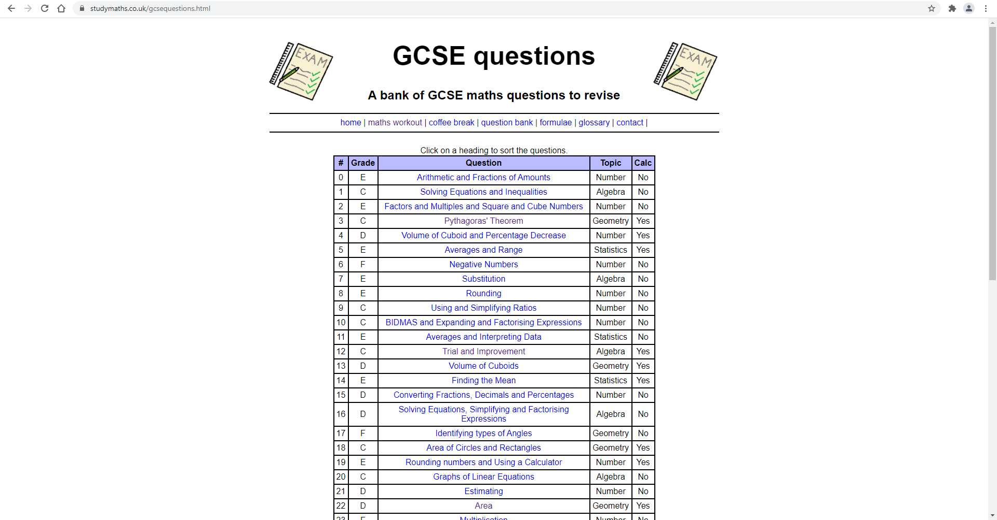

[Fig. 4] Studymaths.co.uk – showcasing the topics list user interface.

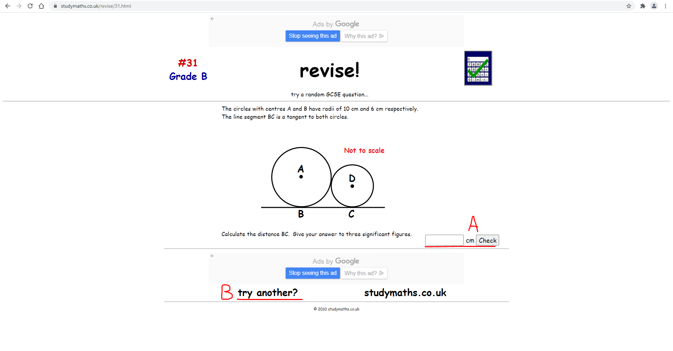

[Fig. 5] Studymaths.co.uk – showcasing the generated question interface.

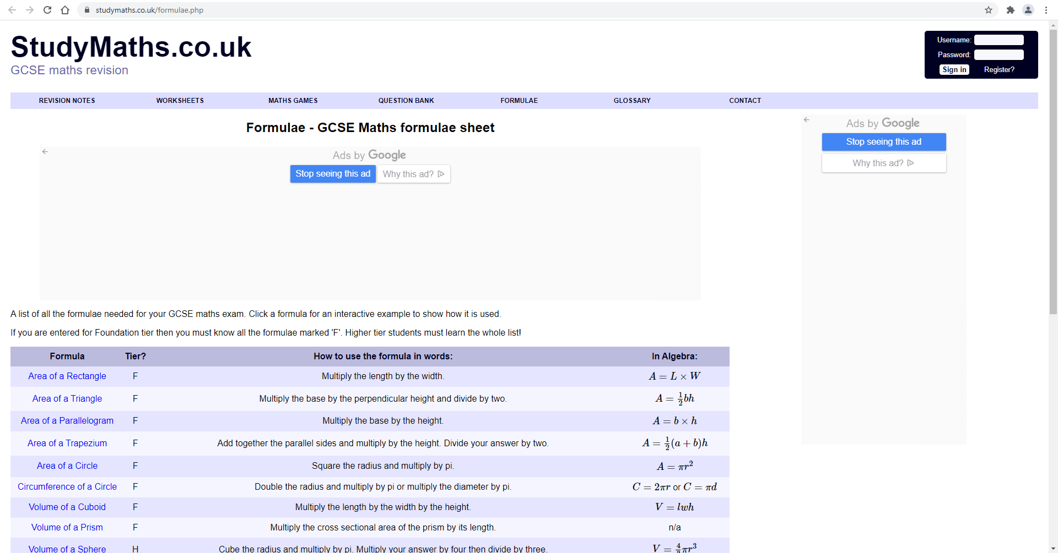

[Fig. 6] Studymaths.co.uk – showcasing a table listing formulas by name, their algebraic definition and explanation.

This approach is similar to the approach discussed before this, however with differing key features and functionalities.

1. **Interface colours are simple and friendly to eyes.**
   1. *A darker blue, lighter blue and white are non-distracting and non-contrasting. It makes sure the user is not spending cognitive energy being distracted by the colours. This feature should be included in the proposed solution.*
   2. *Said colours are not configurable. This is not a major disadvantage, but colour-blind users may find it an inconvenience. The proposed solution should have colour configuration.*
2. **Displays grades for questions to indicate question difficulty.**
   1. *This indicator is good to show what level the user is working at when answering questions and therefore helps the user better choose what topics they need to focus on or try next. The grades themselves are outdated however, as all GCSEs use the 9-1 system now. This should be included in the proposed solution.*
3. **Shows topics in one big non-closable list.**
   1. *It ensures that all the topics are readily available, which makes it easy for the user to quickly find what topic they are looking for. This feature should be in the proposed solution.*
   2. *The list is not closable, which clutters the interface and may be an inconvenience to some users. It also does not provide a search method to find a specific topic, and instead just requires the user to skim-read each heading until they find their topic of choice.*
4. **Question interface is very simple.**
   1. *The interface is easy to understand and use at first glance. It does not provide a lot of buttons or menus to distract the user. This should be included in the proposed solution.*
   2. *If the proposed answer is correct, it changes the text in the submit button. If it is wrong it gives the user the correct answer by replacing the text in the submit button. This is an unintuitive way of giving feedback to the user and can be missed if the user is not paying attention. It is small and hard to see. Labelled in figure 5 as “A”. The button to generate the next question on a random topic is at the bottom of the page, labelled as “B” in figure 5. It blends in with the footer of the page and is hard to spot at first glance. It is also not clear that it is a button. This may cost the user time to realise and therefore they could get distracted by the user interface and not focus on question solving. This should not be included in the proposed solution.*
5. **Has easily accessible alternate revision methods such as puzzles and games.**
   1. *It is a good alternate way of revision compared to standard questions; however, it may not be as effective to most users because they do not require the same cognitive focus as regular questions do. It is a good tool to utilise during breaks in revision as it relieves mental stress and may even offer the user time to clear their head and prepare for more questions without completely letting mathematics out of their head. This should not be included in the proposed solution.*
6. **Does not remember nor record how the user performs – requires the creation of an account.**
   1. *It does so IF the user has not created an account on the website. It does do it If the user has. An account should not be needed for the proposed solution.*

#### Revision Guides and Revision Workbooks

Revision guides written by CGP for example. These books offer comprehensive guides on every topic in mathematics, split by tiers (KS3, GCSE or A-level).

The books are split into multiple categories, and those categories are split into topics. Each topic gets its own page (or 2 in the rare case) and each page is efficiently filled with theory, examples, tips and important notes. Everything is colour coded to aid memory. At the bottom of each topic page, it gives 2 quick practice questions for the user to practice with. At the end of each topic, a check-list of statements is presented, prompting the user to fill it with ticks when they think they have learned and understood it.

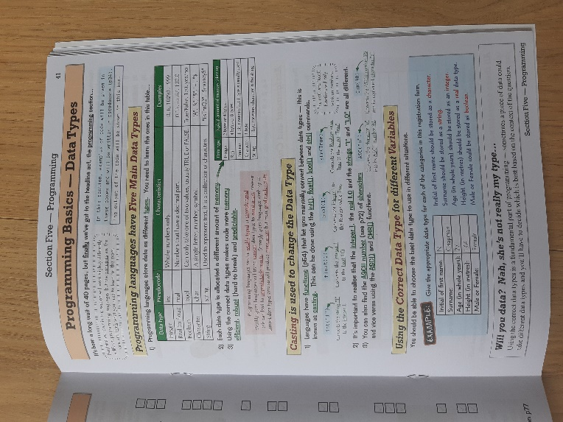 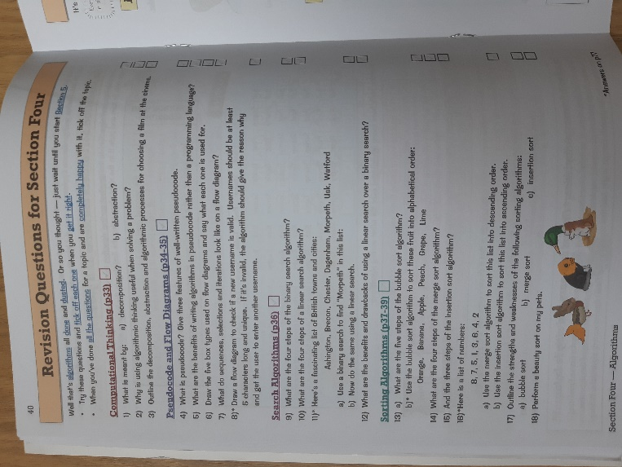

[Fig. 7] – A page of detailed but concise notes. [4] [Fig. 8] – A page of exhaustive revision questions. [4]

Separate workbooks are also available for each subject, that contain questions, rather than theory. They are meant to be used in tandem with the revision guides. They follow a similar structure to the revision guides, except where there is theory in the revision guide, there are questions in the workbook. The following are some key features of this pair of revision aids:

1. **It separates out each topic into categories and the glossary makes it reasonably quick to find each topic.**
   1. *This means the user is not spending a lot of time finding the information they desire. They can spend 60 seconds at most to find the page. This means they spend more time revising than looking for revision material and that is efficient and productive towards their revision goals.*
2. **The notes present in the theory book are concise and easy to read and understand.** 
   1. *The wording is exact and there are very few repeats, meaning the user barely re-reads something they’ve already read. Although re-reading is a good revision practice, rereading repeated information is not helpful when trying to get the most out of revision. This can be seen in figure 7. This should be included in the proposed solution.*
3. **The workbook questions cover every possible type of question a student may get in an exam.**
   1. *This ensures that the user should be prepared for any possible outcome on the day of an exam and they have practiced said outcomes – further increasing their chances of success and chances of dealing better with an unknown scenario or new type of question. This should be included in the proposed solution.*
4. **The colour coding is consistent throughout the revision guide.**
   1. *This ensures that for users who like to remember things by colour, only the most important words and statements get remembered because they are the ones that are highlighted by underline and colour all the time. This is seen in figure 7.*
   2. *Each page has its own colour and it can get a little hard to track if the user is speed-revising a lot of topics, however for most this should not be a problem.*
5. **The revision checklist of questions at the end of each category is exhaustive and detailed.**
   1. *Each question can almost be corresponded to each statement in the book. If every box is ticked at the end, that means the user is also fully prepared for anything that may come at them in an exam. As seen in figure 8.*
   2. *The fact it’s so detailed may be daunting for some users, however for most it should not be an issue.*
6. **The text is sometimes hard to read as it is very closely packed.**
   1. *This is likely due to the fact that each page has an entire topic to cover within it, meaning only the most important information should be on the page, and even then, there is a lot of said information. This means that for users with glasses, they may have usability problems and be discouraged from using the revision aid.*
7. **The layout of text on the page can sometimes be counter-intuitive.**
   1. *Background images of notes may contain key information, but the user may not initially spot that. Examples are placed in strange positions and the key information sections are sometimes not labelled. This could create usability issues where the user is spending excessive time trying to find the information they want to revise.*
8. **The workbooks, by systematic design, allow no generation of new questions.**
   1. *Due to the fact that workbooks in this form are not digital, this is not possible in any way, but regardless, fresh questions to further test and practice mathematics are not possible using this revision aid. This prompts the user to search for alternate methods, which may be good or bad depending on the method they find - if they even find one. This takes away revision time and could impact their performance because of it.*

### How Existing Solutions Affect the Approach

From the research carried out, it is clear that the approach to designing a solution to the problem should be gravitating around these key ideas:

1. **The User Interface (UI) should be very minimalist and informative.**
   1. Nothing should repeat and only the most fundamental of information should be displayed, e.g., formulas and diagrams.
   2. There should be very little clutter in the interface and buttons should be where intuition would imply them to be.
2. **The UI should also be configurable to give the user power to change it to their own liking.**
   1. This makes the solution a lot more personal for each user and it should remember those configurations, background images and colours.
3. **The UI should be usable from the start, along with the rest of the solution.**
   1. This is paramount to successful revision because the user is not spending time trying to understand how the revision aid works, and purely focuses on their learning and practice.
4. **The solution should be re-useable, i.e., a user should always have the option of coming back to the application with fresh content – this implies questions should be generated dynamically.**
   1. With dynamic generation, thorough and consistent practice is ensured – thus also ensuring effective revision and use of time.
5. **The revision material should be organised into logical chunks.**
   1. It should be easy to find a specific topic the user is wanting to focus on, and conversely it should be easy to practice a range of topics and/or all of them if the need arises. It should be dynamic and respond to the user’s requests in a smart way.
   2. As discovered earlier through research into already existing solutions, most make it hard to find what a user wants and it is a long process to practice a very specific set of topics. By ensuring that the user has full control of what they want to practice, it removes that hassle.
6. **The question generation (adhering to point 4) should be random, but targeted towards weaker parts of a user’s ability. Should exhaustively cover every question type.**
   1. The BBC wrote an article detailing what good revision should entail. *“However, the best strategy is to plan ahead and not do all your revision on one subject in a block before moving on to the next - a technique called "distributed practice".”* [5] It is clear that that there should be an option to generate questions across a range of topics as it helps the brain the most and adheres to the distributed practice methodology.
   2. Targeting the weaker parts of the user’s ability helps them practice more of what they know less, and less of what they already know. This ensures that their revision is effective each time they do it.
7. **Progress should be clear and trackable.**
   1. This will help the user better understand how they’re doing and what they should focus on. It can also help with motivation.
8. **The solution should provide model answers.**
   1. These should serve as reminders of how the question should be answered, and what the expected level of detail is in an exam. They should also show how many marks each line of working is worth – to teach the user how to manage their time.
9. **The solution should embed links to further information and study at the user’s request.**
   1. When the user wants to learn more about a specific formula or concept, they can. This will help them in revising and remembering key information while also fostering curiosity.
10. **The solution should be usable for anyone – even people who have never used it before.**
    1. This ensures that the user can fully focus on revising and not working out how the solution works. This is more effective use of revision time. It also improves the user experience.

## What is essential for this to work?

### Essential Features

Based upon the key ideas discussed, client/stakeholder interviews, existing solution research and analysis of the problem itself, the following is an exhaustive list of essential computational features which are to be present in the solution to the problem because either the solution will NOT work without them, or the client *needs* it in their solution.

1. **Generates questions randomly.**
   1. *This means that the next question cannot be anticipated because the user is not the one selecting questions. The randomness will be influenced by how many questions and of what type the user gets correct and incorrect, and will favour generating the ones the user gets incorrect more. This is an essential feature because it allows for almost limitless possibilities for questions and also makes revision more effective because the user is practicing a wide range of questions, mostly from areas where they struggle.*
2. **Saves what questions the user gets correct and incorrect.**
   1. *This means that the solution will save information on past scores into the secondary storage of the user’s hardware. This is an essential feature because it is a prerequisite of a number of other essential features.*
3. **Displays a graph of progress.**
   1. *A bar chart, or scatter diagram of historic scores on that specific topic should be displayed at the end of each round of questions. This is because it provides the user with visual feedback on their progress and allows to better understand how quickly the user is improving in their mathematical ability.*
4. **Organises every topic into a list.**
   1. *This means that each topic will be organised by specification into a list which will be easy to use and navigate. This is essential because it greatly reduces the time requirement to begin revision and therefore wastes less total revision time on non-revision activities.*
5. **Allows those topics to be turned on/off when the algorithm generates questions from topics.**
   1. *This means that the user is given 100% free control on which topics they wish and wish not to revise. This allows the user to freely target their own revision. Previous generation algorithms and favourability of topics will still apply, however.*
6. **Question generation must be configurable.**
   1. *This means that the user should have the option to choose whether the questions the solution generates will be targeted towards them or equally likely. This is essential because when the user feels they are done revising what they’re doing not so well at, they will be able to generate questions from a uniform probability distribution – acting almost like a test.*
   2. *They should also be able to select the number of questions, and the format that they appear on the page with (whether in a list or as single questions). This is necessary because it gives the user the control to choose how they want questions given to them.*
7. **Provides a “model answer” before each list of questions.**
   1. *This should be a toggleable feature and will provide a worked-through example of the type of questions which will appear if a single topic has been selected. This will aid in their revision because it will serve as a reminder and a practical example of what the user’s workings should look like, and that’s why this is an essential feature.*
8. **Displays correct answers and working when a question is answered incorrectly.**
   1. *It should happen in a similar format to how the model answer should be presented and should work in the same way, just this time it will be question-specific. This will aid the user in very quickly figuring out where they are losing marks and therefore it will enable them to figure out where they’re going wrong and how to improve from that.*
9. **User Interface layout must be very simple and easy to use.**
   1. *There should not be any complex looking panels, “flashy” design or anything else that could distract the user from focusing on revision. It also aids in the quick and intuitive navigation of the solution, therefore reducing the wasted time during revision, and therefore increasing the efficiency of the user’s revision. This works similar to how point 4 works.*

### Additional Features

Below is a list of additional features / ”other features” which are not strictly necessary for the solution to work, but would be preferred as additional functionality by the stakeholder and client.

1. **UI must be configurable/customizable – primary/secondary colours, background image.**
   1. *There should be a small settings panel available to the user to configure their interface with, to their own liking and needs. It should also aid in the customisability of the program and will feel more personal to the user when they use it. Many of the stakeholders requested this.*
2. **Provides links to further reading within model answers.**
   1. *Links such as Wikipedia pages, reference webpage links, links to videos, or anything else of the sort to provide the more curious of users with extra material to read and explore, if they’re interested in a topic and want to go deeper into it.*
3. **Displays the mark value of each question.**
   1. *This will be a small formatted number at the bottom of each question, indicating how many marks a question of that kind might be worth in an exam. This will build intuition and serve as a guideline to the user on how much time they should spend on answering the question.*
4. **Provides a list of suggested topics to improve upon.**
   1. *After each section of questions, the user should be prompted with some kind of list or group of topics they need to improve upon the most, based on their scores on said topics.*

### Rejected Features

And finally, a list of features rejected due to their over-complexity or unnecessary addition to the solution.

1. **Leader board to show scores and progress on topics of other members of a user’s class.**
   1. *Why? Because it is overly complex to make in the given timeframe since network architecture and servers will need to be setup.*
2. **Revision videos within the program to aid revision.**
   1. *Why? Because it is too complex to make within the given timeframe of the project and would also require a lot of secondary storage space to support – some computers may not have that. They may also be distracting for some users.*

## Is it going to be limited in any way?

Like with all ideas and solutions to problems in the world, there are some limitations which will be present within the solution to the problem – due to various reasons.

#### It Will Not Support Every Possible Specification

A fully finished commercial solution to the problem will feature support for mathematics specifications for each year group, key stage and exam board (if applicable). Due to the timeframe restriction for the completion of the solution, the working prototype will only contain a portion of the national year 7 mathematics curriculum specification. This limitation ensures that all the essential features can be completed within the timeframe, and in response to the client’s feedback specifically (because they are a mathematics teacher for year 7).

#### It Will Not Support Any Networking Functionality.

A completed solution could possibly have the option to save scores into an online database, and therefore provide the opportunities to implement functionality such as leader boards, accounts, and cross-platform accessibility. Due to a lack of time, complexity, and facilities which do not support the development of such systems, this functionality will not make it into the final solution. IT systems and regulations within the school environment that I am developing in do not support networking and the removal or weakening of those regulations and systems is not an option.

#### It Will Not Work on Smartphones or Tablets

There will not be any support available for smartphones or tablets. In a finished commercial solution, there should be, to give as many people as possible the opportunity to effectively revise, but, due to timeframe requirements and complexity, only desktops or laptops will be able to utilise the solution. The wrappers and installers required for those devices are too complex to implement in the timeframe given and with the resources available.

## Is there any required software or hardware?

Due to this solution being fully computational, there will also be some software and hardware requirements for the solution to work.

#### Needs a User to Have a Working Desktop or Laptop Computer

Because the solution will be available only to desktops and laptops, anyone who wishes to use the solution will need to have a mouse (touch-input will not be supported), a keyboard, a monitor and a basic desktop or laptop computer. Due to the low-end nature of the solution (it will not carry out a lot of complex calculations), system requirements will be minimal.

#### Needs a Java Virtual Machine (JVM)

Because the solution will be implemented using the Java programming language and Java Swing UI library, the solution will require each user to have a Java Virtual Machine (JVM) on their computer. Most machines do have this, but some may not and therefore the user will be prompted to install the JVM before first-run of the solution. The usage of Java is necessary because that is the language that I am most familiar with and that is the language that is supported on the school computers. Java Swing will be utilised because it is easier to use than JavaFX and I am also more familiar with it.

Sounds and videos will not be in the solution (due to reasoning explained in the essential features section), so the headphones or speakers will not be required for the solution to be used.

## What are the success criteria?

Below is an exhaustive list of success criteria, to be used as benchmarks within the design phase but also as points of progress and completion state during implementation and evaluation. Criterion gives it a name; justification explains why it’s a success criterion. This is very similar to the essential features described earlier, however these are more concrete statements that are measurable.

|  |  |
| --- | --- |
| Criterion | Justification |
| 1. Can generate mathematics questions. | The solution can generate a range of mathematics questions and interpret user answers to those questions. This is integral because it forms the main functionality for user revision. |
| 1. Questions generation should be configurable. | The user should be able to select which topics they want questions from because it allows them to target their own revision with specific concepts and methods they struggle with. |
| 1. Question generation should be random. | All questions that it will generate should be random in terms of numbers, variables, and wording. This is because it allows for infinite practice questions and any possible scenario. |
| 1. Question generation should be optionally favoured. | If the option is toggled, the algorithm for generation will be biased and favour generating questions from topics that the user gets more incorrect answers from. |
| 1. Provides a model answer. | Before each section of questions, a model answer with correct workings and tips should be displayed to remind the user what to do and teach them how to do it well. |
| 1. Displays correct answer and workings when answered wrong. | This is to help the user better understand where and how they’re going wrong, and therefore it should help them realise what to practice and how to do better next time they answer a question. |
| 1. Saves scores. | Questions the student answers correctly and incorrectly will be saved. This is for archiving and progress tracking. This data will be utilised in other parts of the solution. |
| 1. Displays historic scores in some form of a graph. | A bar chart, scatter graph, line graph or other suitable form of graph should be displayed in a “statistics” panel in the solution. It should also be displayed at the end of each round of questions. |
| 1. Displays a list of top topics to improve upon. | At the end of each section of questions, and in the overall “statistics” panel, a list of top lowest performing topics should appear, allowing the user to understand what to revise the most. |
| 1. User interface must be configurable. | The colours of the user interface should be configurable from a “settings” screen ~~along with the background image for personalisation~~. This may make the user more productive. |
| 1. Topics and specifications should be in list format. | A main list of specifications and topics should be displayed when the user first opens the solution in a list format for ease of accessibility and swift use. |
| 1. Should provide sources to extra reading. | In the case the user wishes to further explore the topics beyond the specification, the solution should provide “useful reading” via hyperlinks to resources on the world wide web. |
| 1. Accurate to specification. | Each topic should only cover what is needed from the specification of said topic and nothing more. This is to ensure that the questions presented are valid and accurate to exam regulations. |

*\*S.C. 10 (detail) amended. See iteration #4, page 98 for justification.*

# Design

In this phase, I will be detailing and breaking down the design of the solution to the problem, as advised by the client and any other applicable stakeholders. The success criteria were sent to the client to confirm it with them and ensure nothing was left out: “I have had a read through the success criteria and it all sounds great. I can’t think of anything that needs to be added.” [6] was the response. The solution will be implemented in the Java Programming Language with Swing for all the user interface components.

## Problem Decomposition

The problem of designing a mathematics revision aid by the outlined success criteria and analysis above, can be separated into a multitude of sub-problems (modules / large UI components) and those can be separated further into even smaller problems – all the way down to individual functions and algorithms in some cases. The following is a comprehensive overview of the problems and sub-problems which will be discussed in more detail as the decomposition continues.

1. Mathematics Revision Aid and Question Generator.
   1. Initialisation.
      1. Getting initial data.
      2. Generating the user interface.
   2. Algebra Interpretation.
      1. Reading and interpreting algebraic expressions computationally.
         1. Defining symbology and algebra formats for a computer.
      2. Solving questions.
         1. Finding solutions by known mathematical methods.
         2. Ensuring the answer is correct.
   3. Question Generation.
      1. Randomly choosing a topic, question, and question details.
         1. Sorting the topic list.
      2. Handling topic bias based on historical performance.
      3. Ensuring questions are solvable.
      4. Generating correct solution and working.
   4. Visualisation.
      1. Displaying historical performance data.
         1. Graph generation.
         2. Chart generation.
         3. List generation.
      2. Displaying questions.
         1. String handling.
   5. Data Handling and Saving.
      1. Establishing standard data-formats.
      2. Saving data.
      3. Reading and writing the data.

### Main Menu UI and Initialisation

The first thing a user will see when they open the solution is the main menu user interface (UI), allowing for a mode of navigation to question generation, statistics and settings – each with their own sub-interfaces.

This will be generated based on a number of external files with topic names and parameters in them. This is so, that the question types and question formats can easily be edited, without editing any of the solution code itself. If this proves to be a limiting and difficult approach, a database will be used instead.

Each time the solution is activated, the user interface will be dynamically generated. That means the list of topics, suggested topics for improvement and colour schemes will be generated from locally saved data that the user has previously saved. This also means that the UI will be programmed by hand rather than edited via 3rd party tooling.

### Question Generation

The question generation will firstly require a UI to select specifications and topics and other generation specific settings (this will have been generated initially on start-up). The settings panel will be integrated into the main window due to the relatively low number of settings that will be required for the solution to function (with the addition of a few customizability settings too). The statistics panel will be its own separate window to display historical performance data and other necessary information, but with a small panel in the main window for usability.

To actually generate the questions (based off selected topics and settings), it will require a generation module (in the case of Java, a separate class) which will contain the necessary functions to create the questions. The questions will need to be displayed by a visualisation module (another Java class, to be discussed later). As outlined by the analysis and success criteria, the topics of the questions being generated will need to be favoured based on how well or not well the user has performed on those topics in the past. For that, another class will need to be made for handling saved data. All of the saved data will be stored in .JSON files with their respective formats (detailed later).

#### Topic Selection and Question Selection

Topic selection (like previously mentioned) will need to be done randomly, with the probabilities being biased towards topics with more wrong answers (if the user has configured that). To actually select topics after the user has chosen them, they will need to be internally sorted, using for example insertion sort (or any other sorting algorithm), indexed and selected with a random index inputted into a binary search algorithm.

Each topic will have a set of question formats associated with it, with a number of blanks left out to be filled by numbers or words generated randomly. Correct solutions for each question type will also have formats with them, that will change to fit the question’s parameters. These too, will need to be correctly generated, although they should be comparatively easier since the workings will be general.

#### Algebra Interpretation

Algebra interpretation and getting a set of solution answers to each question will be handled by the function which generates the question. Each question format in each topic will have an algebraic expression, absolute value or a file path to a java Class which will compute the answer with the given generated numbers/values. The algebraic expression will be formatted in a specific way that the computer will understand, but that will be explained in the later section.

### Post-Generation Functionality

#### Visualisation and Feedback

Once a question has been chosen, it will need to be graphically displayed on the screen to the user. As discussed within the analysis phase, it should be displayed in list format by default, but should also be displayed as singular questions with more space around it – if configured so.

The visualisation class will also need to deal with generating graphs and charts to display historical performance data. This is because, as outlined by the success criteria and the client’s needs, a visual representation of progress and improvement is vital to effective revision.

#### Data Saving and Handling

Once a round of questions is finished, the data (such as how many were correct, how many were incorrect, which ones were incorrect, etc.) will need to be saved onto the local computer to be used in the future and to be used during the visualisation window within the statistics panel. The data-saving and data handling class will also be used in the initialisation of the solution. Data will also need to be fetched from the file of past question results in the same way it’s saved because the computer also needs to use the data in the file to generate “suggested topics of improvement” lists and work in tandem with the visualisation class to generate performance statistic visualisations.

Common data formats – such as question format, algebra format, result format, etc – will also need to be established as noted before because otherwise, it’ll be very difficult to piece together questions or expressions based on multiple pieces of data stored in multiple variables in multiple places.

## User Interface

Before exploring and necessary algorithms and defining the workflow of the solution, a Graphical User Interface (GUI) is necessary to give meaning to the algorithms which will be written and used. “*A GUI (graphical user interface) is a system of interactive visual components for computer software. A GUI displays objects that convey information, and represent actions that can be taken by the user. The objects change colour, size, or visibility when the user interacts with them.”* [7]. As explained by the quote, it is visual and below is an illustration to show the potential layout and the various panels and screens it might feature – to give meaning to algorithms designed later.

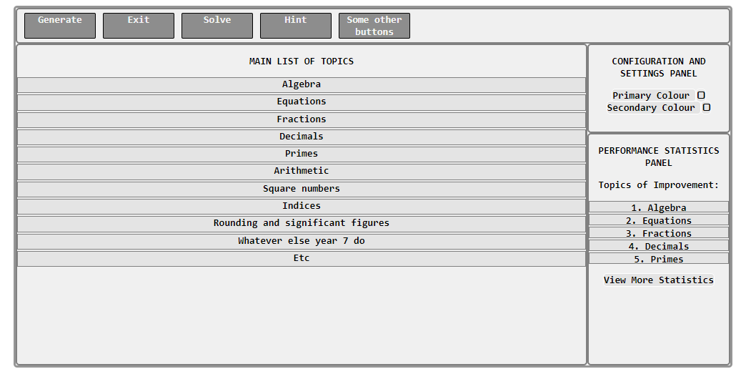

[Fig. 9] – A concept layout of the main window the user will be presented with, designed with HTML and CSS.

Certain features are missing, such as how to display the questions from the configuration panel, and some parts will likely be changed during the development process. This is a general idea of how it will look like. It’s utilising a white/grey/black colour scheme because the user themselves can choose what colour most things will be, as implied by the buttons in the settings panel.

## Necessary Algorithms

Like all computational solutions to problems, algorithms are the basic building blocks. Below I will define the basic functionality and workflow of the solution using pseudocode and flowcharts of some of the main algorithms which will be used.

### Overview

There is no clearly defined “loop” that the solution will explicitly follow. There is however, a main class which will initialise and control the application during its use. There will also be a range of other methods from other classes which will be used during the regular running of the application. Below is an overview flowchart which will provide a clear understanding for the general workflow.

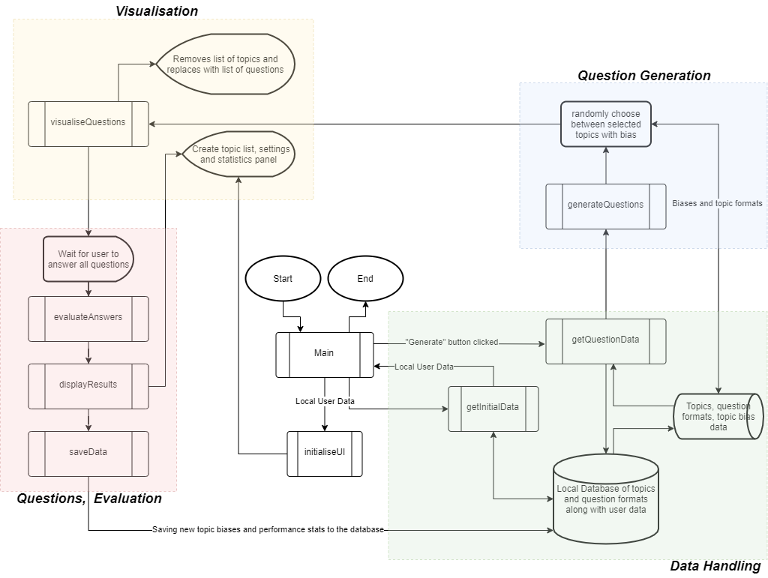

[Fig. 10] An overview flowchart of the basic workflow of the solution.

The above flowchart summarises the general operational workflow of the solution and does not include smaller details like interaction with the configuration and statistics panel, because those will all be event-based interactions and no user interface changes will occur. As is clear by the colours, there are 4 main stages/areas the solution will work from/with. Some, such as the question generation, data handling and visualisation areas will be their own stand-alone classes during implementation, while some such as the questions/evaluation section are just summary guidelines to follow. As previously stated, there is no clearly defined loop due to the event-based nature of the solution, but as is also clear from the flowchart, a loop is present regardless. This means that code will be easier to conceptually organise and debug.

Not all of the subroutines outlined in the overview flowchart fully describe what they aim to do, so the following list describes most of them in moderate detail.

1. **Main**()
   1. Controls the workflow of all the classes and modules by calling subroutines and handling events.
   2. In-charge of initialising the solution. Does not handle logging in, as there will be no login feature.
2. **getInitialData()**
   1. Queries and processes the locally stored files for initial user information such as the colours, settings and other important data.
   2. Returns them to the main method for processing.
3. **getQuestionData()**
   1. Based upon the currently selected topics, it will query the JSON file and get the relevant topics needed for question generation, as specified by the user.
   2. It will not return them to the main method, but instead into a global variable, part of the main class.
4. **generateQuestions()**
   1. This function will process the incoming data from the getQuestionData() method and it will iterate through each one, changing the data and filling in blanks with number/string values to generate a unique set of questions.
5. **visualiseQuestions()**
   1. The above method will use this method to place the questions onto the screen in a set way. How, will be determined by the user’s settings.
6. **evaluateAnswers()**
   1. This method will validate each answer and return true or false if the question is correct or not.
7. **displayResults()**
   1. This method will take the evaluation data from the previous method and alter the user interface accordingly – displaying correct answers correctly, and wrong answers with correct workings and model answers.

### Principal Subroutines Pseudocode

The Main class will house the main control code to manage the running of the solution program. That means things like events and class imports will go there and will be used in a more general way. The code for initialisation and basic running may look like this:



It contains imports to 3 other packages/classes that it will use to take methods from. It will connect to a number of events which it will listen to and react accordingly when they happen. This is what is meant by “Event Based Programming”. This may look very empty at this moment in time, and that is due to the fact that many of this code cannot be determined until the implementation phase begins. The same can be said for the rest of the pseudocode written below.

The other methods referenced within the main class are below and may look like this:



The first initialises the user interface with the initial user data provided by the data handling class, such as the list of suggested topics of improvement and interface colours. The second simply calls the first in the scenario that a round of questions is interrupted by the user. It’s a standalone procedure because more code may be needed to write there within the actual implementation phase.

The code for generating each question may look something like this:



The visualiser class is used iteratively for each of the questions generated randomly from each topic. The logic of how each of the topic biases is also shown. A topic is chosen if the random float (between 0 and 1) is within the topic’s “range” (hence the offset variable). The probability of the topic being chosen is simply topic bias/total bias. Once the topic is chosen, the JSON data gets read, then all the randomisation of the numbers gets done, and the visualiser will create a new UI object to display that question – along with attaching the “correct answers” list to it. The RandomGenerate() function takes care of this.

### JavaScript Object Notation Storage Format

As mentioned earlier, JSON will get used to store the data about everything the solution needs to know. Below are a series of formats which will hopefully not be changed during the development process, since they will form the backbone of the data storage for the solution.

#### Specification Data Storage Format

Below is the intended JSON format to store everything about all the specifications, topics and questions.



Each object/array is explained in its purpose, and it is clear that anything can be stored here. However, the key information is located in the QuestionFormats array. The array will contain any number of objects, each with the necessary properties to generate any kind of question. The mathematics syllabus for KS3 [8] provides a comprehensive overview of all the kinds of questions that somebody may come across during their mathematics studies in secondary school. Therefore, it provided a solid foundation to base the storage format off of. Each answer can be anything between a word, a symbol, a number, or a list of answers of any of those 3 types. Therefore, the storage format has to account for those possibilities.

That is why the CorrectAnswers array can store every possible answer and allows for a string of specially formatted algebra, an absolute value, or a file path to a java class which will calculate the answer based on the previously generated question parameters. The Values array will contain objects which each store the necessary properties to generate the values for the question. If the value is a number, the Min and Max property will need to be used in order to randomly generate it, and its number set will also be chosen based on the Type property (Integer gets whole numbers, Decimal gets floating point numbers). A list of definite values to choose from can also be represented if the Type is String. The CorrectWorkings array will contain general strings to show the solution to a problem.

As per the client’s request, and the success criteria, storage of “Model Answers” in the ExampleQuestions array is also possible along with links to extra reading, within the UsefulReading array.

The file will become very large as more question formats are added, and there may be a time where a custom parsing function will need to be written. For the sake of this prototype, that eventuality will likely not be reached, however it is a consideration none the less. JSON parsers have a maximum file size limit of 4MB (4,194,304 bytes). JSON files themselves however do not have a limit in size by technicality and this method of storage is therefore sufficient for this solution.

#### User Data Storage Format

The user data will store all the relevant settings the user has set during their use of the solution. These are things like colours, and settings for question generation. If more colour categories are added (like tertiary or quaternary, then those can simply be added into the file).



#### Historic Data Storage Format

Below is the format for the historic data file. It is simply an array full of objects, each of which stores data for the score achieved, and maximum possible score the user could have achieved. A new object is created for each topic present in a round of questions – even if there is only 1 question.



This format may also change during the development cycle; however, this is what I believe should be included in the format at the time of writing. The reason for this type of data is being stored in a JSON file, rather than a database is because the rest of the files are also stored in JSON, so this would make implementing the JSON parsing and JSON writing easier since development only has to focus on understanding how to read and write JSON – and not SQL or any other database language.

## Solution Structure

Below is a horizontal hierarchy diagram. It describes the structure of the solution from the perspective of the main functionality of the program, where most of the icons represent either classes at the top level or methods at the bottom level.

[Fig. 11] A hierarchy diagram, illustrating the solution structure as abstract functional components.

The icons themselves should be self-explanatory in terms of what they’re for. The three 3rd level components under Generation will all likely fall under a single method – different from the rest of the bottom level icons as they will all likely have their own methods associated with them. The Data Storage icon’s 3 child components are not going to be classes or methods, rather JSON files to store all the necessary data locally on the user’s operating system. The diagram paints a picture of how the decomposition done in the earlier section has translated over into a more robust structure for the solution to follow, as these icons are all of which need to be implemented for the solution to work.

Explaining why each of the icons exists at the bottom level for each branch would be unnecessary as many were explained during the pseudocode section and the rest are all self-describing labels.

## Key Technicalities – Variables, Data Structures and Classes

Now that a clear structure for the solution has been identified, along with the local data storage formats and the general operating workflow, the core variables, data structures and classes will have to be identified and justified. For this solution, there will be no unique data structures, unless the need for some arises during implementation, hence only variables and classes will be discussed below.

### Variables, Input Sanitisation and Validation

The core, key variables which the solution simply cannot function without, are listed below:

1. UserData: JSON Object
   1. This object will hold all the parsed data from the JSON string. It will be used like a dictionary – being accessed when and where the need arises. Its value will not change during run-time.
2. SpecificationData: JSON Object
   1. This has the same functionality as the variable above, however, it stores all the specifications and question formats (as outlined in the flowchart in the earlier section).
3. HistoricData: JSON Object
   1. Exactly the same idea as the above 2 variables, however it will store the historic performance data – to be used mainly in the statistics panels and overviews.
4. SelectedTopics: Array of Strings
   1. An array of topic names which will constantly change value during the topic selection process. A sorting algorithm such as quicksort will be used in order to maintain this array. This array will be used every time the questions are generated, along with potentially (unsure at the time of writing) remembering which topics have been previously selected after completing a round of questions.
5. DisplayQuestionsAsList: Boolean
   1. Simply a toggleable setting for determining if the questions should be displayed as a list, or as a single question on the screen at once. Affects generation of questions.
6. EnableBias: Boolean
   1. Another toggleable setting to be used during the question generation process to affect the probabilities of topics being chosen.
7. QuestionsPerRound: Integer
   1. This number controls how many questions get generated per round when the “Generate” button is clicked. The user can freely change this number to their needs and liking.

These variables will all be consistently used during regular running of the solution – most during the question generation process (the main idea with the solution). This is not a comprehensive list of all the variables which will be used globally throughout the program as some may be added during the development process due to a rise in need for such a variable.

Most of these variables need to be entered by the user. This means that the data entered must be sanitised and validated. Beyond these variables, there are also other locations within the solution where input must be sanitised and validated before being processed. A systematic explanation of these locations and justification for the validation is as follows:

1. Within the settings panel, DisplayQuestionsAsList will be a simple checkbox, and therefore does not need sanitisation. Validation does not also need to happen because the data will be valid whether it’s true or false as those are the only two states it can be at any time.
2. Within the settings panel, EnableBias will also be a simple text box. No validation and sanitisation will be necessary for the reasons outlined above.
3. Within the settings panel, QuestionsPerRound will require a text box. It will need to be sanitised, since the data type of the value is an integer, and if a user enters something which is not an integer, then the system will cause an exception. Whitespace will also need to be removed. The number, once sanitised, will also need to be validated because the number cannot be negative. That would not make logical sense – and that therefore cannot be accepted. There might be a maximum value, so the inputted value will need to be validated against that as well.
4. There will be a separate window to input colours. If during implementation, the choice is made to implement it graphically, then there will be no need to sanitise or validate the data because all data is valid by default. However, if the choice is made to implement it by a series of text boxes, then each text box will need to be sanitised to only include numbers, and validated to only include numbers within the range 0 to 255 inclusive (since the input needs to be an RGB value).
5. Each question box will also have a textbox to submit the answer. The textbox will need to be sanitised to remove whitespace, and symbols. Text or numbers will need to be allowed, because some questions will require a textual answer and others will need a numerical answer. The answers will need to be validated against the correct answers of that question.

The above locations within the solution are the only areas where the user has complete free will to enter data. Should any more arise during the implementation phase, they will be documented and justified in that respective section of the implementation phase.

### Packages and Classes

Due to the choice to use Java as the programming language to implement the solution in, a structure for the packages and classes will need to be declared – because Java needs to have defined packages and classes.

Due to the nature of the solution, most of the heavy lifting in terms of processing and computing is done during the user interface initialisation phase, and the question generation phase. This means that there is no inherent need for a large number of classes to be defined and utilised. The user interface will consist of UI Objects taken from the Java Swing package and therefore no additional bottom level user interface classes need to be defined. However, there will be a handful of user interface classes which will be made up of multiple Swing components and will encompass their own functionality for the solution to work. Those are illustrated in the following UML (Unified Modelling Language) diagram:

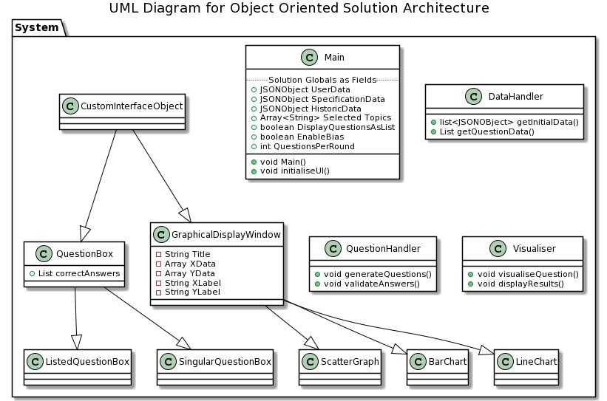

[Fig. 12] A UML Class Diagram, illustrating the solution structure in terms of classes.

The arrows of the diagram above symbolise the inheritance of classes. For example, ListedQuestionBox is a subclass to QuestionBox. This is because the QuestionBox class will provide the same properties/Swing components for any type of question – correct answer values, question wording text box, etc – but each subclass will look different and will be used in different places depending on user settings. There are also 3 main, larger classes which will form the backbone to the functional operation of the solution. They too, will be a part of the System package as shown. The Main class is included here because it is vital to the operation of the solution, even if it doesn’t function like a standalone class.

It is currently unclear how many exact properties and methods all the above classes will have, as the circumstances may change during the development phase. However, the ones that are known are included to provide a clear understanding of the minimum functionality each class needs.

## Usability Features

Due to the nature of the problem and the needs of the client and stakeholders, the solution must be usable. Usable is an ambiguous term on its own, but for this context, it means this:

"The extent to which a product can be used by specified users to achieve specified goals with effectiveness, efficiency, and satisfaction in a specified context of use" [9]. That is the ISO 9241 standard definition for usability. This definition, however, can be rewritten into a list of 5 characteristics (known as the 5 Es of usability) and is presented below [9]:

1. Effective
2. Efficient
3. Engaging
4. Error Tolerant
5. Easy to Learn

This directly means that the solution must be effective at its intended job, efficient in its execution, engaging for the user to use, error tolerant to the user’s intentions, and easy for the user to learn. Realistically, this translates into this solution as follows:

1. The buttons must be scaled in accordance with their importance and frequency of use. This is because if buttons that a user uses often are small, the user will spend more time carefully moving their mouse to the button and will in turn not feel satisfied using the button, especially if the button is used very frequently. The solution’s goal is to provide as little obstacles as possible to the revision process, and therefore they must not feel like an obstacle for the user.
2. The buttons must be obvious and in an intuitive place. This means that more frequently used buttons are somewhere where they are constantly accessible (unless they should not be due to logic) and can be constantly seen. Related buttons (by conceptual function) should also be near each other. For example, the button to generate questions and end the question session should be adjacent because of their relatively similar function.
3. Text boxes must be obvious and consistent in design style. This means that the areas where users can enter input should look the same and behave the same. This is a visual cue to the user which tells them that it’s a place to enter input, without spending time figuring out what the box is if it’s already been seen previously. This makes the solution easier to learn.
4. The menu navigation should be intuitive and quick to do. This means that switching windows should take as little time as possible, and when entering a new window, the contents are displayed in an intuitive way. For example, the list of topics should be separated out by the name of the specification they’re under to make it clearer which topics the user is choosing. Navigating to the settings menu should always go through the same button in the same place or the settings panel should always exist in the same place to ensure the user doesn’t have to learn multiple ways of getting to the same place.
5. The selection of multiple items should be easy and reactive to the user’s decisions. This means that if the user wants to select the entire specification, there will be an obvious button to do so. If they instead want to deselect all of them and select only a few topics, there must also be buttons to do so. These buttons must look and behave the same to signal to the user that their function is conceptually the same and the user will spend less time learning what the buttons do because they already know.
6. The use of colour should also be conceptually known. For example, if a user gets a question correct, the button might highlight green, and a wrong question might highlight red. This is because due to social norms in human society, red is associated with false, and green is associated with true. However, someone who is colour blind may get the colours swapped and misunderstand which questions they got right or wrong. Therefore, there should be alternative means (such as an icon of a tick or the word “correct”) displayed to ensure the user understands which questions correct and which ones are not – regardless of disability.
7. Choice of font must also be appropriate. A font used may not be installed on the user’s computer and will therefore cause problems in the rendering of the GUI. This means that the choice of font should limit itself to default fonts. The choice of font should also be appropriate to context – using a calligraphic font when displaying numbers in the statistics panel simply does not make logical and intuitive sense, and doesn’t fit in from a design perspective.
8. Each window and panel must be minimalistic in design. This means that panels should not overload the user with information or “walls of text” (for lack of better phrasing), but instead provide information in concise wording and only show relevant information that the user wants to see – and nothing more. This means that the user feels less overwhelmed when first opening the solution and can explore its functionality at their own pace – rather than presenting them with everything at once.
9. Naming buttons and panels of the solution should be appropriate and descriptive of their function but also concise. This means that each button does exactly what its name implies. A button called “Generate” will do what it says – generate questions. Another button called “Check” checks the answers and evaluates all questions – like the label implies. If tooltips for each button are chosen to be added during implementation, then the explanations must be concise so not to fill up the UI, but also descriptive and not ambiguous to the user. Since ambiguous is not a factual definition, it will need to be defined by client and stakeholder feedback.

The points outlined above will be adhered to during the implementation process. However, some of the points above may change depending on the client or the stakeholder’s request, since ultimately it is they who will end up using the solution for its purpose. Figure 9 - the concept design for the main GUI - within the User Interface section provides an example of some of the usability features outlined above. This will be improved upon during implementation but may also drastically change at the client’s request.

## Post-Development Data and Concluding Notes

After the implementation phase, testing will need to be done to ensure the solution works as intended and described by the success criteria outlined in the analysis section of this documentation. For this, below is a test table for post-development testing which will be filled out as the testing is done. It provides references to each success criteria and intends to satisfy them fully – some success criteria may require more than 1 test to validate its achievement.

|  |  |  |  |  |  |  |
| --- | --- | --- | --- | --- | --- | --- |
| Test # | Success Criteria # | Test Reason | Input | Desired Output | Actual Output | Success T / F |
| 1 | 1, 2, 3, 10 | To prove the solution can generate questions with any parameters. | Generate button clicked. Questions per round = 10. EnableBias = false. All topics selected. | 10 questions from random topics each with logical wording. |  |  |
| 2 | 1, 2, 10 | Above. | Generate button clicked. Questions per round = 10. EnableBias = false. 1 topic selected. | 10 questions from a single selected topic. |  |  |
| 3 | 1, 2, 10 | Above. | Generate button clicked. Questions per round = 20. EnableBias = false. 1 topic selected. | 20 questions from a single selected topic. |  |  |
| 4 | 1, 3, 4, 10 | To prove bias handling works as intended. | Generate button clicked. Questions per round = 20. EnableBias = true. 2 topics selected. Previously registered wrong answers in one topic. | On average, more questions in the one who’s bias should be higher. |  |  |
| 5 | 5 | To prove model answers are supported. | Generate button clicked. | Single model answer from a topic the user has selected. |  |  |
| 6 | 6 | To prove that correct answers are shown and that questions are evaluated correctly. | Evaluate button clicked with at least 1 wrong answer submitted. | Correct answer and working shown on wrong question only. |  |  |
| 7 | 6 | Above. | Evaluate button clicked with 10 questions per round. All answered wrong. | Evaluates all answers wrong and shows answer and workings. |  |  |
| 8 | 7 | To prove that the solution saves the user’s scores. | Results of a round of 10 questions. | 10 new entries in the historic results file. |  |  |
| 9 | 8 | To prove data can be graphically displayed. | 1 topic selected; line chart selected. | 1 new window with historic scores of the selected topic only. |  |  |
| 10 | 9 | To prove solution’s ability to suggest topics to practice. | None. | Displays top 5 topics with highest bias in the main menu. |  |  |
| 11 | 10 | To prove that the solution is configurable. | File selected from user’s computer for display. | Image displayed in main menu background. |  |  |
| 12 | 11 | To present topics in list format. | None. | Topics shown as a list in the main menu. |  |  |
| 13 | 12 | To prove the solution supports extra reading suggestions. | None. | Main menu has extra reading button on each topic. |  |  |
| 14 | 12 | Above. | None. | Extra reading button displays a link with explanation. |  |  |

Success criterium #13 is not in this table because that is one which can only be validated by the client as they are a mathematics teacher for KS3. For the rest of the criteria, this test table will work in conjunction with the iterative test tables created during each development cycle. These tests serve as overall black box checks, while the iterative test tables serve as white box tests.

# Implementation

Before moving to implementation of the solution to the problem, a number of things must first be clarified and defined in-order for the following sections of development to make sense and have a cohesive presentation.

The Development Methodology which will be used for implementation of the solution, will be Agile for the majority of time, but will take some components from a derivative of Agile, known as Scrum. Specifically, the Minimum Viable Product (MVP) approach it uses. This means that heavy emphasis will be placed on functionality of the product before pleasing aesthetics, and iteratively upgrading a series of prototypes until the final design is reached.

For creating the user interface, Java Swing will be used as previously mentioned. Some Integrated Development Environments (IDEs) provide a ­drag-and-drop system for creating the GUI and the code for that interface is generated automatically. For this solution, I have felt it to be a better approach to hand-code the interface generation myself as opposed to the drag and drop system for a majority of the time. This is because the generated code cannot be edited and therefore, I will have more freedom to change things this way. This is also because the drag-and-drop system is very finnicky to work with when trying to align components and create exactly the layout one wishes to achieve. This will indirectly mean the development time will take slightly longer, however, after a couple of iterations, this speed should get quicker as I get more familiar with the Java Swing Application Programming Interface (API), used to define, and edit the GUI components.

During programming, a suitable Naming Convention will also need to be defined and used for readability, more efficient workflow, and a cohesive codebase. Variable names for Java Swing components will also be included.

|  |  |  |
| --- | --- | --- |
| Keyword/Area/Location | Convention | Example |
| Global variables | UpperCamelCase |  |
| Local variables | lowerCamelCase |  |
| Global constants | CAPITAL_UNDERSCORES |  |
| Local constants | lowercase_underscores |  |
| Class name | UpperCamelCase |  |
| Class public attribute name | UpperCamelCase |  |
| Class private attribute name | lowerCamelCase |  |
| Class static variable name | _lowerCamelCase |  |
| Class public method name | UpperCamelCase() |  |
| Class private method name | lowerCamelCase() |  |
| Class static method name | _lowerCamelCase() |  |
| Method parameters | lowerCamelCase |  |
| Swing component name | shortclassname_UpperCamelCase | btn_Generate |
| Component parameter const. | _lowerCamelCase |  |

## Iteration #1

In this iteration, the plan is to complete a set of prototypes for the main menu itself and its corresponding window – providing a rough layout of the panels and ensuring everything gets generated as it should. This is because this menu is the backbone of the entire solution and everything else will be branching off it as time passes – and it is therefore the most crucial one to make functional.

### Design and Outline

Due to the nature of this iteration, pseudocoding the entire Swing code to display the GUI will simply not be worth the effort since it’s specific to Java. I will instead provide a memory note back to the overall design phase’s user interface section where I defined the original concept idea for the main interface. After sending an image of the concept to the client, and their approval of it fully, no variations in design will be needed. This means that all the code written in this iteration will go fully towards defining the initial interface and some of its related functions.

There are, however, several set-in-stone things which need to be present in the design:

1. A main button panel at the top:
   1. Generate Button
   2. Evaluation Button
   3. Next Question Button
   4. Previous Question Button
2. A settings panel to the right:
   1. Suitable room for inputting user data.
3. A statistics panel to the right:
   1. Suitable room for a list of suggested topics.
   2. A “More Statistics” button to a new window for displaying statistics.
4. A main square area to display topics and questions:
   1. An empty space for now but will contain everything later.

A testing table is presented below of the necessary tests which need to be passed in order to ensure the interface works and is generated as intended by the description above.

|  |  |  |  |  |  |  |
| --- | --- | --- | --- | --- | --- | --- |
| Test # | Success Criteria # | Test Reason | Input | Desired Output | Actual Output | Success T / F |
| 1 | NULL | To ensure the window fits to the user’s screen. | Solution activated. | Window fits to user’s screen. |  |  |
| 2 | NULL | To ensure the solution finishes execution after window closure. | Solution closed. | Solution stops execution. |  |  |
| 3 | NULL | To ensure the abstract design, defined earlier, is followed. | Solution activated. | 4 main panels – topics/questions, settings, statistics and top buttons. |  |  |
| 4 | NULL | To ensure the necessary buttons get generated. | Solution activated. | Buttons visible: Generate, Evaluate, Next Question, Previous Question, More Statistics |  |  |

### Programming and Implementation

#### Code and Justification

Screenshots of the code written in this development phase are below.

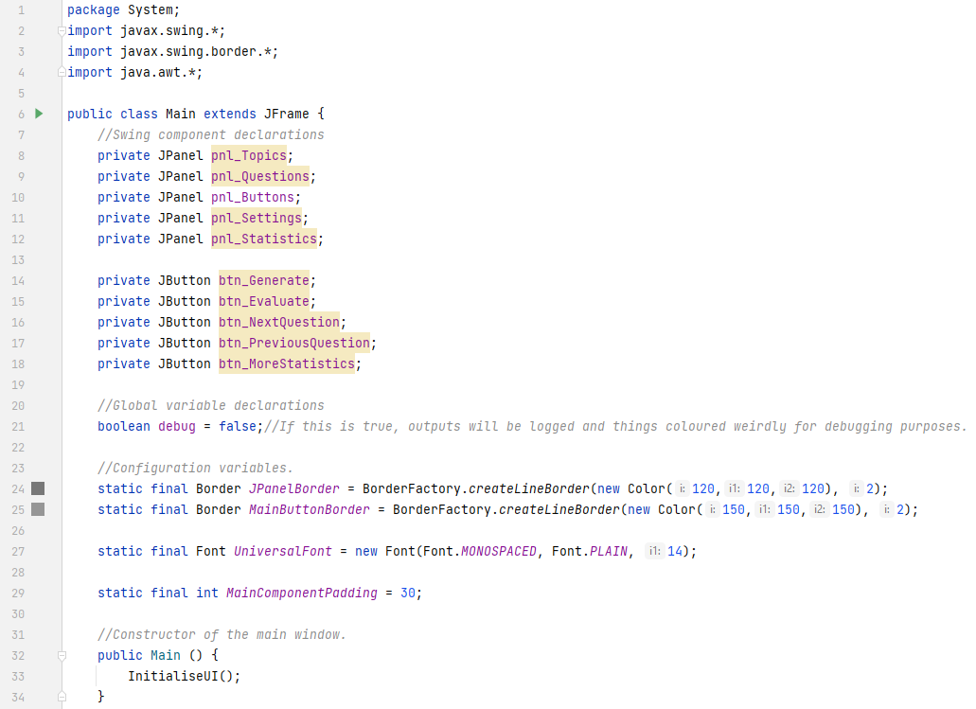

The Java code above is within the Main class. It inherits from a Swing class called JFrame – a top level window container for any of the other swing components to go into. This inheritance is necessary because it is easier to access the main window’s methods if the main class itself is the main window. Imports of the AWT and Java Swing packages are also shown since usage of some of their classes is necessary in the solution’s code. Usage includes the Border and Font classes from AWT to define a common border and font for all the UI components. Along with those variable declarations, other Swing class instance fields are declared at the top for all the necessary panels and their buttons that are needed so far. They are made private because allowing other classes to potentially access them and modify them can be a problem. This, however, may get changed later as I may need to reference them from other classes.

A small debug Boolean is also created purely for ease of development. The later screenshots show where it’s used.

A constructor method of the main class is also present (otherwise the window initialisation will not work). It does *not* contain the UI generation code because I may need to add extra code to that method later and I do not want that code to interfere with the UI generation code.

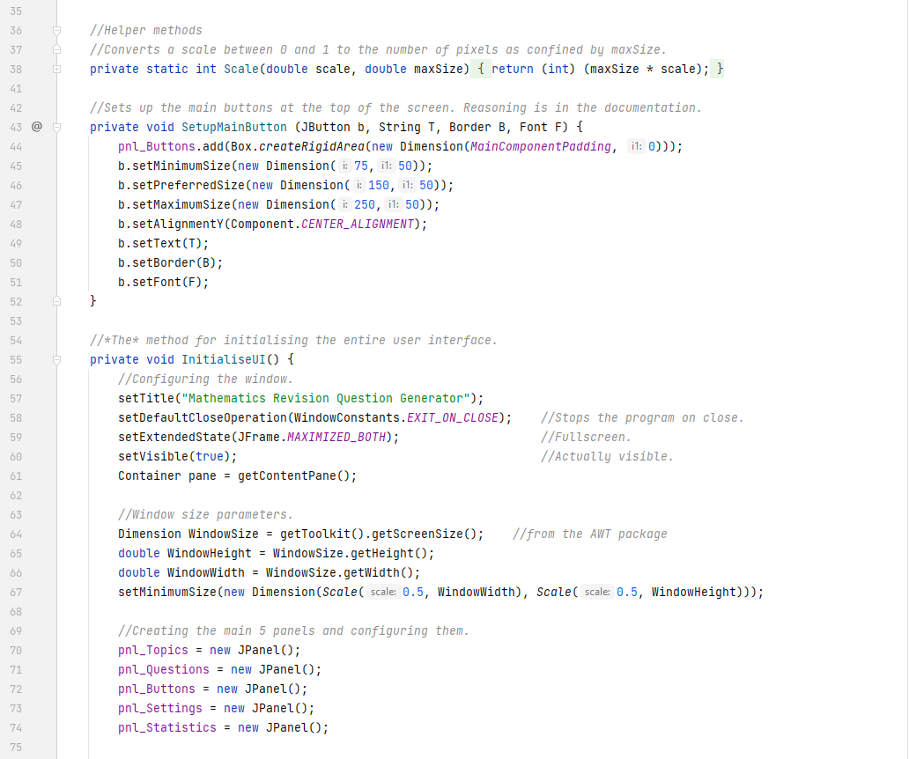

Before discussing the UI generation method, I feel it necessary to discuss what I like to call helper methods. I have defined two at the top. They are methods that do not directly involve themselves with the class (hence they’re mostly defined as static), but they encompass code that I may need to use multiple times. The comments explain their intended function.

SetupMainButton() ensures all the main buttons at the top of the screen look the same – to ensure a cohesive visual style is maintained in the entire solution. Modifying that method will modify the aesthetic properties of all the main buttons.

The InitialiseUI() method was mentioned earlier in the design section, first declared within the overall flowchart. That method is now being defined. To comply with the test requirements outlined in the previous section, the first few lines define how the actual window operates. They ensure the window is made full screen upon start-up, that the solution finishes execution when the window is closed, and that the window cannot be resized any smaller than a specified amount. This is because a lot of unexpected behaviour can be observed with the interface components when the window is sized too small.

This is also the first instance where the use of one of the helper methods is showcased. Since I do not know the size of the user’s screen, it is better to define the minimum size of the window in *relation* to that size. 0.5 means half the window height/width. Each of the 5 panels outlined in the test requirements are also defined as new instances of the JPanel class.

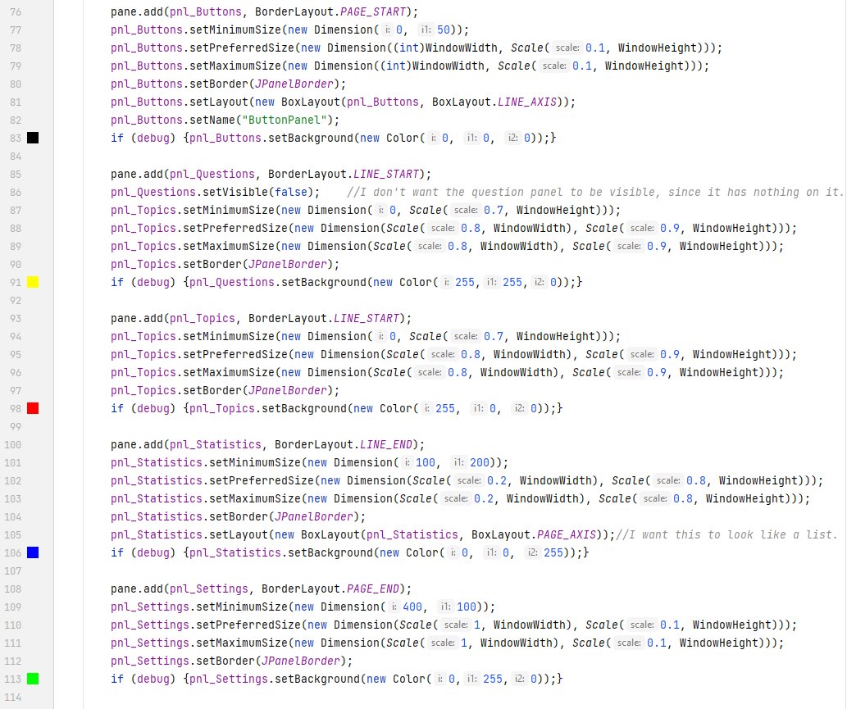

Above is the bulk of the InitialiseUI method code – the definitions and configuration of the main 5 panels. Swing has a group of classes known as Layout Managers which, like the name implies, manage the layout of the components in the container they’re applied to. The main window’s root container (referenced in the previous screenshot) contains all the above 5 panels and I felt it best to use the BorderLayout to lay them out. BorderLayout was chosen because it allows me to achieve the desired panel arrangement in the easiest way. From the Java Documentation from Oracle [10], I learned how to use it and defined the UI to look very similar to the image below. However, due to the choice of using this layout manager, the settings panel had to be moved to the bottom of the screen as the manager does not allow 2 containers to both be visible in the same “section” (LINE_END in this case).

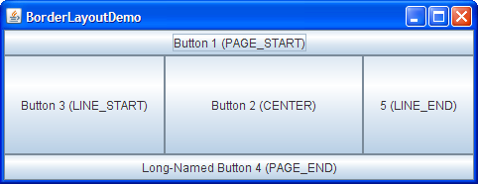

[Fig. 13] A visual demonstration of the BorderLayout layout manager in Swing.

The button panel and settings panel have their own layout managers for the components with in them, and those are there to make component placement very easy – if I ever remove or add any more buttons, the layout manager will add proper spacing and position them in the best way without having to write any extra code.

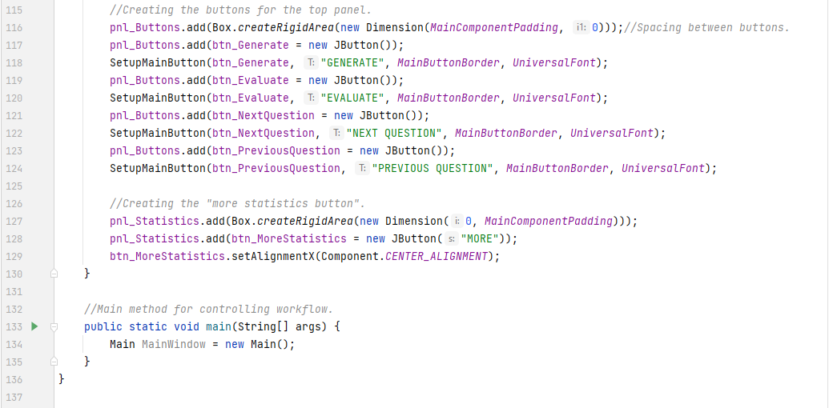

Finishing off the InitialiseUI method code for this iteration, the buttons themselves were defined and added (using the second helper method defined earlier) to the button panel. A rigid box is also created between each one for padding (so that their borders do not collide, and so that the visual quality is improved). The padding can be changed by changing a single variable defined at the top of the main class if the client wishes the padding to be less. A small button for more statistics is also created in the statistics panel. This does not have functionality yet and will likely also change positions as I add more to that panel in later development cycles, but for now, it exists as a baseline.

Finally, the main method below it all, simply creates the main class and initialises the user interface in a single line – since creating the main class automatically initialises the UI since it’s in the constructor method.

#### Prototypes

Due to the nature of this phase, and as described earlier, this iteration does not have any other prototypes for the layout since the client was happy with the layout to begin with. This is also not a working solution of the final idealised product, but it is only a prototype of the user interface.

### Testing, Problem Rectification and Client Feedback

Throughout the programming process of this iteration, white box testing has been carried out to ensure syntax errors, logical errors and swing component rendering errors do not hinder the results of the final black box tests. These inline tests resulted in a handful of smaller errors, but those will be addressed later in this section.

#### Evidence of Testing and Test Results

The test table for the black box testing is completed below. Evidence for each test is also shown below.

|  |  |  |  |  |  |  |
| --- | --- | --- | --- | --- | --- | --- |
| Test # | Success Criteria # | Test Reason | Input | Desired Output | Actual Output | Success T / F |
| 1 | NULL | To ensure the window fits to the user’s screen. | Solution activated. | Window fits to user’s screen. | Window does fit to the user’s screen. | T |
| 2 | NULL | To ensure the solution finishes execution after window closure. | Solution closed. | Solution stops execution. | Solution execution is finished when window is closed. | T |
| 3 | NULL | To ensure the abstract design, defined earlier, is followed. | Solution activated. | 4 main panels – topics/questions, settings, statistics and top buttons. | 4 panels are visible. | T |
| 4 | NULL | To ensure the necessary buttons get generated. | Solution activated. | Buttons visible: Generate, Evaluate, Next Question, Previous Question, More Statistics | All 5 buttons are visible. | T |

As can be seen by the test table, all tests were successful. Evidence for each of the tests above is shown below and annotated.



[Fig. 14] Evidence for test #1.

Due to the nature of this test, it is difficult to show this working, however the middle icon (highlighted with red) is the icon that symbolises the action of taking the window out of full screen, which means the window is in full screen mode. Line 59 in the second code screenshot is the line that makes this happen.

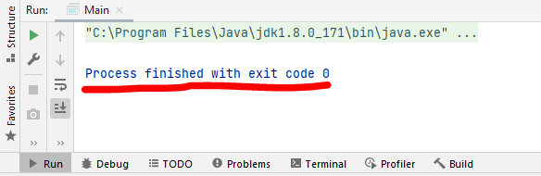

[Fig. 15] Evidence for test #2.

Like test #1, this one is also hard to evidence; however, the above line (underlined in red) only appears when the solution stops execution. When the close button was clicked, that line appeared in the Integrated Development Environment (IDE) console, thus signalling a successful test. Line 58 in the second code screenshot is responsible for this success.

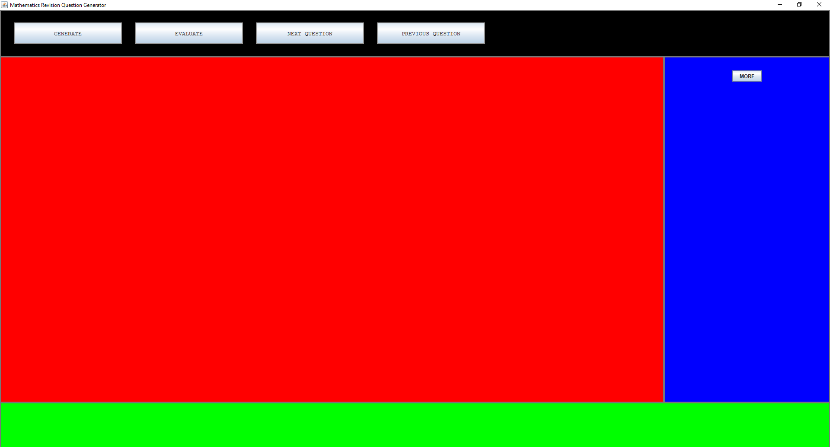

[Fig. 16] Evidence for test #3.

This is where the debug variable mentioned before, is in use. Each of the panels is coloured in a separate colour to show the success of this test. Black is the button panel, red is the topic panel, blue is the statistics panel, green is the settings panel. Yellow would be the 5th questions panel, but that is not shown as the comment explains in the 3rd screenshot.

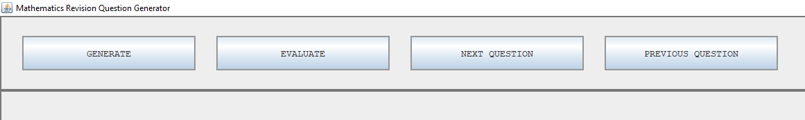

[Fig. 17] Evidence for test #4.

The main 4 buttons – Generate, Evaluate, Next- and Previous question – are shown above.



[Fig. 18] Evidence for test #4.

In conjunction with figure 17, the “More Statistics” button (currently labelled as just “MORE”) is also present in the statistics panel. This means the 4th and final test is also a success.

#### Problems and Remedies

There were no problems in this phase. An attempt was made on creating a custom JButton class for the main buttons, but the button was not rendered by the Swing API after many attempts. This resulted in the removal of the custom class and adding in a static function to the main class to configure the main buttons instead.

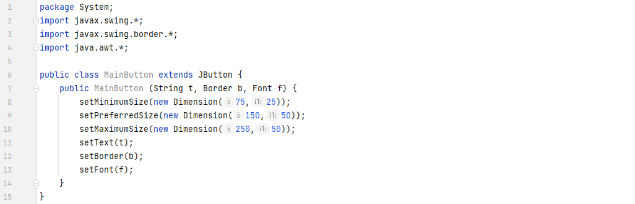

The discarded code is above. At the time of writing, I still have no idea why it does not get rendered properly.

### Evaluation of Development Iteration

Everything that was planned to be successful in this phase, was successful. Problems were addressed in the previous section.

The only notable change in this section was the displacement of the settings panel to the bottom of the screen, rather than it existing in the same area as the statistics panel. This is due to how the chosen layout manager works. This change does not affect anything in future iterations since it is only an aesthetic change. The settings buttons and inputs can still go on there, just in a left-to-right order rather than a top-to-bottom order – in contrast to what was defined in the design section previously.

## Iteration #2

In this iteration, after completing the main user interface, I will create all the necessary JSON files for local storage and get topic generation working, based on a few test-topics I will write into the file. I will also lay down some preparatory code for question generation – taking place in the next iteration should this iteration be a successful one.

### Design and Outline

The format for the JSON files has already been defined in the overall design section, and therefore does not need to be reiterated here. The UI classes for those buttons and components will need to be written. Saving user data will also get implemented. The data handling class and visualisation class will also get partially written.

A lot of the code being written will be put into events, and below is the pseudocode for these methods. I will not pseudocode the event handling, and as previously, I will also not pseudocode the code written to generate the Swing components. I have decided to attach the question generation data directly to the topic label in the list, rather than into a global variable. This will be easier to work with later on in the development process. Due to this, the original workflow of the *getInitialData()* method will not be followed, and below is a newer version.





The pseudocode provides a rough outline of how the JSON file handling will work when reading data. That is all the program is supposed to do at this point in time, so I will not define the writing code. That will be defined in a later iteration. I have also come to the realisation that 2 extra classes will be needed for the specification and topic labels. This means the UML class diagram designed in the Design section is now outdated. I have designed the 2 new classes and the updated diagram is below:

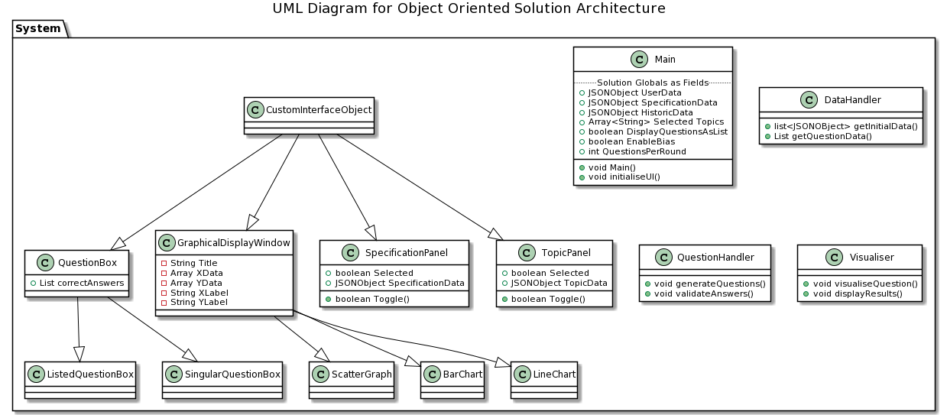[Fig. 19] Updated UML class diagram.

A testing table to be used at the end of this iteration is also shown below:

|  |  |  |  |  |  |  |
| --- | --- | --- | --- | --- | --- | --- |
| Test # | Success Criteria # | Test Reason | Input | Desired Output | Actual Output | Success T / F |
| 1 | NULL | To ensure all topics are correctly displayed by specification. | Solution started. | List of topics, classified by specification |  |  |
| 2 | 2 | To ensure that questions can be displayed in 2 differing ways (later). | Solution started. | “Display Questions as List” button present and internally tracked with a Boolean value. |  |  |
| 3 | NULL | To ensure topics can be selected and deselected visually. | Checkbox present and clicked. | Checkbox toggles to the opposite state. |  |  |
| 4 | NULL | To ensure selected topics are represented internally too. (Supplementary to test #3) | Solution started. | List of selected topics changing values and printed to console. |  |  |
| 5 | NULL | To ensure all correct data is attached to each topic internally. | Solution started. | Variable(s) containing all topic data printed to console. |  |  |

### Programming and Implementation

Upon completion of the implementation phase of this iteration, a few internal things have changed with the code. Some of the variable names used in the last iteration have been renamed to fit the naming convention defined at the start, as I forgot to properly adhere to it in the first iteration. I’ve also added a few new variables that were not previously planned for, but this will be discussed properly a later section. A number of new classes and files have also been written, along with the installation of a library.

As a prerequisite to file handling, I’ve needed to install the JSON.simple library to the project. This library offers the use of a few critical classes – such as the JSONObject and JSONArray – along with methods to parse JSON files. This then lead directly to writing the first JSON file with test data to be used throughout the rest of the project. It looks like this:

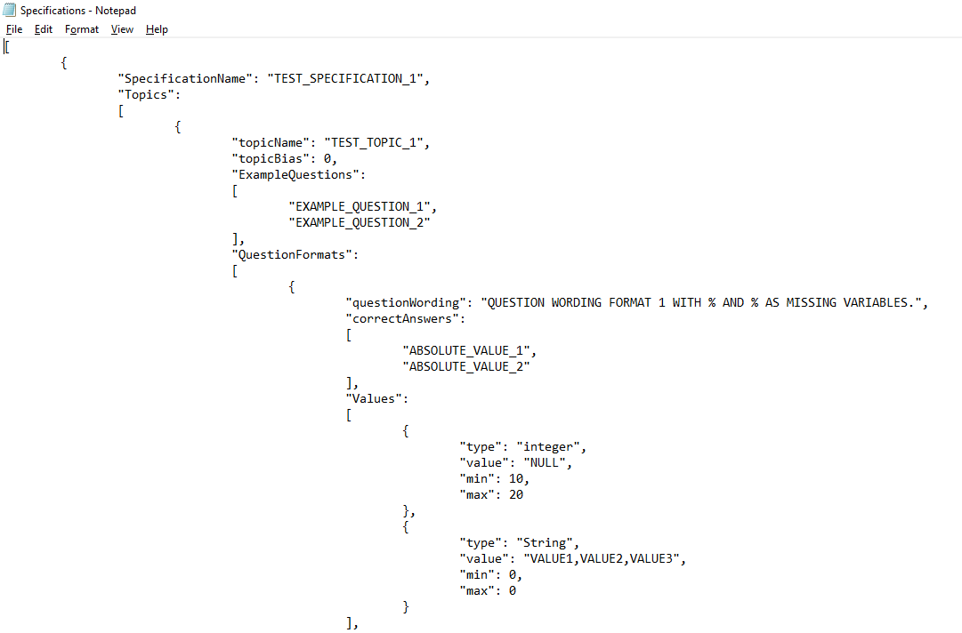

[Fig. 20] A section of the Specifications.json file.

I’ve used an online tool [11] to validate the JSON each time I make changes to the file to ensure no exceptions happen because of invalid formatting. The example format written in the design section was formatted slightly wrong, but that took no time to overcome.

A note before documenting the additions to the code: I have chosen not to define the Visualiser class in this iteration, because I found it easier and quicker to call the functions defined in pseudocode above in the main class instead.

#### Code and Justification

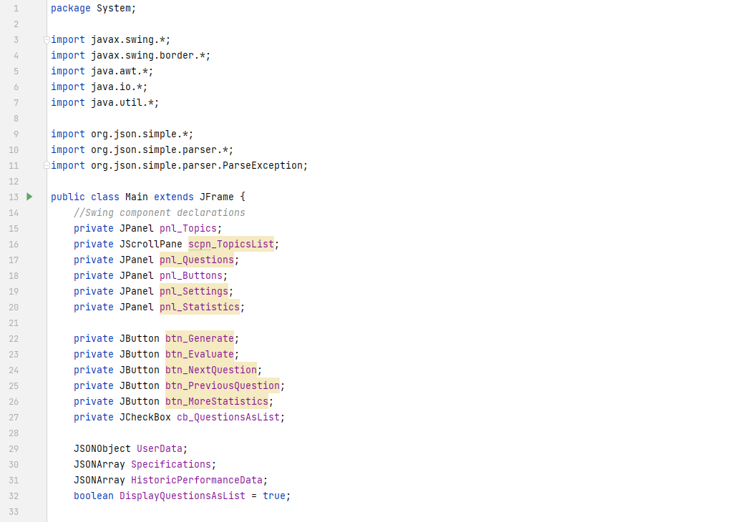

In comparison to the previous iteration, a number of new imports, global variables and Swing components have been added to facilitate the extra UI components and data that needs to be stored. This list will continue to expand in further iterations, so this will be the last time this part of the code gets documented in full, otherwise I’ll waste a couple screenshots on code that have nothing of interest to mention.

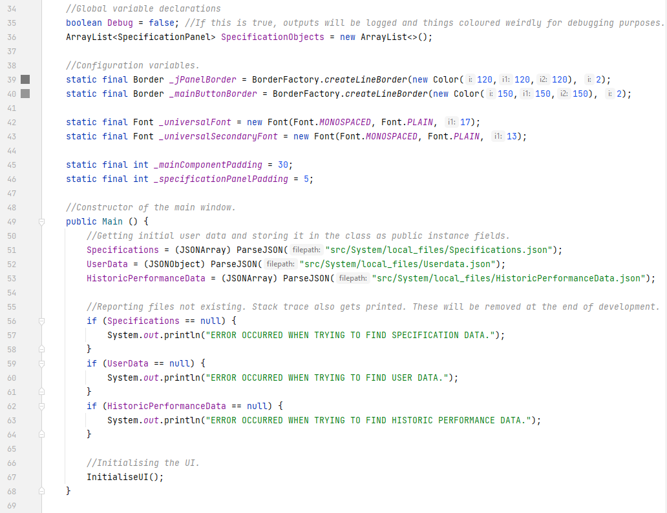

There are a couple new configuration variables to keep a uniform design for the whole user interface.

In the constructor for the main frame, basic file handling has been added which reads, parses and stores the JSON data from the main 3 files. Sanity checks follow to make sure the files exist, and if they do not, then output. Only the first one exists at the moment, but this does not cause any issues since there are now dependencies on those files in the system yet.

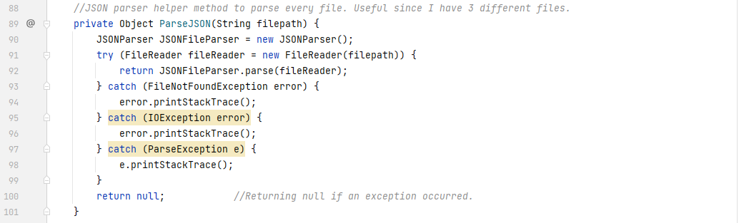

The unknown method for parsing JSON in the previous screenshot is shown here. This uses the JSON.simple library’s own method, but also finds the file from the relative file path and handles any errors which may occur.

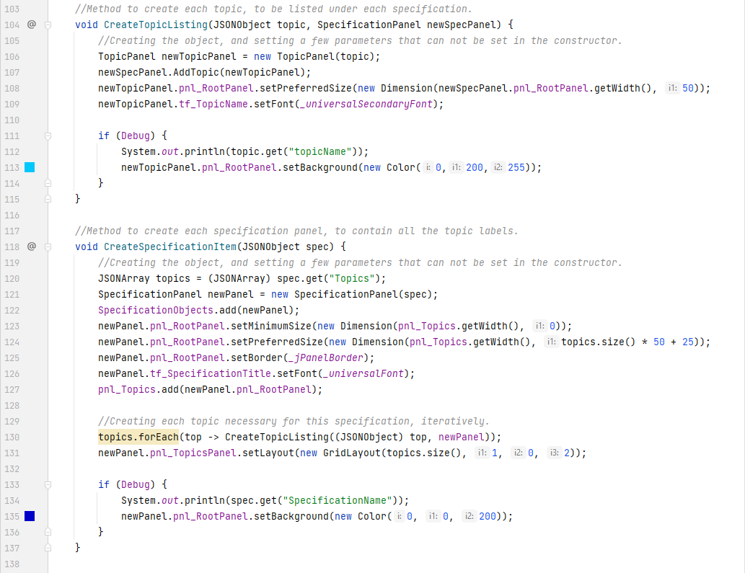

Two new methods have also been written for creating and displaying the specifications and topics from the JSONObject parsed earlier. Due to the Swing API being very awkward and difficult to work with at times, these two methods went through a lot of revisions due to rendering errors and problems with objects not being how I’d like them to be. Algorithmically, these methods are very simple. For each specification in the file, the specification method gets called, and for each topic under each specification, the topics method gets called.

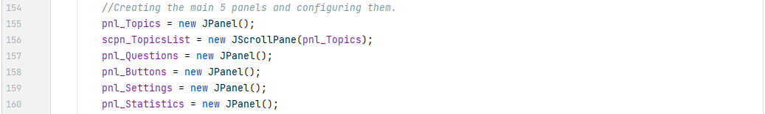

Within the method to initialise the UI, the panel structure has been slightly changed due to the way scrolling panes work in Swing. The topics panel is now *inside* a new scrolling pane, and the scrolling pane now takes the place of where the previous topic panel was. Visually, there is nothing different but an extra scroll bar on the right.

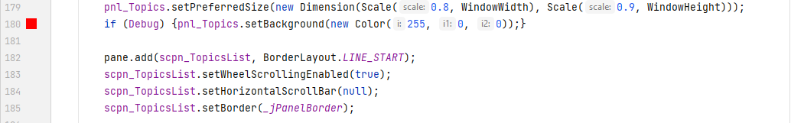

Due to this change however, this section also had to be changed in order to avoid rendering bugs.

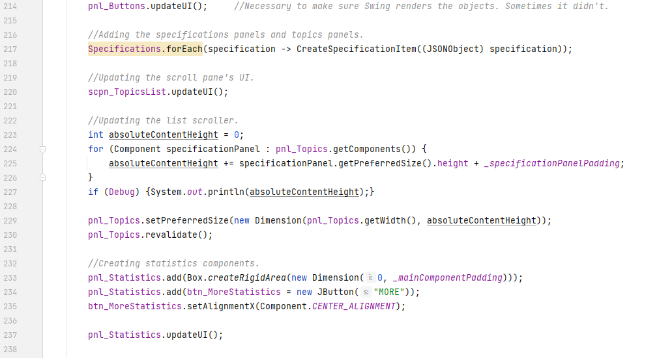

The bottom of the method has been updated with various pieces of code too. This is where the specifications and topics panels creation methods are actually being called from. The topics panel is being updated here to make sure the scroll pane is able to scroll to full content size of the topics panel (and if the content size is less than the panel’s size, no scroll bar is present). The statistics panel is also getting its UI updated after everything else because the buttons on it were not showing up due to another Swing rendering bug.

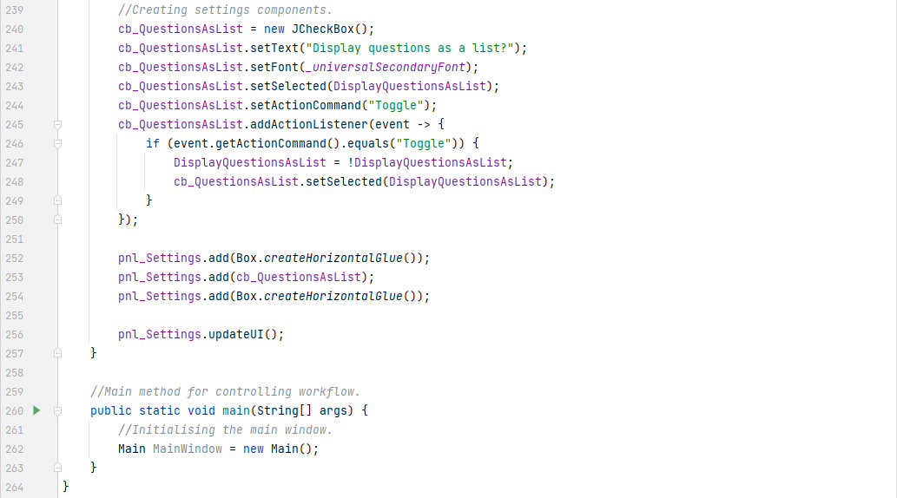

Due to the addition of a new settings button, extra code was added. This is the first use of an event handler in Java Swing and involves simply detecting and handling the button being pressed. This also involves a new internally tracked value (which will later get saved to user data) and this handler method configures said value.

The panels for the topics and specifications themselves have been defined in 2 new classes, as specified in the earlier design section.

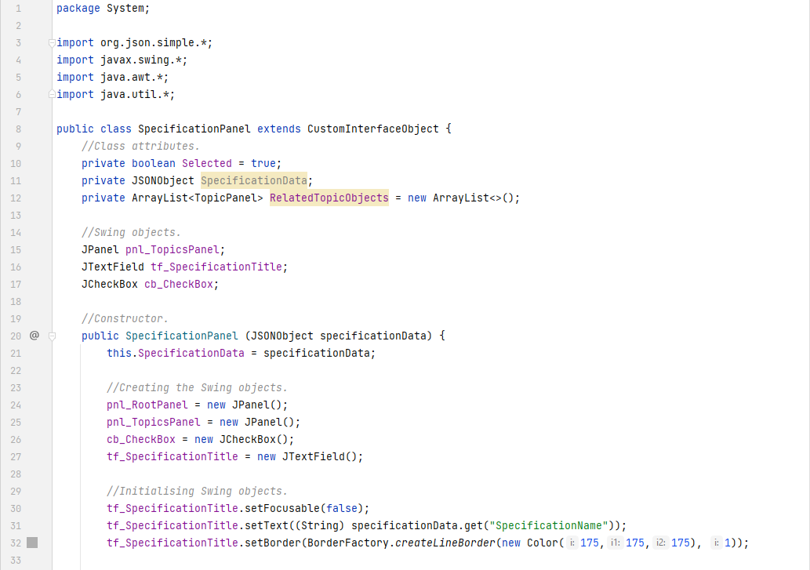

This is the new **SpecificationPanel** class, which inherits from the **CustomInterfaceObject** class (which has also been defined and will be shown later). It is its own class because it is useful to *abstract* what the panel is doing away when programming in the main file.

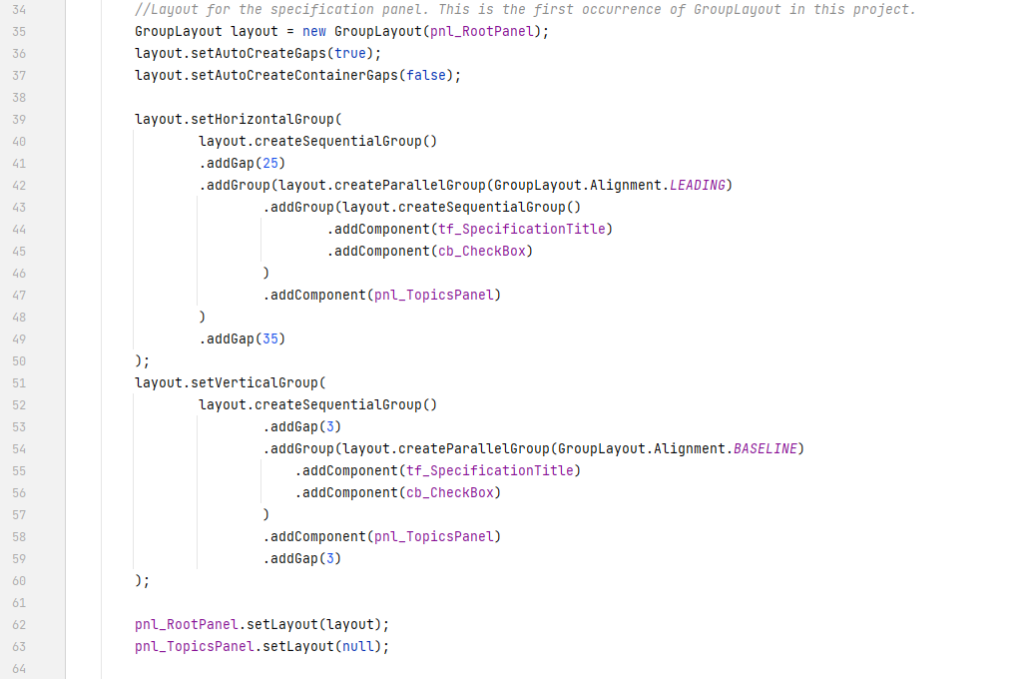

Due to this, the class also handles its own Swing object rendering settings. When using this class in the main file, all I need to care about is correctly parenting the root panel, and the rest is handled in the code above. It is making use of *GroupLayout*, which is a layout manager for Swing objects, where each object has to be defined twice. It was a lot of trial and error to get the code to work.

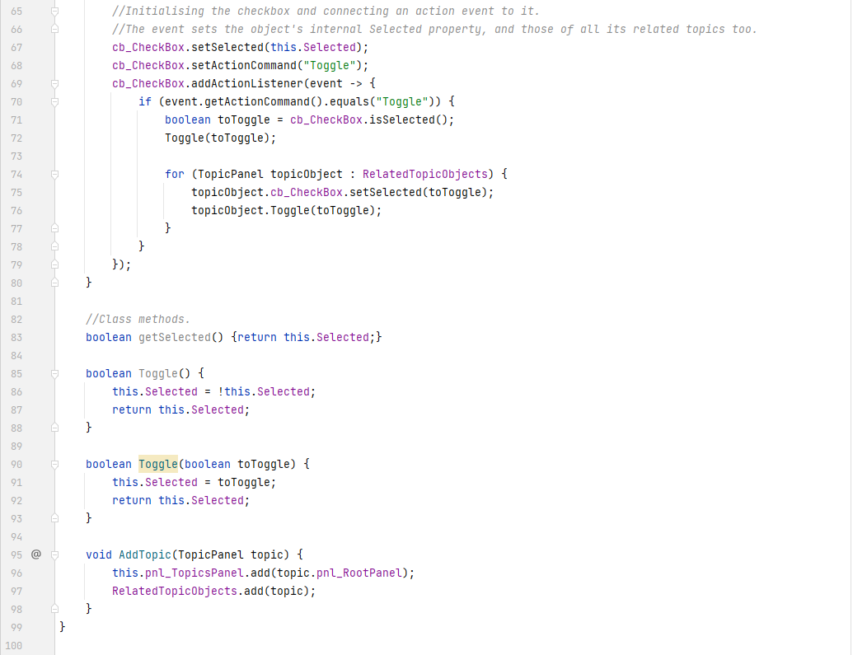

The class (naturally) also has its own methods which I can call in the main file and made use of in the earlier screenshots. This is also another use case of an event handler to handle the check box being clicked. I do not have to worry about the panel’s buttons being pressed in the main file, because that functionality is again, *abstracted* away to this file. This makes programming large systems like these a lot smoother and easier to do.

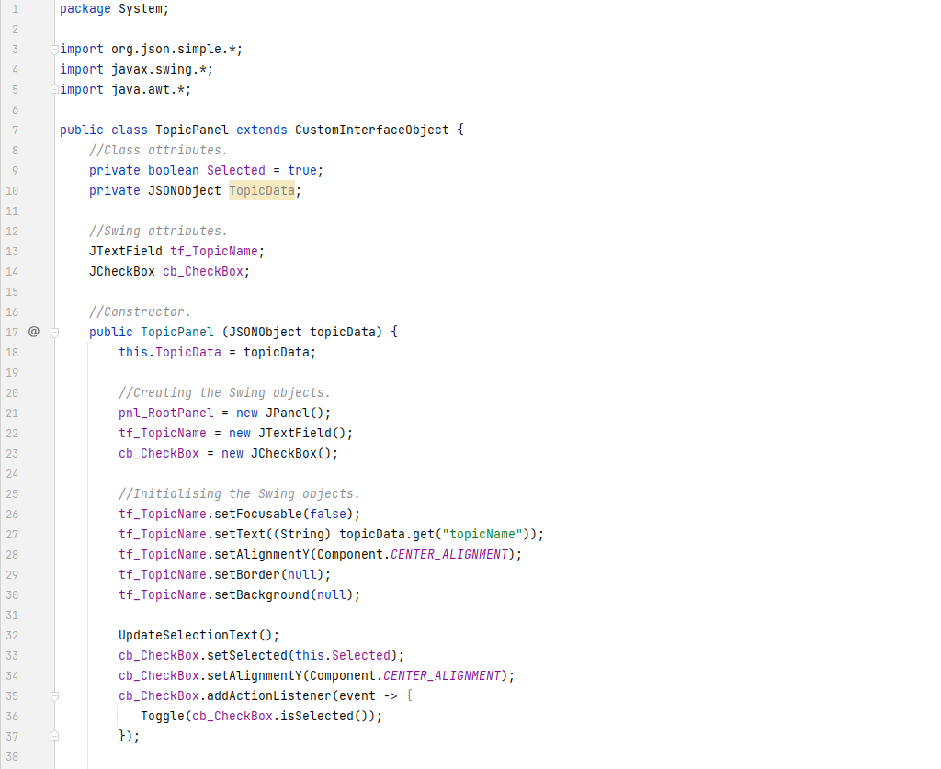

The **TopicPanel** class was also referenced earlier and is shown above. It also inherits from the **CustomInterfaceObject** class and has similar functionality as the specifications panel.

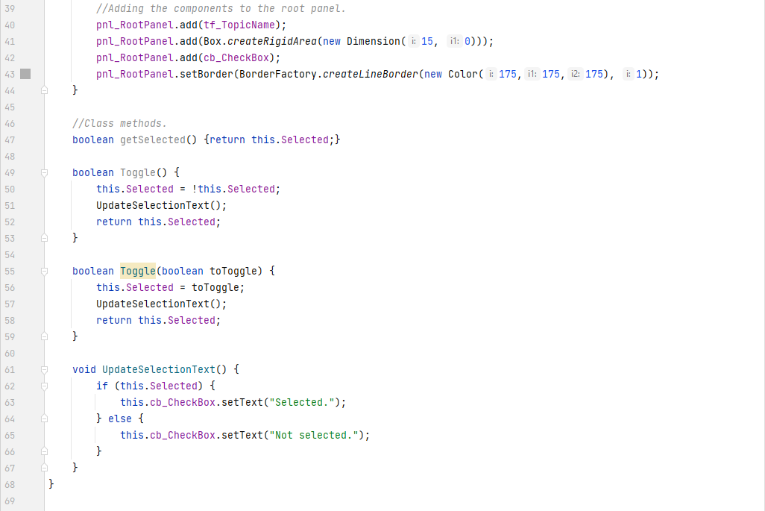

The event handler combining with the class’ own methods leads to behaviour which manages itself. If the user clicks on the checkbox, the text and its corresponding internal value get changed accordingly.

Together with this behaviour and the behaviour of the specification panel, smart behaviour is achieved. The user can individually select and deselect each topic at their choosing, but they also have the option to bulk-select or bulk-deselect multiple topics by specification, because if the checkbox on the specification panel is toggled, it calls each of its topic objects’ toggle method too, to update the selection both visually and internally.

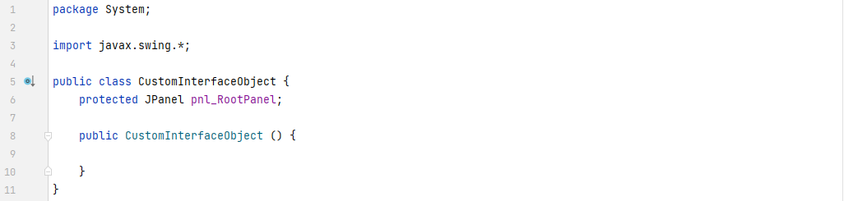

The **CustomInterfaceObject** class has been defined too, but it is currently relatively empty, because it has nothing to put in, apart from a single Swing object that each object of this class’ subclasses will need to inherently have.

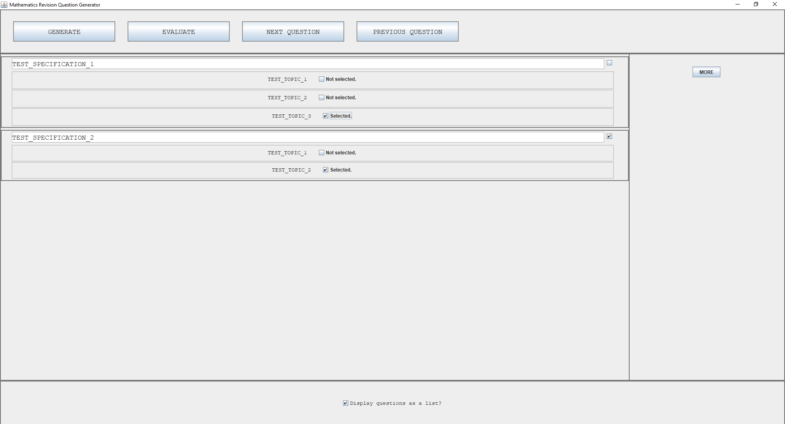

[Fig. 21] General look of the user interface.

The general look of the UI is above. The extra button in the settings panel is shown. There are 2 specification panels with 2 and 3 topic panels in them, and the selection boxes can be seen as toggled an untoggled. “The font is clear and it is a good, readable size” as described by the client.

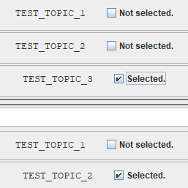

[Fig. 22] Selection boxes demonstration.

A clearer image of the selection boxes can also be seen from the image above. This has been tested with multiple specification and topic numbers, and scroll bar is present when the content size is greater than the panel’s size (although this is not present in the image above).

#### Prototypes

This iteration is not yet a full prototype of the product as the questions still need to be generated from the topics list and they need to be evaluated too, but a crucial part of that is now complete. The user can now modify their local files to include any topics they want, and all their information will be stored in the system, ready to be used by the generation and evaluation code.

### Testing, Problem Rectification and Client Feedback

#### Evidence of Testing and Test Results

|  |  |  |  |  |  |  |
| --- | --- | --- | --- | --- | --- | --- |
| Test # | Success Criteria # | Test Reason | Input | Desired Output | Actual Output | Success T / F |
| 1 | NULL | To ensure all topics are correctly displayed by specification. | Solution started. | List of topics, classified by specification | 2 specifications and 5 topics, sorted correctly into each. | T |
| 2 | 2 | To ensure that questions can be displayed in 2 differing ways (later). | Solution started. | “Display Questions as List” button present and internally tracked with a Boolean value. | Button present. Checkbox toggled causes output log. | T |
| 3 | NULL | To ensure topics can be selected and deselected visually. | Checkbox present and clicked. | Checkbox toggles to the opposite state. | Checkbox toggles to the opposite state. | T |
| 4 | NULL | To ensure selected topics are represented internally too. (Supplementary to test #3) | Solution started. | List of selected topics changing values printed to console. | Topics which were selected and deselected printed to console. | T |
| 5 | NULL | To ensure all correct data is attached to each topic internally. | Solution started. | Variable(s) containing all topic data printed to console. | Topics in their specifications printed to console | T |

All the evidence for each of the above tests is below.

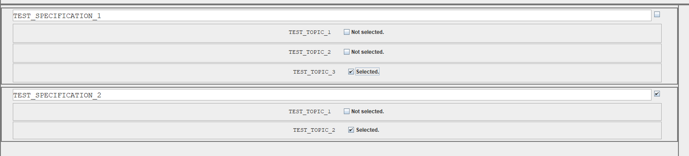

[Fig. 23] Evidence for test #1.

Each specification is clearly labelled and defined with borders, and each topic below them is also clear.

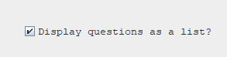



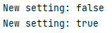

[Fig. 24-26] Evidence for test #2.

The state of the question and the output itself should clearly show the internal tracking of this value, and the visual representation of this value.



[Fig. 27] Evidence for test #3.

Each of the topics can be visually selected and deselected by simply clicking on the checkbox. The status phrase next to the checkbox also changes.

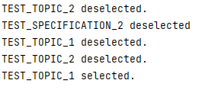

[Fig. 28] Evidence for test #4.

Each of the topics and its selected state is printed to the console when that state changes upon a user clicking it.

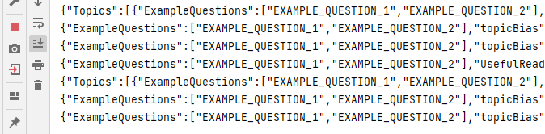

[Fig. 29] Evidence for test #5.

Each specification’s JSON data and each topic’s JSON data are clearly printed to the output box above. The text goes off the screen, but that should not matter, since the text is still there.

#### Problems and Remedies

An initial problem at the start of this iteration, was not being able to correctly load and register the JSON.simple library into the project’s folder system. This was quickly resolved after searching on the internet. The only thing I lost was time.

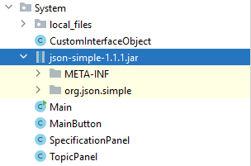

[Fig. 30] Image of the JSON.simple JAR file, integrated into the project as a library.

Reading the JSON data also proved to be a small issue, since I did not have any knowledge of where the root path of the project was, but after figuring that out, directing the parser to the correct file directory was easy.

A lot of time was also spent on attaining the correct layout and rendering of all of the swing objects seen in the earlier screenshots. I am still getting used to Swing and learning how things work, so this issue will get less throughout each iteration. Provided nothing changes in terms of how things look, the current generation code will not need to be rewritten in the future either.

### Evaluation of Development Iteration

This iteration is a successful one. Every previously set-out design goal was met, and no tests failed. Knowledge and understanding of the Java Swing API got better, and the client is happy with progress as well.

There were no noteworthy changes in this iteration. The next iteration’s success will not be affected by the success of this one for this reason.

## Iteration #3

In this iteration, the core functionality of the solution will be implemented – that being the question generation code and answering questions. This will be by far the largest iteration and by nature, the hardest one. Many things will likely change the design of this project moving forward.

### Design and Outline

Firstly, one of the two distinct question classes will need to be defined and written in order to correctly display each question. I will be doing only one of these in this iteration because it is not necessary for the other to exist yet, since this iteration will serve as the first prototype of the solution. Pseudocode will not be written for these classes since they are all mostly Swing object generation and rendering, and they have no set functionality in them that is algorithmic.

Then, the QuestionGenerator class will need to be defined and written to process the JSON data from all the currently selected topics and formulate questions from them. Evaluation of those questions will also need to be done. Bias will also get its code here. The pseudocode for this has been defined earlier in the overall design section, but will be expanded upon, below:



The code above is very general but gets the point across. The method names will likely change during implementation and so will the exact specifics of how it will work but that is the idea. There is also a “RandomGenerate()” method there which is not defined. That method is the bread and butter of the question generation process and is defined next.



This pseudocode provides an idea of how each question’s data will actually be chosen and randomly generated for each of the selected topics. Note the comments saying that some parts are not written. Sometimes for some answers, simple algebra will not be enough to calculate the answer based on the given values. This means that the system administrator can write their own Java class to calculate the answer for them and return it. This of course will need the file path of that class. This functionality will not be defined in this iteration (prototyping), but its place is there. Other values will also be attached to the JSON data but, for this pseudocode’s purpose, it is not algorithmic so was not included. There is also a method in there labelled “processString()”. This method will handle the algebra interpretation but is not defined here since I am unsure of the exact format I would like to use during implementation. I will instead document that method clearly in the evaluation section of this iteration.

After the user has answered all the questions, this method will be called to evaluate their answers and provide feedback.



The code above is also a general workflow for how the questions will be evaluated. Again, the names of the methods and specifics of undefined methods (like the data handler’s method above) will likely change, but the overall idea is clear.

The questions will be generated based on user specified settings too, so a few extra buttons for those will also need to be added.



Lastly, the Generate button and Evaluate button will need event handlers to run all the previously written code.



The code above is very simple, but again, gets the general algorithmic idea across.

The test table for this iteration will be larger than the other two and will finally start to test against success criteria laid out in the analysis section.

|  |  |  |  |  |  |  |
| --- | --- | --- | --- | --- | --- | --- |
| Test # | Success Criteria # | Test Reason | Input | Desired Output | Actual Output | Success T / F |
| 1 | 1 | To ensure each question panel displays correctly. | Generate button clicked. | Topics panel disappears and a number of question panels appears. |  |  |
| 2 | 1, 2, 3, 4 | To ensure questions can be generated correctly. | Generate button clicked. | Wording, values and answers are correctly calculated and generated. |  |  |
| 3 | 5, 6 | To ensure each question is evaluated correctly. | Evaluate button clicked. | Each answer to each question is compared with the provided answer and correctly recorded. |  |  |
| 4 | 5, 6 | To ensure visual feedback is given on the correctness of each question (supplementary to test #3). | Evaluate button clicked. | Question turns green with a checkmark, or red with a cross to signify a question being right or wrong. Question also has the correct answer displayed. |  |  |
| 5 | 2 | To ensure the user is able to change bias and question generation settings. | Bias checkbox toggled and question number box value changed. | Values changed internally and printed to console. |  |  |
| 6 | NULL | To ensure user provided answers are sanitised and validated. | Evaluate button clicked. | Converts answers to lowercase and removes whitespace. |  |  |
| 7 | NULL | To ensure blank answers are treated as wrong answers. | Evaluate button clicked. | To correctly identify blanks as incorrect answers. |  |  |
| 8 | NULL | To ensure each group of questions is independent from each other (internally, everything is reset when a round of questions is done). | Multiple presses of the generate button after multiple rounds of questions. | No bugs or inconsistencies with Swing component rendering or data not being cleared are found. |  |  |

### Programming and Implementation

#### Code and Justification

The first thing I completed in this iteration were additions to the settings panel. It now looks like this.



[Fig. 31] Additions to the settings panel. Partial evidence for test #5.

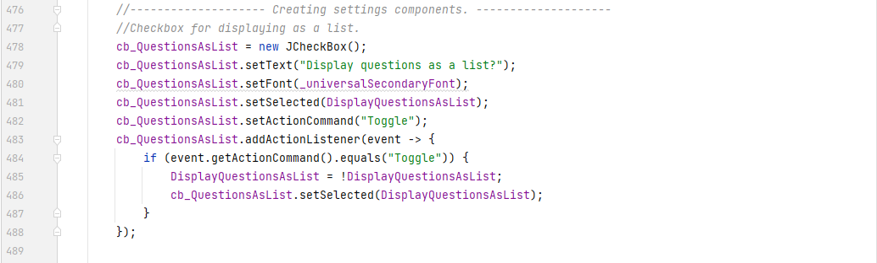

There isn’t an awful lot to say about these additions since they were relatively trivial in function. I am simply creating a checkbox, configuring its properties and adding an event handler with a lambda expression to negate the internal setting value that keeps track of this.

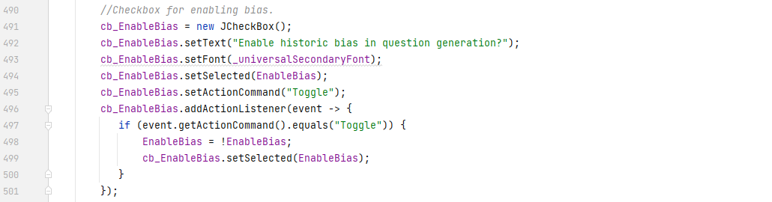

The second checkbox looks practically identical in both rendering and code. It carries out the same function as the previous one, just for a different value.

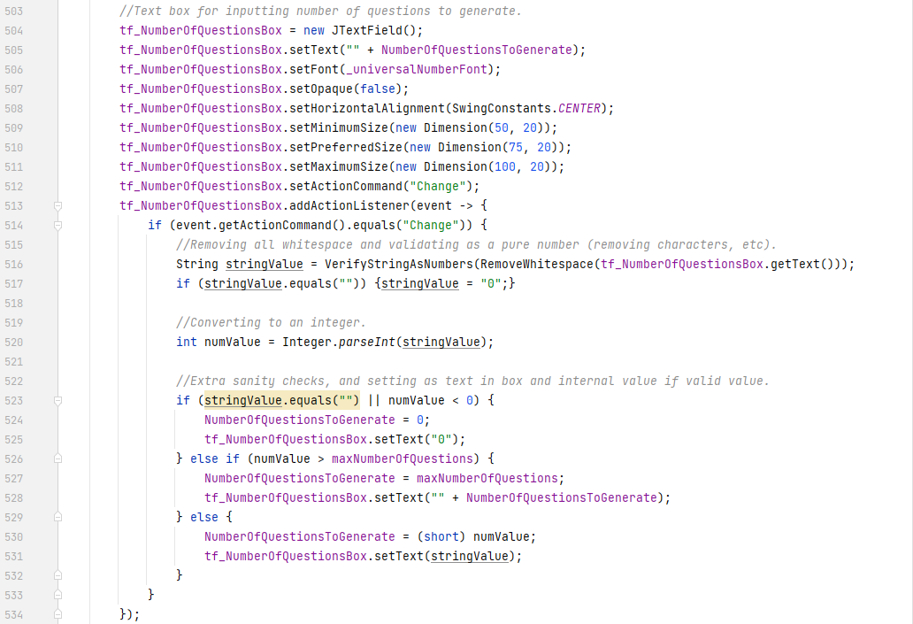

This is where it starts getting a little more interesting. For the user to effectively specify the number of questions they want to generate, a lot of processing must be done to the input, since the user is able to enter any valid Unicode characters they can think of. However, since the value is supposed to be a number, constrained between a maximum and a minimum, two new functions have been written to tackle this problem and they are detailed overleaf. This is the first occurrence of input sanitisation and validation within this project. The rest of the function is relatively straightforward, however. It parses the string into an integer, compares it to the limits, and constrains it within them if necessary. Currently the limits are 0 and 50. Extensive peer-testing has been done to account for every possibility of combination, and each of them do not cause this method to error. Combinations like 123, --123, a123, 123869172391927319263, awAIgkAGdAJg, etc, are all correctly parsed.

Once the parsing is done, it simply sets the NumberOfQuestions value to the user specified value.

The first of these methods, RemoveWhitespace(String) is shown below:

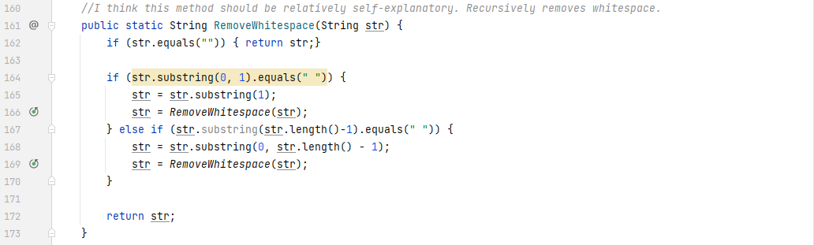

This method is rather simple in its nature. It simply checks the first and last character of the string it has been passed, and if it’s whitespace, it removes it, and calls itself again to check the new string’s start and end. It does this until it finds no whitespace, in which case it returns the clean string. I will be using this in the rest of the code from now on. Due to the realisation that if the static keyword is applied to a method of a class or an attribute of a class, then a specific instance of that class is not necessary to call that method, and hence, it can be called from anywhere in the System package. This method is an example of input sanitisation.

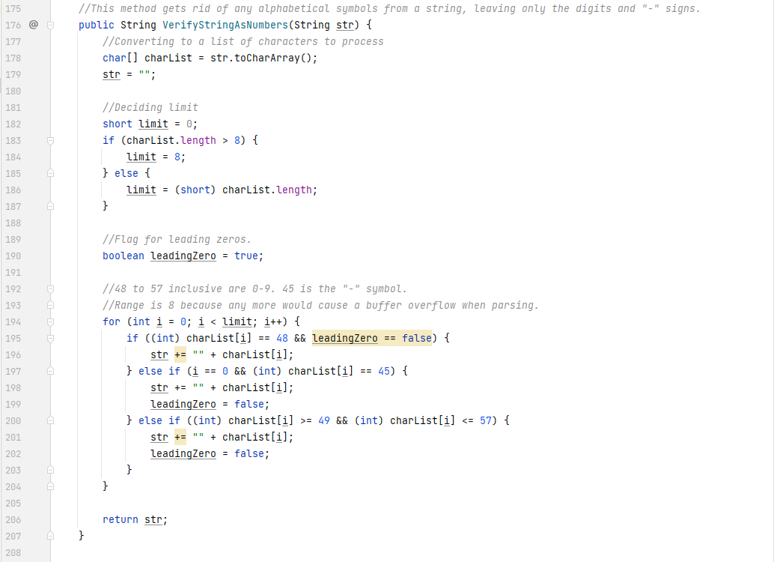

This method is the one referenced in the previous one above. It is an example of input validation. It ensures that the string which has been passed to it, is a valid mathematical integer. If it is not, it removes the characters which make it so. In this case, it removes any leading zeros, alphabetical characters, or other symbols and only leaves the digits from 0 to 9 and the negative sign. It does so by iterating through each character in the string, and ignoring the ones which do not fit the criteria specified above. This will also be used in other areas of the solution.

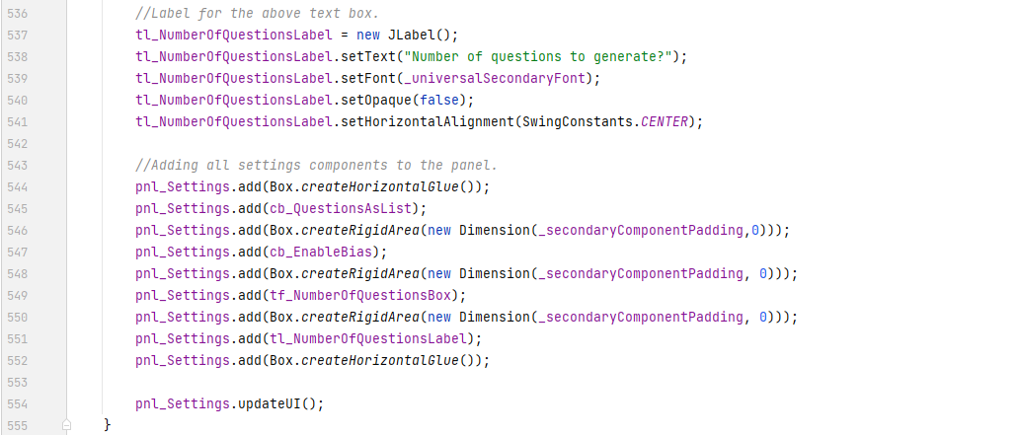

And lastly, a label to the previous input box, and the code to add all the components to the settings panel with some spaces between them. Utilising BoxLayout in Swing is a very convenient and useful LayoutManager for linear button panels such as these and I will be sure to use it again if the need ever arises.

Now that the settings panels have been added, it was time to work on the core functionality of the entire project – the question generation.

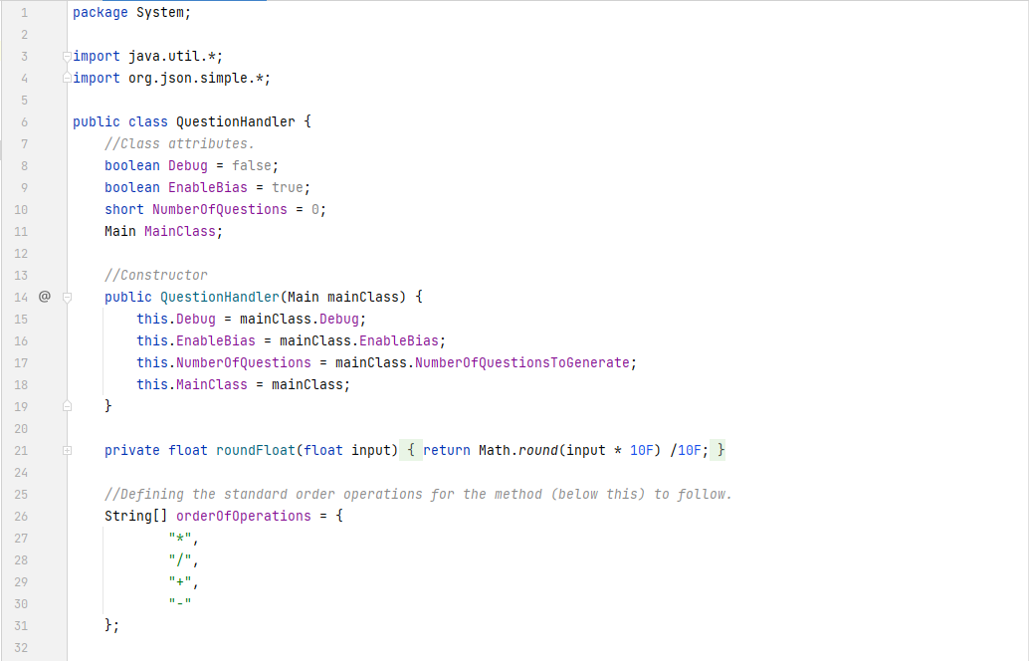

Firstly, it was necessary to define the previously spoken about class – the QuestionHandler. In the above code, you can see a reference to the main class. This is there out of the stark realisation that I can pass the reference to the main class instance into any class I write. This means that the class can access any of the public methods and attributes connected to the main class. Since the main class holds all the internal configuration constants, this behaviour was desired.

On line 21, I have also written a method to round floating point values to the nearest decimal place using a neat number hack, where if rounding the number x10 and then dividing by 10 gives the 1st decimal place rounding of that number. This method can be expanded to include any decimal place rounding by simply raising the 10 to a power of an exponent, where the exponent is the number of decimal places the user desires. This has not been implemented however because there is no inherent need for it, and it is more prone to decimal point inaccuracy, the higher the desired decimal place rounding is.

And finally, an array of strings, defining the order in which operations must be carried out. This will be used in the algebra interpretation shown in the later methods.

Before moving to the rest of the code in the QuestionHandler class, it is important to document the code which invokes the QuestionHandler’s code in the first place – to give the code context.

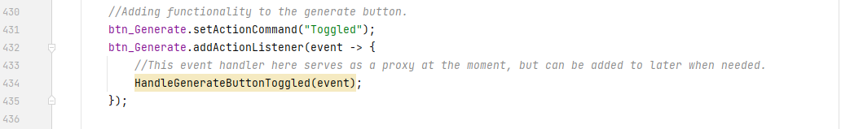

This section of the main class invokes a method written in the main class when the Generate button is clicked.

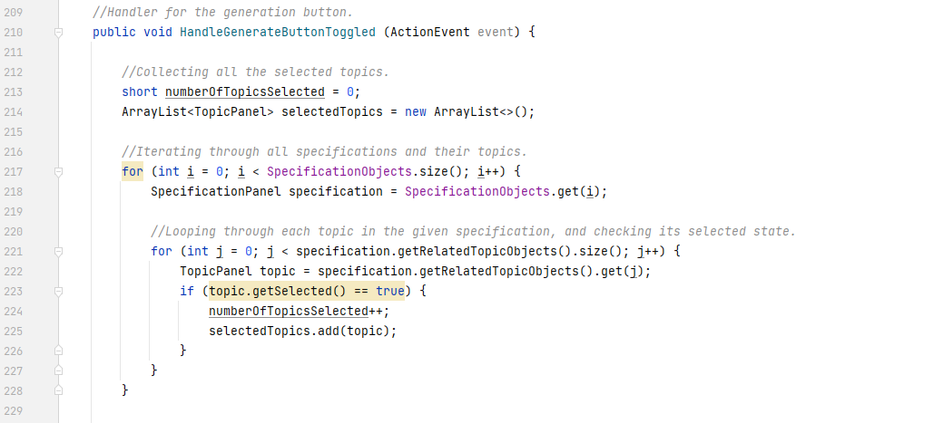

The above code first of all aims to determine if there are any topics selected, and if there are, store them in an ArrayList.

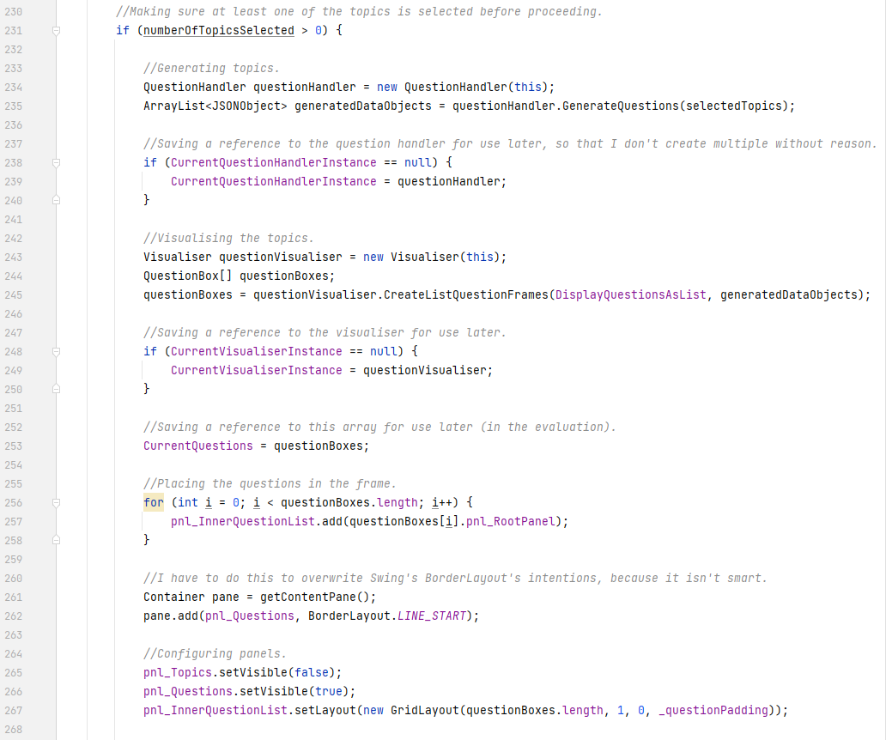

The latter part of the method determines what happens when there is at least 1 topic selected. It creates new instances of the QuestionHandler and Visualiser classes, and stores them as attributes to the main class if none are already present (this is because it is wasteful in memory and time to constantly create and destroy instances of classes). It then calls the GenerateQuestions() method from the QuestionHandler class, and converts the JSON data it received into question panels using the Visualiser class. It stores those panels in a list (also an attribute to the main class) and then configures the already present panels to view them by inserting and unhiding the questions panel.

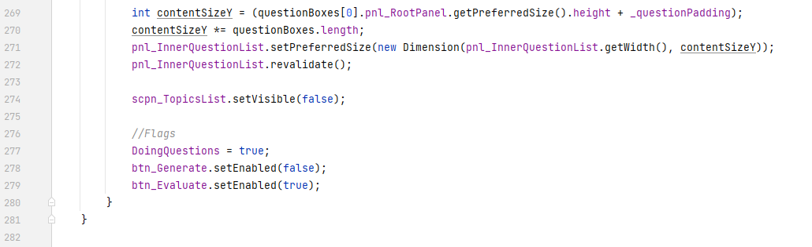It then sets some flags for other parts of the solution to know if the user is doing questions or not (useful for other things later) and enables the next button in the top section of the menu (it doesn’t make sense to evaluate questions when there are no questions to evaluate!).

Now that context for the QuestionHandler’s methods has been established, I can document the method itself.

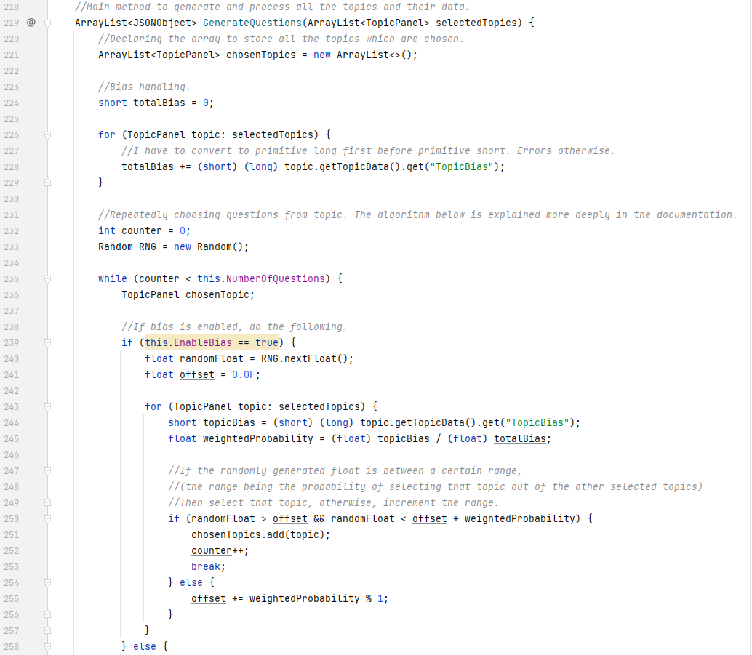

The method is mostly iterations over JSON data and processing it. It firstly begins by counting up the total bias present in the list of selected topics. It also initialises the RNG (Random Number Generator) which it will use in later code blocks. If bias is enabled, then it chooses each topic based upon how much bias it has. The greater the bias, the greater its probability of being chosen. It trials and errors the RNG for alpha values (numbers between 0 and 1 inclusive) until the correct boundary of probability of achieved, in which case it adds the topic to the list of chosen topics and continues in the outer while loop.

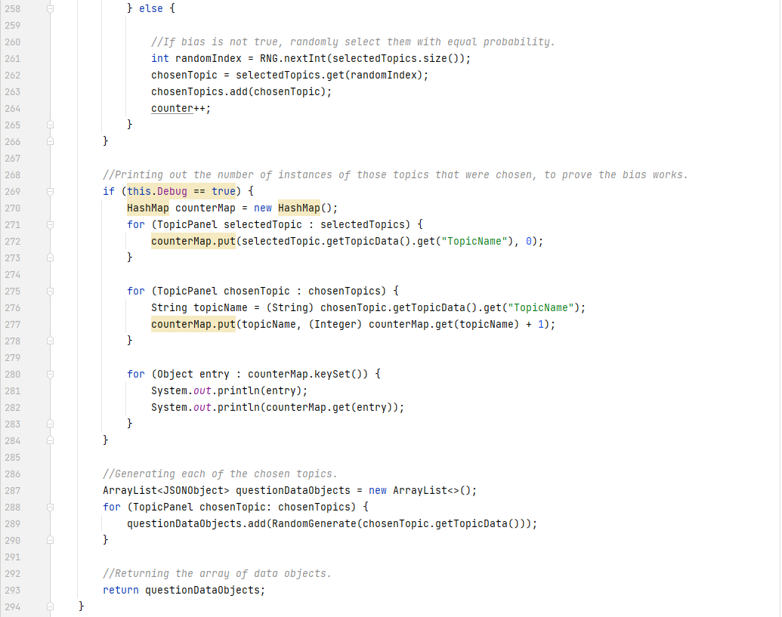

If bias is *not* enabled, then it simply assumes constant probability for all topics and chooses a random index from the chosen topics, adds that topic to the list, and repeats until the desired number of topics has been chosen. The majority of the final part of the code is simply there for debugging purposes and proof of concept for the bias handling. If debugging is turned on, and a very large number of topics is chosen, then it will print out the number of every topic it picked. This is clear in the image below. I requested to generate 500 topics, where TEST_TOPIC_3 had a bias of 2, and TEST_TOPIC_1 and TEST_TOPIC_2 each had a bias of 1. This would theoretically result in 50% being topic 3, 25% topic 2 and 25% topic 1. And as is seen by the numbers, that is roughly the case, and therefore the algorithm works as intended.

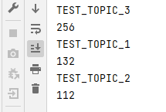

[Fig. 32] A proof that the bias algorithm works as designed and intended. Partial evidence for test #5.

Within the GenerateTopics() method, there was another method – RandomGenerate(). This method is the method which actually generates all the correct question data from the given topic data.

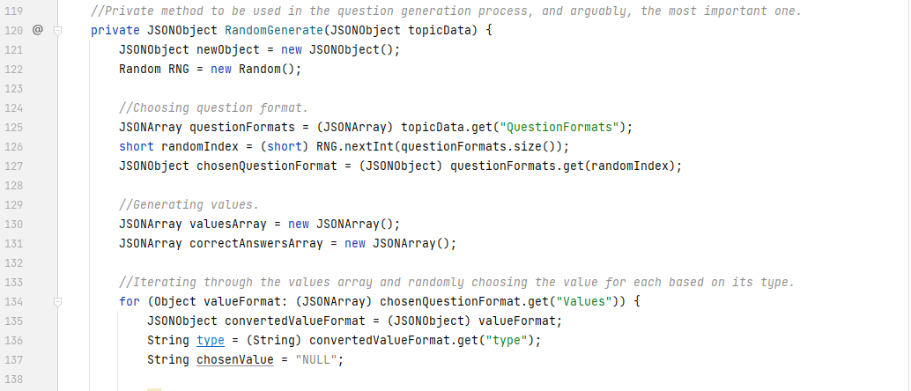

The start of it simply contains some variable declaration and choosing of the correct question format. It then initialises some arrays for the values to go into and starts the iteration process to choose all the values the question should have, based on the format’s “type” argument.

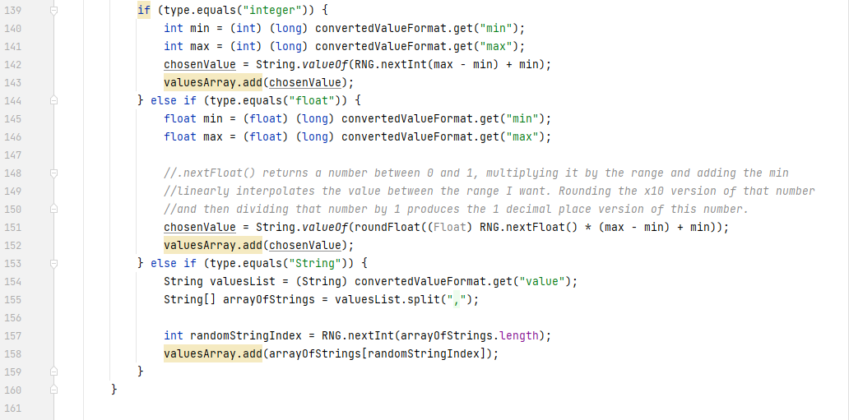

Within that loop, each of the 3 possible arguments the “type” parameter could have are handled. Integers are randomly generated within a min and a max (inclusive), floats are generated within a min and a max (inclusive) and then rounded to the 1st decimal place, and strings are chosen based on a random index in the “value” list of values. An image of the values being identified, read and correctly generated is shown below:

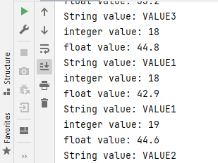

[Fig. 33] Values being correctly identified by type and generated appropriately. Evidence for test #2.

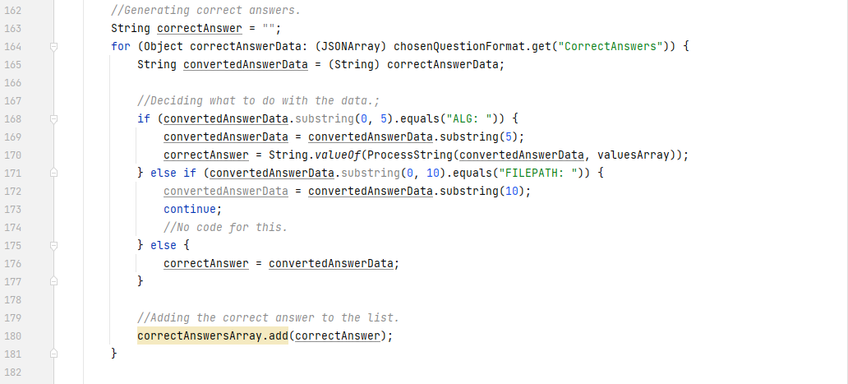

Then, after the values have been chosen, they are then used to generate the correct answers (since you can’t generate answers if you don’t know what the values are!). During writing, I found it best to use the following formats in the answers array.

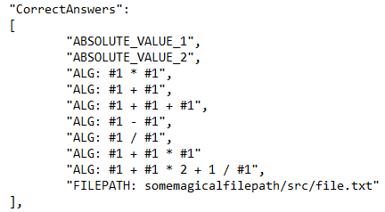

[Fig. 34] The chosen format for each of the 3 correct answer types.

Answers can be absolute values for the case when a question is something like “Name a circle theorem.” and the answer can be “alternate segment theorem”. Answers can be numerical too, and they’d require the use of the previously generated values to get to them. For example, the question “What is the surface area of a triangle with width 5 and height 10?” and your answer would have to be 0.5 * 5 * 10 which is 25. But the 5 and 10 were generated, so the solution needs to know how to use those numbers to get to that answer – and that is where the “ALG:” identifier comes in. Variables are numbers prefixed with a # symbol and arithmetic operators are between them. Each of the symbols (operators, variables or absolute values) have to be separated with a space because that is what the algorithm looks for when separating each of the symbols. At the time of writing, brackets and indices are not supported in this system which limits the use of this format. In the next iteration, this will be rectified. Lastly, the “FILEPATH:” identifier specifies an absolute file path to a java class which runs code to generate the answer. This may be necessary when getting to the answer is not as simple as writing algebra. At the time of writing, this is also not implemented as can be seen from the above screenshot. This is because this is not a necessary feature for the prototype but is in there regardless because it is what I would include if I was making this a fully-fledged product.

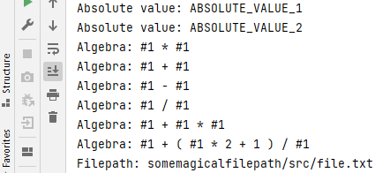

[Fig. 35] The algebra being correctly read from the file and handled.

The method named ProcessString() deals with this algebraic interpretation and is shown below:

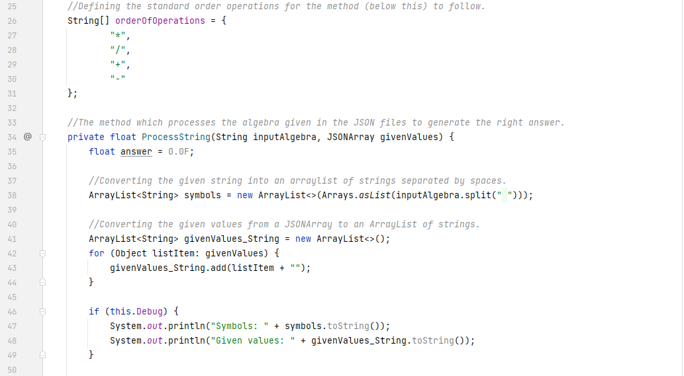

As previously seen, the order of operations must be defined. The answer will always be a number, and since floating point values also include integers, then the return type and variable declaration must be floats. It splits the algebra by spaces and saves them into an ArrayList called symbols. It is an ArrayList and not just an array of strings, because standard arrays do not offer the same level of functionality as ArrayLists do. This can be seen in the next screenshot.

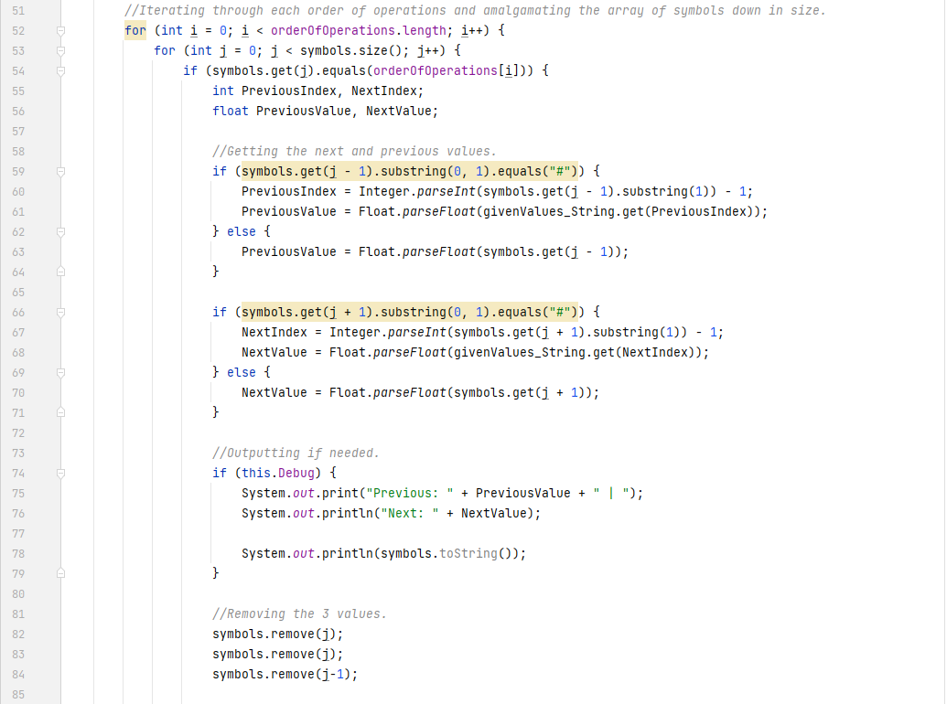

Then begins the entire iteration process. It iterates through the order of operations (achieving the fact that it handles whatever I put into the array first – like multiplication and division) and then iterates through each of the symbols, checking whether it matches the currently desired operator. It also stores the indexes and if need be, values of the two adjacent symbols. Before carrying out the mathematics, and adding the new result in, it removes the current symbol and its two adjacent values from the array. This is why an ArrayList is used.

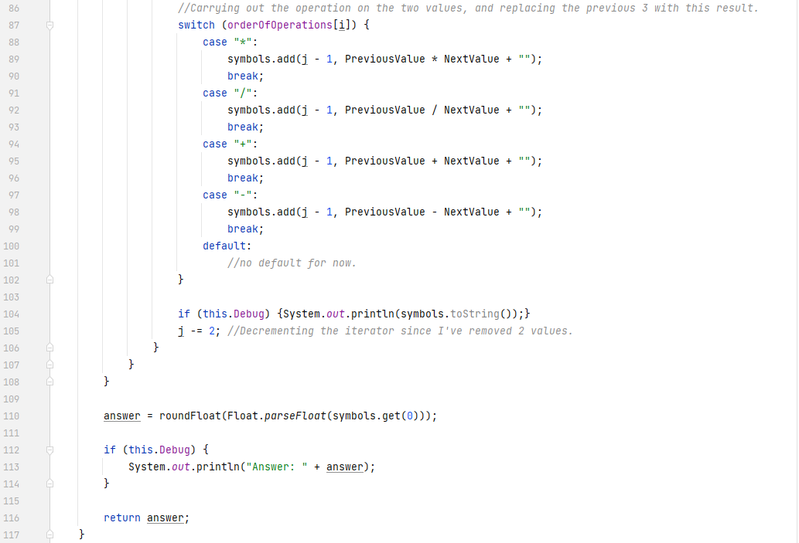

It then uses a switch case defined for each operator and adds the newly computed value to the ArrayList. Once done, it decrements the inner loop iterator by 2 (because 3 values were removed and only 1 was added back) and carries on iterating until the outer loop is finished – in which case it parses the current string to a float and returns that float as an answer to this algebra. The iterative process can be seen below. If followed closely, then it can be observed that the rules of order of operations has been correctly followed.

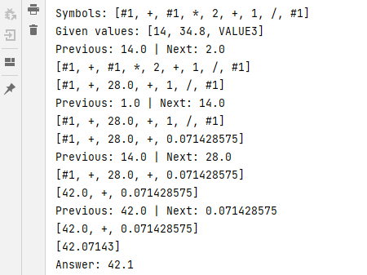

[Fig. 36] Demonstrating the correct implementation of BIDMAS order of operations based on written algebra.

In the next iteration, when brackets and indices will be defined to further improve the range of algebraic answers the system administrator can define, implementing them will be rather straightforward. Brackets will simply be the algorithm being recursively called on a subset of values from the main array, and indices will simply be another order of operations that goes before multiplication, defined as a carat (“^”).

Once all the absolute and algebraic answers have been defined. The rest of the RandomGenerate() method can be executed.

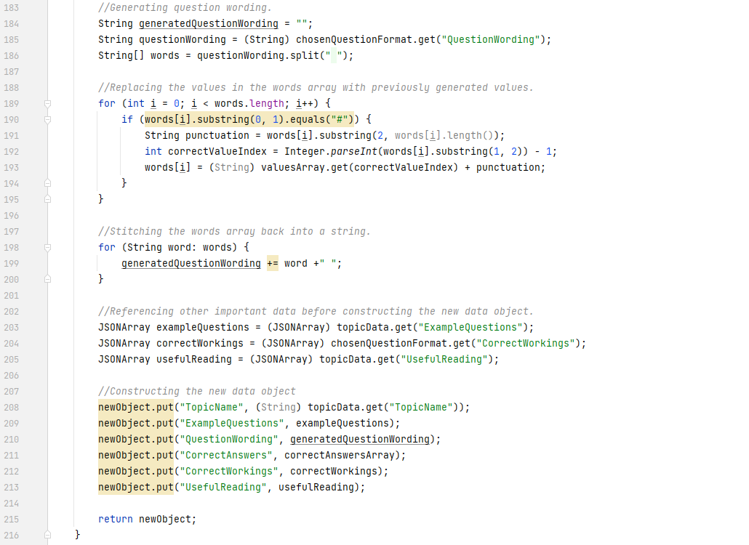

The question wording gets generated by taking the previous format and replacing all the #1 and #2 terms with their corresponding generated values. It also considers and handles any case where there is punctuation or other words connected to the identifier and correctly handles them (I’m not fully sure where this may be necessary, but it’s built in regardless to make the eventual system admin’s job of setting up question formats easier). Once done, it defines new JSONArrays, and places all the generated data into the previously defined new JSONObject and returns it.



[Fig. 37] Showing the question format correctly being generated with the special punctuation case too. Evidence for test #2.

Below is an image of the expanded JSON data of the returned object after it has been generated. The correct answers, question wording and other data can be clearly seen. This is what the data for a single question looks like. So, for 10 questions, there would be 10 of these well organised data objects. Memory usage of all this string data *can* get a little high when the number of questions being generated gets high – however that is the nature of string data. The usual compression method of turning all this into a Base64 encoded string (like images on websites commonly are) is not available because the data will get cleaned up from memory by Java’s memory management once the questions are done anyway – therefore providing no significant short term or long-term benefit. The floating-point values in the CorrectAnswers array are not absolute numbers themselves, rather strings, because most of the time they will be small numbers (not much bigger than 1000) and ASCII characters only take up 8 bits, each, whereas floats take up 32, therefore saving a few bytes overall. This will make no major improvement to the memory here either, but it’s an improvement nevertheless.

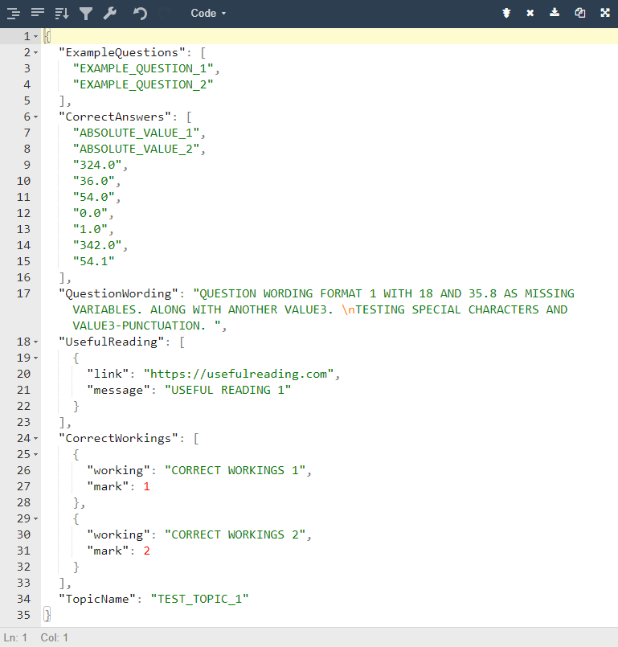

[Fig. 38] Demonstrating the JSON data of the generated question data.

Now that all the data is correctly generated, it is simply a case of displaying the data to the screen in the appropriate format.

For this, 2 new classes have been defined, as per the UML diagram in the design phase. Firstly, the abstract QuestionBox class.

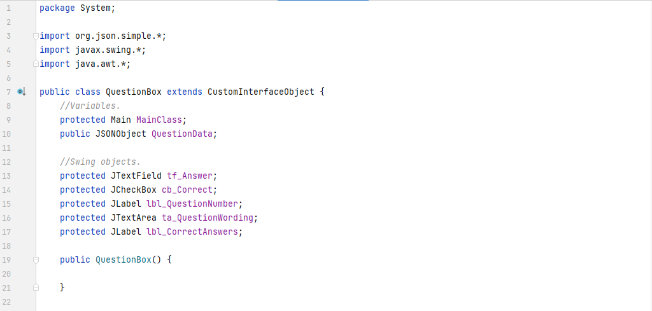

Since it is simply a parent class that should not define how it looks, it has nothing in the constructor. It simply defines the attributes all of its subclasses need to have. It will eventually have 2 subclasses, but for this iteration and this prototype, only 1 is implemented for now – the ListedQuestionBox.

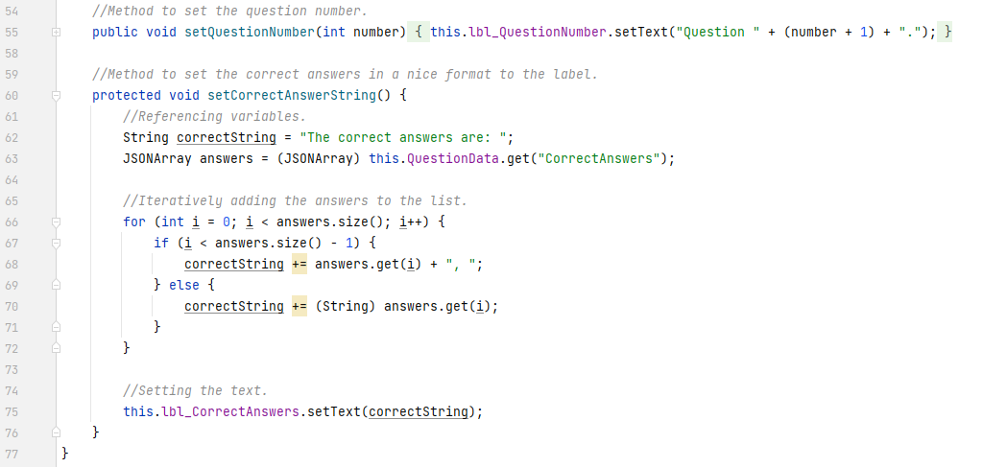

Since both subclasses will have question numbers and correct answer strings, this abstract class also defines these methods. It iterates through each of the correct answers and places commas between them for presentation purposes.

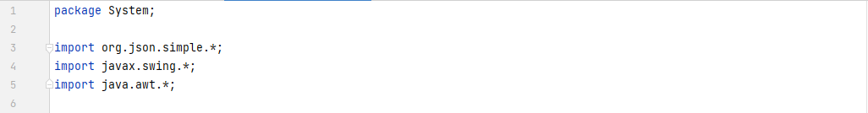

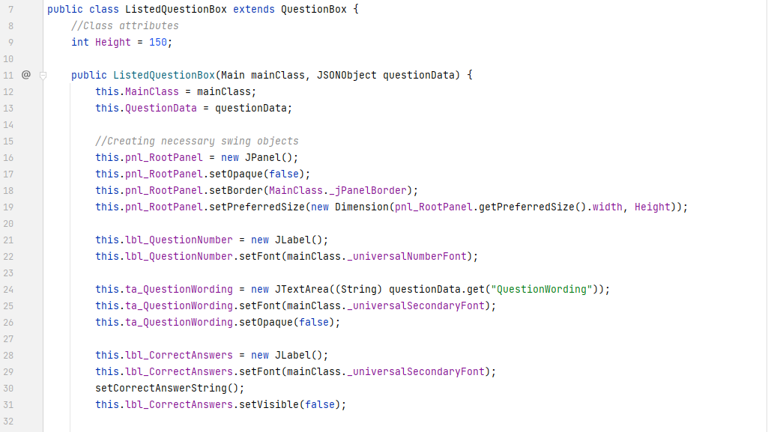

It defines a height of the panel in pixels and instantiates the inherited Swing attributes. That is all.

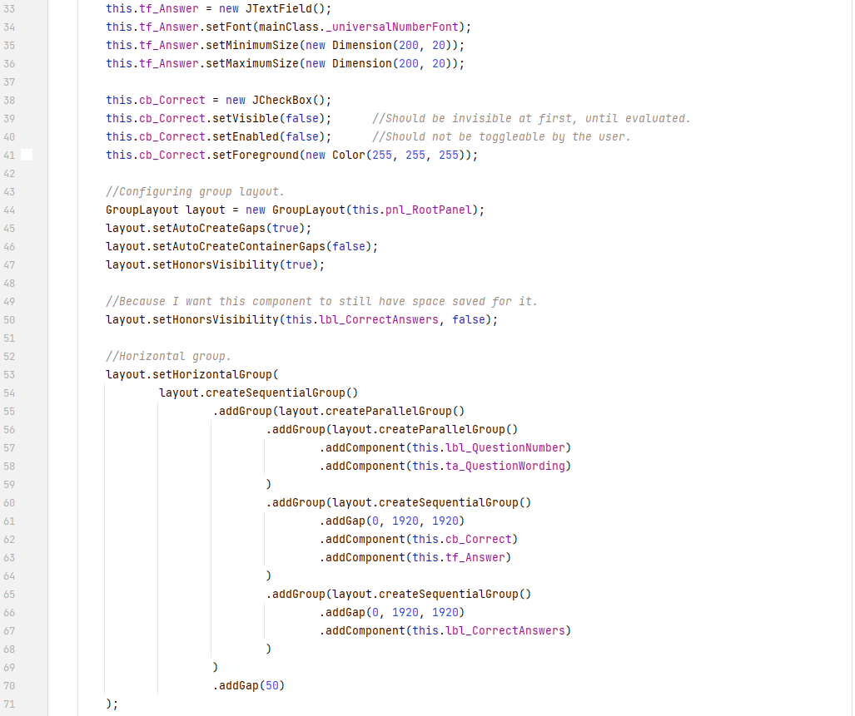

Again, it simply instantiates all the values, and defines how they should be laid out using GroupLayout.

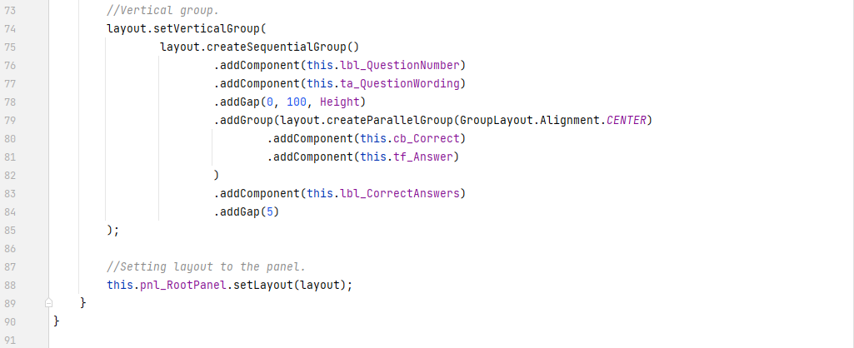

For all this layout work, the end result looks like this:

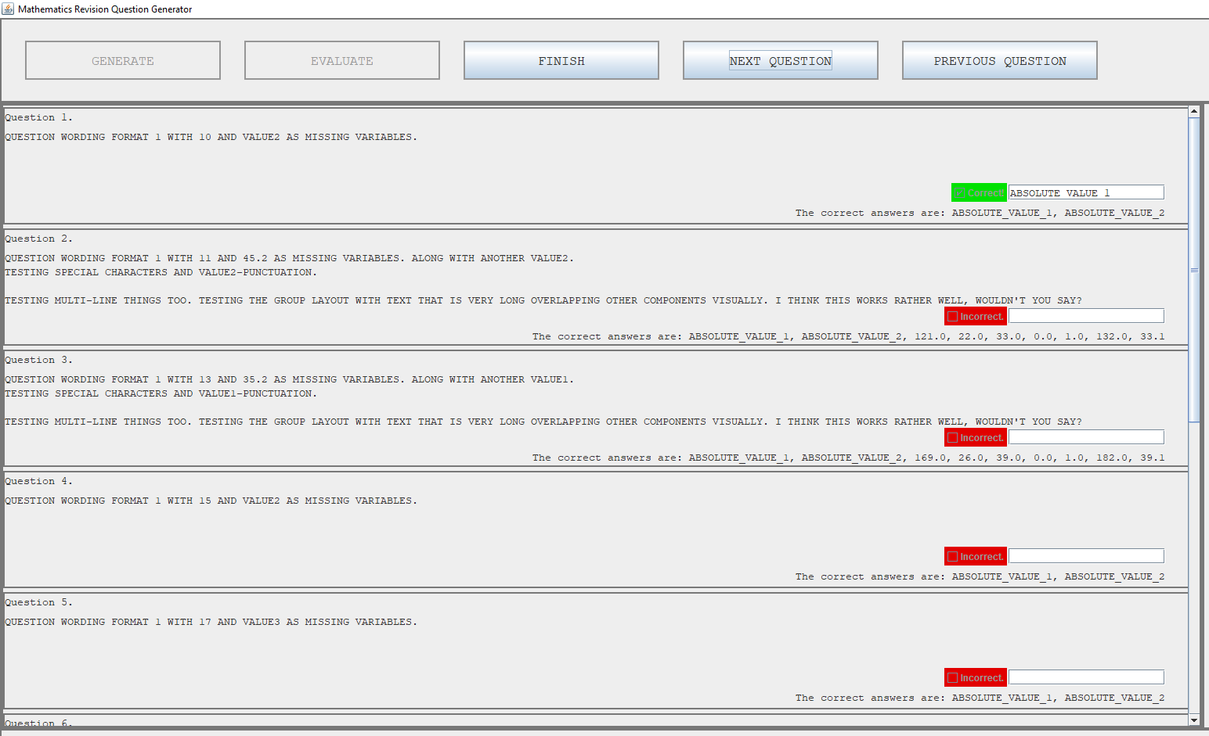

[Fig. 39] Demonstrating the entire UI and listed questions after being generated. The text is blurry but that should not matter since the main idea is to show the layout along with the look and feel. Evidence for test #1, #2, #3, #4 and #7.

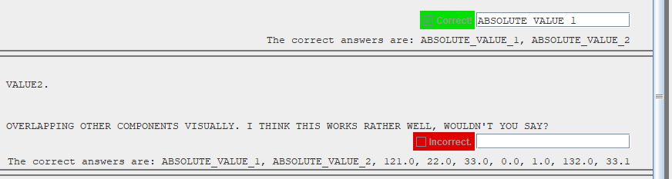

[Fig. 40] A closer screenshot of the correct box, and incorrect box, along with the correct answers. Evidence for test #1, #2, #3, #4 and #7.

As is clear from the figure 39, the new buttons are also at the top. A closer screenshot is below.

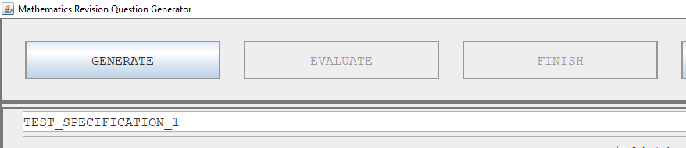

[Fig. 41] Demonstrating the new Finish button addition to the top panel.

As can be seen from the above images, the questions the user has generated can also be evaluated. The code for this is below.

The evaluation and finish buttons now have functionality in the main class.

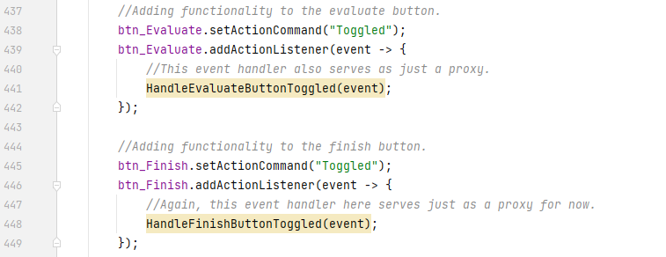

The first method leads to this.

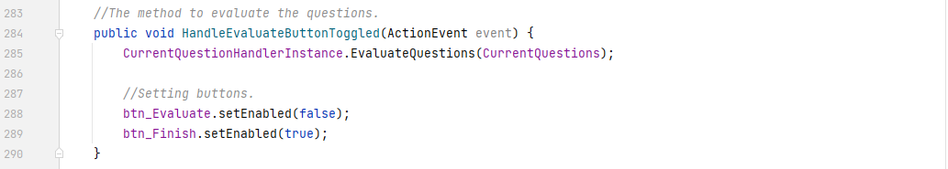

The first of which is a method which is a part of the question handler instance which was referenced in the previous question generation method. This is how it comes into use here. The question handler already knows the main class settings and other data already in it – cleaner code and more abstract code. It also sets the button itself not enabled and sets the finish button enabled. This is so that no multiple calls are made to the evaluation button and that the finish button can only be pressed after the evaluation button is pressed.

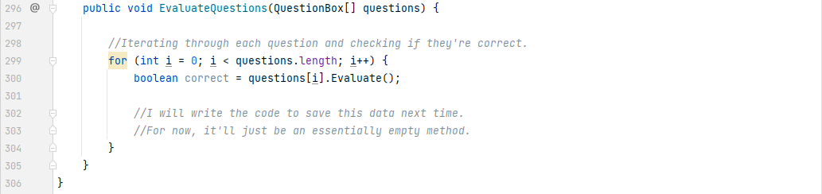

The method above is also very abstract, because each one of the QuestionBox subclass instances has its own evaluation method, so therefore this method simply iterates through all the questions and calls that method on each one. As can be seen from the comments in the code, the data handling will go here when that task comes up.

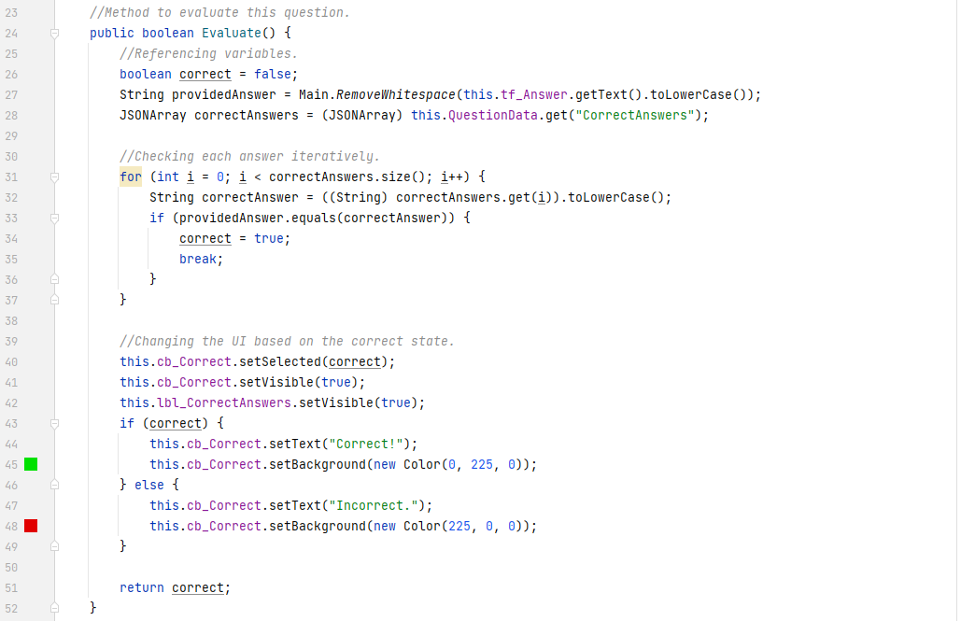

The evaluation method is shown. It simply iterates through the correct answers array, and checks if the sanitised version of the user’s answer is equal to any of the provided answers. This is where the earlier whitespace removal method defined in the main class comes into use. I am using the lowercase version of each string to ensure no capitalisation errors cause the user to lose marks when they did indeed have the correct answer submitted. I am also *not* using the previously defined VerifyStringAsNumber() method here because it strictly wants the string to be an integer, but the input here can be an integer, a float or a word – so it would actually break the code instead.

Once the correct answer has been evaluated, the answers text field and correctness checkbox get made visible, and the checkbox gets coloured and ticked based on the correctness of the provided answer. This is a rather “hacky” way of implementing the visual feedback ideas discussed in the overall design phase’s usability section. A potential improvement would be to use icons with custom tick and cross images made with vector graphics, however that is out of the scope of this project and not a necessary addition given the timeframe and client/stakeholder needs.

#### Prototypes

With the closure of this phase, I can confidently say that this is the first real prototype of the working solution. One can view topics, select them, configure question generation, generate questions and evaluate the questions – repeating the process however many times they like. This is the 1st of 2 core features of the desired working solution – the other being the data handling and historic bias towards more incorrect topics. Those will get implemented in the next few iterations. The client has also been notified of the progress through an email. Their feedback will be discussed in the next section.

### Testing, Problem Rectification and Client Feedback

#### Evidence of Testing and Test Results

|  |  |  |  |  |  |  |
| --- | --- | --- | --- | --- | --- | --- |
| Test # | Success Criteria # | Test Reason | Input | Desired Output | Actual Output | Success T / F |
| 1 | 1 | To ensure each question panel displays correctly. | Generate button clicked. | Topics panel disappears and a number of question panels appears. | All topics display correctly. | T |
| 2 | 1, 2, 3, 4 | To ensure questions can be generated correctly. | Generate button clicked. | Wording, values and answers are correctly calculated and generated. | Wording contains values, and answers are correct. | T |
| 3 | 5, 6 | To ensure each question is evaluated correctly. | Evaluate button clicked. | Each answer to each question is compared with the provided answer and correctly recorded. | Answers are correctly evaluated. | T |
| 4 | 5, 6 | To ensure visual feedback is given on the correctness of each question (supplementary to test #3). | Evaluate button clicked. | Question turns green with a checkmark, or red with a cross to signify a question being right or wrong. Question also has the correct answer displayed. | Clear green/red box with a tick/no tick in it upon correctly or incorrectly answering. | T |
| 5 | 2 | To ensure the user is able to change bias and question generation settings. | Bias checkbox toggled and question number box value changed. | Values changed internally and printed to console. | Values printed as needed. | T |
| 6 | NULL | To ensure user provided answers are sanitised and validated. | Evaluate button clicked. | Converts answers to lowercase and removes whitespace. | Whitespace is removed and converts to lowercase. | T |
| 7 | NULL | To ensure blank answers are treated as wrong answers. | Evaluate button clicked. | To correctly identify blanks as incorrect answers. | Marks empty box as incorrect. | T |
| 8 | NULL | To ensure each group of questions is independent from each other (internally, everything is reset when a round of questions is done). | Multiple presses of the generate button after multiple rounds of questions. | No bugs or inconsistencies with Swing component rendering or data not being cleared are found. | No components render incorrectly. Data is cleared dereferenced from memory. | T |

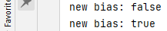

[Fig. 42] Evidence for test #5.

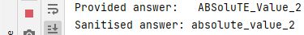

[Fig. 43] Evidence for test #6.

Due to the nature of test #8, evidencing is difficult. However, I think showing that 2 different sets of questions do not interfere with each other visually nor internally is enough proof that the test is successful.

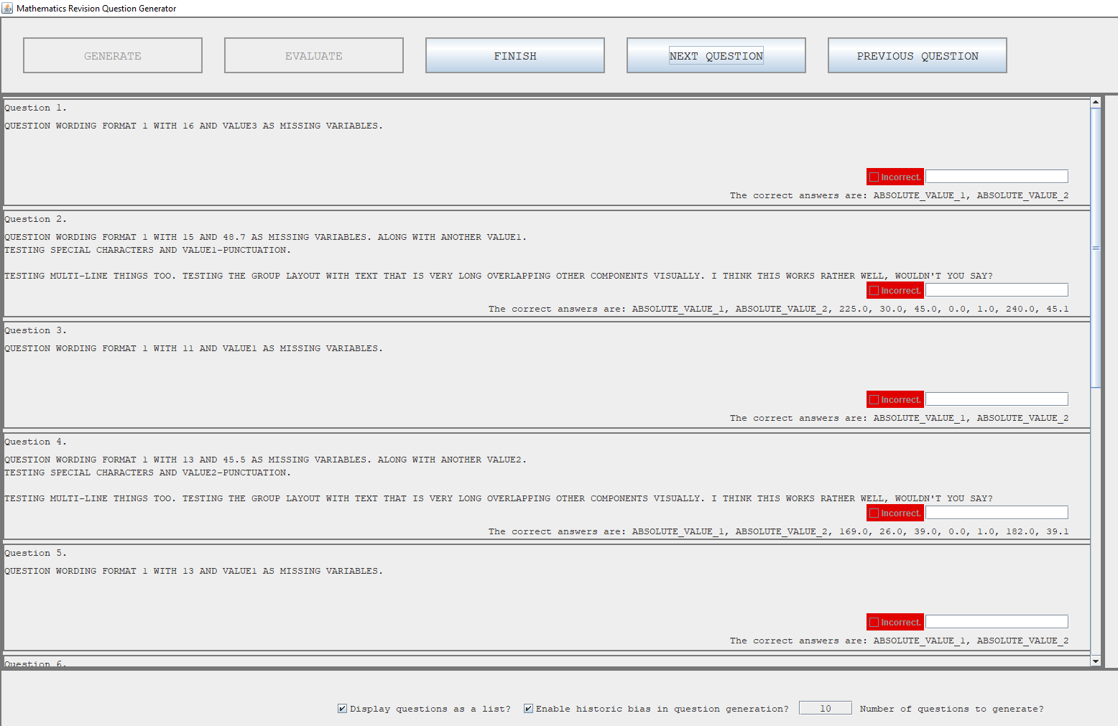

[Fig. 44] Evidence for test #8. The first set of questions.

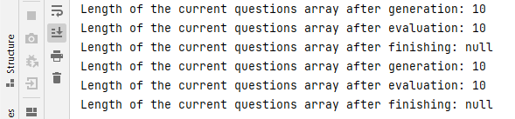

[Fig. 45] Evidence for test #8. Demonstrating that any previously generated questions don’t persist in the array.

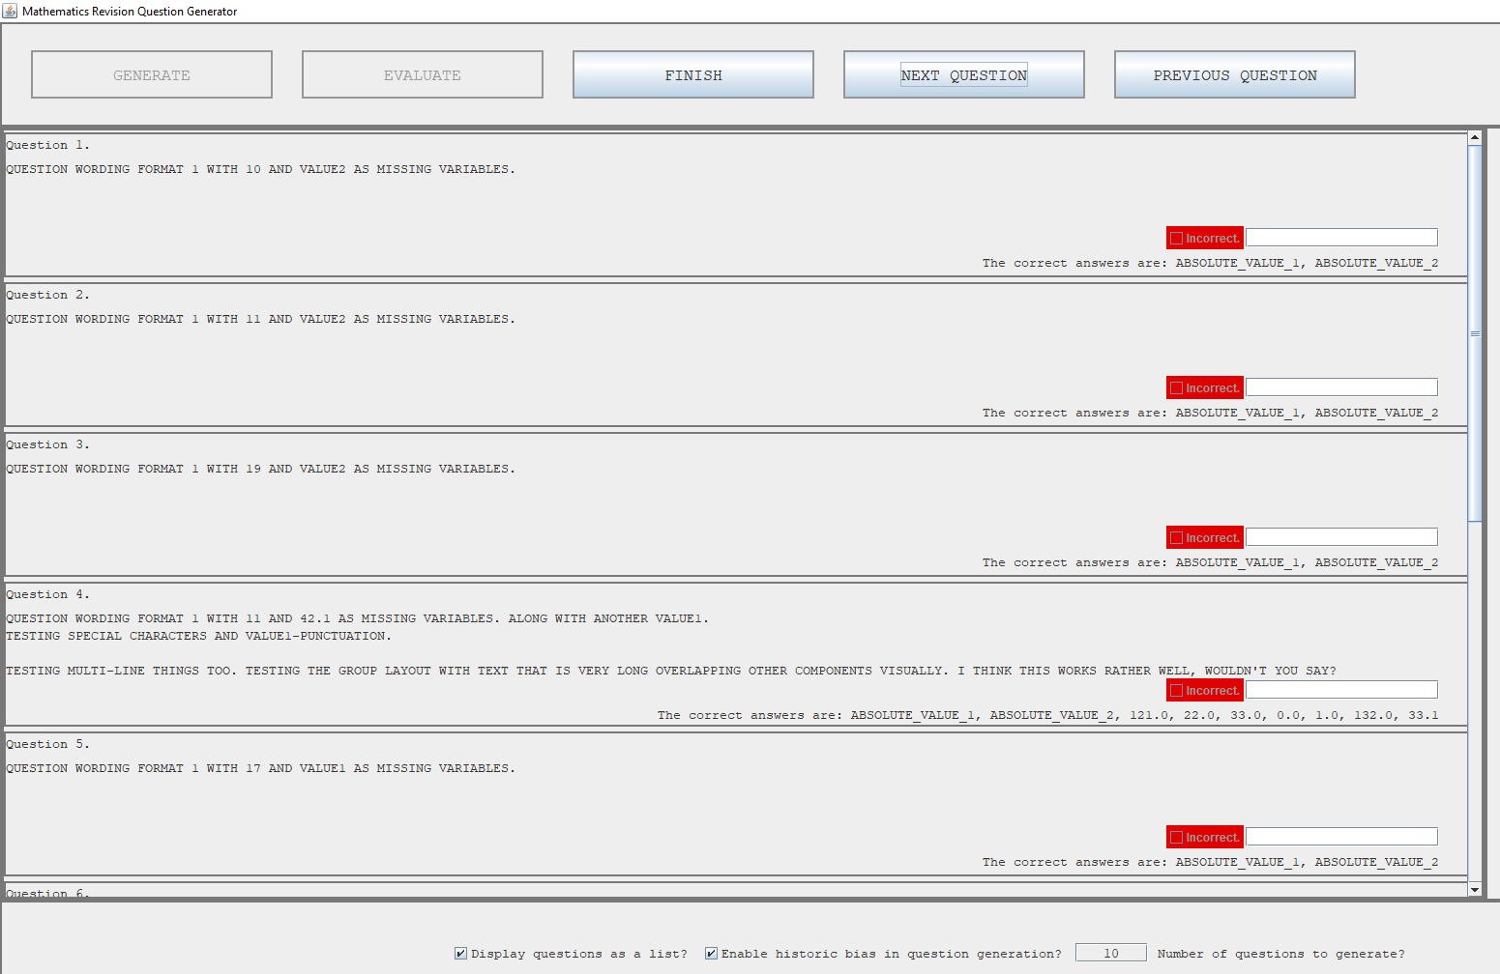

[Fig. 46] Evidence for test #8. The first set of questions is different to this one, signifying a new set of questions.

#### Problems and Remedies

This iteration being the largest one by far has therefore had its fair share of issues.

Notably, the algorithm for generating the data was one which was not written in pseudocode initially since I had never implemented such functionality. A large number of small errors like rounding floats at every step or not decrementing the iterator in the algorithm caused me to spend time discussing with peers and researching on the internet about how to approach this kind of problem. Eventually figuring out that compilers use context free grammar to achieve this very kind of purpose, it was too late to change the codebase and JSON format, so I stuck with what I had previously written as it worked the solution’s satisfaction. This is a very constrained way to approach parsing algebra however, and if I ever write this kind of code again, I will be sure to context free grammar.

I had to slightly reorganise some of the main panels to account for the new list of questions which need to be scrolled. This caused a number of rendering issues like some panels being visible when not supposed to and vice versa. This was resolved after adding colours to each panel in debug mode (similar to the first iteration) and therefore figuring out what needs to be visible and what doesn’t. This also developed my understanding of BorderLayout since having 2 panels in the same region only causes it to render the one added last. I will use this property if I ever want to replace panels in regions defined by BorderLayout.

### Evaluation of Development Iteration

This iteration, even for its size, was a complete success. Every test was carried out with the expected outcome. There were no major hurdles to get past – only minor ones – and the ones that did prove tricky, were already discussed in the previous section.

In regards to changes, there were only a few trivial changes (i.e., nothing that changes the functionality of the solution at its core). The only changes that did take place were the addition of the “Finish” button and the visual text change for the bias button.

The Finish button had to be added because of the need for a user-controlled span of time where they are free to review their answers before the application changes the interface back to the list of topics. For usability, a button was chosen instead of something like a limiting timer. This change came out of necessity and practicality and does *not* impact the future development of the solution.

The other notable change, was the visual change to the text on the bias button. Before, it was “Enable historic bias in question generation?” and from feedback from the client, it is now “Enable smart question generation?”. This is a justified change because students in lower year groups (such as year 7 or 8) may not know the exact meaning of “historic bias” and therefore may confuse them.

## Iteration #4

Now that the first prototype of the solution is finished, work on the 2nd core feature can begin – that being locally saved data and updating topic bias. In this iteration, I will be writing the necessary code to update the local JSON files to save updates to bias values, and to keep track of scores on topics. This will also present a convenient opportunity to implement saving user settings too. This means that settings will now persist between opening and closing the application.

### Design and Outline

A list of things which must be implemented/completed/done this iteration are as follows:

1. Reviewing (and amending if necessary) the JSON data format for user settings, from the design phase.
2. Saving user settings when program closes.
3. Reading user settings when program opens and applying those as necessary.
4. Creating a few *real* topics in *real* specifications for proper question answer testing to take place.
5. Reviewing (and amending if necessary) the JSON data format for topic performance data from the design phase.
6. Saving scores on topics at each evaluation phase.
7. Changing bias based on scores at each evaluation phase.
8. Change the wording of the bias toggle in the settings panel, as per client request.

This also means writing the final core class – the DataHandler. This will do most of the saving and will be called and controlled from the main class like the other two core classes so far. Pseudocode algorithms for most of the above are below:

Firstly, a reminder of what the user settings data object should look like:



There was key for storing the file path to a custom background image, but after discussion with the client, it was decided to remove this from the format since I will not include it in this prototype solution. That is because there is no adequate space to add the image. Furthermore, it adds very little value to the overall product if included and is not worth the time and effort to change the interface. The relevant success criterion has been amended. The format can be amended when new settings are needed and can easily be edited by the user themselves. The first 2 values will, in this iteration at least, be completely empty but will still exist since they will be filled with values in coming iterations.



Procedures to save user settings and to get user settings. The first will be called when the program is about to be closed, and the second will be called immediately on start-up. The specific way to write to JSON files with the JSON.simple library is unclear at this time, but that is an abstraction the pseudocode should not worry about and hence simply says “write”. The details will be worked out during the implementation of these procedures.

Next, the historic performance data format and its related subroutines.



This format is slightly different to what was defined in the design phase. Namely, the root array stores only a finite number of objects, those being objects which directly correspond to the specification data. For every specification object in the Specifications.json file, there will be a specification object here too. Here however, the object contains an array of smaller JSONObjects, each corresponding to a moment in time where several questions from a topic in that specification were completed – saving the score the user achieved on those questions, the max score they *could* have achieved, and the date of when it happened. The date is not *necessary* information per-say but may come in handy later when implementing graphs to show performance.



The two subroutines above will be the principal subroutines used when saving data after a round of questions is complete. The first iterates through every specification in the performance data and then iterates through each of the current questions to count the topics that exist, their max scores and achieved scores. It needs to iterate specifications and check the specification name of the topic the question is from to make sure it checks the *correct* topic in the *correct* specification (in the eventuality that 2 specifications have a topic with the same name). Once counted, it creates a new topic object (utilising the second function) and adds it to the JSON array. Once done, it iterates through each topic in the specification and updates each one’s bias based on how many questions the user got wrong (worked out by finding the difference between the max score and achieved score).

These subroutines illustrate the need to amend the current code and include topic and specification names in the question data. Note that all the above functions will go into the data handler class during implementation.

Below is the test-table for this iteration. All the tests are aimed at success criteria #7 and therefore, assuming success at this iteration, that success criteria should be fully satisfied.

|  |  |  |  |  |  |  |
| --- | --- | --- | --- | --- | --- | --- |
| Test # | Success Criteria # | Test Reason | Input | Desired Output | Actual Output | Success T / F |
| 1 | 7 | To ensure data gets read correctly from the correct file. | Program started. | Correct data printed to output. |  |  |
| 2 | 7 | To ensure settings get correctly set. | Program started. | Correct values when compared with file values. |  |  |
| 3 | 7 | To ensure settings get correctly saved. | Program closed. | Set values in program get set correctly in file. |  |  |
| 4 | 7 | Scores per topic per specification are correctly counted. | Evaluate button toggled. | Correct score and max score values printed to output per topic. |  |  |
| 5 | 7 | Scores per topic per specification are correctly written to file. | Evaluate button toggled. | New objects in JSON file with correct data about the topics in them. |  |  |
| 6 | 7 | Biases for every topic are updated. | Evaluate button toggled. | Only topics which had questions about them have their bias values changed. |  |  |
| 7 | 7 | To ensure no duplicate data exists. | Multiple evaluate button toggles. | No duplicate objects in the JSON file. |  |  |

### Programming and Implementation

#### Code and Justification

The first thing to get working was the process of saving user data. This is because by nature, the process is much easier than the rest of the data handling in this iteration and due my unfamiliarity with JSON file handling, this also proved as a crucial learning experience.

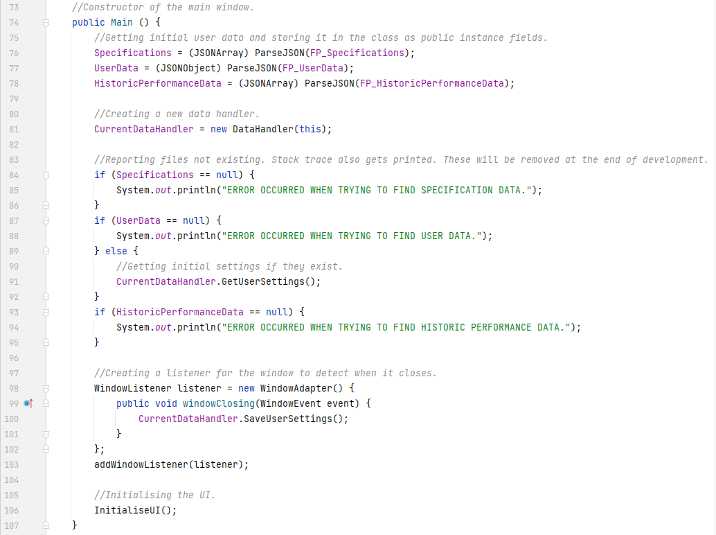

The constructor for the main class can be seen above. It remains mostly the same as seen in iteration #1, however, an instance of the DataHandler class gets created and referenced as part of an instance of the main class. Using this data handler, initial user settings are read, parsed, and set by its method GetUserSettings(). An event handler listening for the window being closed is also added after all the file handling has finished. This is here to make sure that before the solution finishes execution, all user settings are saved. This means that if at any point the user changes the settings at the bottom, they are saved to file no matter what (unless the computer itself shuts down, in which case the data is lost).

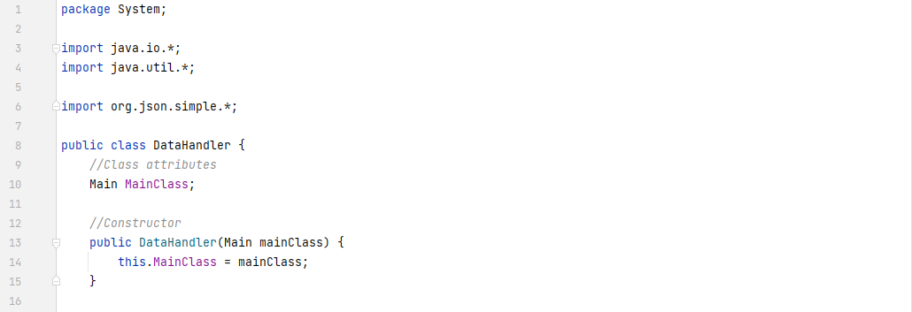

The class definition for the DataHandler is now also written.

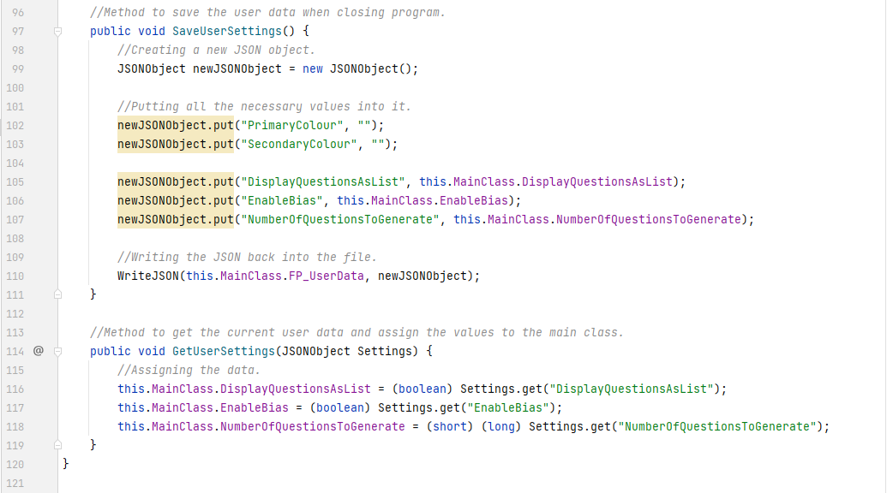

The code for the 2 methods seen in the constructor for the main class can be seen above. The first, simply follows what was written in the pseudocode and does not need further explanation. The latter is much simpler than its pseudocode counterpart due to the realisation that the main class already parses the user data file on construction. Therefore, one can simply pass it as a parameter to the method and the values get set from there. The first method makes use of a custom method to write to a file with a specified file path. The file path is there because later, I will need to write to another, different file.

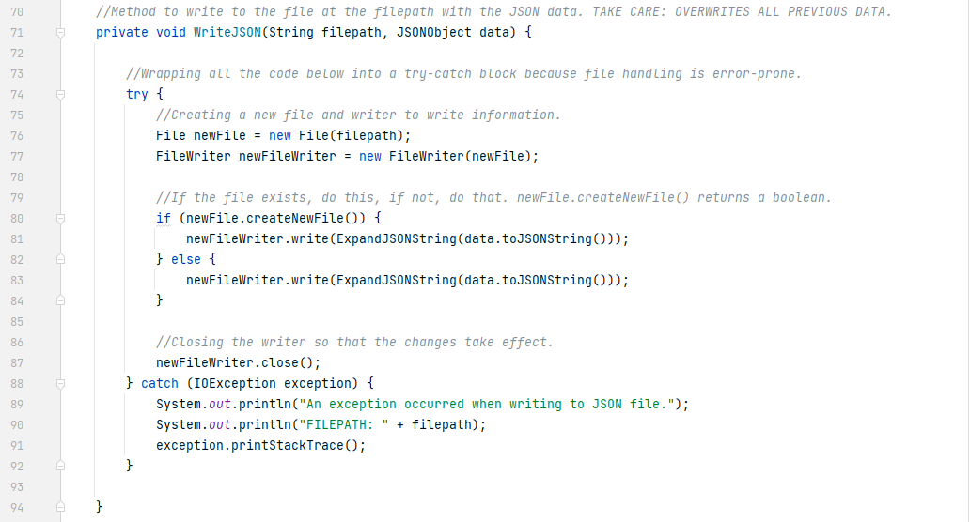

The above method simply finds the file at the specified file path and overwrites all the data there with a processed JSONString also provided to it if the file is found. If not, it throws an exception.

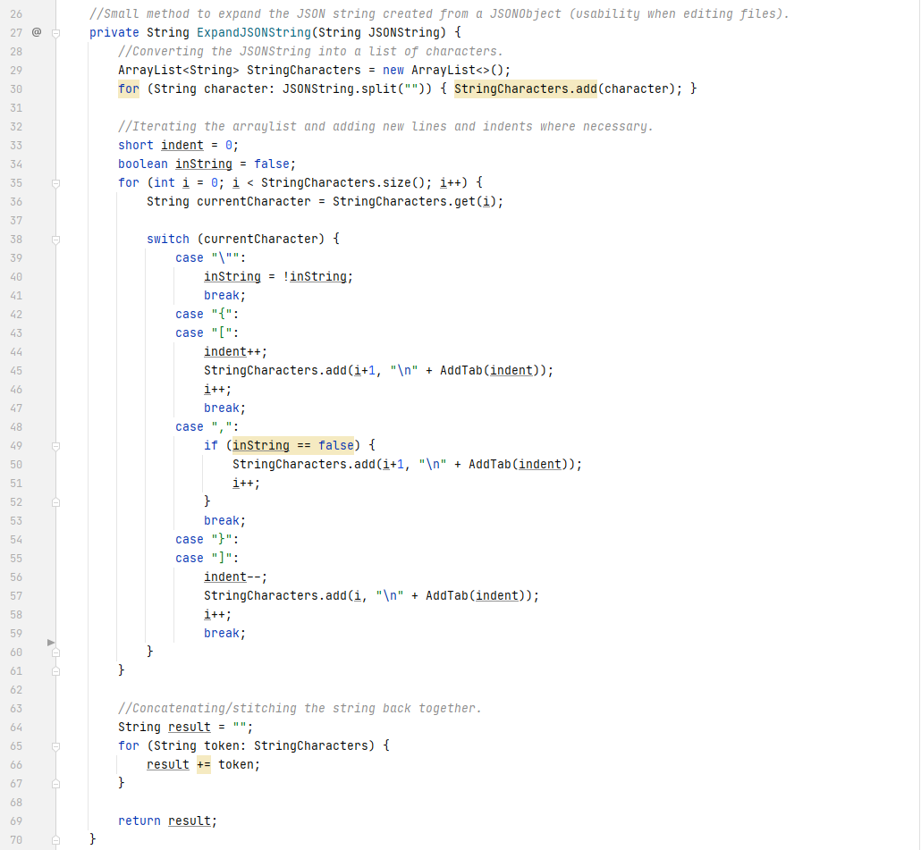

The method above is the processing mentioned in the previous method. This method simply formats the JSONString before writing to the file so that anyone viewing the file can easily see where things are. It uses a simple switch case on every string character in the provided JSONString and if it finds certain JSON tokens like {} or [], it adds newlines and indents. The more curly/square brackets it finds, the more indents it adds. It also handles the special case when the JSON values present contain commas. Since commas have their own place is in JSON formatting (delimiter between array elements), it is important to know when the comma is a part of the structure or a part of the value. That is why the Boolean inString exists. It is true when the character it is currently examining is a part of a value, and therefore does not trigger the formatting code when a comma is found.

Instead of the file looking like this:



[Fig. 47] Compact JSON string.

It looks like this:

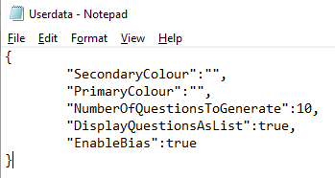

[Fig. 48] Expanded JSON string.

As is visually clear, the format is easier to work with when editing and viewing the data from any text editor. It is not a direct user usability feature, but it improves the quality of life for anyone editing the files directly. This can further be improved by adding whitespace between the colons, but it is not necessary for the purposes of these files. If the client asks for it, I will include it in the next iteration.

Now that reading and writing to the user data file works, implementing the rest of the features spoken about during this iteration can begin. The first thing, to do, is to make some changes to the existing code.

The SpecificationPanel got a new method:



This is because it needs to be used in the Main class method for creating topic listings.

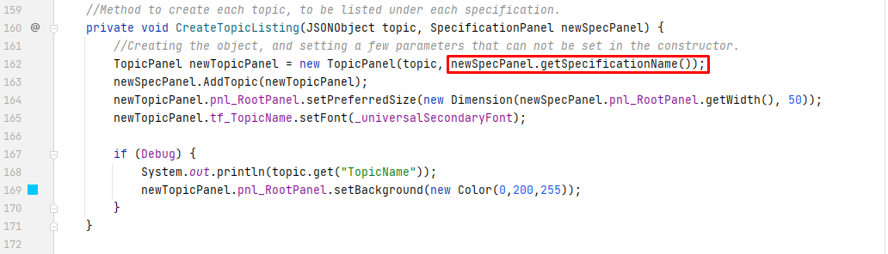

And this is because the first few lines of TopicPanel’s constructor got updated.

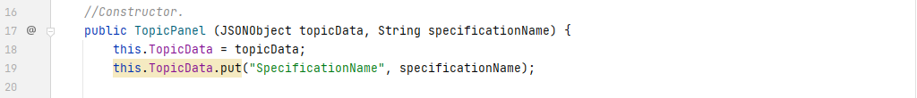

Before, the topic data would be the same as what’s present in the specifications JSON file. However, for saving the data later, it is necessary to know the specification the topic is a part of, and therefore it is necessary to include a new JSON value in the data, storing the name of the specification it is in.

Before data can be saved, the file for the data must be present. It is therefore important to ensure the file exists independent of if it’s there or not in the first place. For this reason, the Main class constructor got updated:

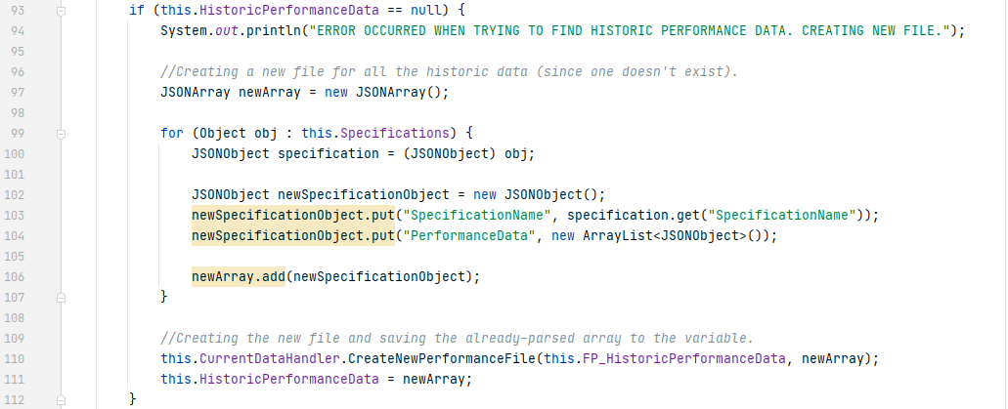

If the performance file is not found, it creates one at that location by taking all the specifications in the specifications file, constructing a JSON object with the needed fields, and writing it to the location by using a proxy method called CreateNewPerformanceFile().



It is a proxy method because it simply calls the already written WriteJSON() method with the same parameters it has been passed. It needs to exist because the WriteJSON() method is a *private* method in the DataHandler class, and I did not consider it a good idea to make it a public method just for this specific use case. Due to the realisation that the files I am writing to are meant to be JSON arrays rather than objects, the WriteJSON() method has also been generalised.

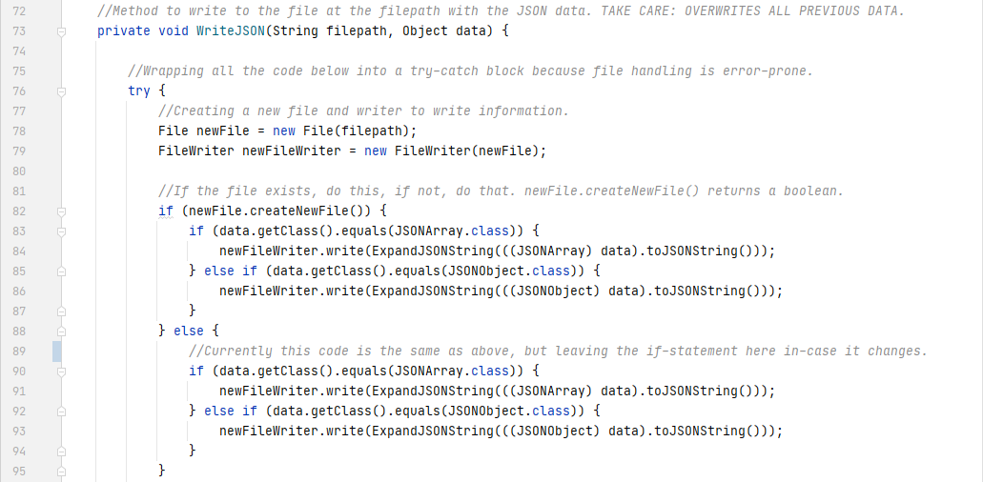

The rest of the method is the same as shown before. Now it accepts the data with the type being Object and casts the object into its respective data type when getting the JSON string. The code does not look aesthetically pleasing and it is duplicate, but it works.

Now that the prerequisite work is complete, the principal method for saving scores – as outlined in the pseudocode – can be implemented. The overall workflow of it is straightforward. It creates new, empty objects, and places all the currently existing data into those objects, but while it places them, it also adds to the data or changes the data. When finished, it overwrites everything previously saved to those files with the new data.

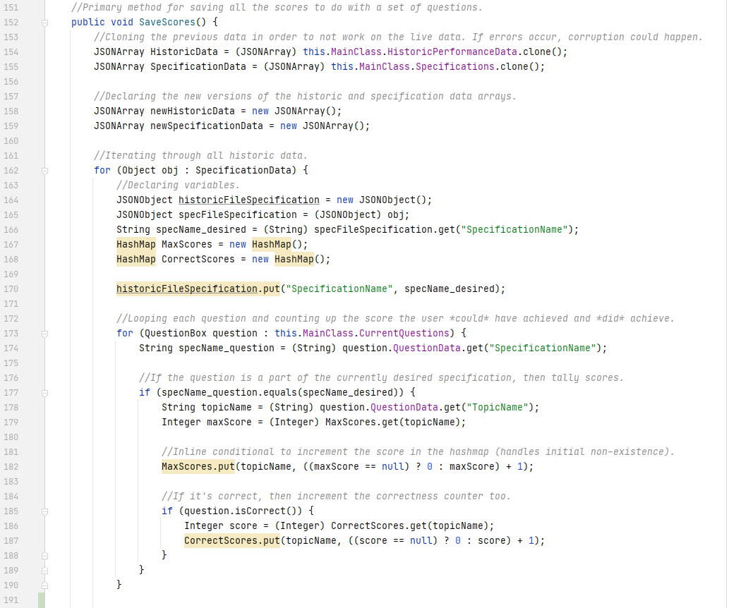

It begins by cloning the previously parsed JSON data into new objects. This is a necessary step because in the rare occurrence that something goes wrong when writing the processed data to the file, the parsed data in the main class is not affected and the rest of the application can function without error. It then begins iterating through every specification in the specifications file (since that is the source of truth for everything else because the system administrator should be manually editing only that one). This means that if ever any new specifications or topics within them get added, the currently existing performance data will not be affected, as it will simply add in a new section for the new specification in the file.

It iterates through all the current questions and checks what specification the topic of that question is a part of (hence the earlier data was needed to be added). If they match, it increments that topic’s max score and score (if the answer is correct) by 1 in their respective hash maps. I am utilising HashMaps for this because I need to store a number for every topic, in the form of a key-value pair. Each topic can be represented as a unique string (its name) for the key and the number is the value. Using normal ArrayLists and Arrays simply would not work in this case. HashMaps are also more commonly known as dictionaries outside of Java.

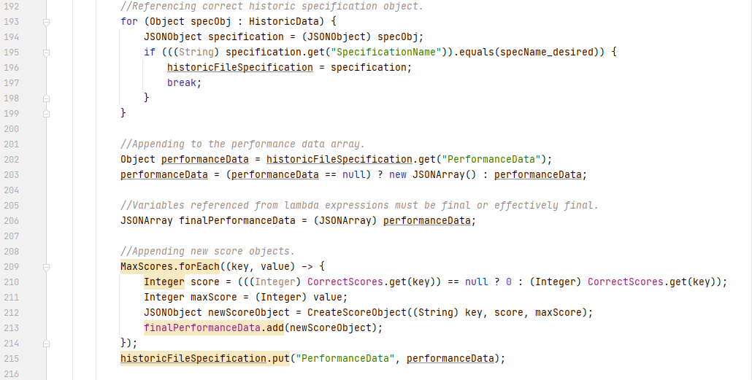

It then finds the corresponding historic JSON performance data associated with the desired specification and references it. This is because the method needs to *append (add)* to the pre-existing performance data to do with that specification, rather than overwriting it. Once done, it iterates through the MaxScores HashMap and uses a lambda expression with inline conditionals (syntactic sugar for readability), creates new JSON performance data, and appends to the existing array.

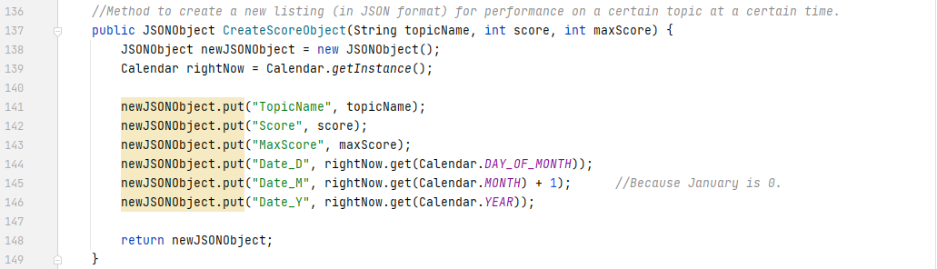

The method seen in the previous code is shown above. It creates a JSON object which follows the format for performance data decided at the start of this implementation iteration.

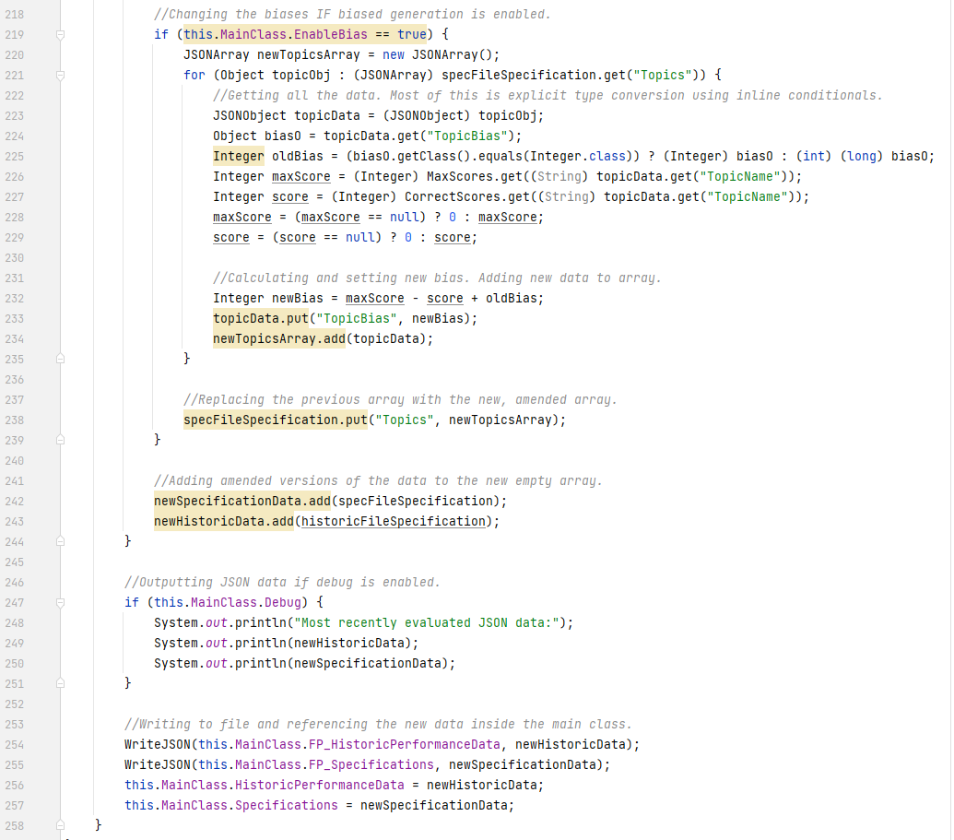

After the performance data is updated, the biases in the specification file also need to be updated. This should only be done if biased generation is enabled, which is why the above code checks that value before creating a new topics array and updating the biases. The power of inline conditionals in Java can be seen clearly here. Before this iteration, I was not aware of them. It greatly improves code clarity and readability. Rather than spending 5 lines writing a small if this else that statement, 1 line is enough for the same job. This is, again, known as *syntactic sugar*. The code on line 231 also accounts for the topics that were *not* included in the current questions because maxScore is 0 and score is 0, therefore newBias = oldBias.

Once the biases are updated, the new specification object is added to the new array declared at the top of the method, and the whole process is repeated for every other specification. Once the iteration is complete, the new arrays with the new data overwrite the old data – thus conceptually “saving” the scores on top of what was already there. They are also referenced in the main class.

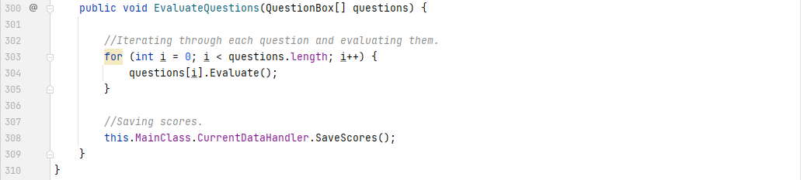

This method is called in the QuestionHandler class, when the Evaluate button is activated.

#### Prototypes

This iteration is working towards completing the 2nd core feature of the solution, which is saving data and displaying performance information to do with those graphs. This is progress in working towards the 2nd complete prototype.

### Testing, Problem Rectification and Client Feedback

#### Evidence of Testing and Test Results

|  |  |  |  |  |  |  |
| --- | --- | --- | --- | --- | --- | --- |
| Test # | Success Criteria # | Test Reason | Input | Desired Output | Actual Output | Success T / F |
| 1 | 7 | To ensure data gets read correctly from the correct file. | Program started. | Correct data printed to output. | Correct data printed to output. | T |
| 2 | 7 | To ensure settings get correctly set. | Program started. | Correct values when compared with file values. | Correct values in the program after changing file. | T |
| 3 | 7 | To ensure settings get correctly saved. | Program closed. | Set values in program get set correctly in file. | Correct values in the file. | T |
| 4 | 7 | Scores per topic per specification are correctly counted. | Evaluate button toggled. | Correct score and max score values printed to output per topic. | Correct values printed to output. | T |
| 5 | 7 | Scores per topic per specification are correctly written to file. | Evaluate button toggled. | New objects in JSON file with correct data about the topics in them. | Correct data inside the file under the correct specifications. | T |
| 6 | 7 | Biases for every topic are updated. | Evaluate button toggled. | Only topics which had questions about them have their bias values changed. | Bias for 1 topic has updated correctly, and therefore has also correctly updated for the rest. | T |
| 7 | 7 | To ensure no duplicate data exists. | Multiple evaluate button toggles. | No duplicate objects in the JSON file. | There are no duplicates present in the file. | T |

Evidence for the above tests is documented below.

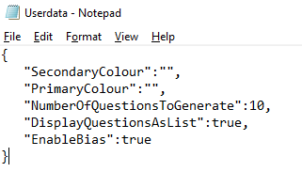

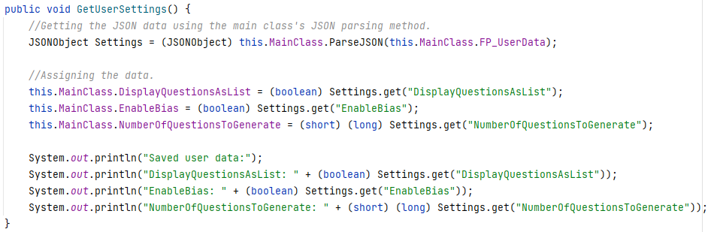

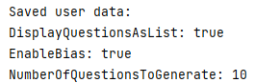

[Fig. 49-51] Evidence for test #1.

From the screenshot of the code above, it is clear the data being read from the file is correct, as further shown by the output with the values present in the file.

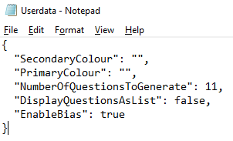



[Fig. 52-53] Evidence for test #2.

In this example, the values present in the file were the same as what can be seen in the user interface. This test is very similar to test #1, however the difference is that it correctly assigns them *before* the visuals get updated upon initialisation.

It is important to also mention the change in wording of the middle check box. Previously “Enable historic bias?” was written for that checkbox’s label. At the end of iteration 3, the client thought students in year 7 may not be aware of the meaning of “historic bias” and requested for me to change that phrase. It is now “Enable smart question generation?”. I believe this is a much more fitting phrase and the client agrees.



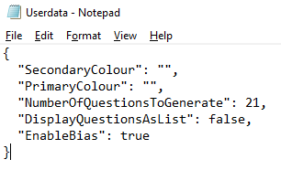

[Fig. 54-55] Evidence for test #3.

Test #3 is a reverse of test #1 and test #2, where the visuals get changed, and the correct data gets saved to the file in a user-friendly format (default JSON strings are all on one line, rendering any attempts to make edits to the file time consuming and error prone.

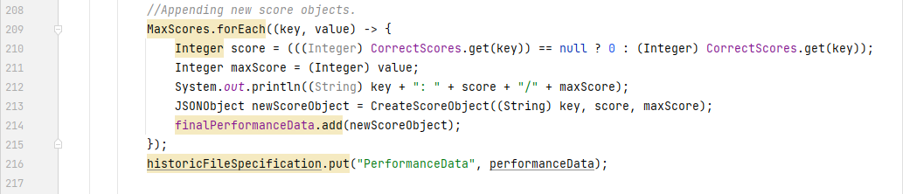

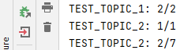

[Fig. 56-57] Evidence for test #4

The printout for each of the topics in the given list of questions shows clearly that the maximum scores add to 10, and the 5 correct answers were all counted correctly.

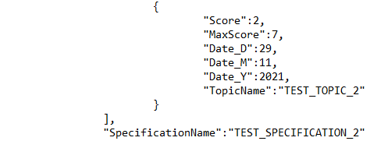

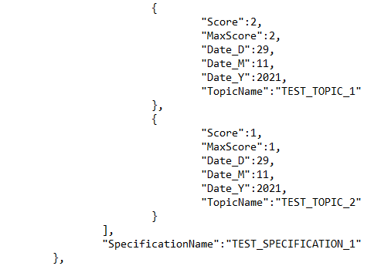

[Fig. 58-59] Evidence for test #5.

From the images, following the data from the previously answered questions, the data inputted into the file is correct and under the correct specifications. The max score, score and date values are accurate.



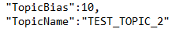

[Fig. 60-61] Evidence for test #6.

The first image was taken before the round of questions, the second image was taken after. This clearly shows that, since 2 questions out of 7 were correctly answered and 5 were incorrect, the bias should increase by 5 and it clearly has.

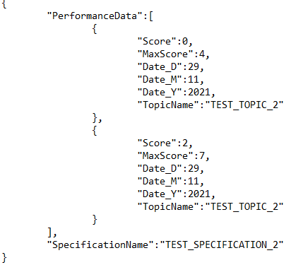

[Fig. 62] Evidence for test #7.

There are no duplicates. That is clear from the fact that the maxScore value in the file is different for both entries, along with the score, signifying that the entry is from a different round. The start and end of the JSON object can be seen, therefore showing that these are the *only* data, further proving that there are no duplicates.

#### Problems and Remedies

During implementation, I came to the realisation that the way I had written the code as outlined by the pseudocode (in the design section of this iteration), did not account for the event that the system administrator would like to add a new specification. This resulted in having to rewrite most of the algorithm, but to instead loop through all the specifications in the specifications file, rather than the historic data file since the historic data file’s list of specifications is *based* on the list of specifications in the specifications file. The remedied code is the code documented in the above implementation section and is therefore not shown here. The previous code was not discarded, rather, refactored to suit the new requirements.

During the implementation of the algorithm to expand and format the JSON for the usability of the system administrator, I implemented the ability for the algorithm to recognise commas when adding tabs and newlines. I did not however, consider the possibility of the commas being present inside a value itself. This caused a visual bug that translated across the string of correct answers inside the solution. This was obviously unacceptable, so by adding a flag to the algorithm to keep track of when it is inside a string, it will then ignore the commas that are not a part of the JSON structuring symbols. Figure 63 below shows exactly this problem. The usually invisible newline and tab characters are being added as explicit strings to the values because the values are separated by commas. The fixed version is already documented in the above implementation section and therefore does not need to be redocumented here. The fix was simply adding an extra Boolean value, and a new case in the switch statement for quotation marks.

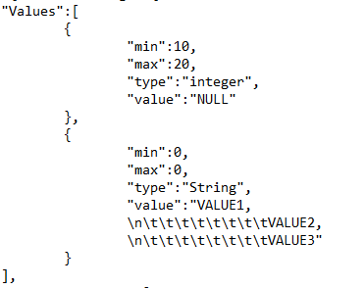

[Fig. 63] Showcasing a bug in the JSON formatter algorithm.

Another potential problem discovered during implementation involves the size of the historic performance data file itself. After only 5 rounds of 10 questions (5 questions), the file increased from 1KB to 4KB. This may not seem like a large increase in size, however, when combined with the fact that the user will do a significantly larger number of questions in potentially smaller groups and with more topics, this number could increase very quickly. This is not a problem since the size limit for a JSON parser in Java is undefined (and therefore limitless), however it may simply take more and more time when saving data as the user creates more of it. There is no need to fix it at the given moment in time.

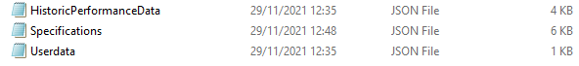

[Fig. 64] The size of the historic performance data file could be a problem.

### Evaluation of Development Iteration

During this iteration, every test was successful in meeting its required criteria and there were no major hurdles, as opposed to the last one. I would consider this a complete success. After implementation, I have also written the first *real* topic, part of a *real* specification. Areas of shapes within the Edexcel specification is now in the JSON file. It includes 2 question formats along with the rest of the information. This will be updated soon with more formats, and more topics, however, for now, this will do.

There are no major changes to discuss here. The only minor changes were discussed in the previous problems and remedies section. A small, noteworthy change is the removal of the background image from the success criteria. Justification for it is on page 98 of this document.

There is no noteworthy impact to discuss on future iterations by this iteration.

## Iteration #5

In this iteration, I will be working towards getting the 2nd prototype of the solution functional. This means I will be working on the user’s ability to customise the interface, the display of suggested topics of improvement, and progress graph generation of a select topic. I will also be carrying out internal improvements to the current algorithms such as the question generation algorithm to include indices and brackets. By the end of this iteration, the solution should in theory be a functional prototype of the envisioned design – simply missing alternative features (like questions appearing as singular pages, rather than list objects, or having bar charts instead of scatter graphs). Alternative features will be completed in later iterations after the core functionality outlined by the success criteria is present.

### Design and Outline

Firstly, implementation of suggested topics. After creating the necessary Swing components, I would simply create a list of 5 JLabels, containing the names of the 5 topics that have the highest overall bias associated with them. This means finding the maximum 5 biases from all the topics. The code would look something like this.



The first method simply gets a list of every topic in the system, and the second partially sorts it. Rather, it finds the maximum value in the list, adds it to a new list, and removes that value from the HashMap. The resulting list of keys from maximum values is automatically sorted. This technically counts as sorting, however it simply not carried out on the entire list. Hence the method is called PartialSort(). It has no official algorithmic name since I came up with it for this specific purpose.

Changing colours – an important part of the user experience and success criteria – is detailed in the algorithms below. The general idea is that, if a Swing object of some class belongs to a predefined list of classes that need colouring, the background, foreground, and border will be coloured with the primary and secondary colours.



The 2 methods above will be a part of the visualiser class. The first uses *recursion* to ensure that each component, starting from the root component, is coloured accordingly. The actual colouring and navigation of the parent-child tree will likely be more complex than the pseudocode above due to the inherent difficulty of navigating the parent-child tree in Java Swing is, but the general idea is the same.

Lastly, generating graphical feedback on the progress of the user through scatter graphs. As stated above, this iteration will only implement the scatter graph. The line chart and bar chart will come later, since the aim is to get the *prototype* working. The general idea is simple: Create a new JFrame instance (and therefore a stand-alone window) that will be of a fixed size and centred to the screen. Then, the necessary parts of a graph will be drawn onto it (axes, axis labels, title, etc) and then the necessary points will be plotted. Since the main class already tracks which, topics are selected, it is very easy to use those for the graph generation. This means that if the user has selected all 50 topics the solution offers, 50 graphs will be generated – 1 for each. This may be an inconvenience. For that, I will also implement a limit for which any number of topics higher than that value, will not allow the user to generate graphs. This will all be done in event handlers inside the main class itself and not in the Visualiser class – since that class’ job is only to visualise information, not handle *business logic*. Later, once more graphs are implemented, the user will be able to choose which graph they want to generate through a drop-down menu.

The algorithm for generating the data for a scatter graph is:



The general idea is simple. Iterate through each of the selected topics, creating a new instance of the ScatterGraph class. Then, collect 2 lists of values – one for x, the other for y – where x is the time in days since last being tested on this topic, and y is a number between 1 and 0, indicating the overall fraction of score achieved from that test on that day. That is why the y value is score / maxScore. Due to this necessary functionality, I have also found it convenient to *redefine the object format* in the PerformanceData array in the JSON file for each specification. Instead of having 3 separate fields for day, month, and year (originally thinking they’d be useful to mark key milestones only), it is more memory efficient and convenient to store the actual time after epoch of each object. This not only simplifies the object, but as mentioned, saves physical character count in the JSON file (therefore saving memory usage and lessening the memory problem discussed at the end of iteration 4). It is also a more versatile value because I can get the day, month, and year from that value, but not vice versa.

This change does make all the current data invalid and therefore subject to deletion. However, this is not a problem because the solution is still in a development phase and therefore no *real user data* has been recorded.

The second method seen above simply converts the epoch difference in time from seconds to days and implicitly rounds it down (since it’s integer division). This is because having the x-axis use very large time values is simply not convenient, nor readable for the user. Having the data only show for the last 30 days makes a lot more sense and is relevant for the user. This is a usability feature.

With respect to the algorithms detailed above, the testing table for this iteration is below:

|  |  |  |  |  |  |  |
| --- | --- | --- | --- | --- | --- | --- |
| Test # | Success Criteria # | Test Reason | Input | Desired Output | Actual Output | Success T / F |
| 1 | 9 | To ensure the list of suggested topics is accurate to specification file. | Solution started / Questions finished | List of 5 topics in descending order of bias. |  |  |
| 2 | 10 | To ensure the colours get correctly applied to only the designated component classes. | Primary colour box changed / secondary colour box changed. | Colours of backgrounds, foregrounds and borders changing correctly on only the desired components. |  |  |
| 3 | 8 | To ensure visual generation of scatter graph is correct. | Generate Graph button activated. | Separate window with a fixed size, generated with correct title and axis labels. |  |  |
| 4 | 8 | To ensure the data on the graph is correctly plotted. | Generate Graph button activated. | Points on the graph appear in correct places as according to the data. |  |  |
| 5 | 8 | To ensure only the last 30 days are displayed. | Generate Graph button activated. | Data that is 31 days or older is not shown. |  |  |

### Programming and Implementation

#### Code and Justification

Firstly, the list of suggested topics. This is a rather simple endeavour. It needs 2 extra Swing components – a label and the panel. Along with the methods in the Visualiser class.

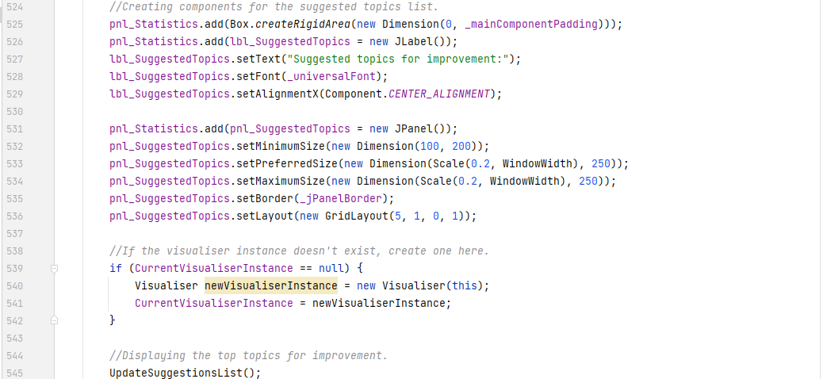

Above, the new code added to the main class can be seen. It creates the label and gives it an appropriate title. Then, it creates the panel and gives it a grid layout with 5 rows and 1 column. I have decided to hard code the number 5 into the solution since it will likely never get changed as it was in the success criteria and the client is happy with it as well.

Then, it creates the labels for each of the topics, and adds them to panel, after making sure the Visualiser itself exists. It needs to do this check because previously, by this point in the solution, an instance of the Visualiser class had not been created, and therefore needs to. However, if in future, I decide to create that instance a lot earlier than this point, the check above will work regardless.

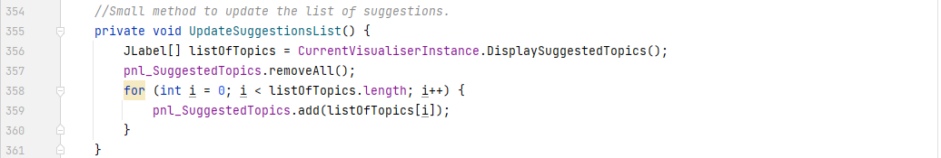

The code that adds the labels to the list is above. The gets new topics, removes the old ones, and adds the new ones in their place. It’s a standalone method because it needs to be called from other places in the code.

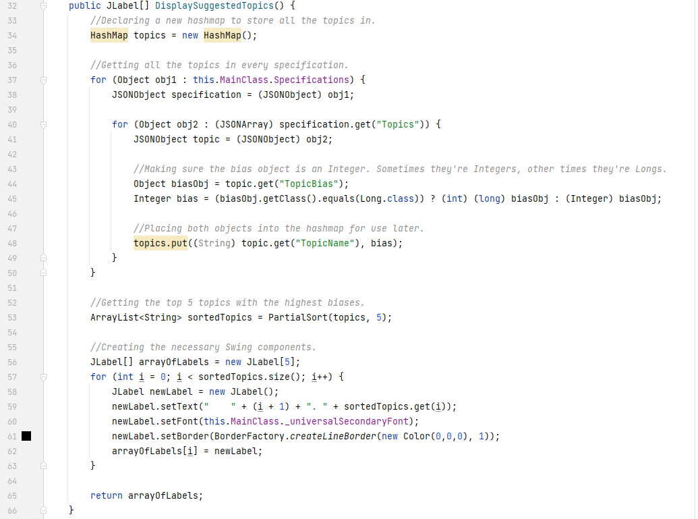

The algorithm in the Visualiser class shown above is largely the same as what the original pseudocode showed. It creates a new HashMap, finds all the topics in the specifications file, and collects them by name and bias. Then, it uses the PartialSort() method with a target of 5 elements. Once it has the top 5, it creates a new list of JLabel instances with the name of their corresponding topic. Once they’ve all been created and stylistic settings applied, it returns the list to be used in the main class.

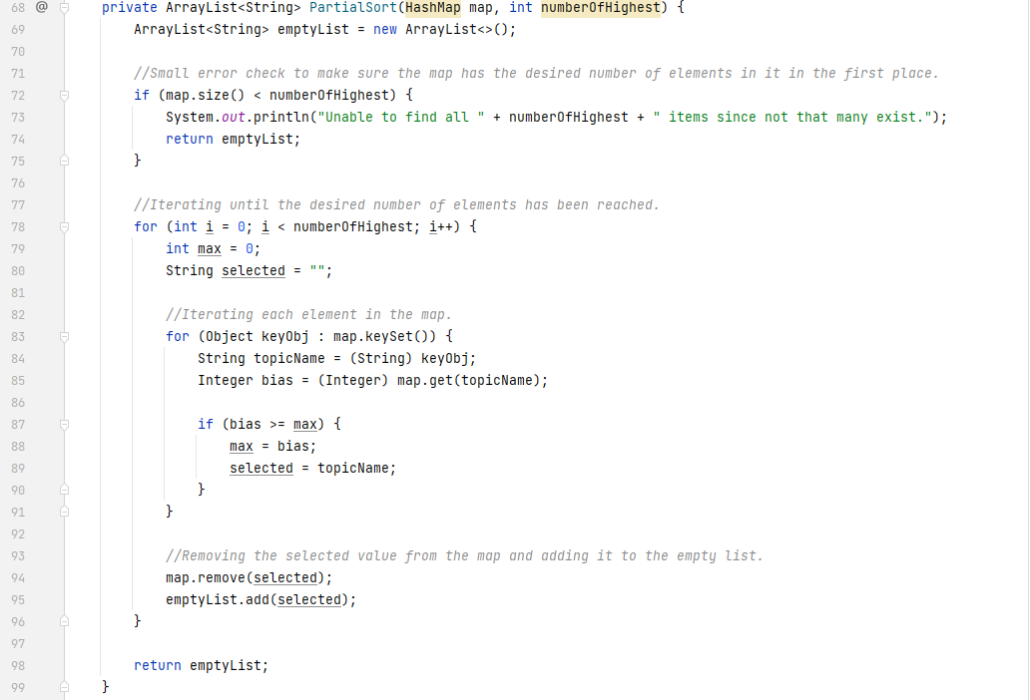

The PartialSort() method is also very similar to what was outlined in the pseudocode. It creates a new empty list, does a small error-check, and then iterates until the desired number of elements has been reached – iterating in the inner loop to find the maximum value of that HashMap. Once it finds the maximum, it removes the element from the HashMap and adds it to the empty list and then repeats the entire process. The error check is there because it would not return the desired number of elements if the number of items in the HashMap is less than the desired number of items.

Now that the list of suggested topics is complete, work on the user’s ability to colour the interface can begin. Firstly, it was important to declare a place where the current colours can be stored in. Since I have so far been grouping all the variables that get stored in files in one place, it makes sense to add the two integer arrays to the same place in the main class. These are integer arrays because I will ask the user to enter an RGB colour combination into a text box as the input. This means that the interface can be coloured in 2563 different ways for both the primary and secondary colour slots.

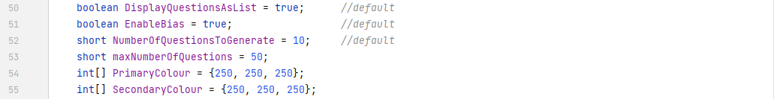

Since the variables have been declared, it makes sense to add the necessary components to the user interface next.

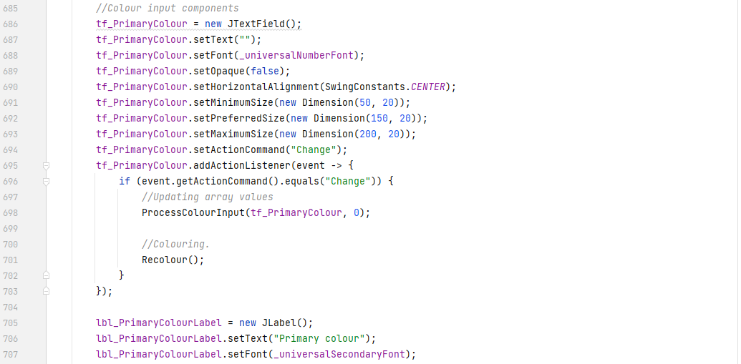

The code above is simply creating a new text field and label, sets all their parameters, and attaches an event handler to the foremost. The event handler calls 2 methods.

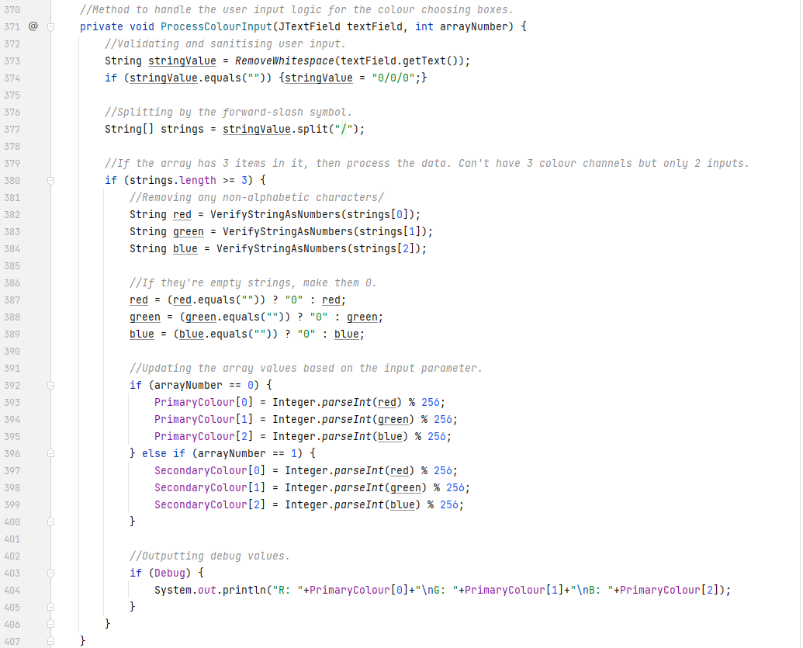

The idea of the method is simple. It sanitises the user input in the JTextField, and then turns the single String into 3 distinct numbers – 1 for each colour channel. It also validates the user input as well. It makes sure the numbers come in the ###/###/### format and handles numbers bigger than 255.

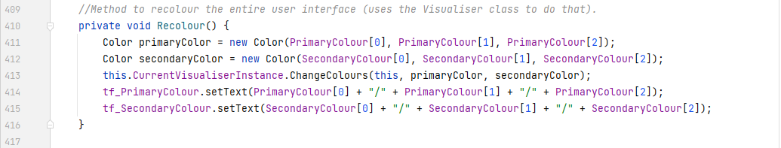

The second method is a much smaller one. It converts the previously attained integers into 2 colour objects, uses the Visualiser class to colour the entire user interface and sets the text in the text fields themselves to keep the interface looking aesthetically pleasing. I have written this method in the main class because it is very useful code that I need to run in multiple different places and times in the rest of the main class. Yet another example of *modularity*.

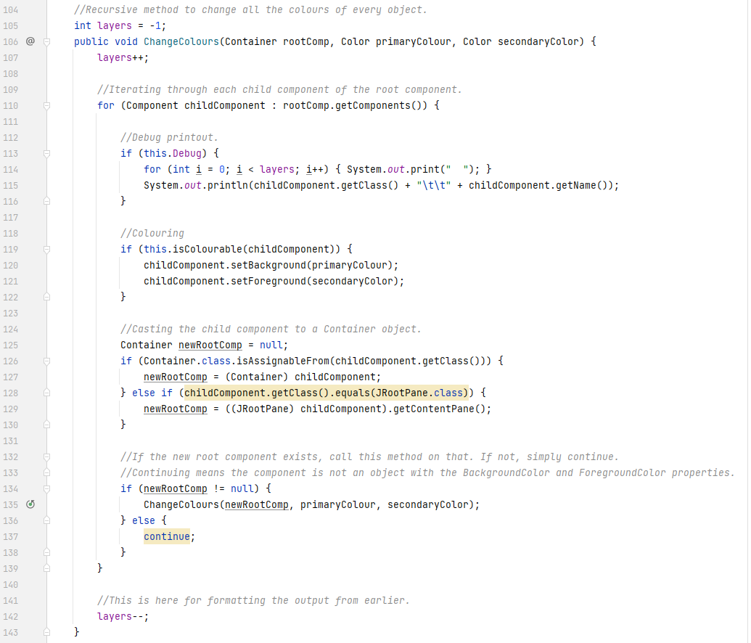

The method above is an implementation of the ChangeColours() method from the pseudocode earlier. It uses *recursion* to traverse the Swing object tree in the application – calling itself on the children of its root component. It colours the component if the component is colourable. It then checks if the current child in the loop is a valid Container object or an object which inherits from the Container class. This is necessary because only Containers or subclasses of Containers have the getComponents() method. If the child is a valid Container, it calls itself on that child. If not, it continues to the next child. Due to the nature of this method, it is also useful for printing the entire Swing object tree into the console for debugging purposes – which is why the Debug printouts are also there.

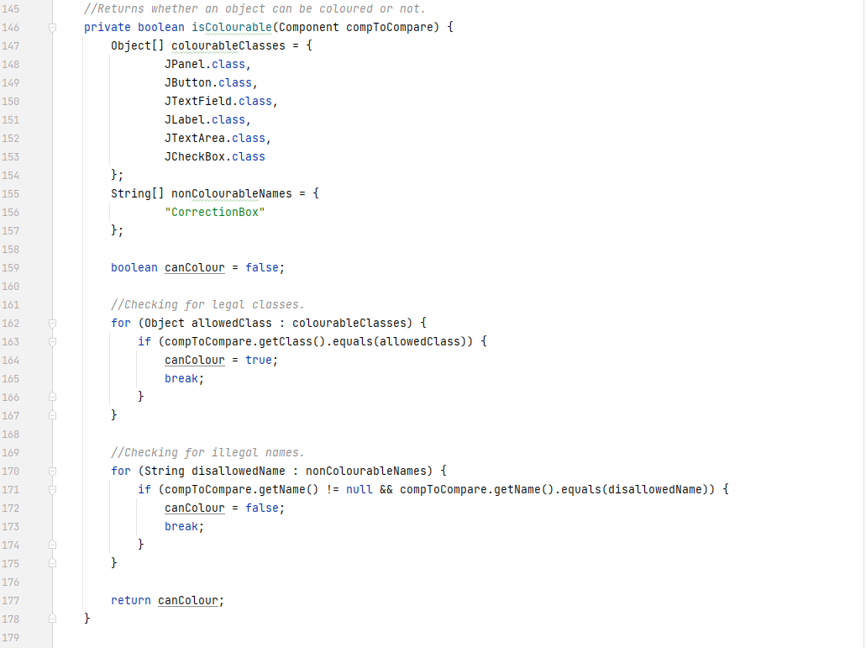

This method is also somewhat like the pseudocode earlier. It defines 2 arrays – 1 containing the valid classes which can be coloured, and 1 for containing a list of object names which are to be ignored when colouring. The latter acts like a *blacklist*. Since Swing does not have a Custom property system and creating custom variants of every Swing component would be outside the scope of this project, I have opted to use component names as the property to check when determining if a should not be painted.

It declares a flag. Iterates through the list of colourable classes and compares the given component’s class. If they match, make the flag true and break out of the loop. Then, check the name of the component against the names in the array. If the name matches to at least 1 in the array, make the flag false and break the loop. If neither loop matches, the flag’s default value is still false and still means the component cannot be coloured.

Within the colouring process, it may be noted that I have left out the colouring of the Border. This is because the Swing API in its current state does not have properties stored within Border objects. That means, if I call Component.getBorder() on a component, I get the Border it has. But the Border object does not have any methods like Border.setColor() or Border.setThickness(). I cannot edit the Border an object already has. I would have to define a new Border using BorderFactory, but in that case I don’t know the other properties of the border too because it does not have methods like Border.getThickness() or Border.getColor(). In short, it is not possible to change the colour of an object’s border where the rest of the properties are unknown. If the Swing API gets an update and this changes, I will be sure to add border colouring into the method too.

The new user interface with the new buttons looks like this:

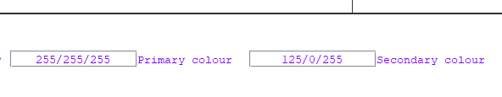

[Fig. 65] An image of the settings interface containing the text fields to edit colours.

The colours have already been changed in the interface above. The primary colour is the background of every colourable component, and the secondary colour is the foreground (text colour) of every colourable component. The Recolour() method is called at the end of each of the main stages for question generation – after generation, after evaluation, and after finishing. This is to ensure that the interface always remains aesthetically consistent.

There was also a smaller change to the variable initialisation in the main class.

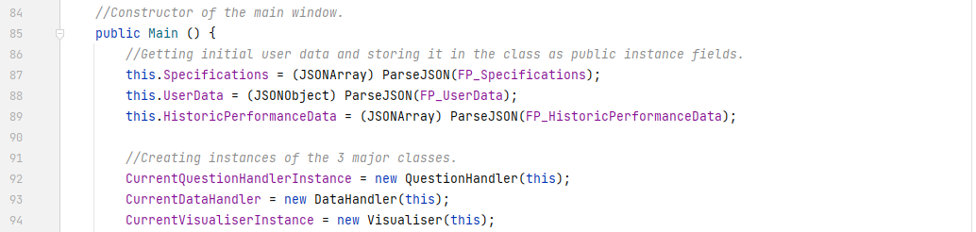

The Main class constructor now initialises all 3 of the core Handlers immediately on start-up. This means that checking the existence of these handlers in the rest of the codebase is now redundant code and has been removed. This does not change the functionality, but it does make the code cleaner, more readable, and less confusing for me as a programmer. It also technically reduces the execution time of the constructor because it removes the checks for those objects, but this optimisation has negligible impact.

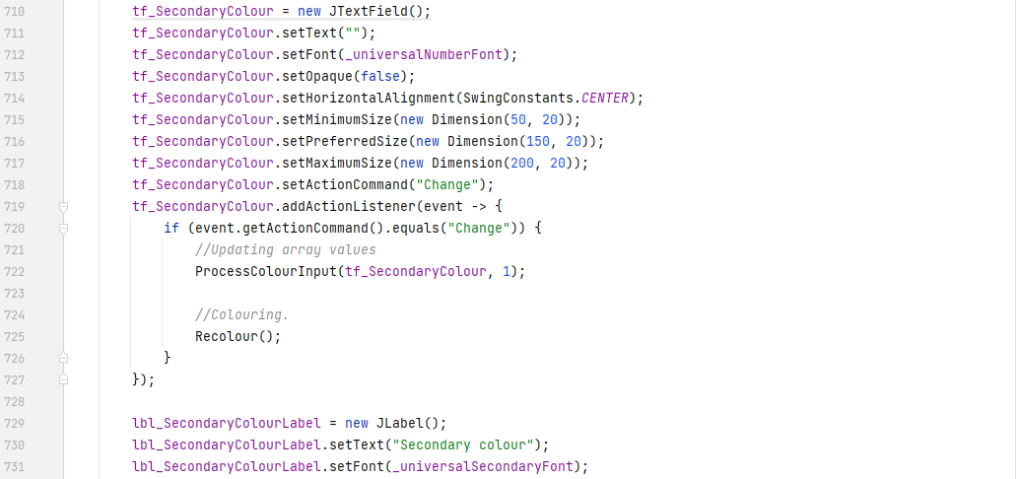

The Swing code for the second text field and label is identical to the first.

As the last thing in this iteration, graph generation will need to be implemented. Firstly, like always, the interface needs to include more components to create graphs. I have decided to remove the previous “More Statistics” button and replace it with a new button “Create Graph(s)” and a JComboBox for selecting the type of graph. This is because the previous button had no significant use and was therefore taking up space.

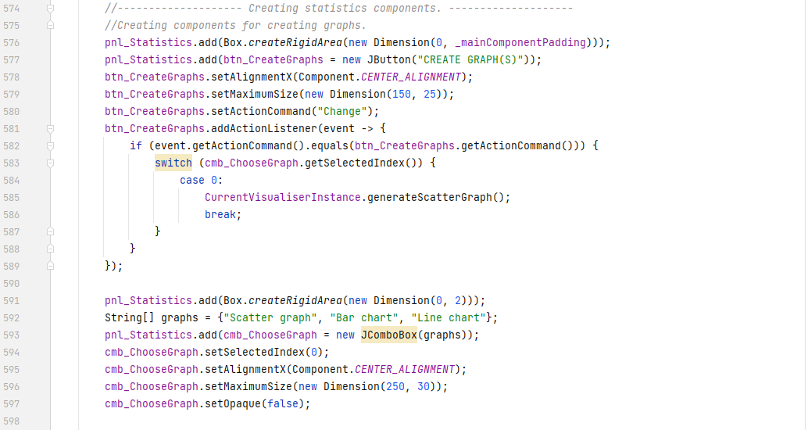

The code above creates the 2 new components, sets their parameters, and adds an event handler to the first. The handler checks the currently selected combo box option and calls the respective method from the visualiser class.

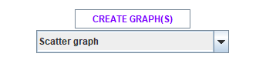

[Fig. 66] What the new UI components look like.

The first thing to write is the abstract class from which every graphical display will base its design off. Every graph needs to have an x- and y-axis, along with the axis labels and titles. This means that this abstract class will handle all the Swing component generation for those elements. A change needs to be made, however. The previously designed UML diagram, outlining the System package class structure and inheritance tree remains the same – except that the GraphicalDisplayWindow no longer will inherit from the CustomInterfaceObject class. This is because unlike languages such as C++, Common Lisp, Curl, OCaml or any other, Java does not support *multiple inheritance*. This is an issue because the GraphicalDisplayWindow should inherit from the JFrame class to make writing most of the Swing code a lot easier and quicker. This means that the GraphicalDisplayWindow *cannot* inherit from the CustomInterfaceObject class. This is not a problem however, since the CustomInterfaceObject class will not provide any methods or instance fields that are necessary in the graph generation code.

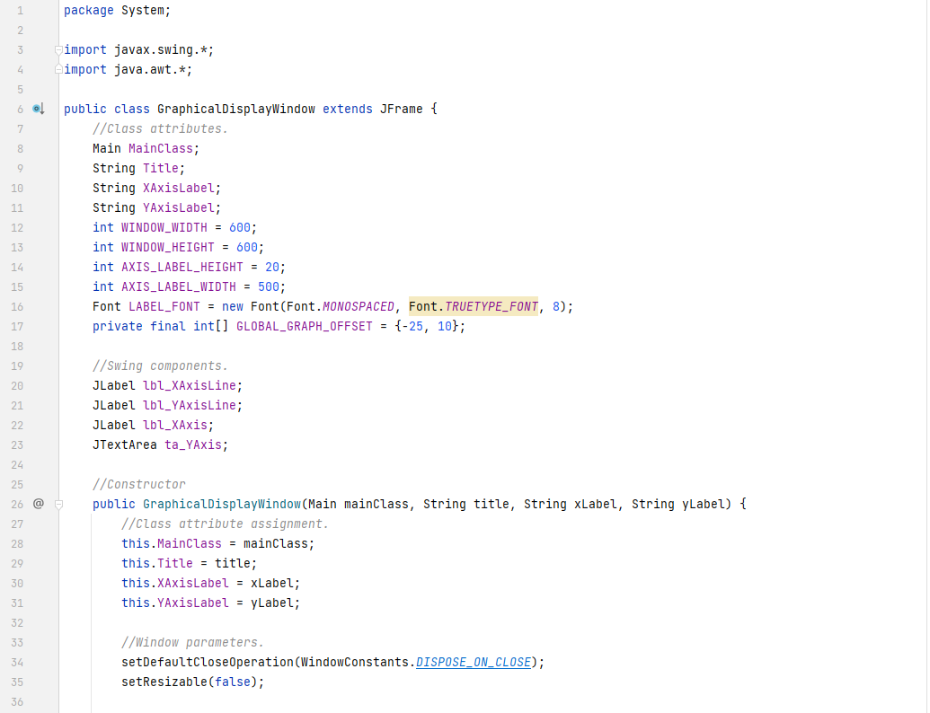

Above can be seen the class instantiation and part of the constructor code. The default close operation for this JFrame subclass is “DISPOSE_ON_CLOSE”. That is because when the user is finished reading their graph and would like to close it, I do not want the rest of the Swing application to close with it. This means that if they press X at the top right on the graph window, the window and *just* the window will close. If the user presses the X at the top right of the *main* window, then the entire application (along with any graph windows) will also close.

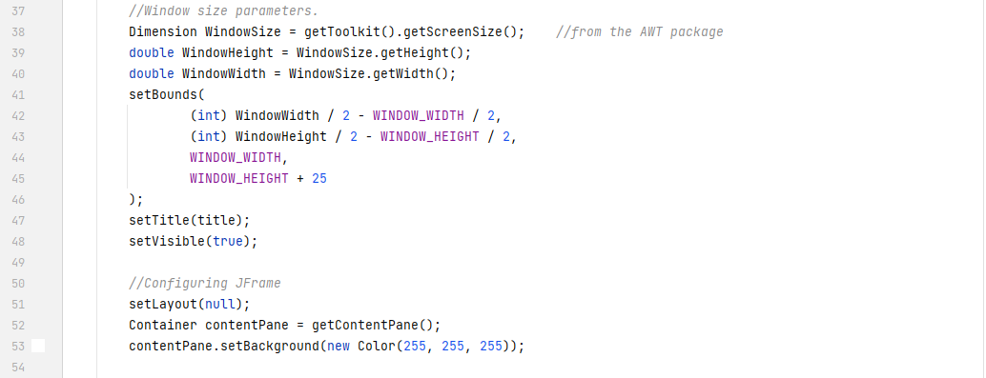

All the Swing components will be placed into the window via absolute and static values. This is because none of the components inside these graphs will ever need to *move*. This is also why there will be no layout manager for the window. The bounding code simply displays the window in the middle of the user’s screen. The 25-pixel offset is there to account for the size of the Windows top bar.

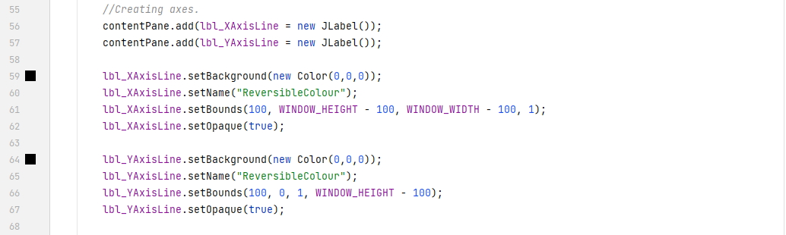

Now that the window has been created and configured, the axes and axis labels can be created. The naming of the components here is important because these components use the background colour property as their main colour (since they have no text in them). This means that the previously written colouring method will paint them the same colour as the background of the window – making them impossible to see.

In Java Swing, there is also no user-friendly and easy way to create simple lines for the axes. To get around this problem, I have decided to use opaque, coloured in, empty JLabels where one dimension is only a couple of pixels wide – practically looking like a line. Until the Swing API gets a more robust way to draw arbitrary lines, this code will stay. This approach is limited to drawing lines that are either perfectly horizontal or perfectly vertical – but this is not an issue since I do not need rotated lines to be drawn for this use-case anyway.

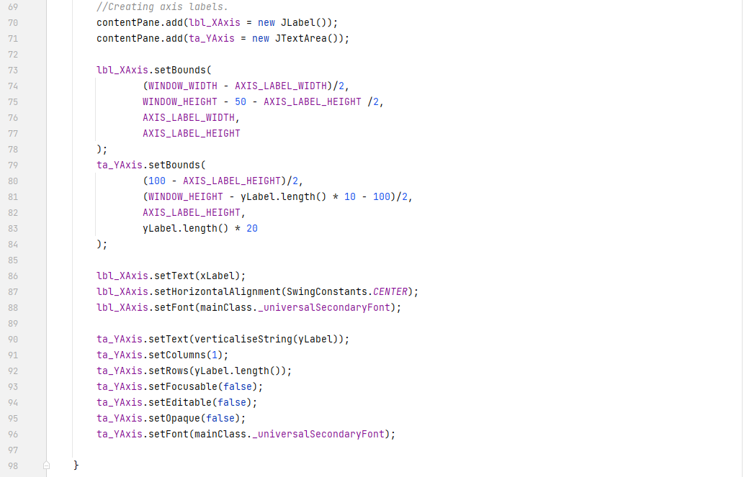

Finally, creating 2 labels to act as axis titles. The x-axis was very easy to implement. Just a horizontal JLabel, centred and below the axis line. The y-axis, however, was much more difficult. As mentioned previously, there is no one easy way to rotate a component by some arbitrary angle. One can override the internal drawing methods of the components, but this approach yields in buggy and incorrectly rendered components (the clipping box cannot be rotated at all). Therefore, an alternative is needed.

I have instead decided to use a JTextArea for the vertical label combined with a method which “verticalizes” text. JTextAreas can write on multiple lines – JLabels cannot. This means that I can get the input string, add newline characters (“\n”) between each letter, and set that as the text area’s text instead. This produces text that is vertical in overall reading direction, but the characters themselves maintain their original orientation.

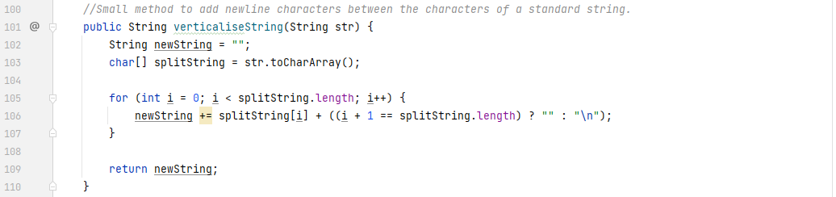

That is exactly what the method above does. It yields a result like:



[Fig. 67] A verticalized string within a JTextArea.

This is a rather “hacky” workaround. However, for now, it will have to do. It functions as intended and is not impossible to read (although may take some getting used to).

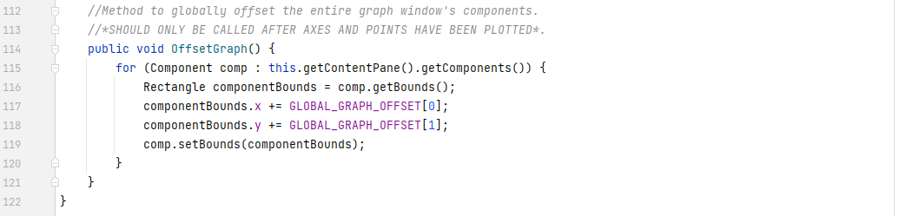

Finally, a method to offset every component in the window by some arbitrary number of pixels. This is here because I may need to reposition everything in the window to fix clipping problems.

Now that the abstract graph class has been written, the ScatterGraph class itself can be written, along with the code for creating one. I will start with the latter.

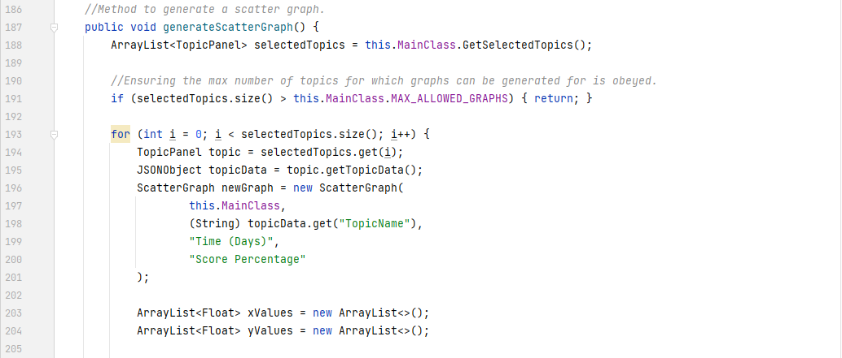

The code above follows what the original pseudocode aimed to do. It gets all the selected topics and checks if the number of topics that are selected is greater than the maximum allowed number. If there are less selected, then it creates a scatter graph for each one, using the topic’s data.

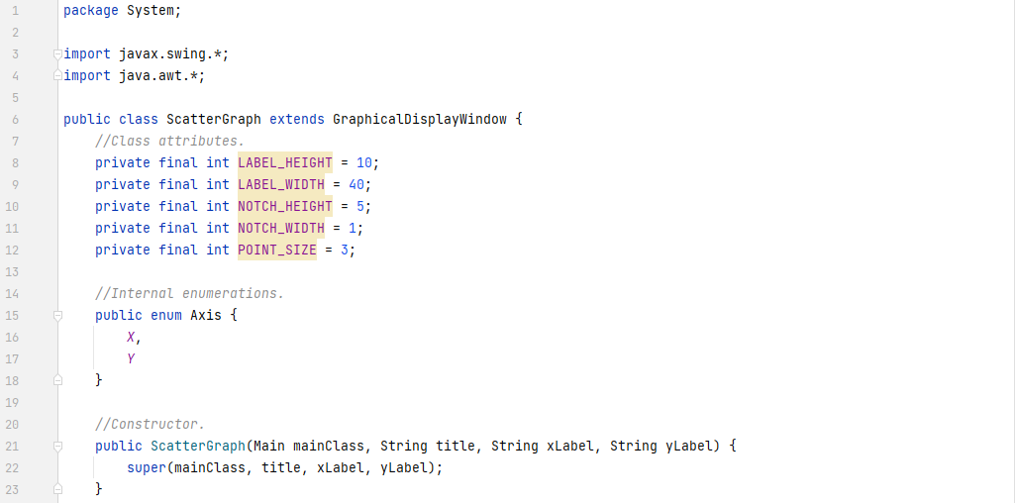

The ScatterGraph class’s constructor simply calls the GraphicalDisplayWindow’s constructor with the given arguments it was passed. It also makes use for the first time of something I forgot existed – *enumerables (Enums)*. These are constant values with a nametag assigned to them and they are extremely useful when a programmer needs to *classify* multiple *unique objects or values*. In this case, instead of remembering “0 means x-axis, 1 means y-axis” or using absolute string values like “X-Axis” or “Y-Axis” (which take up a lot of memory), I simply define the Enum, and the Java compiler assigns numerical values to them at run-time – saving memory and maintaining readability.

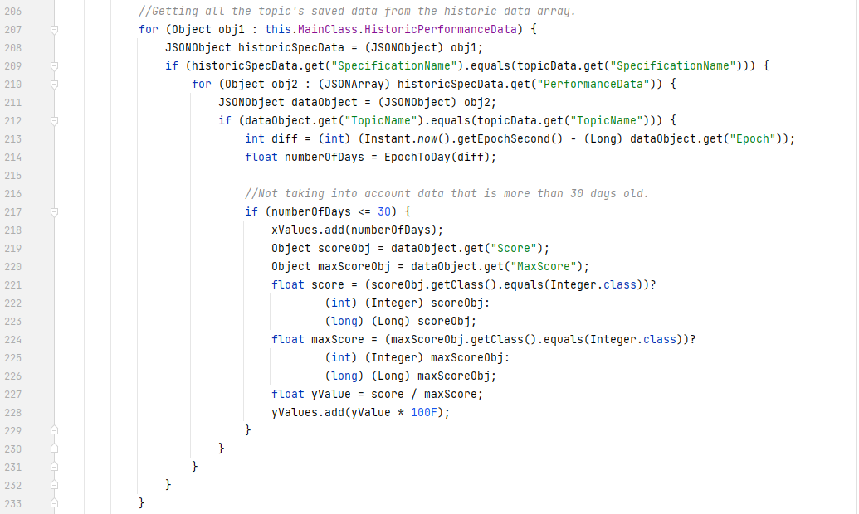

Then, it lists through each of the historic data entries and saves the data that are to do with the currently targeted topic. It then saves the number of days since that data into the list of x values and the percentage of the max score achieved on that occasion into the y values list. It only includes the data from the past 30 days, however.

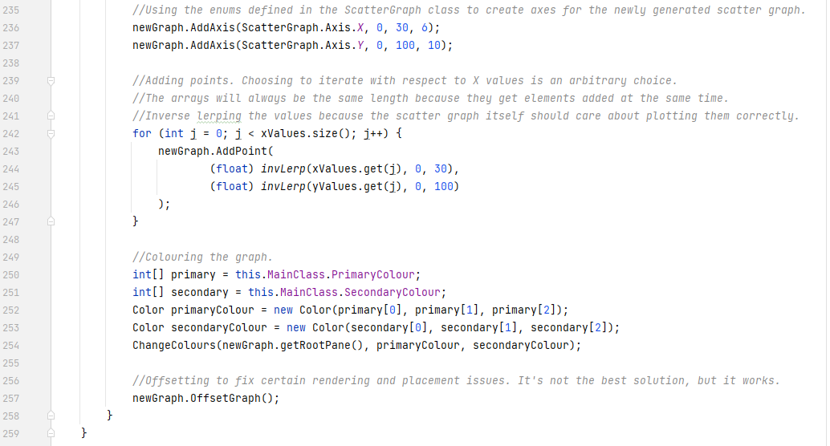

After all the data has been correctly collected and processed, it adds the axes to the graph (using the previously defined enumerable), plots each of the points and colours the window. It also offsets the entire graph to fix some of those previously mentioned rendering errors.

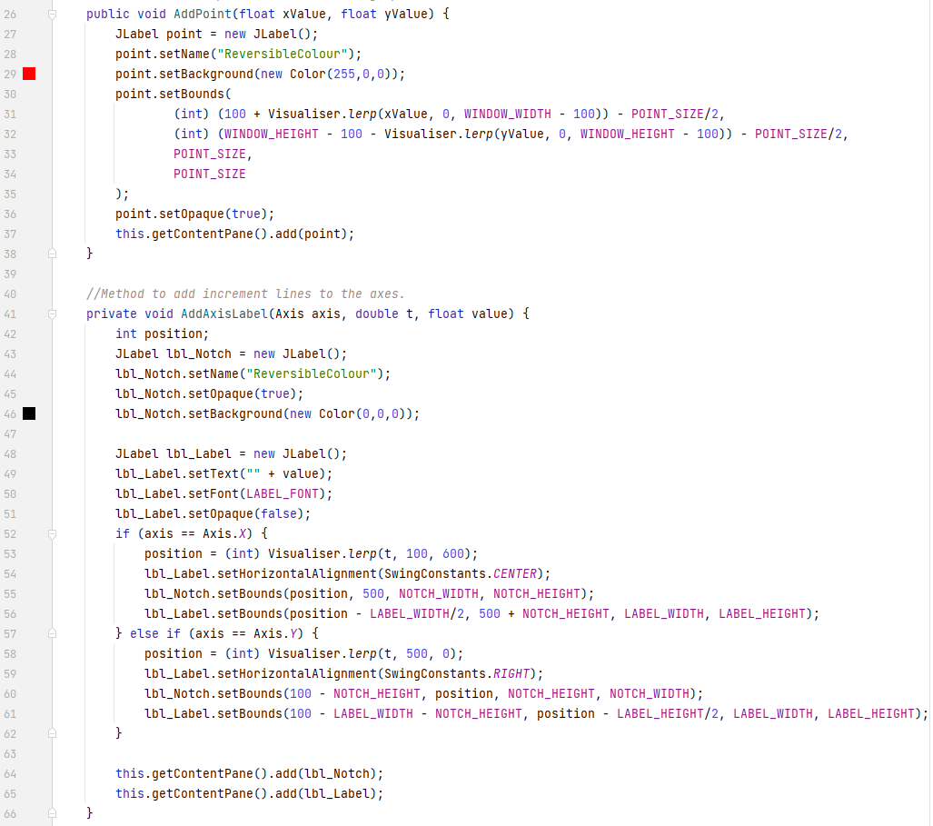

The 2 methods seen previously are above. The foremost uses the same JLabel technique from earlier to add small points to the graph that are only a few pixels in size. The latter uses the same technique once again, but this time, simply creates the small notch and adds a label to it on the axis.

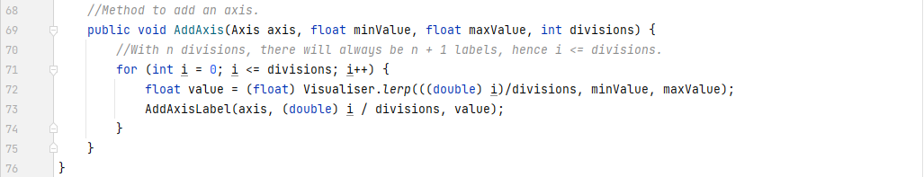

The method which calls the axis labeller is above. The reason for the different loop terminating condition is justified in the comment.

All 3 methods make use of a technique called *linear interpolation* for converting the x and y values to absolute pixel positions. These methods are extremely commonplace in shader programming and graphics rendering software across the software industry. The first, *lerp*, takes in some value between 0 and 1 (inclusive) and returns a value between the supplied minimum and maximum. This is useful if a programmer knows “I want to get 20% of the way from this to that”. They can simply multiply the difference between the minimum and maximum by 0.2 and add the minimum. The second method, *invLerp* does the opposite of this functionality. It takes a value between some minimum and maximum and returns the corresponding *alpha* value for that range. Combined, these form the *remap* function. This function, as implied by the name, remaps a value from 1 range to another. For the purposes of this application, this function is necessary for converting the x and y values to pixel values on the screen. This is because an x value of 30 does not correspond to 30 pixels on the screen – it needs to be 500 pixels. It is essentially converting from 1 range to another. The remap function itself is not used explicitly, but the conceptual functionality is.

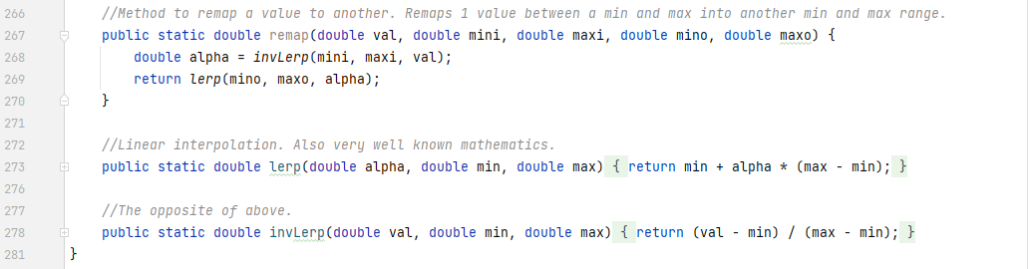

It is necessary to note, that these are not “clamped interpolation”. This means that inputting an alpha value of 1.2 is perfectly acceptable. If a value is outside its designated range, this will be reflected when it gets remapped. I have not clamped these because of the potential need for using values outside their intended ranges later in the project.

The converter method from epoch seconds to days is the exact same as the pseudocode.



All the code above, combines to produce an output which looks like this:

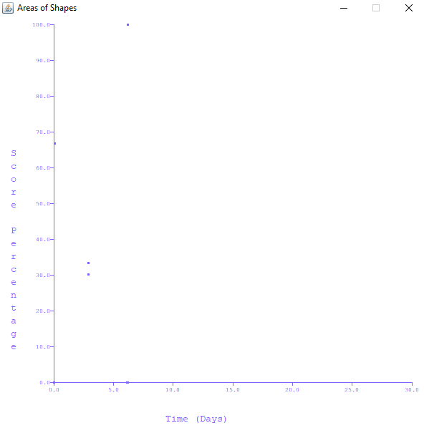

[Fig. 68] The final result of the graph generation code. Evidence for test #3-#5.

The small dots represent the scores in percent out of 100 that the user achieved, and the x-axis shows the number of days it has been since they achieved that score. The colouring – like previously shown – is dependent from the user’s selected secondary colour. This graph could improve by having custom cross icons for the points on the graph and lines being drawn between each point. It could also benefit from a calculated number showing the direction that the user is going in (gradient of the graph). These are not necessary for this iteration however and will be included if the client wishes for them to be included – since these are not strictly necessary for the prototypical version of the working solution.

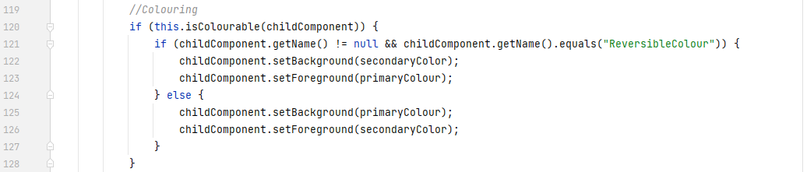

The colouring code from the Visualiser class got changed to allow the “ReversibleColour” name exception to be handled (as noted previously).

#### Prototypes

This phase checks 3 and a half success criteria in the list and is therefore the 2nd prototype of the working solution. There are now ways to customise the user interface and for the user to get statistical feedback on their performance in 2 different ways – a visual graph and a list of top 5 topics to improve upon. After testing and evaluation of this iteration, an image showcasing this version along with a list of additions and changes will be sent to the client. Feedback will be acted upon if given.

### Testing, Problem Rectification and Client Feedback

#### Evidence of Testing and Test Results

|  |  |  |  |  |  |  |
| --- | --- | --- | --- | --- | --- | --- |
| Test # | Success Criteria # | Test Reason | Input | Desired Output | Actual Output | Success T / F |
| 1 | 9 | To ensure the list of suggested topics is accurate to specification file. | Solution started / Questions finished | List of 5 topics in descending order of bias. | List of 5 topics correctly displays with correct bias ordering. | T |
| 2 | 10 | To ensure the colours get correctly applied to only the designated component classes. | Primary colour box changed / secondary colour box changed. | Colours of backgrounds, foregrounds and borders changing correctly on only the desired components. | Colours changing on the desired components. | T |
| 3 | 8 | To ensure visual generation of scatter graph is correct. | Generate Graph button activated. | Separate window with a fixed size, generated with correct title and axis labels. | Title, axes, window, and sizes are all correct. | T |
| 4 | 8 | To ensure the data on the graph is correctly plotted. | Generate Graph button activated. | Points on the graph appear in correct places as according to the data. | Points on graph are correctly interpolated. | T |
| 5 | 8 | To ensure only the last 30 days are displayed. | Generate Graph button activated. | Data that is 31 days or older is not shown. | Data that is more than 30 days old is not shown. | T |

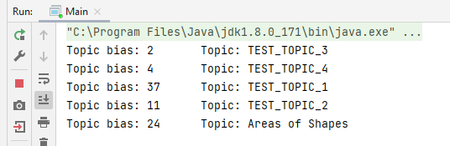

[Fig. 69] Evidence for test #1.

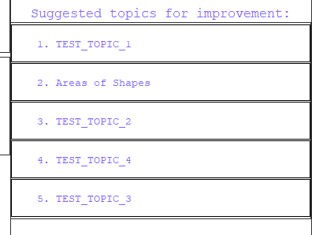

[Fig. 70] Evidence for test #1.

The topics get displayed in the correct order, due to the biases in figure 69. The ordering should be TEST_TOPIC_1, Areas of Shapes, TEST_TOPIC_2, TEST_TOPIC_4, TEST_TOPIC_3 – which it is.

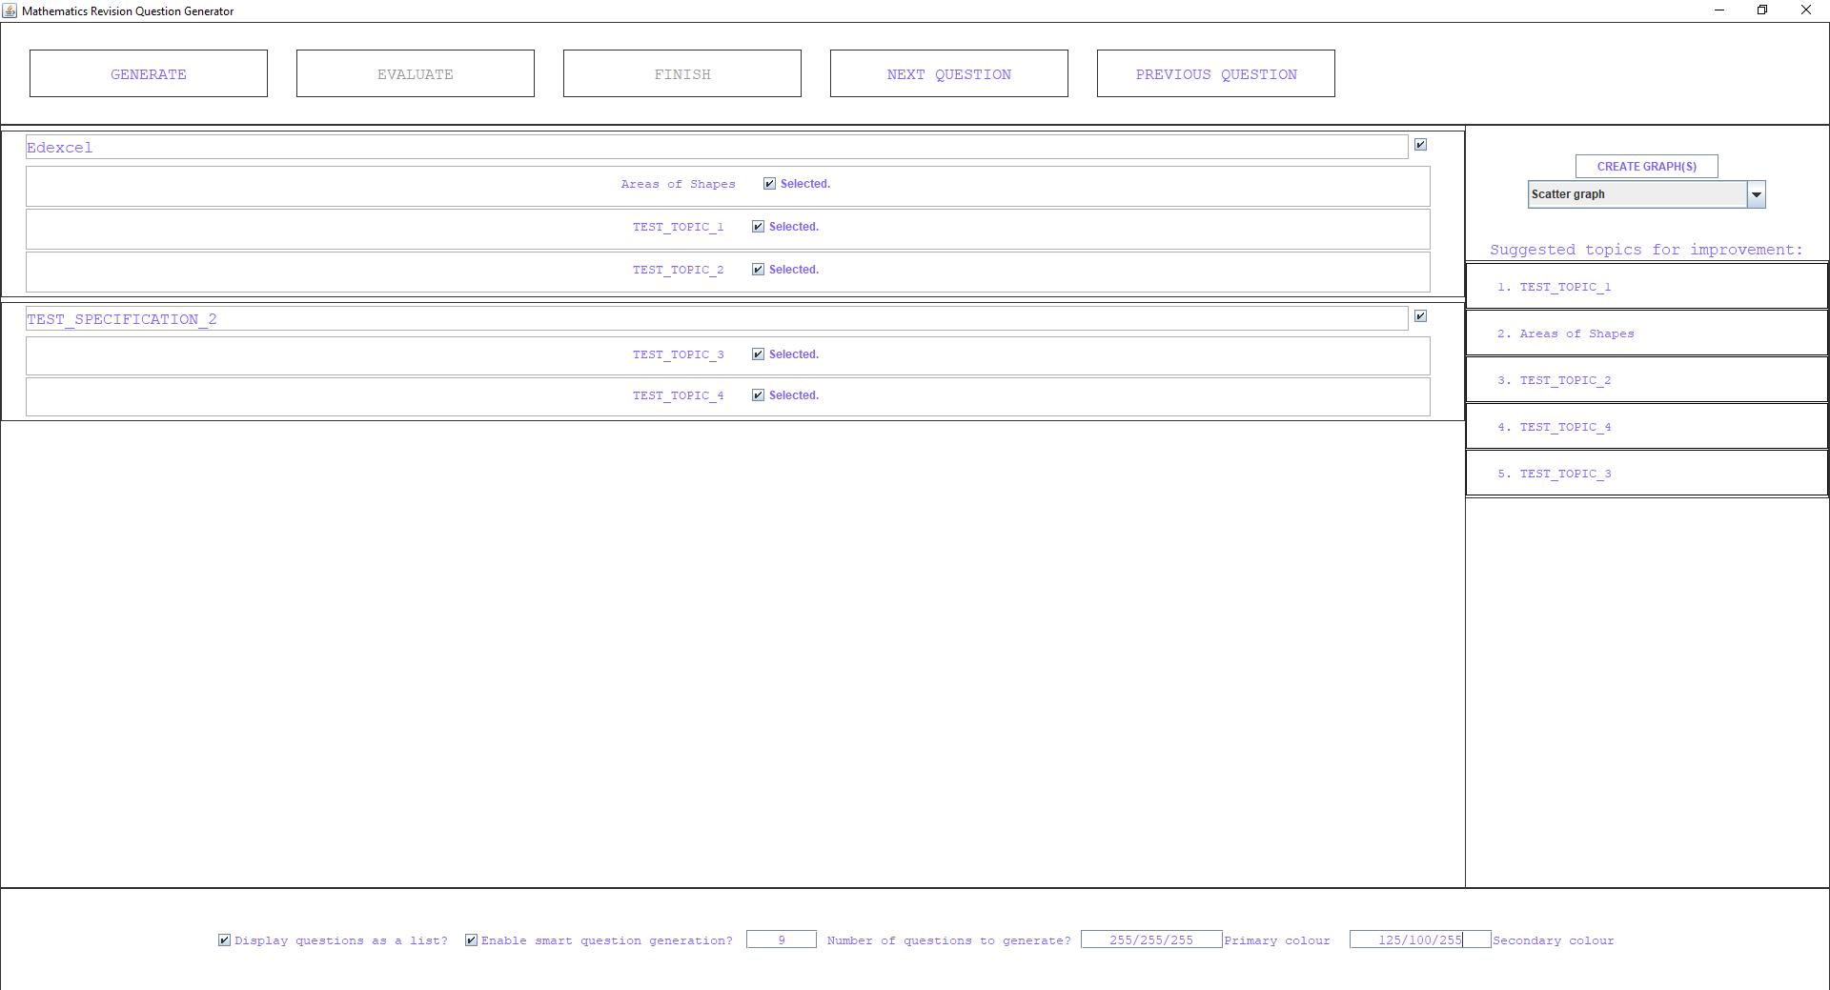

[Fig. 71] Evidence for test #2.

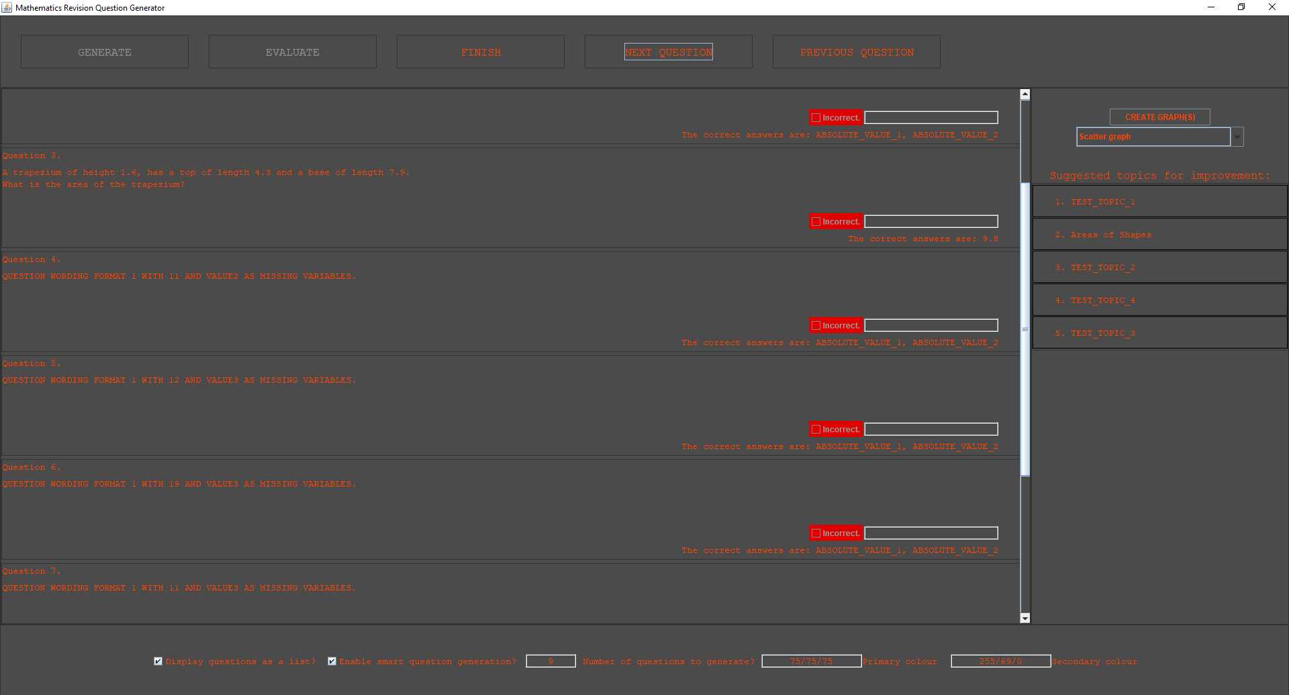

[Fig. 72] Evidence for test #2.

It is clear from figures 71-72 that the colours change only on the correct components (the red correctness indicators are still red, but text and backgrounds are orange/grey respectively). The colours of borders remain the same. The foreground colour of the scrollbar cannot be changed (at least, it is excessively difficult to do so), hence it is white. The same can be said for the checkboxes.

Evidence for tests #3 through #5 is in figure 68 (page 136) and will not be repeated here for the sake of organisation. However, test #5 needs to prove that it does not display data that is more than 30 days old. Hence, figure 73 shows some fabricated data that is more than 30 days old from the epoch timestamp of the time of writing (1639126183).

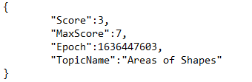

[Fig. 73] Evidence for test #5.

This data does not appear on the graph in figure 68, and therefore test #5 is successful.

#### Problems and Remedies

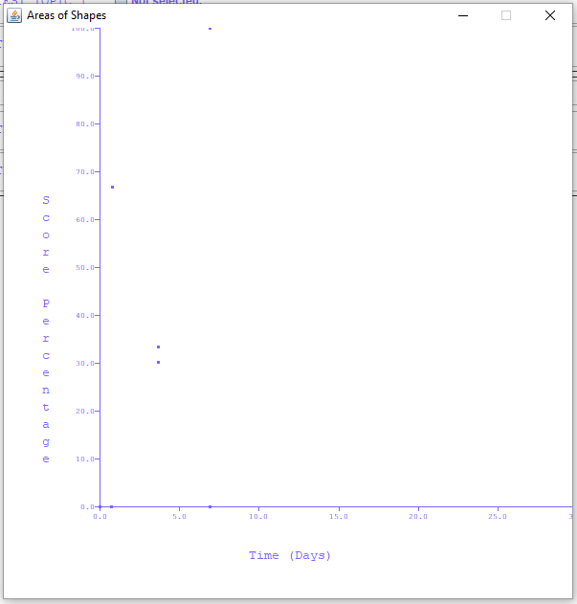

[Fig. 74] Clipping issues when generating graphs.

Due to the way I implemented the graph generation code and the placement of Swing components, there were clipping issues near the edges of the graph. The 100 at the top edge and the 30 at the right edge cannot be seen – and to someone who doesn’t know what those numbers are, what they should be is unclear. That is the complete reason as to why the graph offset method exists in the GraphicalDisplayWindow class. It moves every component by some translation vector – in this case, -25px horizontally (left) and 10px vertically (down). The result is what can be seen in figure 68.

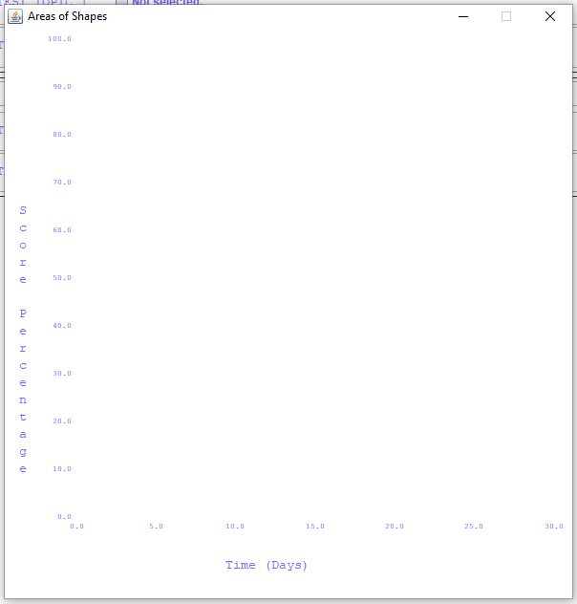

[Fig. 75] Colour problems on the scatter graph.

Another problem was colouring the graph components after they’ve been created and placed. Because of the class whitelist in the isColourable() method, JLabels get their backgrounds set to the primary colour and the foregrounds set to the secondary colour. This is a problem for this specific use case because the graph’s axes, axis markers and points are all JLabels with their background colours distinguishing them from the rest – since foreground colour only applies to the text *within* a JLabel. To fix this, an exception had to be made in the colouring method for Swing components that have the name “ReversibleColour”. Named objects have their colouring reversed – where the background is the secondary colour, and the foreground is the primary instead. If this bug were not fixed, any scatter graphs generated would look like the graph in figure 75 (above). The specific fix code is on page 137 of the implementation section of this iteration. 30 minutes was lost to finding the cause of this bug.

The rest of this iteration was free of noteworthy problems so no more will be discussed here. The rest of the problems were small errors caused due to incorrect syntax or logic and did not cause a hurdle.

### Evaluation of Development Iteration

This iteration (like all previous iterations so far) was 100% successful. Every test succeeded and every initially planned feature was implemented with no major changes needing to be made. Each of those features is likely to be mostly bug free – but this will of course be tested fully in the evaluation phase when beta testers (stakeholders) get to try out the solution. The end of this iteration also marks the completion of yet another prototype of the working solution – since it now can display visual feedback on the user’s performance and suggest improvements.

A noteworthy change is the non-inheritance of the CustomInterfaceObject class from the GraphicalDisplayWindow class – but as previously mentioned, this has no meaningful impact. The format of the time data inside the performance data file was also changed. The previous 3 fields containing the day, month and year were removed, and replaced with a single field containing the time after Unix epoch (00:00 on the 1st of January 1970) in seconds. This change caused all the previously stored performance data to be invalid (and deleted as a result), but that was no issue since the data was generated from development and testing, rather than real user use. This change is also for the better since the time after epoch is much more accurate (accurate to the second, rather than the day) than the previous storage method. It also saves memory.

These changes have no meaningful impact on future iterations. Everything can proceed as planned in the next iteration.

## Iteration #6

This is where I will complete the final success criteria of the project. It will mostly involve UI work and no significantly complex algorithms. The final success criteria to complete are #5, #6, #12 and #13. #6 is partially complete already.

### Design and Outline

As noted in the section above, this iteration will be completely about adding extra UI to the question panels. That means the only code that will be written, is UI logic and UI instantiation. Neither of those require significant use of complex algorithms (although small if statements, for-each loops, and event handlers will be used) and therefore pseudocode will not be written for this iteration.

However, the idea for the UI changes is as follows:

1. Success criterion #5.
   1. A model answer for every unique topic present in the list of questions will be displayed in the same list.
   2. This will be controlled via a setting “Display Model Answers”.
   3. A subclass of CustomInterfaceObject will be written for this purpose, named “ModelAnswer”.
   4. It will make use of a similar UI structure as the current ListedQuestionBox does, but with variation in a few components.
2. Success criterion #6.
   1. The current question panel will *extend* downwards for each question when the Evaluate button is toggled.
   2. This extension will show a small list of correct workings with the number of marks each working is worth, on the trailing edge of the working.
   3. A JPanel using GridLayout with smaller JPanels within – each with their own JTextArea and JLabel for displaying the information. Display structure configured using GroupLayout.
   4. Due to the extension, the GridLayout and JScrollPane may need to be reconfigured when the Evaluate button is toggled.
3. Success criterion #12.
   1. The list of topics has a button to display a list of links to external reading – either in the form of a *Uniform Resource Locator (URL)* link or some other form of text that indicates to the user on how to find extra resources.
   2. This will be present in its own JFrame with GridLayout in a similar way as the correct workings will be.
4. Success criterion #13.
   1. This will involve manually inputting several topics from a few common specifications.
   2. This will also involve removing all the pre-existing topics and their related data.
   3. This will not be a set objective to complete in *this iteration specifically*. It will be an on-going process which will finish in the Evaluation phase but start here.

The test table for this iteration is presented below:

|  |  |  |  |  |  |  |
| --- | --- | --- | --- | --- | --- | --- |
| Test # | Success Criteria # | Test Reason | Input | Desired Output | Actual Output | Success T / F |
| 1 | 5 | To ensure that a single model answer is shown for each unique topic. | Generate button clicked. | A varying number of model answer panels appear *before* the rest of the questions. If there are 50 questions, and 6 unique topics, then the list will be 56 panels long. |  |  |
| 2 | 5 | To ensure the model answer displays the right information. | Generate button clicked. | The model answer should show the question wording, then the workings and then the answer. |  |  |
| 3 | 5 | To ensure model answers display only when needed. | Generate button clicked. | Model answer appears when setting for “Display Model Answer” is true, and vice versa. |  |  |
| 4 | 6 | To ensure panel extension is dynamically handled. | Evaluate button clicked. | Every question panel dynamically changes in size as the new panel(s) get(s) added – without affecting the display of everything else. |  |  |
| 5 | 6 | To ensure scrolling still works after correct workings are shown. | Evaluate button clicked. | Scrolling to the end of the list of questions is still possible without some questions going missing due to clipping issues. |  |  |
| 6 | 6 | Workings are question specific. | Evaluate button clicked. | Workings contain numbers generated in the question. |  |  |
| 7 | 12 | To ensure external reading is presented in a list format *upon a button press on the associated topic*. | Solution started. | External reading list is present, in the correct order, in a separate window. |  |  |
| 8 | 12 | To ensure the external reading window is separate and does not close the rest of the application. | Button on respective topic listing pressed. | Window appears and disappears upon closing. |  |  |
| 9 | 12 | External reading links are clickable. | Button on respective topic listing pressed. | Clicking URL link in the list opens a new tab in the user’s default browser. |  |  |

### Programming and Implementation

#### Code and Justification

The first thing to do, was to create the actual checkbox itself that toggles between showing and not showing the model answers.

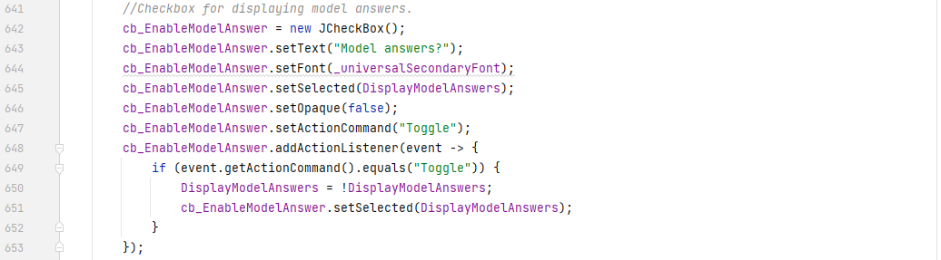

The code above is almost a carbon copy of the other settings checkboxes, but that is all that’s needed. The Userdata.json file also had to be updated with the new setting, and therefore the data handler did too, to accommodate this change.

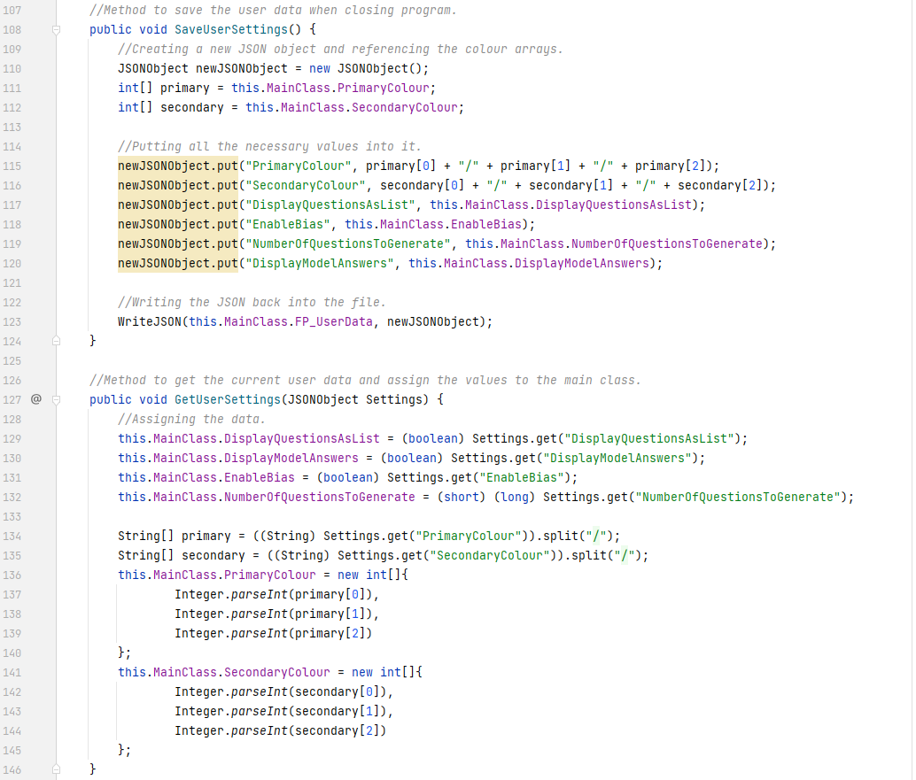

Line 120 and line 130 are the new additions to that method.

The new button fits between the 2 previous buttons, and therefore makes the settings panel now look like this:

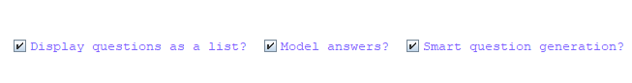

[Fig. 76] The model answer button has been added to the settings panel.

I have changed the wording on some of the other buttons to also be a bit shorter, since the settings panel is nearly running out of horizontal screen space, and in-case future buttons need to be added, space should not be wasted on weightless words.

Now that the button is in place, the user interface can be designed and placed into the list of questions.

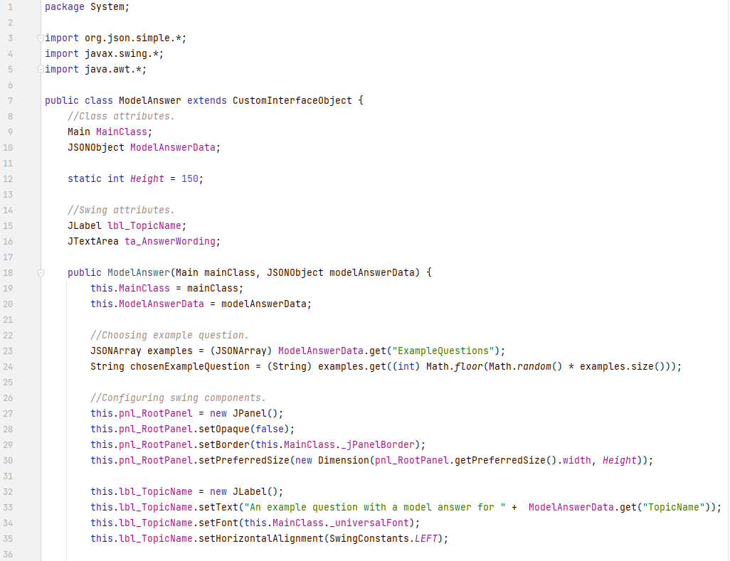

The ModelAnswer class is shown above. As aforementioned, the code will be like the question box, but this time with less components. The code above simply declares the class, declares its attributes, and declares the constructor.

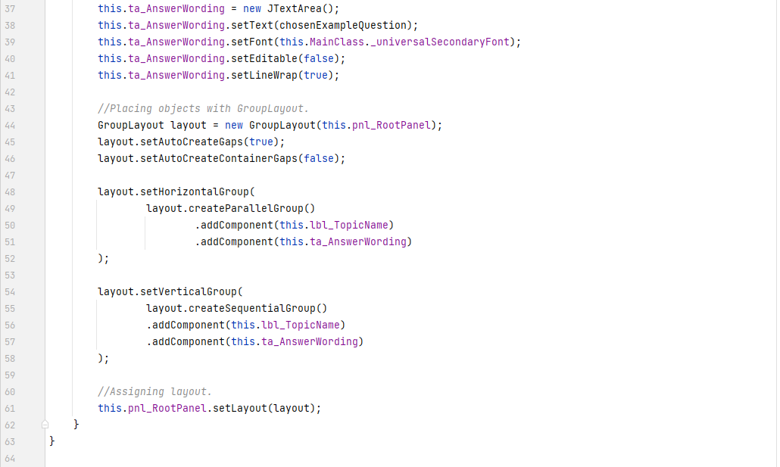

The layout configuration is done with GroupLayout once again and assigned to the root panel.

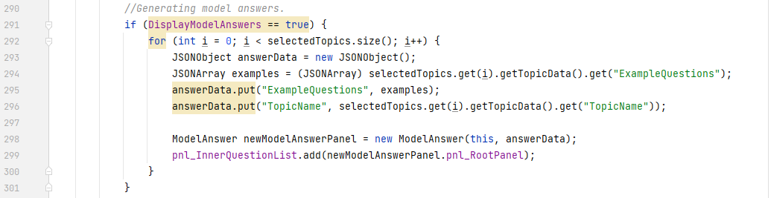

In the main class’s HandleGenerateButtonToggle() method, the above code gets all the topic data and for each of the selected topics (since each selected topic is a unique topic in its own right), creates a new ModelAnswer instance, and adds it to the question list panel to be displayed in the viewport.

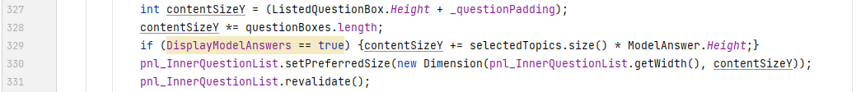

Line 329 has also been added to account for the new y-axis size of the viewport – to count all the model answer panels as well.

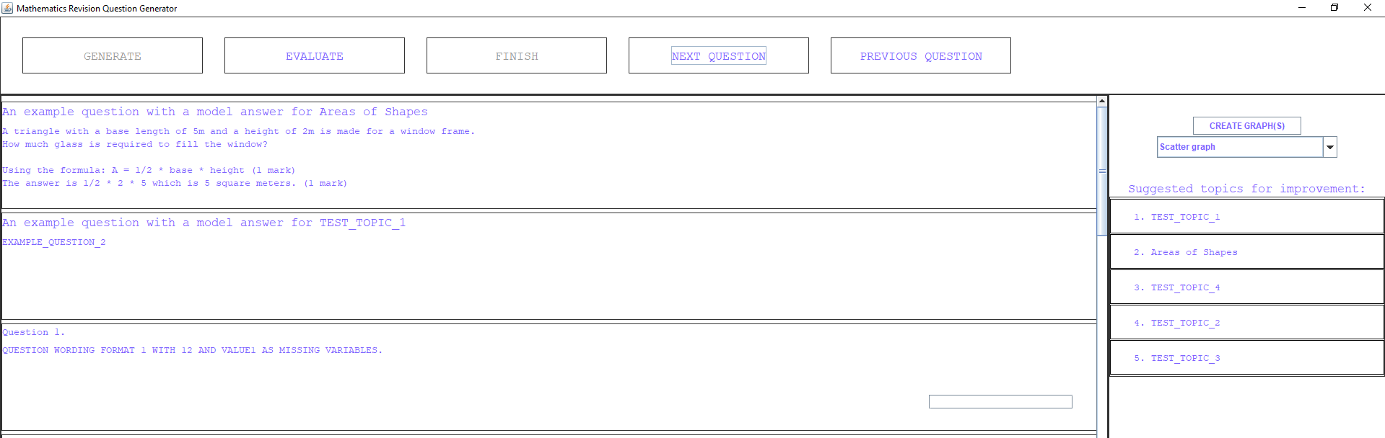

[Fig. 77] Model answers being displayed before questions. Evidence for test #1.

Combining all the code together, the model answers now appear as above. There were only 2 topics in the selection, and therefore only 2 model answers appeared. It is also clear from the image that a random model answer from each topic’s list is being selected every time. This is because, if the system administrator wishes to only have 1 model answer per topic, they can do so. However, if they wish for more than 1, then the class constructor will choose a random one. This is for variation in the model answers.

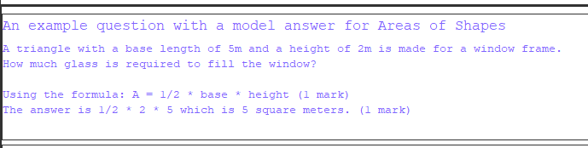

[Fig. 78] A closer demonstration of one of the model answer panels. Evidence for test #2

The question, workings and marks are all built into the same value in the .json file. Therefore, if the system administrator wishes to change the wording and the lines of working, they must manually edit them from the file. This may be an inconvenience, but due to the likely low probability of changing these example questions and their wording after they’ve been set once, this is something not worth changing.

With success criteria #5 done, success criteria #6 can be implemented. This means drastically changing the ListedQuestionBox’s aesthetic structure.

Firstly, it was necessary to slightly amend the QuestionBox class to include the extra panel.

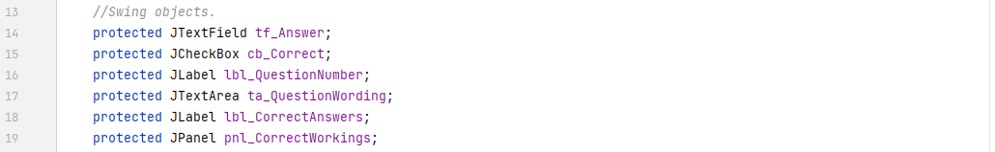



Since all question boxes will have this, the visibility can be set from this class.

The ListedQuestionBox class can now use this new Swing object and define its properties. The height of the entire question panel is the vertical size because I would like the question boxes to double in height every time that they get extended.



Since it will contain a list of panels, GridLayout with number of rows set to 0 (the equivalent of “any” or “infinite”) and number of columns set to 1 will behave just like a list should. The GroupLayout that manages the layout of the entire question box also needed to know about the new panel so that was added in too.

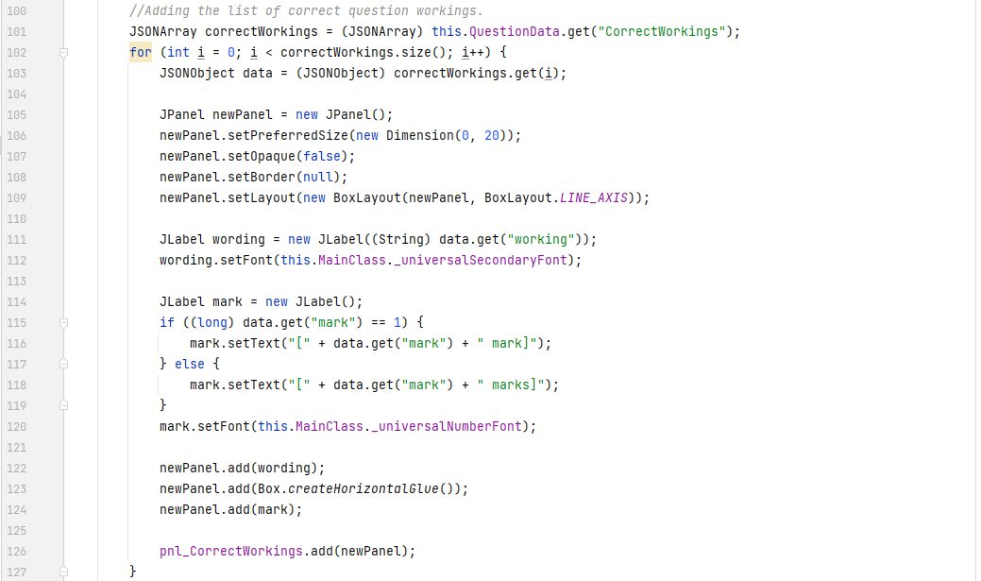

The code above is new. This code is relatively simple. It lists through each of the JSONObjects in the JSONArray and creates a new panel for each one. Into each of those panels, it places a JLabel with the workings in it, and a JLabel with the number of marks it is worth as well – separated by a HorizontalGlue. BoxLayout allowed defining the layout structure to be simple for this case. The rest of the code simply adds wording themselves into it along with deciding between “mark” being singular or plural based on the number of marks each working is worth. I did not specify any sizing for the panel and components because the GridLayout object and BoxLayout override any component sizing constraints regardless of if they’ve been defined.

The wording of the workings themselves needed to be processed prior to being written to the component. Test #6 declares that all workings should be question-specific, and that means they must use values from the given question rather than arbitrary algebra. This is because it will help the user better understand where numbers go in the formulas if they can see it – among other reasons.

For this, a stand-alone parser had to be written for processing the wording of the markings. This has replaced the previous for loop within the RandomGenerate() method of the QuestionHandler and therefore also processes the question wording.

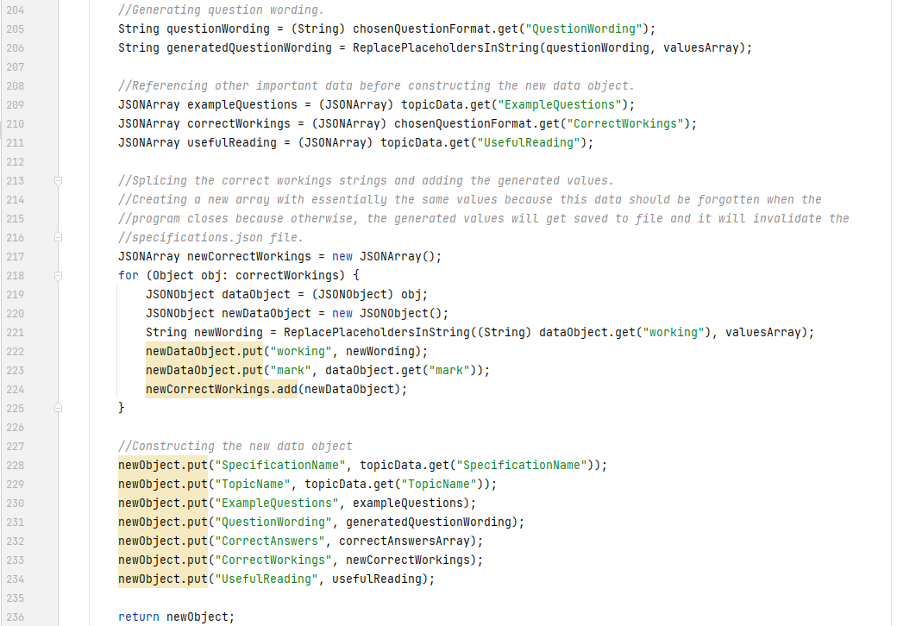

The code here has been updated. The for-loop is no longer here. It has been replaced by the new method ReplacePlaceholdersInString(). The comment in the image also justifies the creation of a *new* JSONArray to effectively store the same data. Due to the way that the data saving is done in this solution, and since arrays and objects are passed by reference in Java, the generated data would carry across to the Specifications.json file and that is not a good thing!

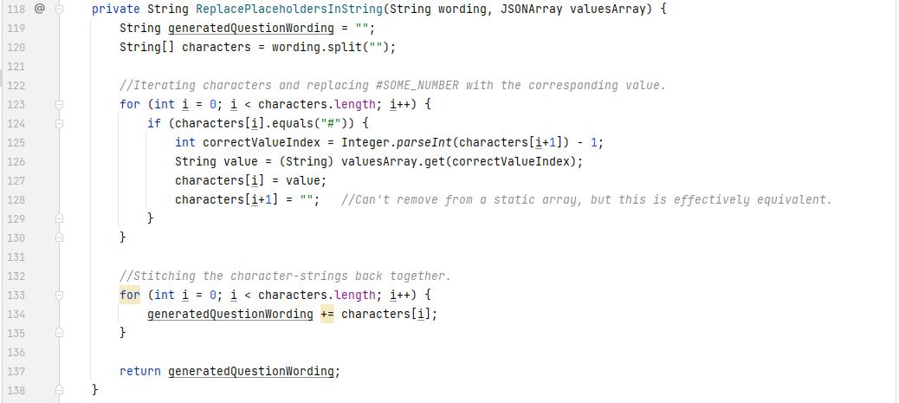

The method above is like the one before, but it has been greatly generalised and improved. Before, it split everything into words. Now, it splits into characters and replaces necessary ones with the values. This now allows both suffixes *and prefixes* of words to remain attached to the values if they need to. It is also a much more readable algorithm and more performant (taking substrings and looping inside other loops very quickly increases the time complexity of an algorithm).

For the panel extension to be done in the first place, the main class had to also be amended. There is now a new method.

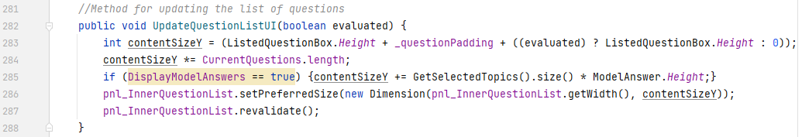

This method removed a heap of redundant code from other methods and is generalised. It can be used to set the sizing of the JScrollPane both *before and after* the evaluation (and panel extension) has been done. This updates the scroll bar and the viewport to fit the newly resized components.

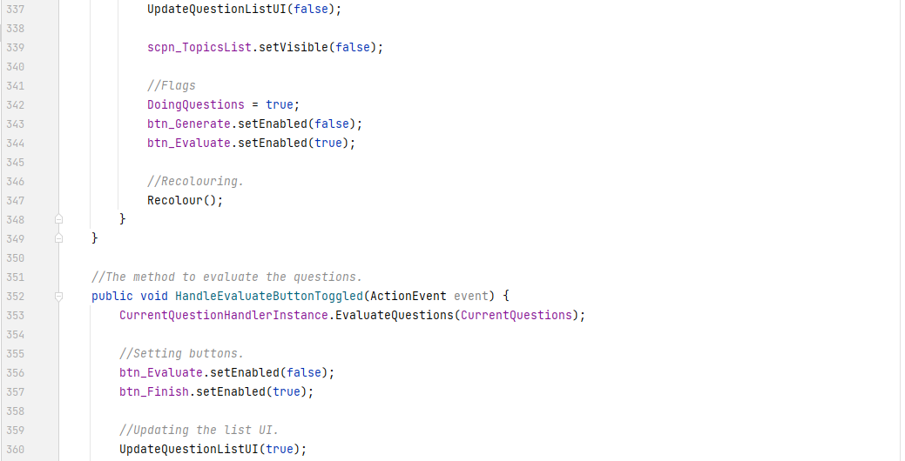

It is now called with evaluated as *false* in the generation method and *true* in the evaluation method. This means test #4 and test #5 should now be satisfied.

Combining all the new code above together, produces the following results, going from:

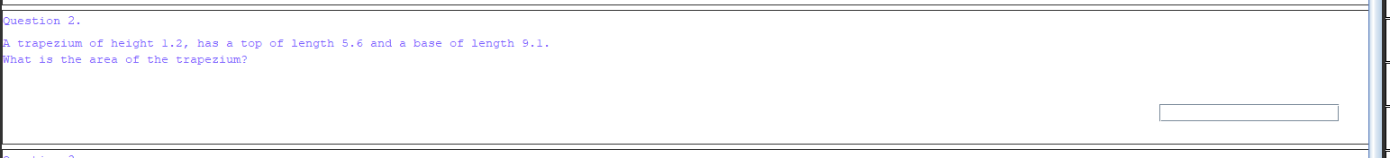

To this:

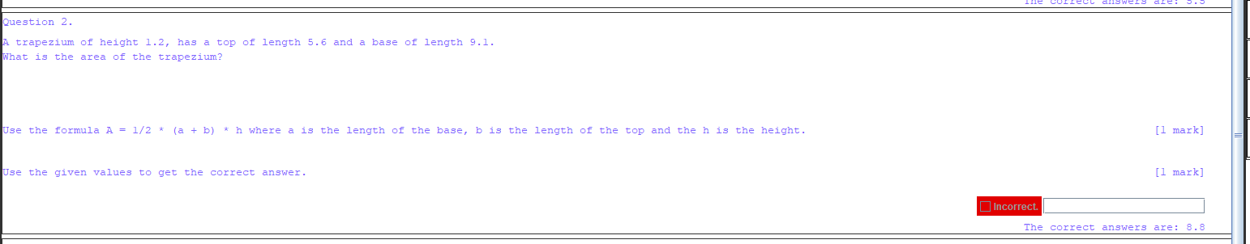

The wording and marks get displayed above the answer box and above the list of correct answers. This is a logical structure as that’s how it would be like in an exam.

Question 5 is an example of the previous parsing algorithm being at work. It is using the same values as the question wording uses, which makes the workings out easier to understand and read.

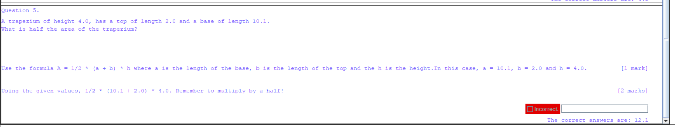

[Fig. 79] Showing the extended panels with correct workings out. Evidence for tests #4-6.

A zoomed in section of the 2nd line is below.

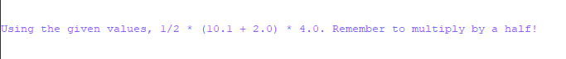

[Fig. 80] Higher quality image showing the wording with the correct values. Evidence for test #6.

The number of marks is also displayed on the right side, on the same line as the working. It also adapts its spelling based on the number – as previously specified.

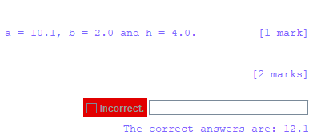

[Fig. 81] Showing the number of marks being present as well. Evidence for test #6.

Lastly, the extra reading list functionality should be implemented. Before doing anything else, it is imperative that some way of accessing the list is implemented before the list itself. For that, additions to the TopicPanel class have been made. A new button has been added, along with layout changes.

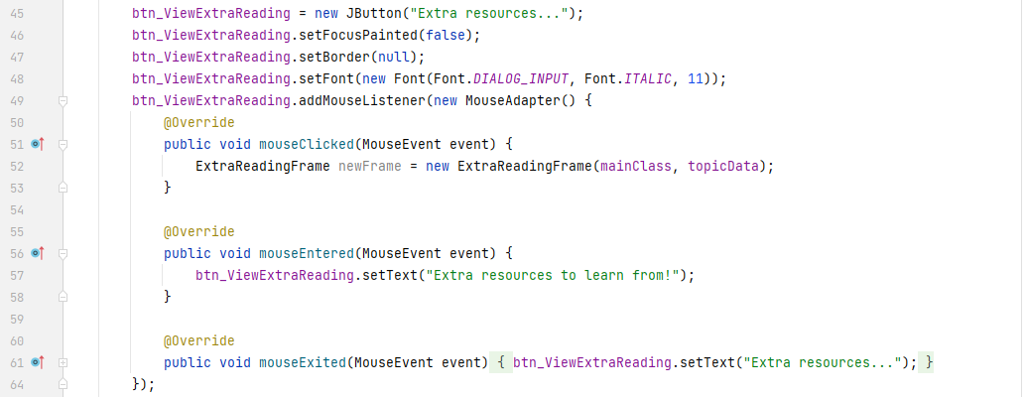

This button is one-of-a-kind for this project, because it overrides the default mouse listener methods with custom behaviour. In this case, that custom behaviour is a change in the button’s text when the user hovers over or exits the button’s bounding box. This is done because seeing components change and move on the screen as the user simply moves their mouse adds to the user experience when utilising the product. The main reason for adding the custom functionality, however, was because I needed the button to create a new window that displays the extra reading suggestions. Rather than using the same approach of adding an action listener, as I have done to all the previous buttons, I decided to try something new. Had I used an action event, the entering and exiting events could not be listened for and therefore the extra UX (User Experience) functionality could not have been implemented.

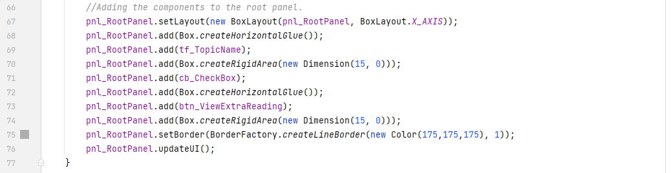

The layout improvements mentioned look like this. Previously (since this class was one of the first that I had written), the root panel didn’t have a layout manager set, yet it still somehow worked. Regardless, it now has a BoxLayout which I am using to place the topic title label and checkbox in the middle of the listing, but the new button is pushed to the right. The result is this:



[Fig. 82] The new button added to each topic listing.



[Fig. 83] Upon hovering over the button, the text changes and the components move to the left to accommodate this.



[Fig. 84] A better quality image of the button before hovering.



[Fig. 85] A better quality image of the button after hovering.

These buttons, like mentioned, are added to each topic listing automatically since they are a part of the TopicPanel class. Even if they all run the same code, the code passes the topic’s unique data to the new frame instance, and therefore is still able to create unique JFrames.

Mentioning the new frame, the code for the frame is shown below:

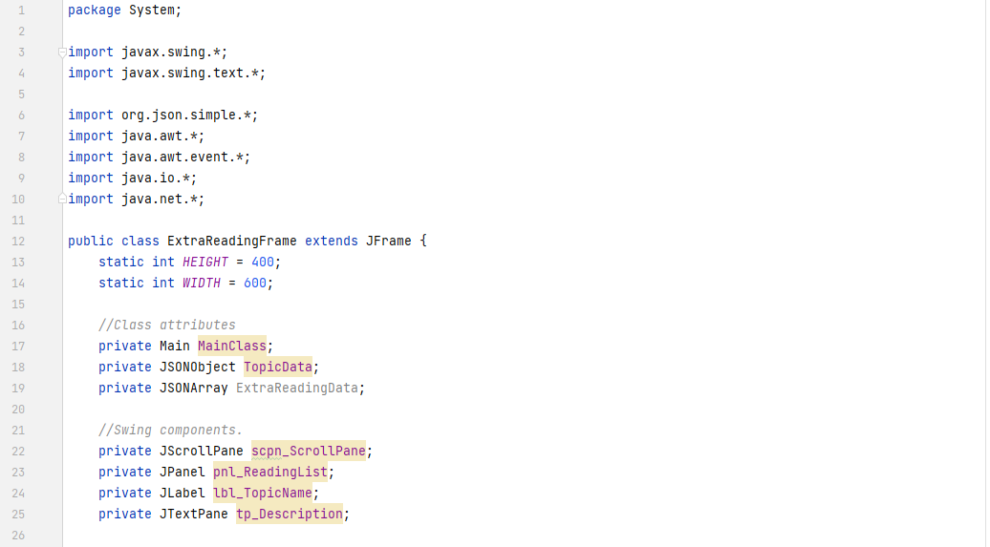

The ExtraReadingFrame class is another class which does *not* inherit from the CustomInterfaceObject, and instead inherits from the JFrame class. For justification, refer to page 128 of this document.

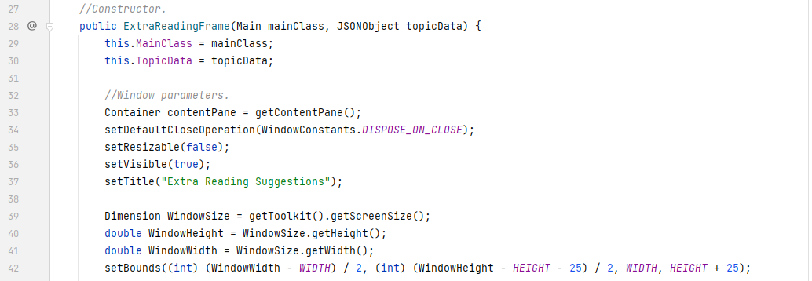

Like all previous JFrame constructor classes, this one follows the same standard – non-resizable, absolute size in pixels and centred to the screen.

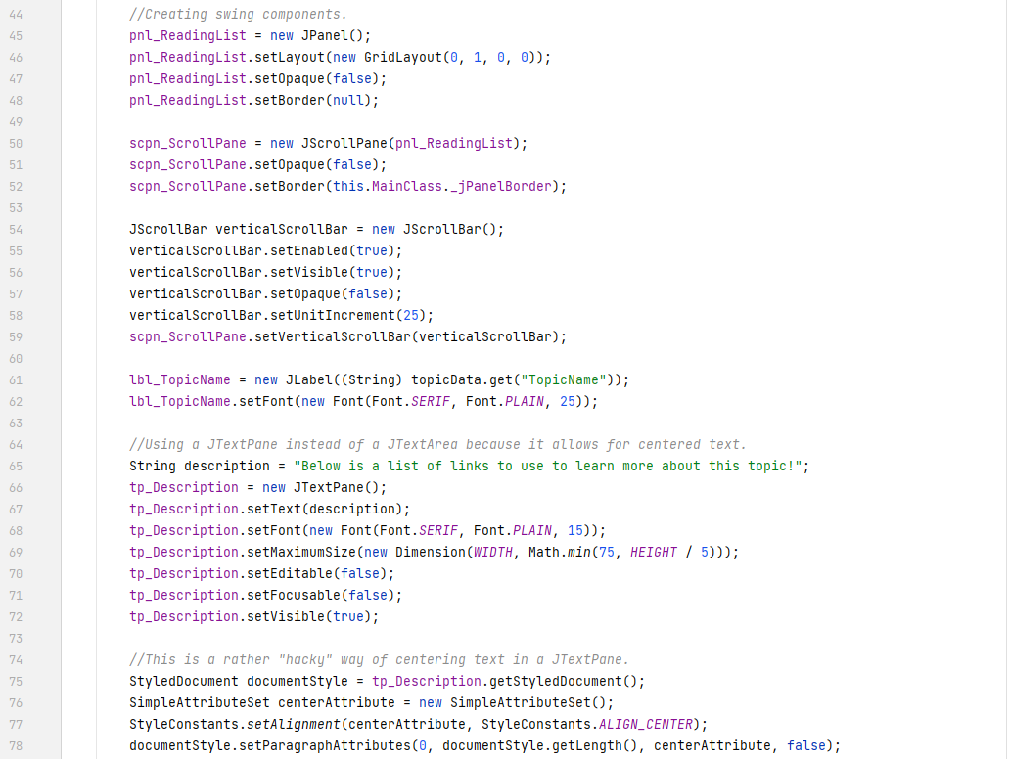

The Swing component declaration code is also rather simple. Create the panel, the scroll pane around it, the label for the topic name and the text pane for the description of the window. The latter, however, is different. To improve the user experience, I, along with my client, agreed that it would be best to add a small description to the window to explain what it’s for. I originally attempted to implement this with a JTextArea, but after realising that aesthetically, the window looks nicer (and the client agreed) if all text was central to the screen, rather than pushed to the left. The JTextArea component does not have the ability to centre its text, so a JTextPane had to be used instead since the text in that *can* be centred. The solution is by using an attribute set with the alignment property set to centre.

As has become my preference, I am using GroupLayout to manage the structure of how the window looks. Lines 88-92 are a solution for centring components horizontally.

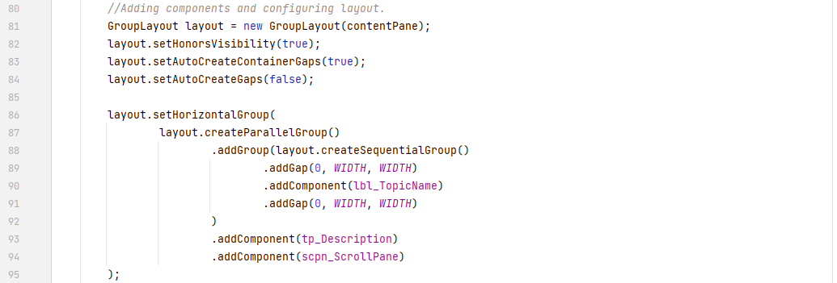

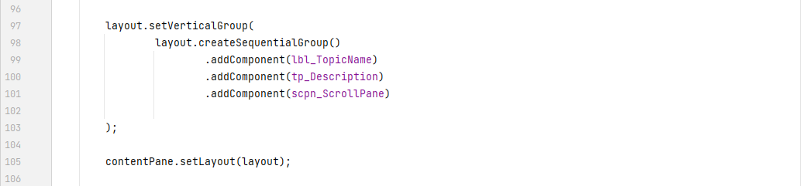

Since the main window itself is done, now is a suitable time to add each of the links of suggested reading to the window – arguably, the main feature.

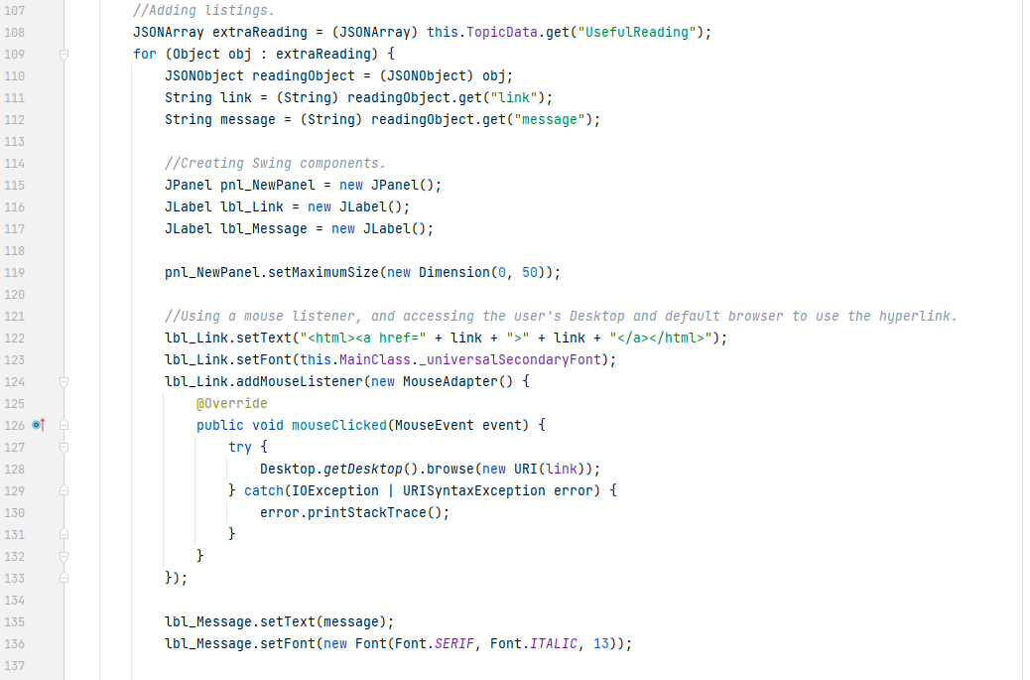

The code above iterates through each of the JSONObjects in the JSONArray called “UsefulReading”. It creates a new JPanel, and as previously specified in the design section, also creates 2 labels to show the information within the panel. I discovered that JLabels have built-in HTML parsing for their Text property. This means that I can place the link inside HTML code, and it will be rendered as HTML would render it. I am also using another override method on the mouse listener. This time, it tries to access the user’s Desktop and go to the link specified through their default browser. If this fails, it prints the stack trace (but the user will never see that).

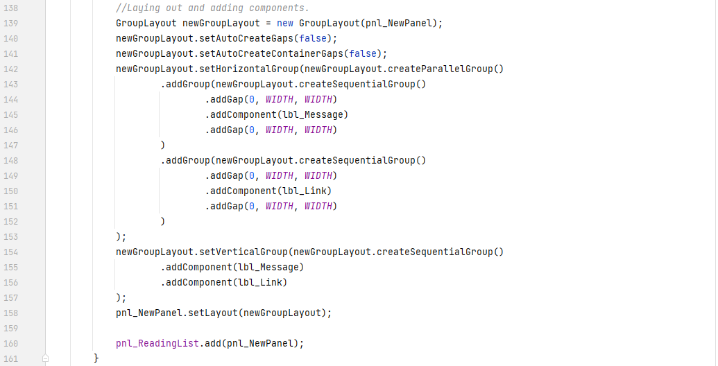

And as before, GroupLayout is used once more to lay out the components before placing the new panel in the outer panel. The same centring technique as shown above is used here (it’s very easy and very useful).

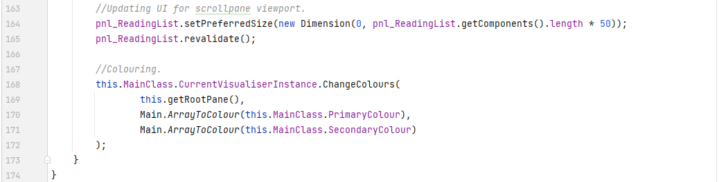

Once all the new panels have been placed in the outer panel, the outer panel’s preferred size is set and its revalidate() method is called. This is due to the same issue that was fixed in the Main class – scroll panes don’t automatically detect updates to their viewport’s components and therefore do not adjust themselves when updates do occur. This means the revalidate() method must be called on the scroll pane’s primary child component for it to notice any changes and calibrate the scroll bar according to those changes.

Once all else is done, the new window is coloured using the main class’s reference to the visualiser instance’s ChangeColours() method. The result of all the code above is shown below:

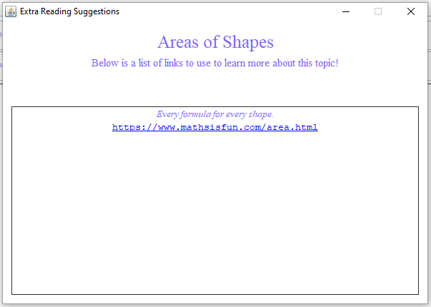

[Fig. 86] The new ExtraReadingFrame window generated for the Areas of Shapes topic. Evidence for test #7.

As can be seen, the text is centred, coloured, and formatted to be aesthetically pleasing and easy to understand. The scrollbar is not present since there is only 1 listing.

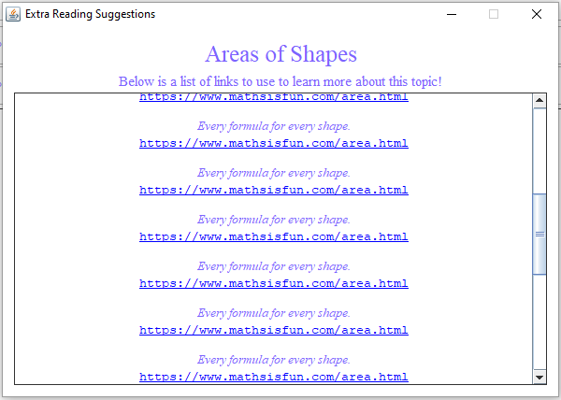

[Fig. 87] Showing the scroll bar in use to scroll through multiple links. Evidence for test #7.

#### Prototypes

The end of this iteration marks the completion of all the programming-dependent success criteria, and therefore marks the completion of the final prototype of the working solution. All major features have been implemented as defined and needed by the success criteria. The client has been informed and feedback will be discussed in the evaluation of this iteration.

### Testing, Problem Rectification and Client Feedback

#### Evidence of Testing and Test Results

|  |  |  |  |  |  |  |
| --- | --- | --- | --- | --- | --- | --- |
| Test # | Success Criteria # | Test Reason | Input | Desired Output | Actual Output | Success T / F |
| 1 | 5 | To ensure that a single model answer is shown for each unique topic. | Generate button clicked. | A varying number of model answer panels appear *before* the rest of the questions. If there are 50 questions, and 6 unique topics, then the list will be 56 panels long. | Panels appear before questions, and 1 for each unique topic. | T |
| 2 | 5 | To ensure the model answer displays the right information. | Generate button clicked. | The model answer should show the question wording, then the workings and then the answer. | Panel displays information in the same format it has in the .json file. | T |
| 3 | 5 | To ensure model answers display only when needed. | Generate button clicked. | Model answer appears when setting for “Display Model Answer” is true, and vice versa. | Model answer does/does not appear as required. | T |
| 4 | 6 | To ensure panel extension is dynamically handled. | Evaluate button clicked. | Every question panel dynamically changes in size as the new panel(s) get(s) added – without affecting the display of everything else. | Panels extend out and the rest of the panels and components within panels do not get changed. | T |
| 5 | 6 | To ensure scrolling still works after correct workings are shown. | Evaluate button clicked. | Scrolling to the end of the list of questions is still possible without some questions going missing due to clipping issues. | The user is still able to scroll to the end upon showing workings. | T |
| 6 | 6 | Workings are question specific. | Evaluate button clicked. | Workings contain numbers generated in the question. | Workings contain the generated numbers. | T |
| 7 | 12 | To ensure external reading is presented in a list format *upon a button press on the associated topic*. | Solution started. | External reading list is present, in the correct order, in a separate window. | All suggestions to external reading are present in a list format in another window. | T |
| 8 | 12 | To ensure the external reading window is separate and does not close the rest of the application. | Button on respective topic listing pressed. | Window appears and disappears upon closing. | The solution does not close when the X on the new window is toggled. | T |
| 9 | 12 | External reading links are clickable. | Button on respective topic listing pressed. | Clicking URL link in the list opens a new tab in the user’s default browser. | Provided the link is correct, the target resource is reached. | T |

Figures 77-78 are evidence for test #1 and test #2 respectively.

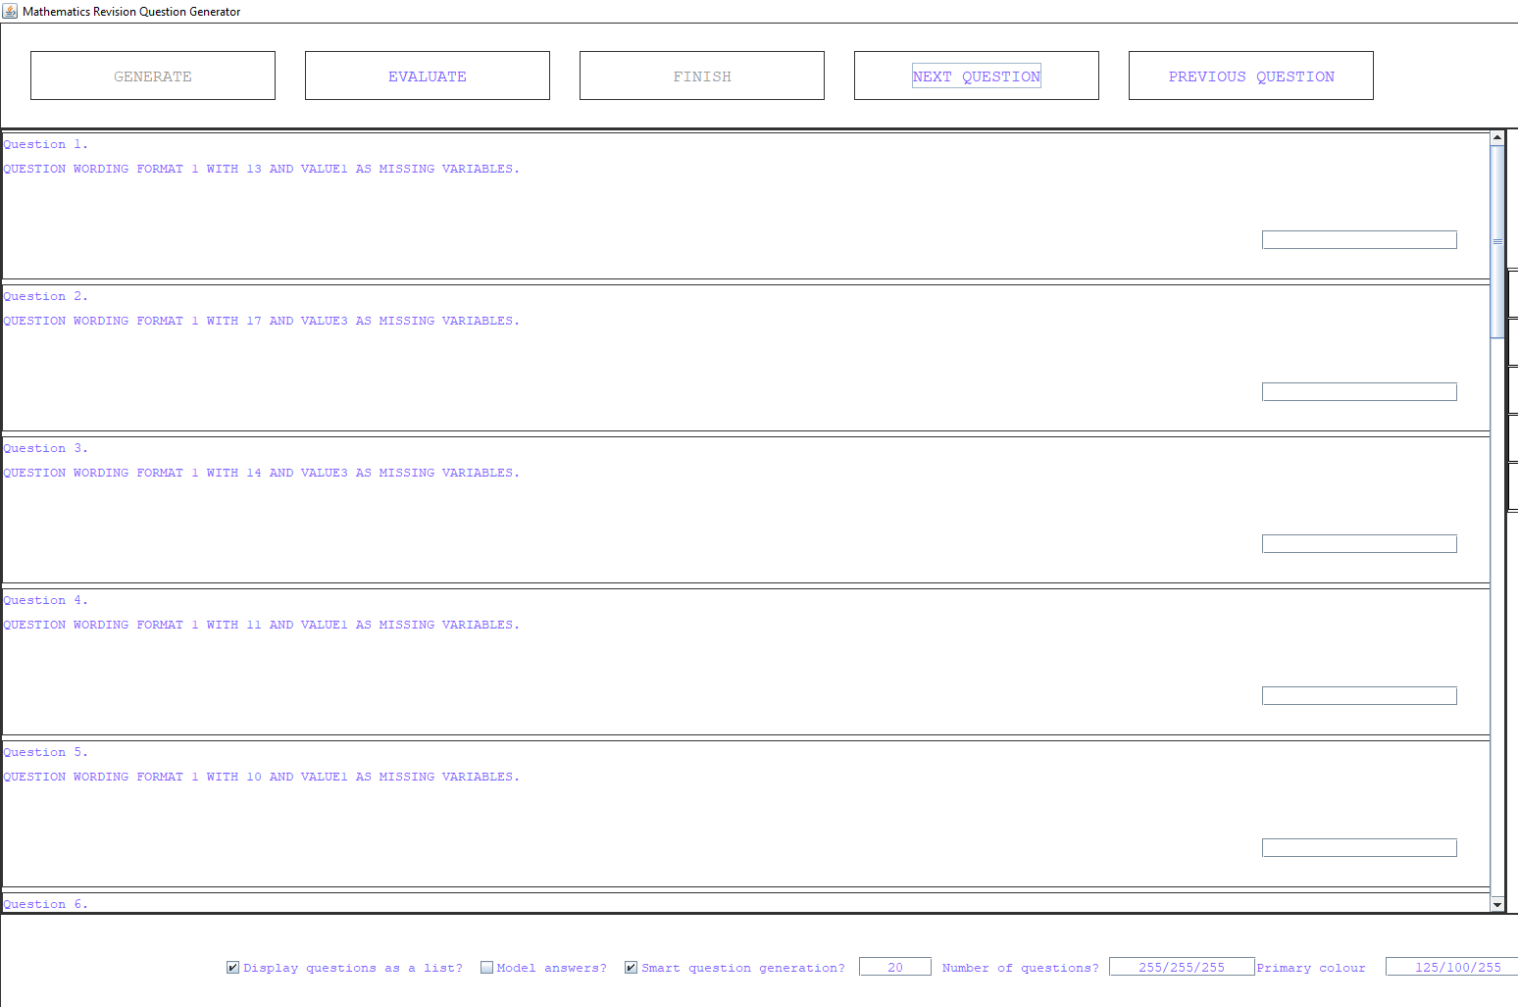

[Fig. 88] Evidence for test #3.

From figure 88, model answers do not get created if the button is not toggled at the bottom of the screen. Therefore, test #3 is a pass.

Figures 79-81 are evidence for tests #4-6 and therefore no further proof is demonstrated here.

Figures 86-87 are evidence for test #7.

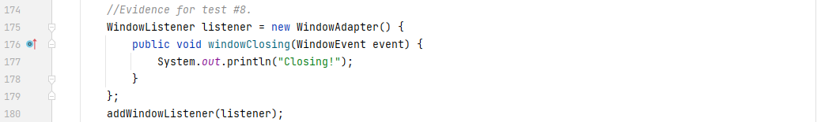

[Fig. 89] Showing the code that prints when the ExtraReadingFrame window is closing.

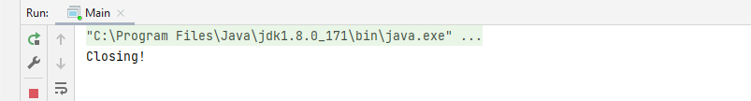

[Fig. 90] The console after closing the window.

As can be seen from figures 89 and 90, the rest of the application does not close when the smaller window is closed. This is evident from the fact that the default “Processed finished with exit code 0” is not present in the log, thus implying the rest of the application is still running.

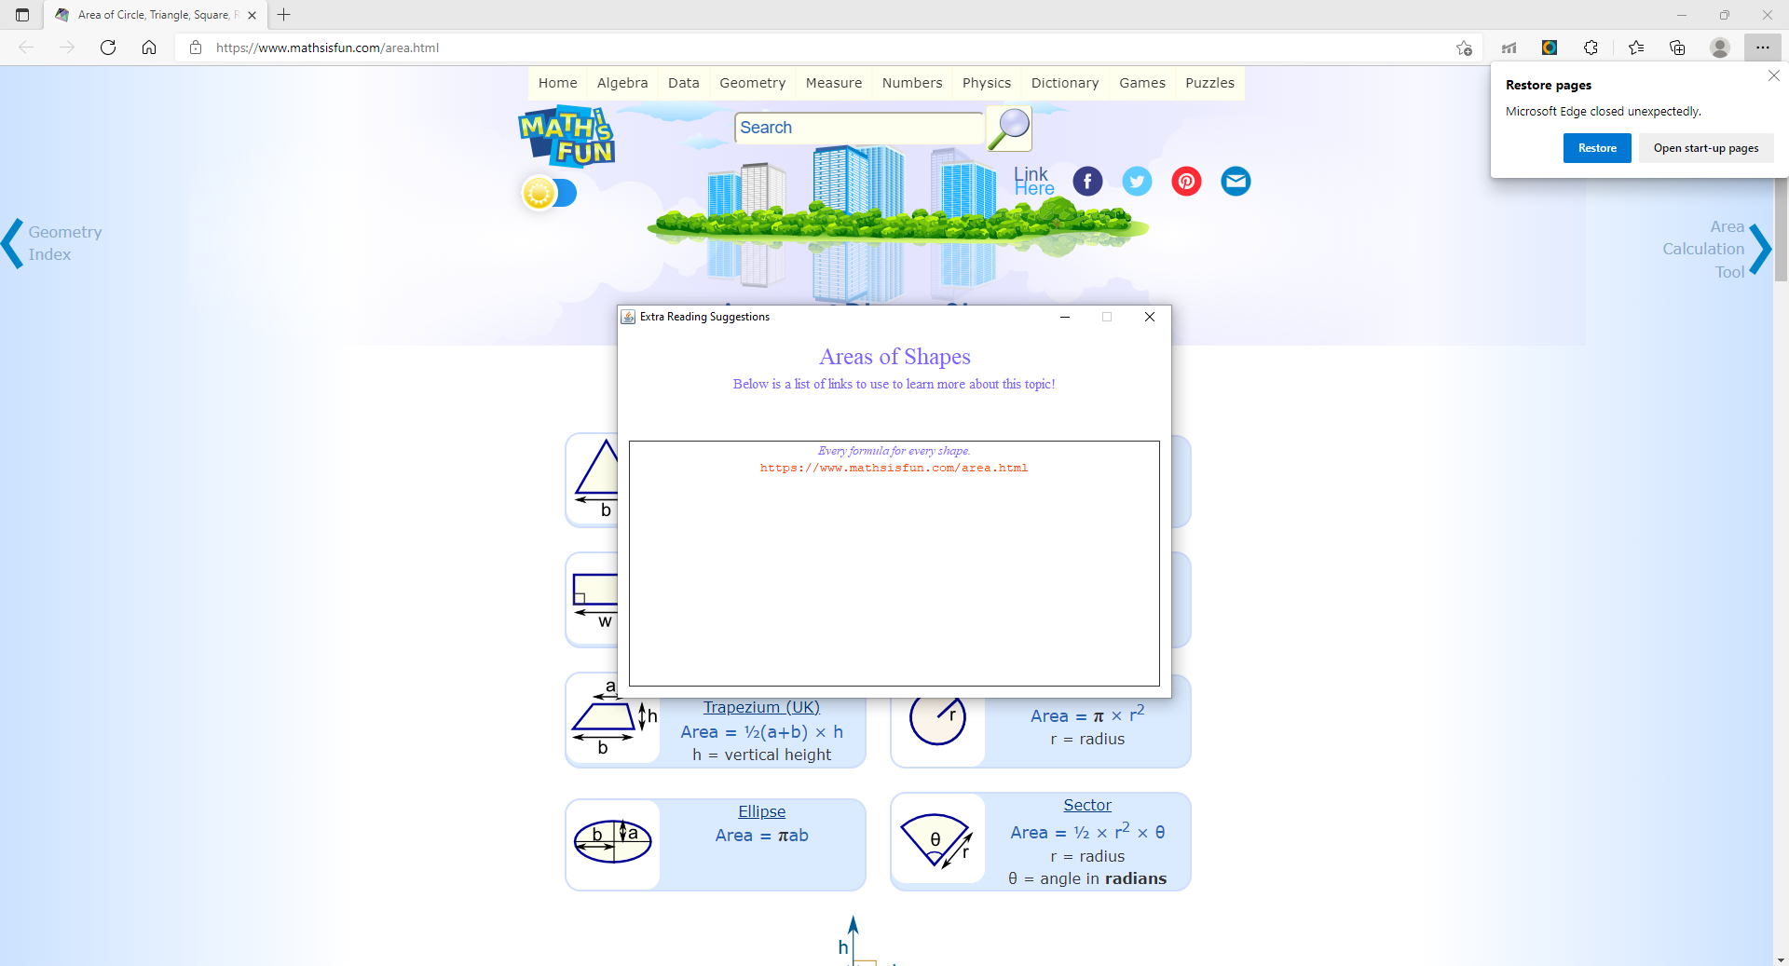

[Fig. 91] Evidence for test #9.

Figure 91 shows the text on the list being orange and the website open in the background.

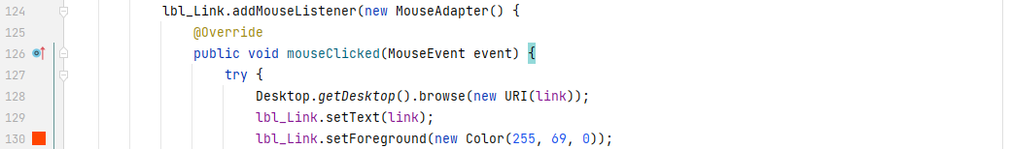

[Fig. 92] Evidence for test #9.

Figure 92 shows the code that causes the change in colour. This is temporary code, but the link works as intended, and therefore test #9 is a pass.

#### Problems and Remedies

As previously seen in the implementation section, a new parser had to be written for replacing the placeholder value references with the actual generated values within the question wording and the workings of the question. This is more specifically due to the issue shown in the image below:

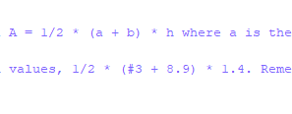

[Fig. 93] Incorrect string splicing due to limited design in the algorithm.

While attempting to implement a method to swap these references out, I realised that the previous code could not handle the cases where there are letters *in front* of the reference and that is the reason #3 does not get replaced with its corresponding value.

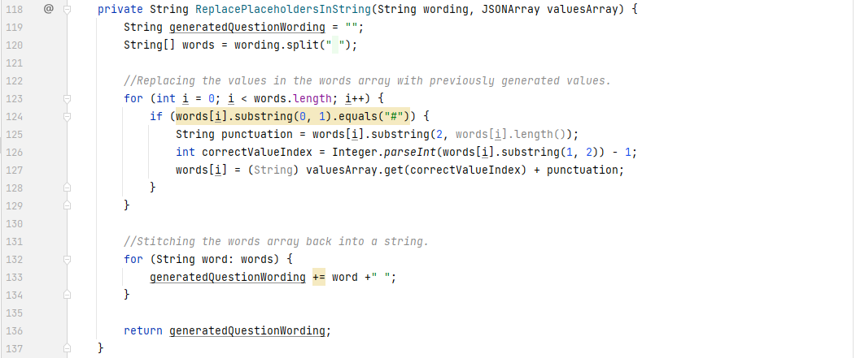

The method that I originally implemented to change these strings is seen above. It’s practically the same code as previously, but now in a stand-alone method for use in multiple places in the RandomGenerate() method (another good example of modularity). Since the method was dealing with words rather than characters, the substring choice was limited. Therefore, I generalised the method even more to simply deal with the characters on their own. I had a lot of trouble getting this to work, but finally came up with the solution, shown below:



This code is the same as what was shown in the implementation section. Line 124 uses the .equals() method, because the raw comparison operator == does not work with strings. “#” == “#” would return false since they are different objects, stored in different places in memory (even if they store the same data).

### Evaluation of Development Iteration

Like all previous iterations, this iteration had all its tests succeed. I encountered a limited number of problems – and the ones that I did, were rectified swiftly. The success criteria that were aimed to be completed by the end of this iteration were all completed (bar the last one, for it is not a directly programming related criterion).

There were no major changes to the pre-existing codebase either in terms of structure or functionality.

There will also be no impact on future iterations since this is the last iteration of a working prototype of the proposed solution.

# Evaluation

This is the final major phase of the development process of a working prototype for the proposed solution to the problem. In this phase, I will test the prototype with the predefined post-development testing table. I will also arrange a time and place for the client and some stakeholders/end-users to test the prototype for usability and robustness.

## Post Development Testing and Testing to Inform Evaluation

To critically evaluate the success/unsuccess of the prototype, it is important to test the prototype as thoroughly as possible to identify any errors – whether small or large. If the errors are small enough and the time cost is also small enough, I will rectify those errors and retest the prototype where the tests failed.

This section is split into 3 subsections. The first will test how well the prototype functions in comparison to how it *should* function. This subsection will use the post-development test table mentioned earlier. The second subsection will test the prototype for robustness. This means that any places in the prototype, where *exceptional input or extreme conditions* can be inputted will be tested. Examples include (but are not limited to): negative or alphabetical characters being inputted into a textbox that only accepts positive whole numbers; using an *auto clicker* to stress test buttons; Rapidly opening and closing windows that seem like they perform a lot of heavy processes behind the scenes. Finally, the last subsection will be carried out by the client and stakeholders/end-users (a mathematics teacher and several year 7 students respectively) for how usable the prototype is and how easy they find their user experience to be.

### Functionality Testing

The post-development test table written in the Design phase is below

|  |  |  |  |  |  |  |
| --- | --- | --- | --- | --- | --- | --- |
| Test # | Success Criteria # | Test Reason | Input | Desired Output | Actual Output | Success T / F |
| 1 | 1, 2, 3, 10 | To prove the solution can generate questions with any parameters. | Generate button clicked. Questions per round = 10. EnableBias = false. All topics selected. | 10 questions from random topics each with logical wording. | 10 questions generated from each of the 14 selected topics. | T |
| 2 | 1, 2, 10 | Above. | Generate button clicked. Questions per round = 10. EnableBias = false. 1 topic selected. | 10 questions from a single selected topic. | 10 questions from Areas of Shapes only. | T |
| 3 | 1, 2, 10 | Above. | Generate button clicked. Questions per round = 20. EnableBias = false. 1 topic selected. | 20 questions from a single selected topic. | 20 questions from Areas of Shapes only. | T |
| 4 | 1, 3, 4, 10 | To prove bias handling works as intended. | Generate button clicked. Questions per round = 20. EnableBias = true. 2 topics selected. Previously registered wrong answers in one topic. | On average, more questions in the one who’s bias should be higher. | Areas of Shapes had a bias of 2, Volumes of Objects had a bias of 1. 393 AoS questions and 207 VoO questions out of 600. | T |
| 5 | 5 | To prove model answers are supported. | Generate button clicked. | Single model answer from a topic the user has selected. | A single model answer was generated. | T |
| 6 | 6 | To prove that correct answers are shown and that questions are evaluated correctly. | Evaluate button clicked with at least 1 wrong answer submitted. | Correct answer and working shown on wrong question only. | 8 incorrect and 2 correct answers (1 of each shown in proof). | T |
| 7 | 6 | Above. | Evaluate button clicked with 10 questions per round. All answered wrong. | Evaluates all answers wrong and shows answer and workings. | 10 questions all evaluated to be wrong with correct working visible. | T |
| 8 | 7 | To prove that the solution saves the user’s scores. | Results of a round of 10 questions. | 10 new entries in the historic results file. | 2 new entries that reflect the user’s performance | T |
| 9 | 8 | To prove data can be graphically displayed. | 1 topic selected; line chart selected. | 1 new window with historic scores of the selected topic only. | A scatter graph display’s the user’s performance. | T |
| 10 | 9 | To prove solution’s ability to suggest topics to practice. | None. | Displays top 5 topics with highest bias in the main menu. | A list of top 5 topics for improvement. | T |
| 12 | 11 | To present topics in list format. | None. | Topics shown as a list in the main menu. | Topics shown as a list. | T |
| 13 | 12 | To prove the solution supports extra reading suggestions. | None. | Main menu has extra reading button on each topic. | Extra reading buttons present. | T |
| 14 | 12 | Above. | None. | Extra reading button displays a link with explanation. | Links present. | T |

It should be noted that test #11 is omitted from this table, because of the amendment to success criteria #10. Below is all the evidence for each of the functionality tests above:

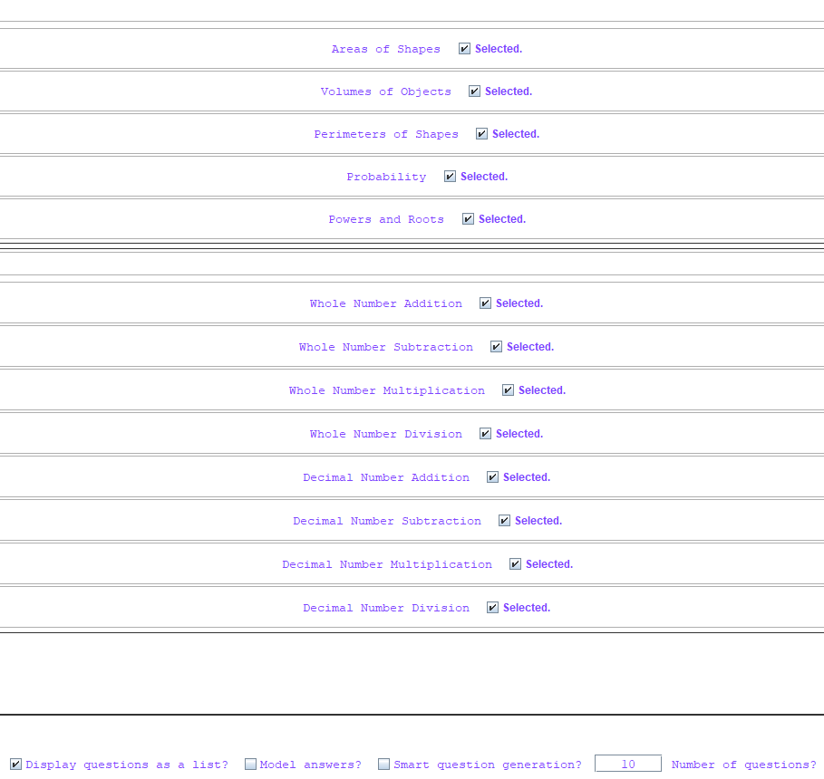

[Fig. 94] Evidence for test #1 and #12. All topics are selected. 10 questions to generate.

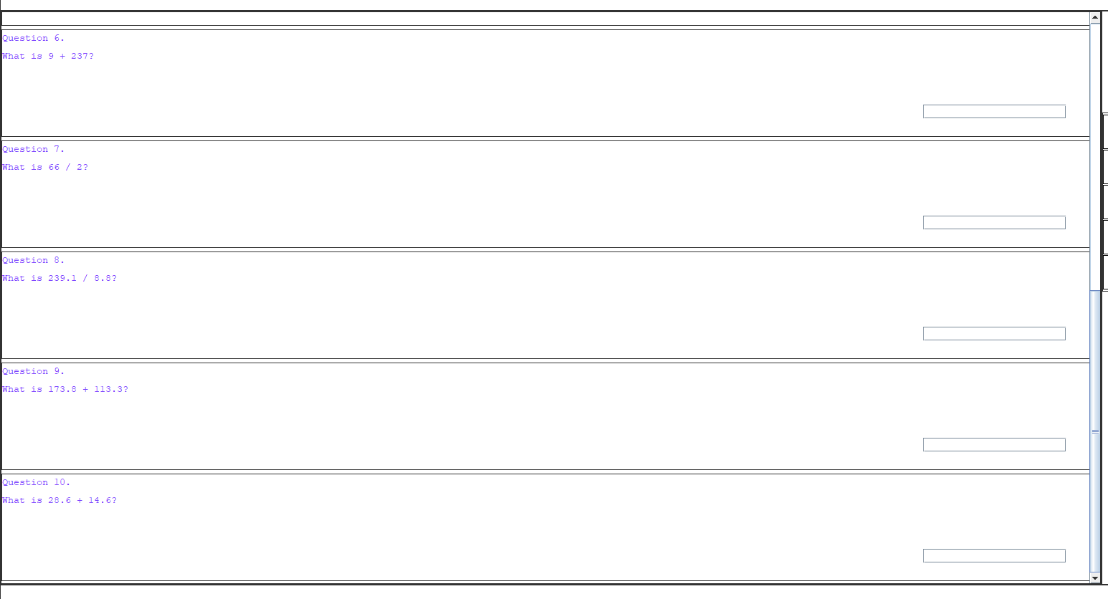

[Fig. 95] Evidence for test #1. 10 questions have been generated with logical wording.

Test #1 is fully successful and satisfies all success criteria as per the test and success criteria.

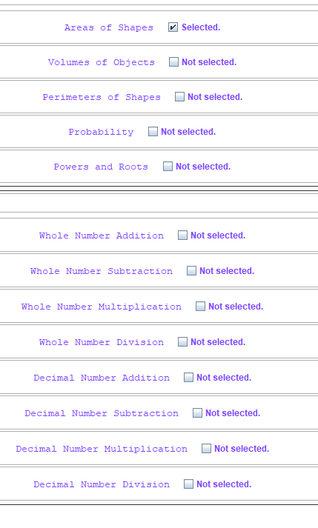

[Fig. 96] Evidence for test #2 and #12. All topics except Areas of Shapes are unselected.

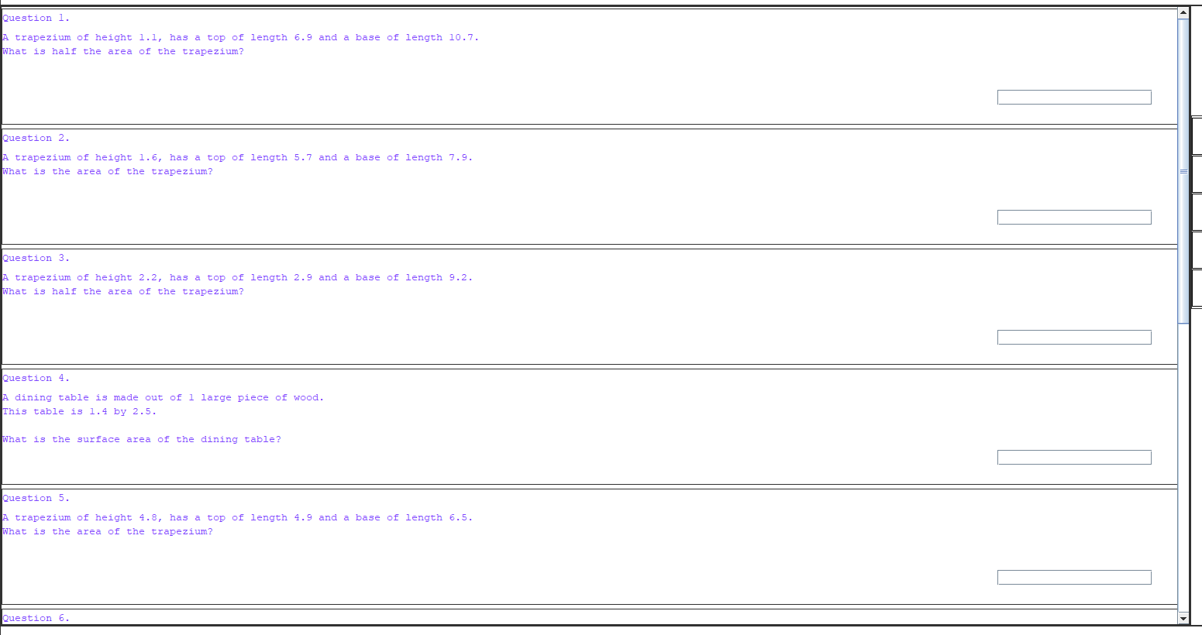

[Fig. 97] Evidence for test #2. The first 5 questions are all about areas of shapes as expected.

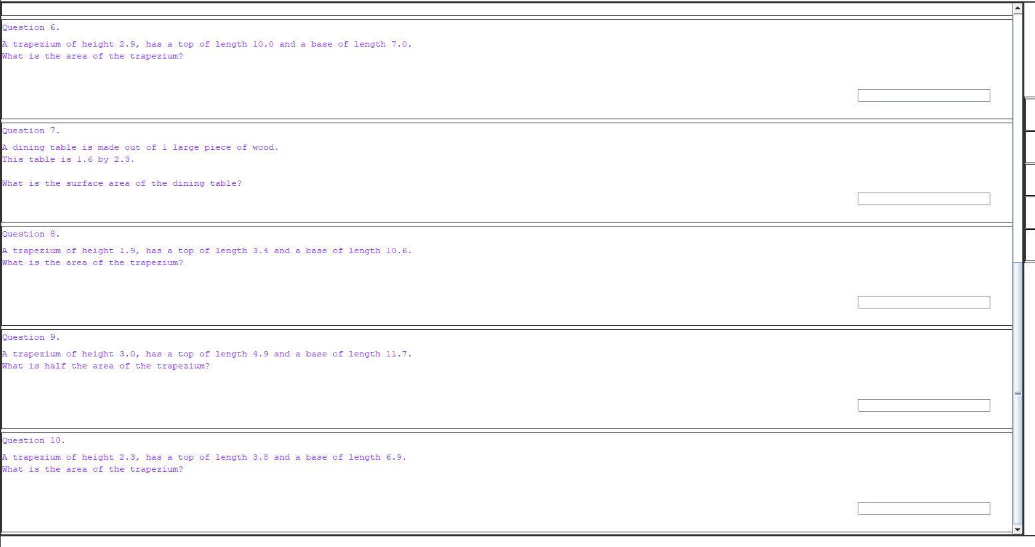

[Fig. 98] Evidence for test #2. The last 5 questions are all about areas of shapes as expected.

Test #2 is fully successful and satisfies all success criteria as per the test and success criteria.

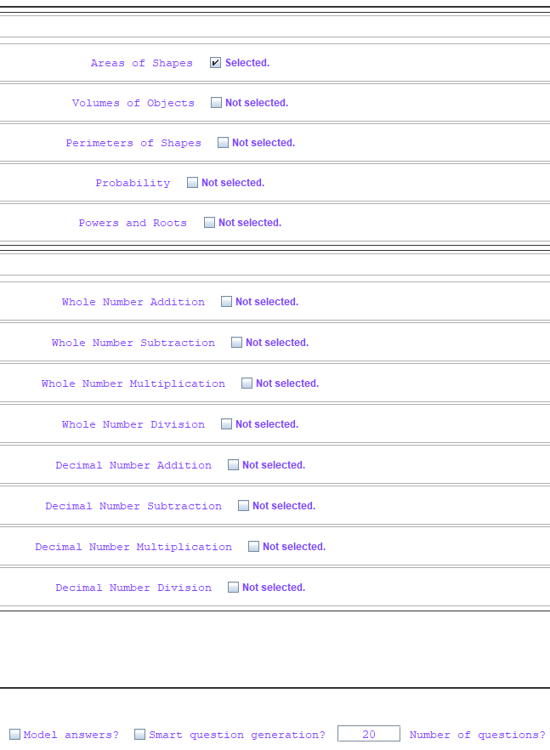

[Fig. 99] Evidence for test #3. All topics but Areas of Shapes is selected. Bias = false, 20 questions to generate.

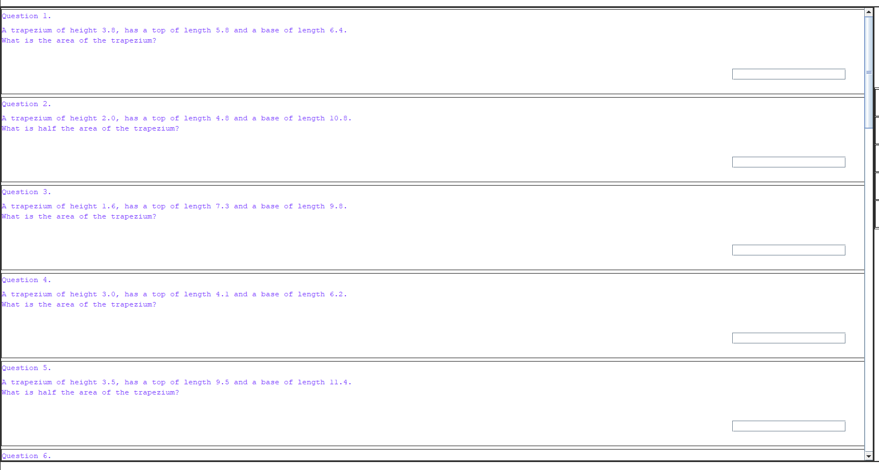

[Fig. 100] Evidence for test #3. The first 5 questions are all about areas of shapes.

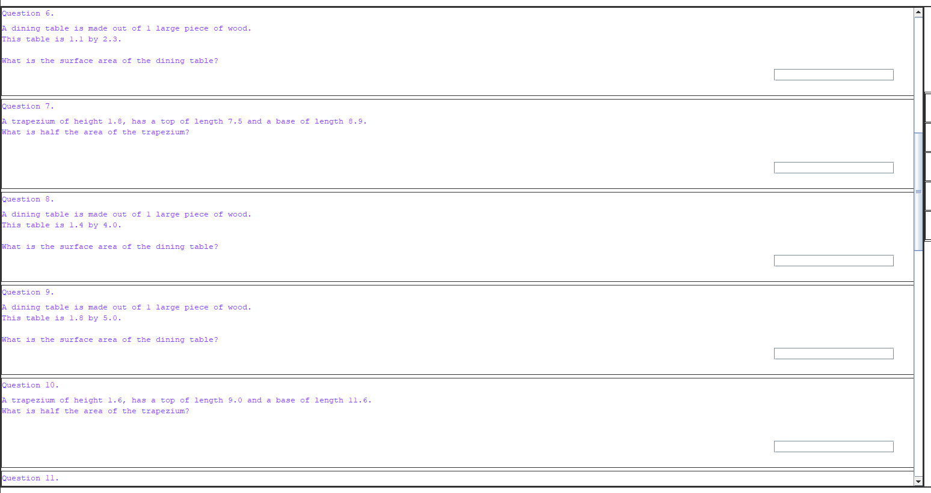

[Fig. 101] Evidence for test #3. The 2nd group of 5 questions are all about areas of shapes.

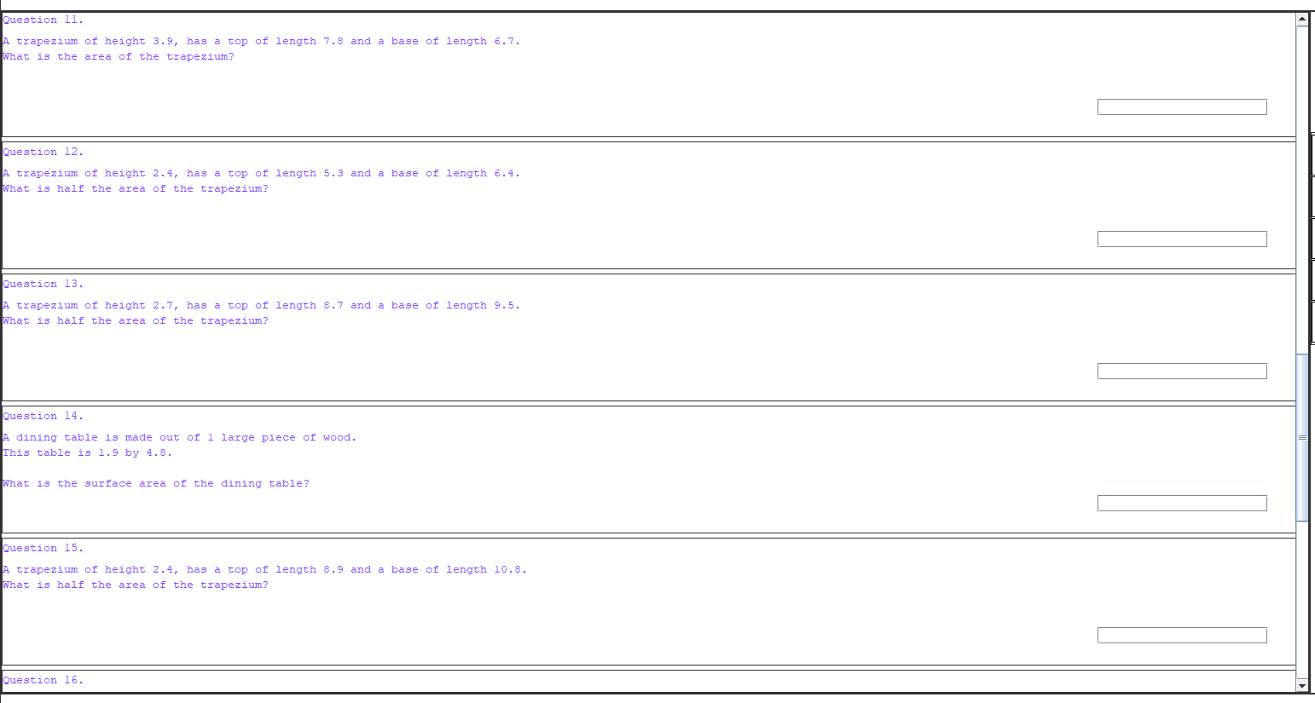

[Fig. 102] Evidence for test #3. The 3rd group of 5 questions are all about areas of shapes.

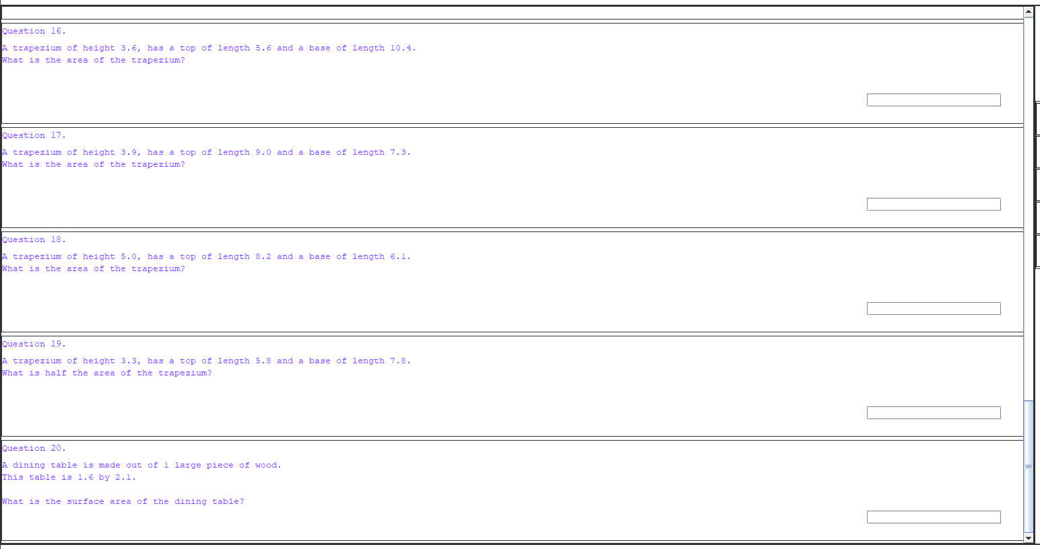

[Fig. 103] Evidence for test #3. The last 5 questions are all about areas of shapes.

Test #3 is fully successful and satisfies all success criteria as per the test and success criteria.

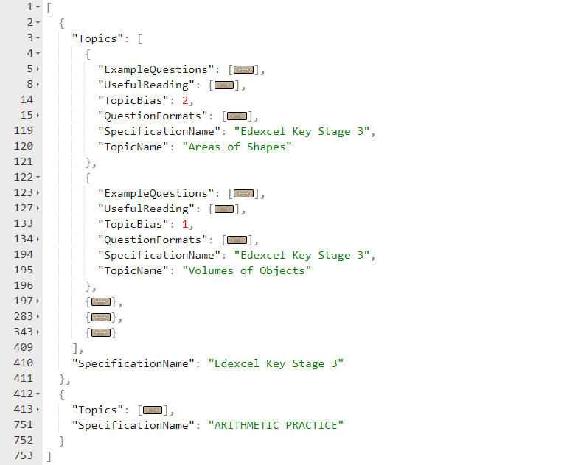

[Fig. 104] Evidence for test #4. Areas of Shapes has a bias of 2, while Volumes of Objects has a bias of 1.

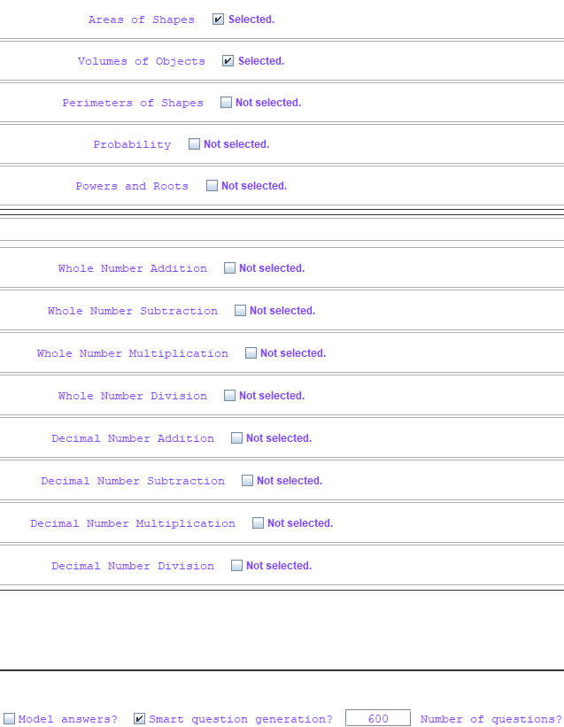

[Fig. 105] Evidence for test #4. 600 questions to generate, the 2 topics highlighted as in the previous figure. Bias is also enabled.

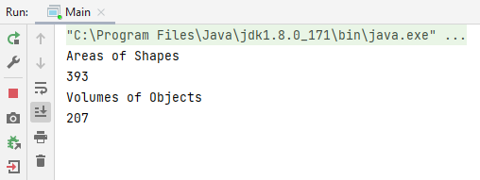

[Fig. 106] Evidence for test #4. The ratio of questions to generate is as expected. 2:1 Areas of Shapes to Volumes of Objects.

Test #4 is fully successful and satisfies all success criteria as per the test and success criteria.

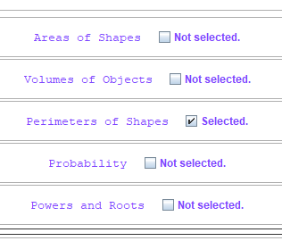

[Fig. 107] Evidence for test #5. A single topic is selected.

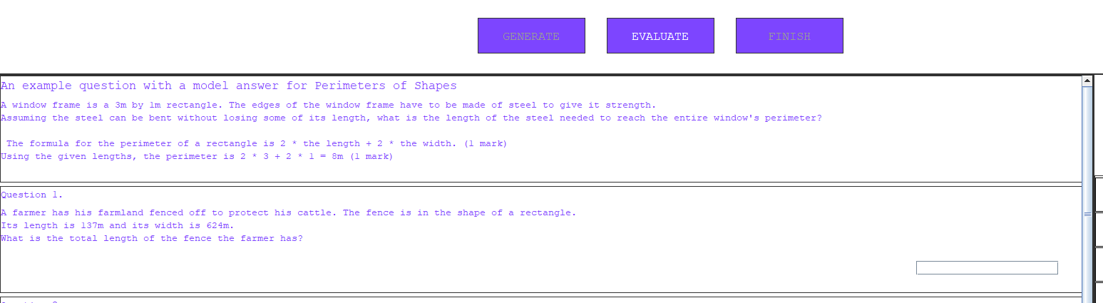

[Fig. 108] Evidence for test #5. A single model answer is shown for the singular topic that was selected.

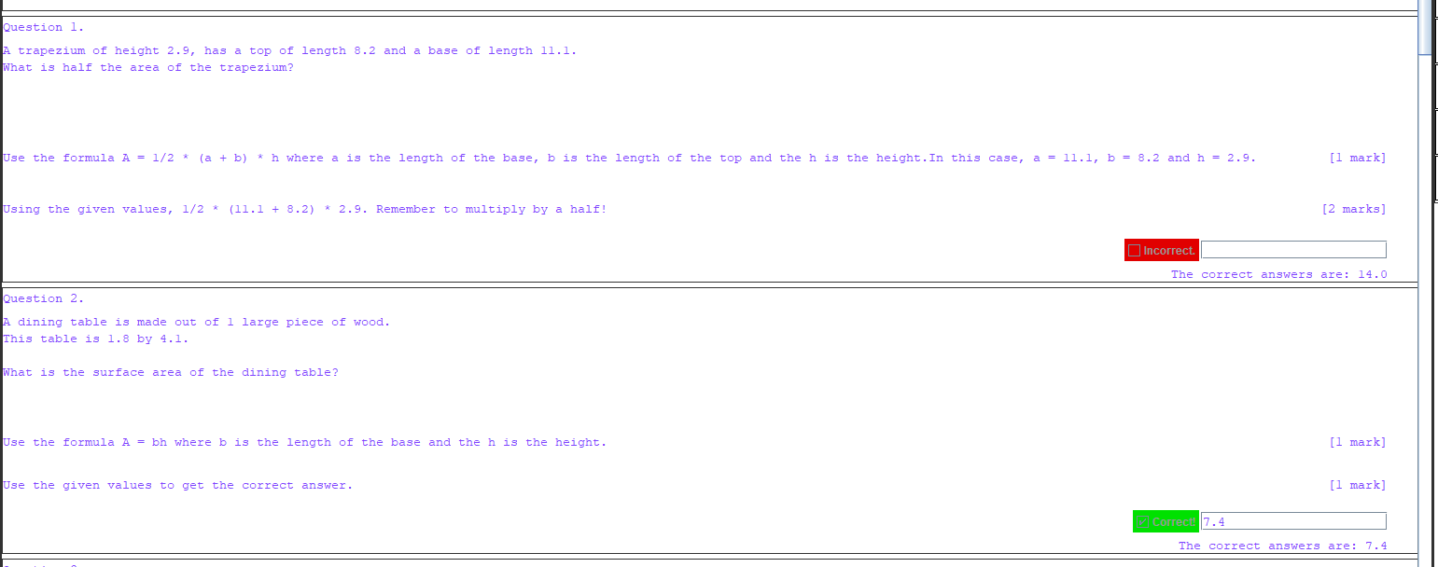

[Fig. 109] Evidence for test #6. An incorrect question and a correct question show that evaluation works as required.

Test #6 should fail - by technical definition of wording of the expected output - because the figure above shows the correct answer and correct working for a correctly answered question. However, because showing the correct method is beneficial regardless of the state of the question’s answer, I am considering this test a pass because it *does still show correct workings and correct answers* as the test’s purpose intends it to. Therefore, success criterion #6 is also satisfied fully in this case.

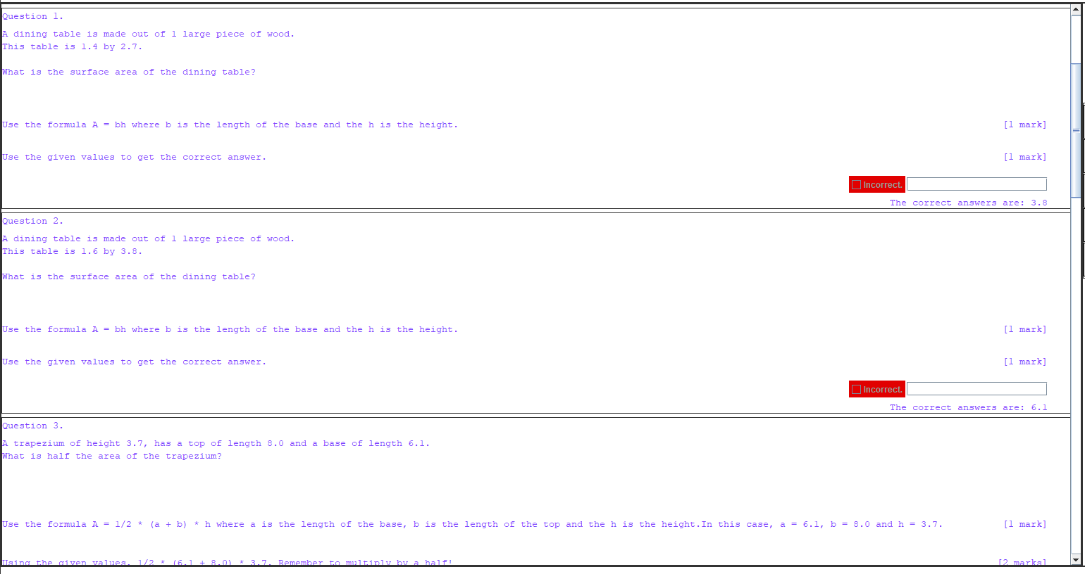

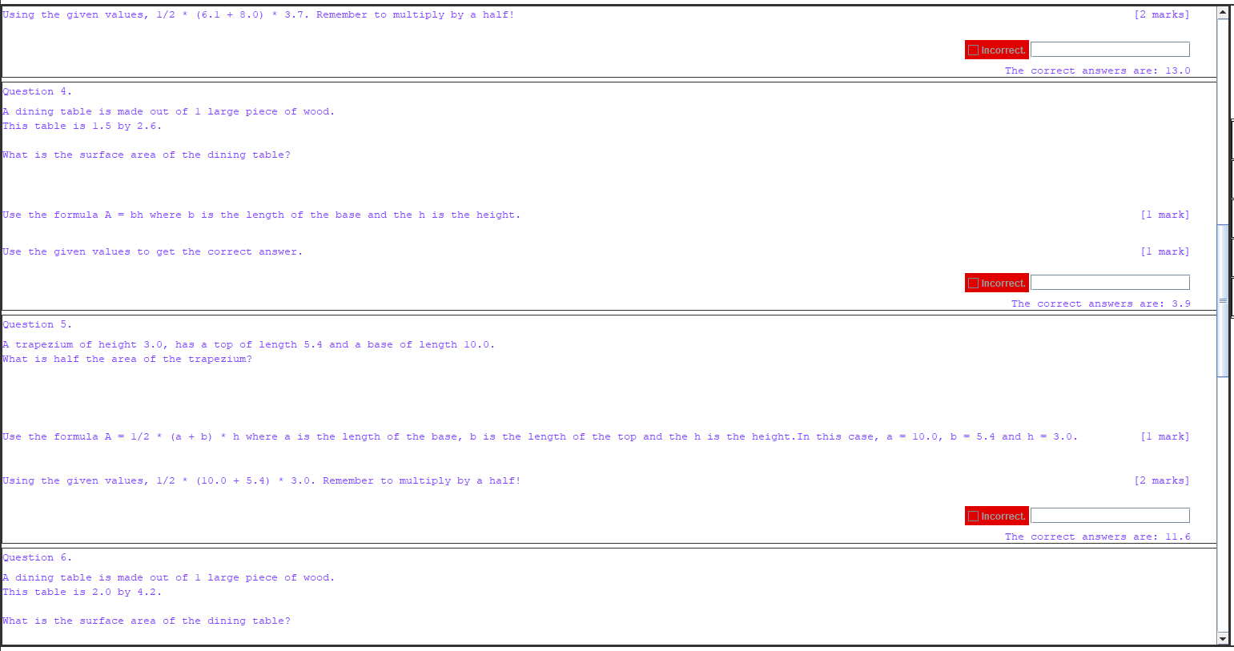

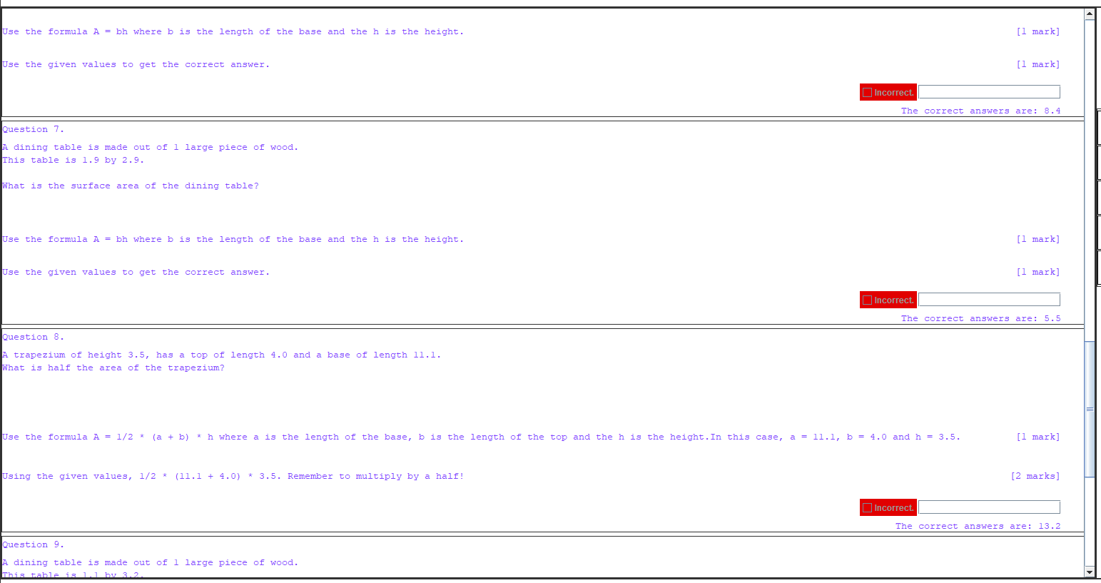

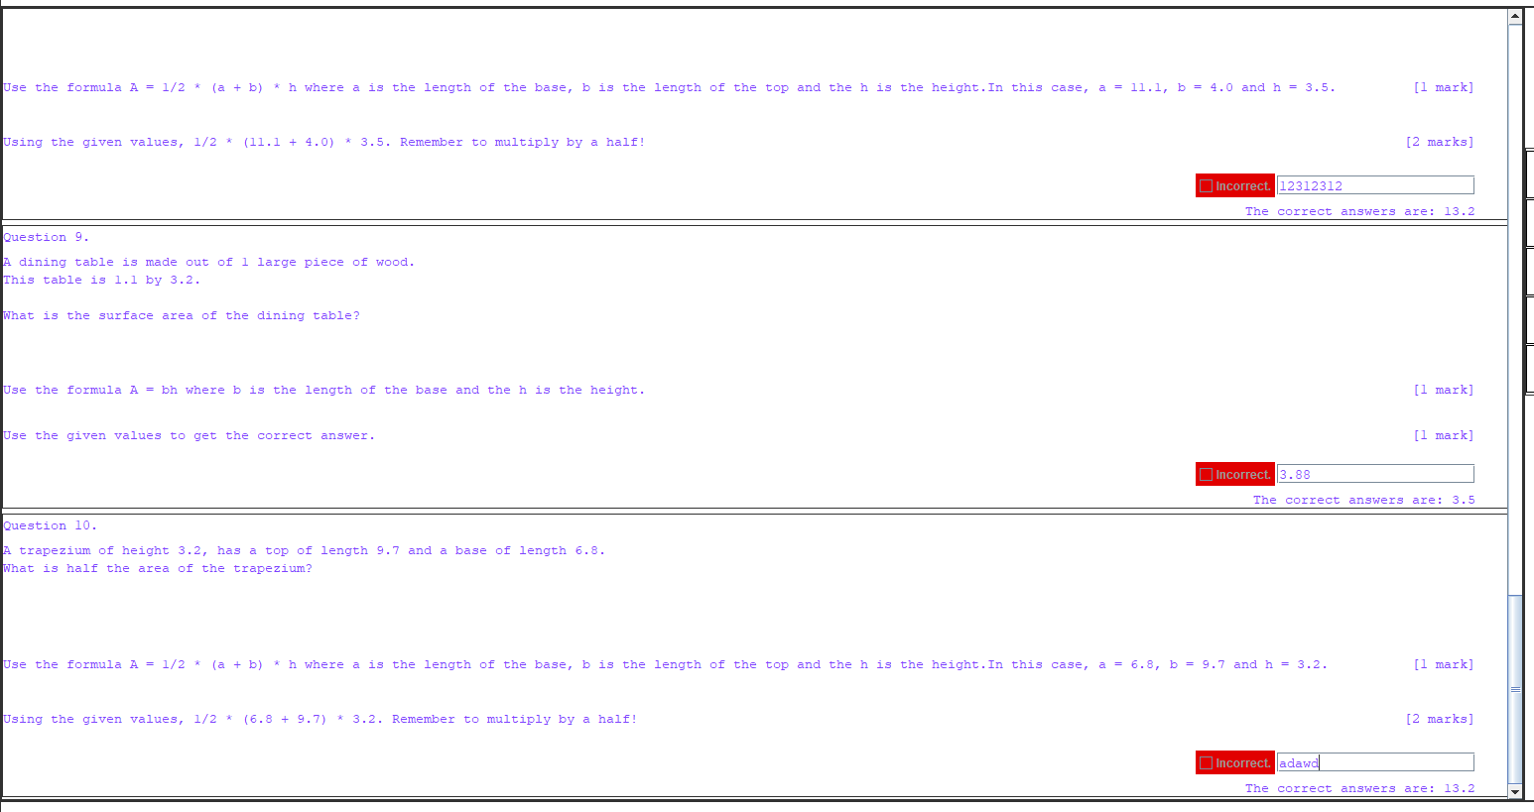

[Fig. 110-113] Evidence for test #7. Each of the 10 generated questions is incorrectly answered. The last 3 also prove that not just empty spaces get evaluated incorrectly.

Test #7 is successful and therefore fully satisfies success criterion #6.

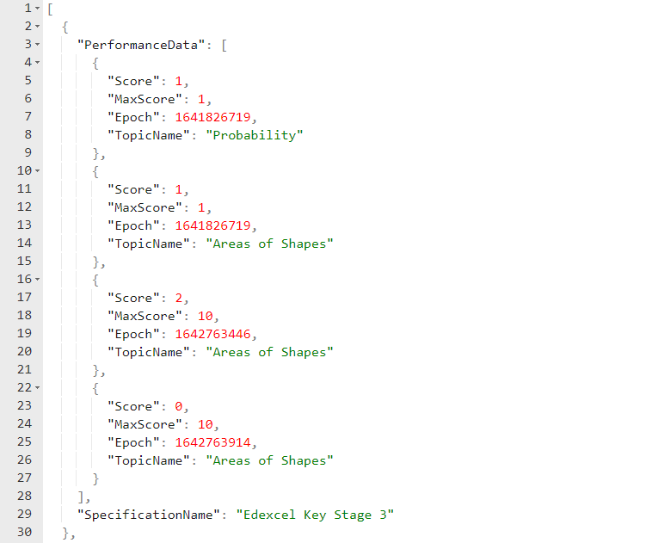

[Fig. 114] Evidence for test #8. 2 new entries have been made for the 2 sets of questions evaluated for test #6 and test #7.

Again, the wording of the test’s expected outcome, by definition, makes this test fail. However, the test’s purpose is to store the user’s performance data and that is what this test shows. During development, specifically in iteration #4, I realised that there is a more efficient way to store the scores of the user, and implemented a more compact storage format, than the one originally proposed in the design phase. Due to this, the test still succeeds, even if the wording technically doesn’t allow it to do so.

Because of this, success criterion #7 is fully satisfied as per its requirements.

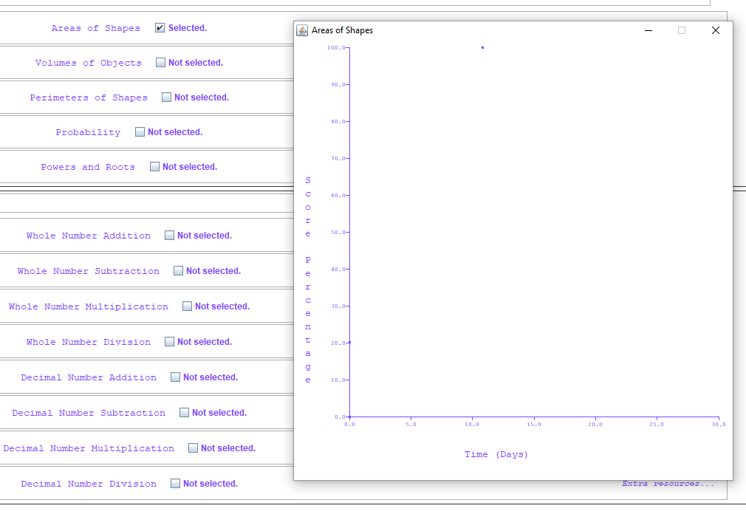

[Fig. 115] Evidence for test #9. Areas of Shapes is selected, and a Scatter Graph appears only for that.

An error has been made when wording the test’s expected outcome. It requires a “line chart”, when the intended phrase was “scatter graph”. This test still succeeds however, because the solution can display historic performance data graphically. From the size of the image in this document, it may be difficult to see, but there are 2 darker spots near 20.0 and 0.0 on the Y-axis – these indicate the 2 results of test #6 and test #7’s set of questions respectively.

Because of this, success criterion #8 is fully satisfied as per its outlined requirements.

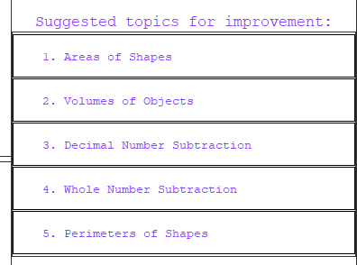

[Fig. 116] Evidence for test #10.

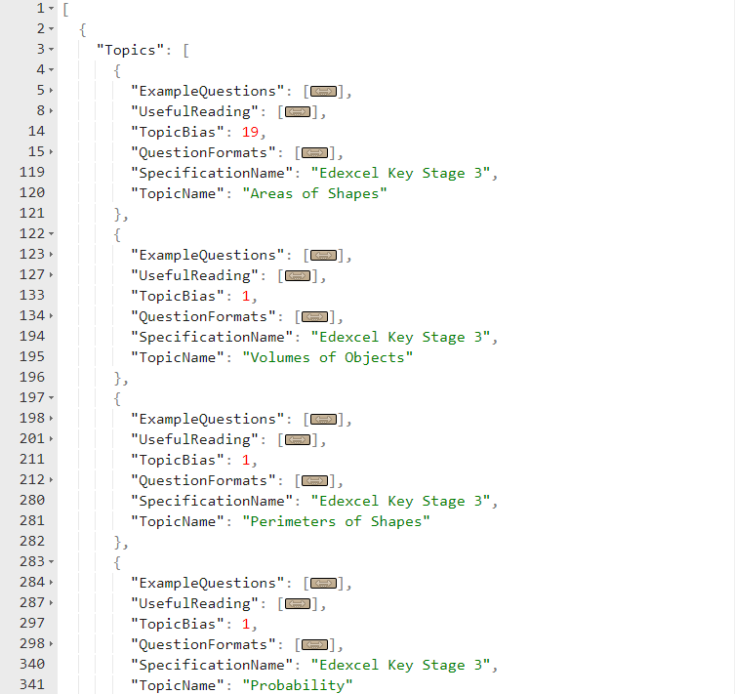

[Fig. 117] Evidence for test #10. The specifications file shows that Areas of Shapes has the highest bias and is therefore at the top of the list in the previous figure. Therefore, test #10 is successful and success criterion #9 is fully satisfied.

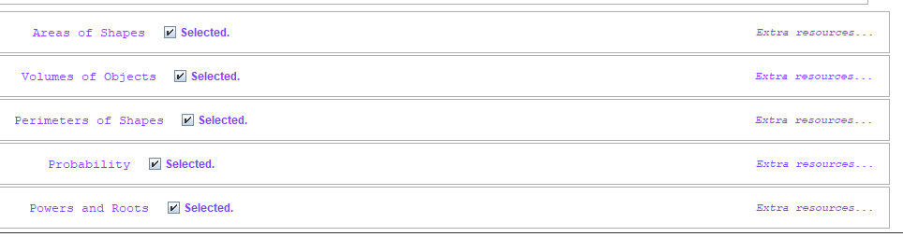

[Fig. 118] Evidence for test #13. There are buttons for extra resources for every topic.

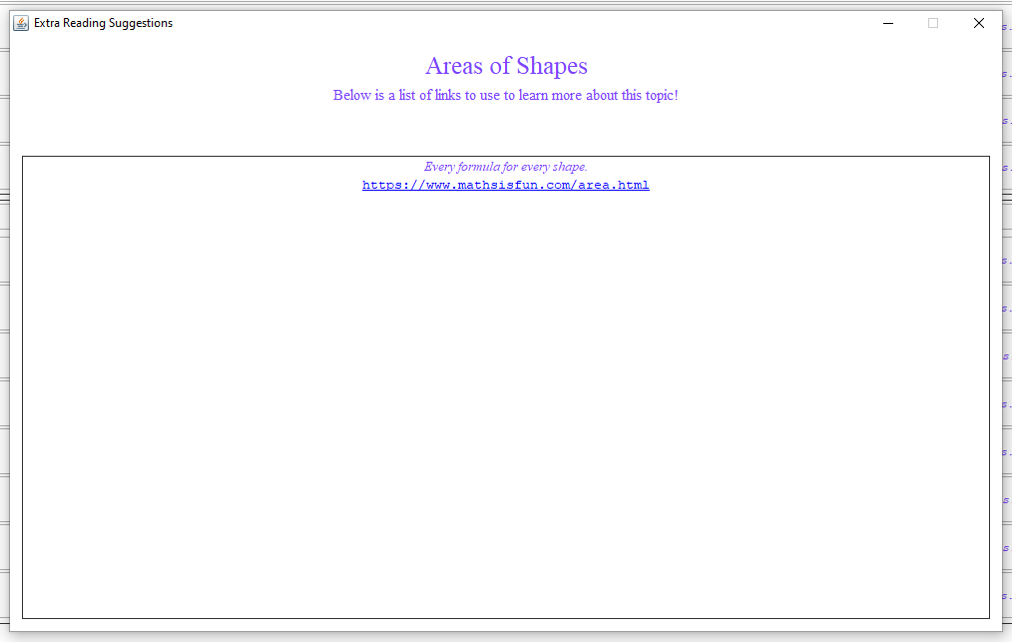

[Fig. 119] Evidence for test #14. Clicking the button opens a new window with a list of links to further reading.

Each of the tests above are successful (with respect to the test reason, not the specific expected test outcome in some cases).

In my own opinion, this test table was not exhaustive when compared to the success criteria. Colouring (as implied by criteria #10) was not tested here, and criteria #13 is difficult to prove. It either requires inefficient cross-referencing with the specification, or the client’s professional opinion. I will go with the latter since it’s simpler and quicker.

For criteria #13, the client has given their opinion and said, “I have had a look at the Year 7 specification, and it seems to have everything you had in your programme.” [12]. Therefore, success criteria #13 is met, but only in the scope of this prototype (it would have to be retested for a full production solution).

For criteria #10, I deem it unnecessary to repeat previous testing, so refer to iteration #5, figures 71 and 72 for proof of the solution being able to colour the user interface.

Due to the numerous pieces of evidence for all functionality tests, every success criterion – as outlined in the Analysis phase – has been met *fully*.

### Robustness Testing

#### RGB Colour Input Validation and Sanitisation

Firstly, the settings boxes will have to be tested for user input validation and sanitisation, with *extreme user input*. This means alphanumeric values; negatives; non-alphabetical characters; out-of-bounds numbers; floating-point values into integer boxes.

I have made some additions to the code to colour the text in the JTextField based upon its validity. This is purely for evidencing purposes and the changes were minor so I will not evidence the code here. Below is a test table for all the potential kinds of user input a user may enter.

|  |  |  |  |  |
| --- | --- | --- | --- | --- |
| Test # | Input | Desired Output | Actual Output | Success T / F |
| 1 | 255/255/255 | Valid. | Valid. | T |
| 2 | 125/1/65 | Valid. | Valid. | T |
| 3 | 0/0/0 | Valid. | Valid. | T |
| 4 | 0/255/0 | Valid. | Valid. | T |
| 5 | -1/123/255 | Invalid. | Invalid. | T |
| 6 | -255/-255/-255 | Invalid. | Invalid. | T |
| 7 | 0/0/256 | Invalid. | Invalid. | T |
| 8 | 4/4/4/4 | Invalid. | Invalid. | T |
| 9 | 5/5 | Invalid. | Invalid. | T |
| 10 | 255 | Invalid. | Invalid. | T |
| 11 | Abc/def/ghiwae | Invalid. | Invalid. | T |
| 12 | 0-12/255/255 | Invalid. | Invalid. | T |
| 13 | 9.54/240/240 | Invalid. | Invalid. | T |
| 14 | A0a/12321/1251 | Invalid. | Invalid. | T |
| 15 | 123 / 123 / 123 | Invalid. | Invalid. | T |
| 16 | /// | Invalid. | Invalid. | T |





























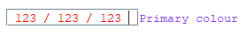



[Fig. 120-135] Evidence for test #1-16 respectively.

The same algorithm runs on the JTextField responsible for the secondary colour too, so therefore no testing is required for that, since it will produce the same results. It must be noted however, that even if something like test #7’s input is considered invalid RGB, the system will attempt to replace it with a valid input – in this case, 0/1/0. The same can be said for any of the tests with alphabetical characters or negative numbers. If it cannot replace, it will simply write the previous valid value to the box. Test #15 will remove the whitespace. This goes for any other inputs that contain alphabetical characters mixed with numerical characters. The alphabetical characters will be removed, and the numerical characters will remain. This is input sanitisation and the tests above are input validation.

#### Window Creator Buttons for Graphs and Reading Frames

There are 2 buttons that create new windows in the solution: The graph creation button and the extra reading buttons for all the topics. I will be testing their robustness if the user attempts to click them multiple times per second.

|  |  |  |  |  |
| --- | --- | --- | --- | --- |
| Test # | Input | Desired Output | Actual Output | Success T / F |
| 1 | “Create Graph” button clicked 5 times with 3 topics selected. | 3 graphs generated. | 15 graphs generated | F |
| 2 | “Extra resources to learn from!” button clicked 3 times for 1 topic. | 1 new resources window created for that topic. | 3 windows created. | F |
| 3 | “Extra resources to learn from!” button clicked 3 times for 2 separate topics. | 2 new resources windows created for those 2 topics. | 6 windows created. | F |

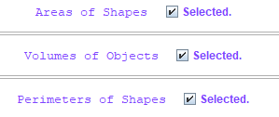

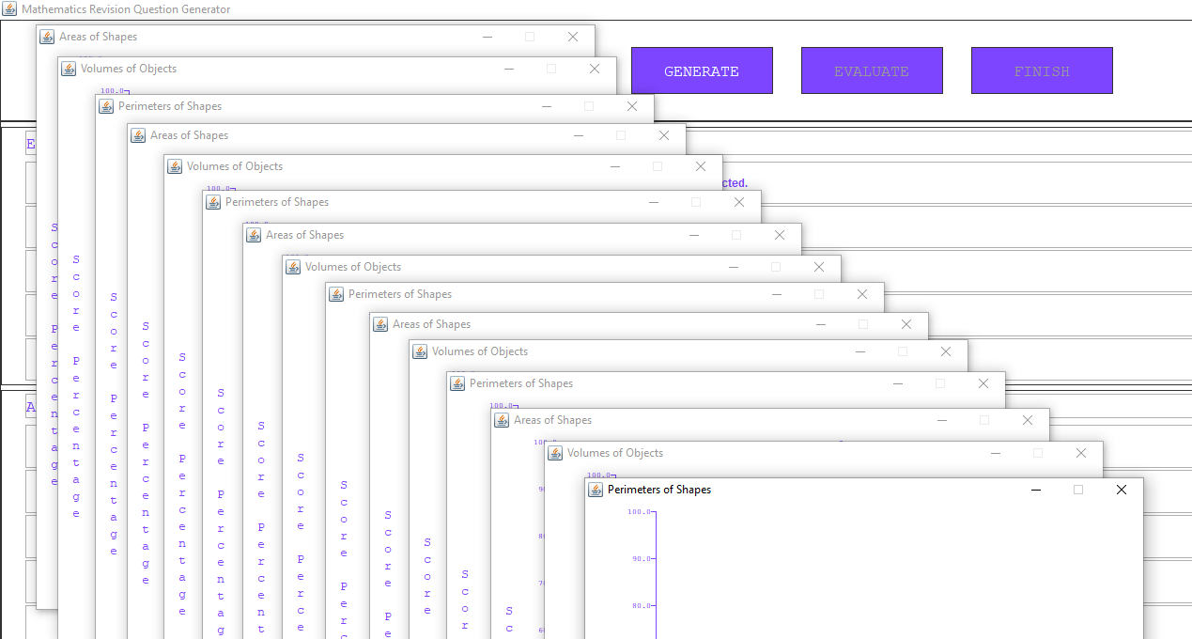

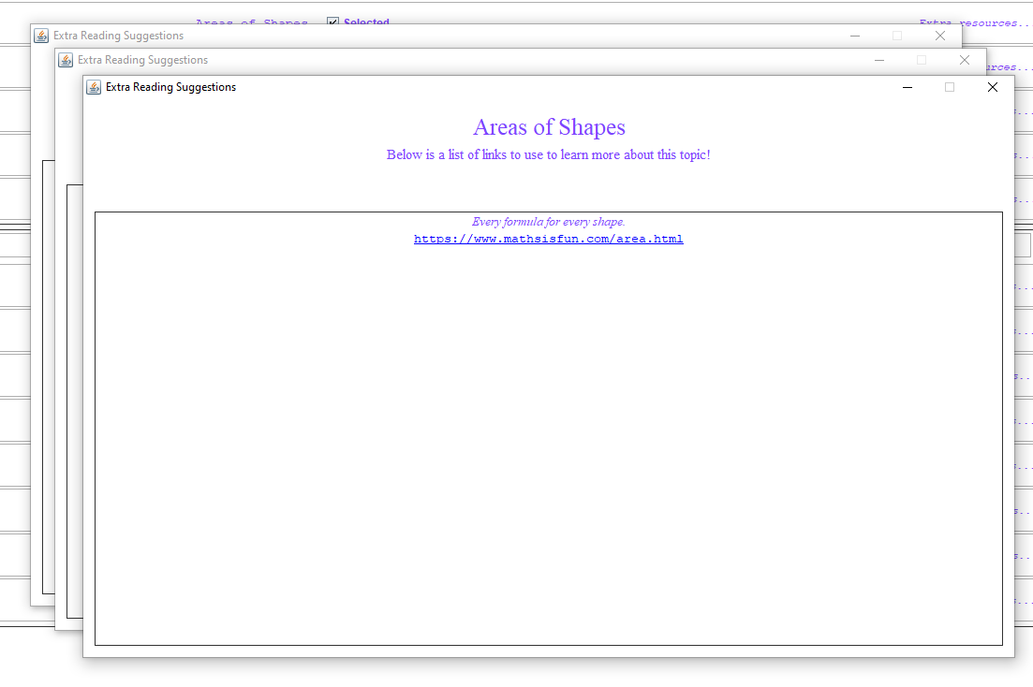

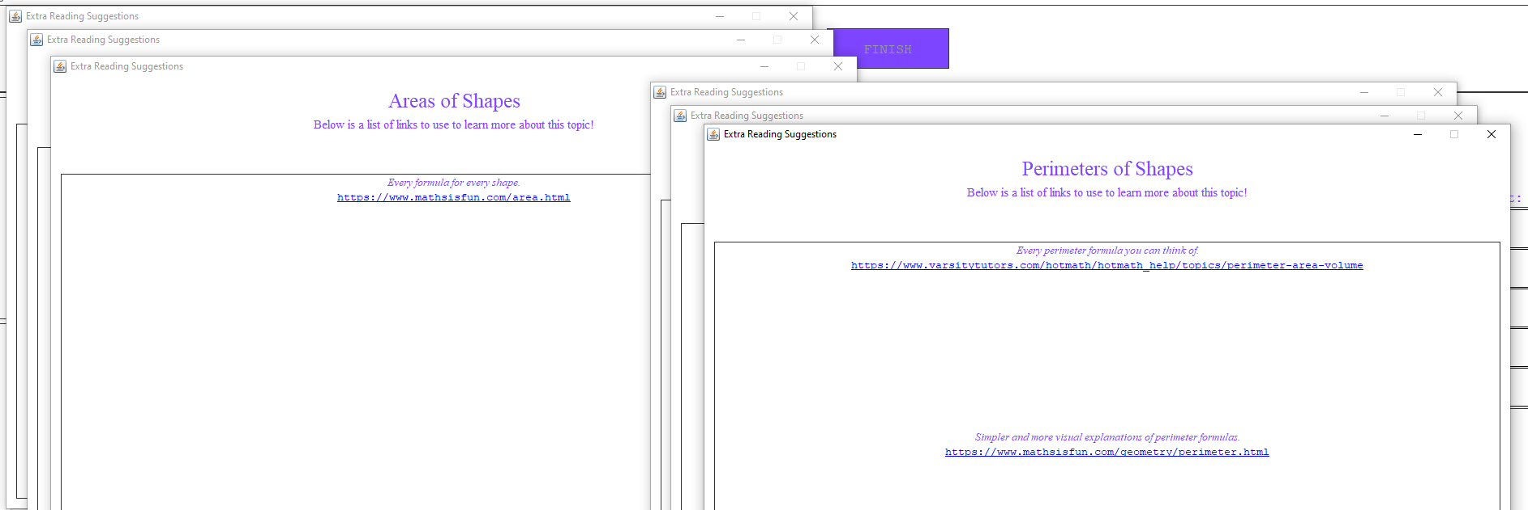

[Fig. 136-139] Evidence for test #1-3.

During development, I did not account for the possibility that a user may try to open the same window multiple times. Therefore, all tests failed. This is a problem because the user could attempt to use a type of 3rd party software known as an “auto clicker” and repeatedly press these buttons to create 100s of windows and slow down the computer. However, there is a simple fix for it.

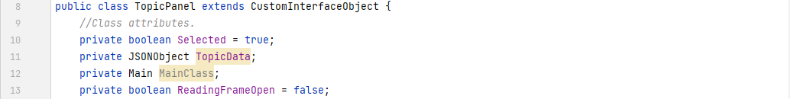

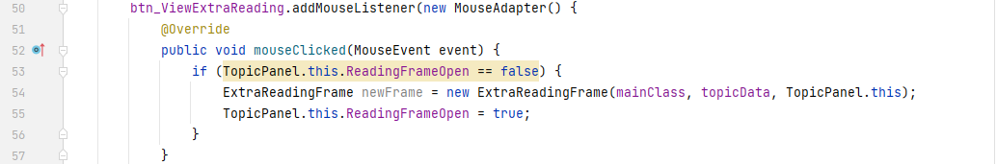



In the TopicPanel class, I have created a new class attribute that keeps track of whether a reading window is open or not. It also passes the instance of the TopicPanel to the ExtraReadingFrame, so that when the window closes, it can use the new setter method to set that value back to false.

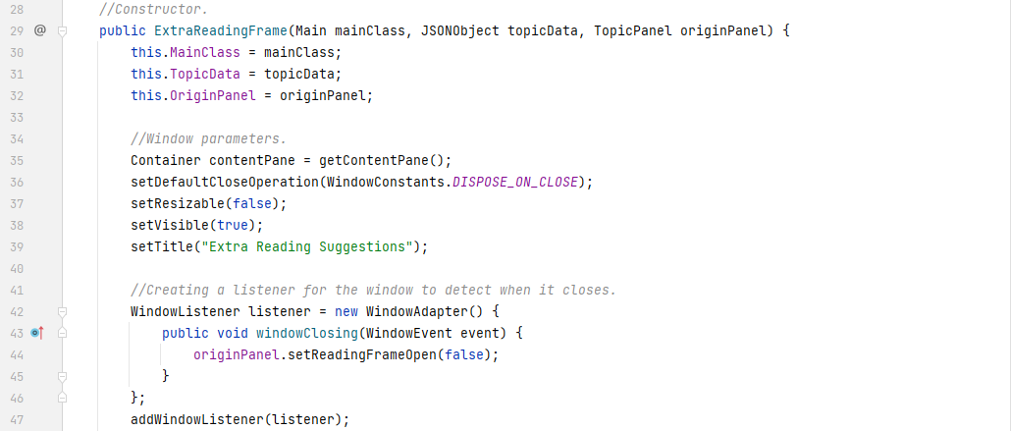

This implementation ensures that no new windows can be opened if there already is one open. Note that there is no getter method for the new state because it is not needed here (since it’s never used in any code). This is simply due to my preference in programming style – only choosing to add the methods that are needed and adding new ones only when necessary – because it keeps the codebase only as big as it needs to be which makes it easier to maintain and work with.

To remedy the issue for graph generation, a different approach will need to be made. Because the user can have multiple graph windows open concurrently, a simple Boolean flag cannot be used. Instead, a counter variable in the main class is suitable instead because it can be dynamically updated at run time depending on how many windows are open. Hence, a new class attribute was added to the main class.

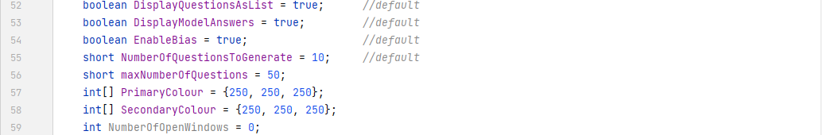

The Visualiser class’s method for generating scatter graphs now checks if the requested number of new graphs combined with the current number of open graphs is less than what’s allowed (a new constant variable also in the main class). If it is, it doesn’t create any new ones.

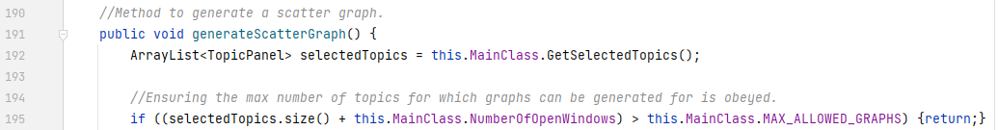

When every graph is generated, the counter in the main class is incremented by 1 (instead of adding the number of graphs generated at the end of the method, incrementing it dynamically is better in-case it *somehow* errors halfway through another loop iteration – negating the scenario where the number of graphs open and the counter that keeps track of them are out of sync).



And to detect when graphs are closed, a window listener was added to the ScatterGraph class constructor to decrement the counter when it closes.

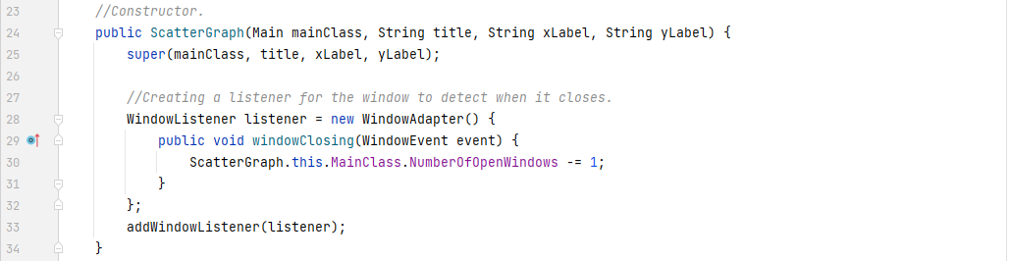

The reason I didn’t do this to begin-with for the reading frames too, is because I wanted to keep the logic for reading frames and graphs separate. Had they both followed the same counter, the user would have been able to open multiple reading frames at the same time – which is undesirable.

Now that the remedies have been made, retesting with the same tests is in order. Due to the nature of these tests, I figure it best to include print statements in the places of interest in the code to show that windows truly are being opened and closed in the right amounts.

In the Main class and the ScatterGraph class.

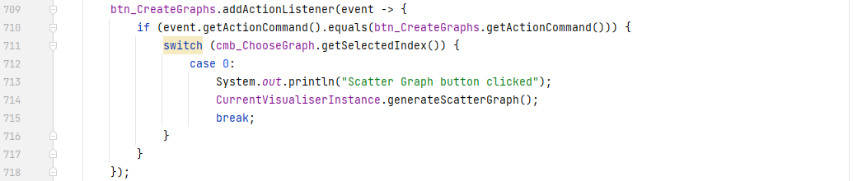

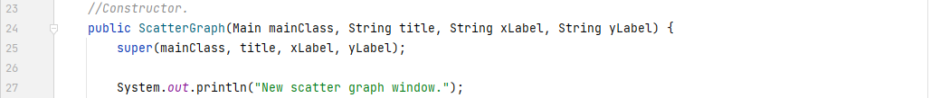

In the TopicPanel class and the ExtraReadingFrame class.

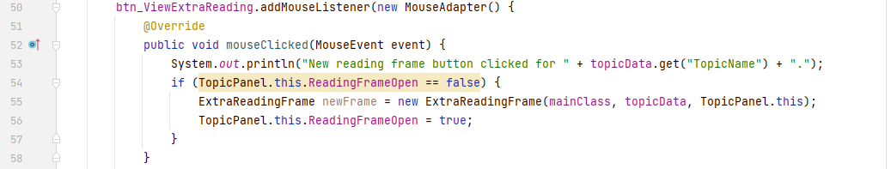

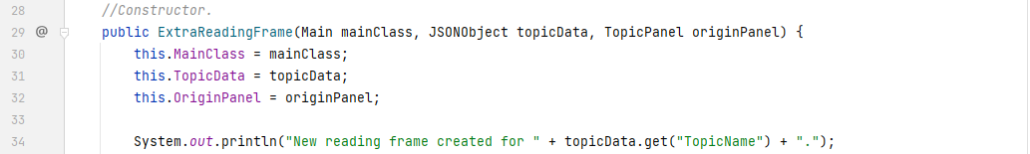

The testing table is the same as what was used previously. Whether these windows closing is kept track of, and works is not part of this robustness test, and will therefore not be included here. They will be their own robustness tests after this one.

|  |  |  |  |  |
| --- | --- | --- | --- | --- |
| Test # | Input | Desired Output | Actual Output | Success T / F |
| 1 | “Create Graph” button clicked 5 times with 3 topics selected. | 3 graphs generated. | 3 graphs generated. | T |
| 2 | “Extra resources to learn from!” button clicked 3 times for 1 topic. | 1 new resources window created for that topic. | 1 window created. | T |
| 3 | “Extra resources to learn from!” button clicked 3 times for 2 separate topics. | 2 new resources windows created for those 2 topics. | 2 new resources windows created for those 2 topics. | T |

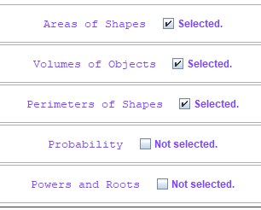

[Fig. 140] Evidence for test #1. Only 3 topics are selected.

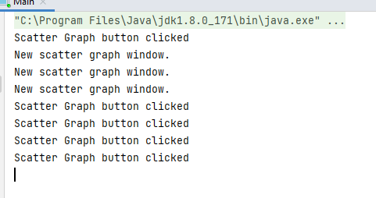

[Fig. 141] Evidence for test #1. After the 1st click, 3 windows were created and no more after extra clicks.

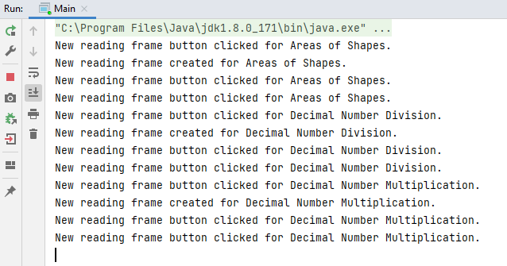

[Fig. 142] Evidence for test #2-3. A new window was created only after the 1st click and no more for subsequent clicks.

Now that the number of open windows has been restricted, it is necessary to test whether these windows also close and reopen without any desynchronisation issues mentioned in the last test. For this, a new testing table is required.

|  |  |  |  |  |
| --- | --- | --- | --- | --- |
| Test # | Input | Desired Output | Actual Output | Success T / F |
| 1 | Create Graph button toggled for 3 selected topics, 3 windows closed, and Create Graph button toggled once more with 3 topics selected. | 3 scatter graphs generated, then those 3 closed, and 3 more generated. | 3 graphs created, 3 closed, 3 more created. | T |
| 2 | Extra Reading button toggled, the new window then closed, and the same button toggled once more. | 1 new window created, that new window closed, the same window recreated. | 1 window opened, 1 closed, and 1 reopened. | T |

For these tests to work, the print statements left from the previous robustness tests need to be changed slightly and a few new ones added. The scatter graph creator method in the Visualiser class has a new print statement and the one from the ScatterGraph constructor was removed.

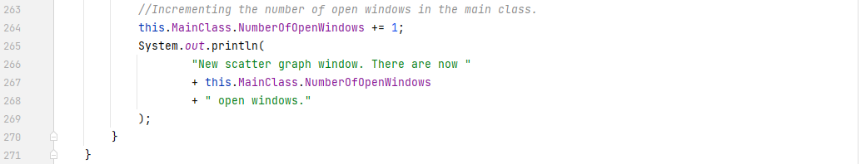

The window closing print statement from the ScatterGraph class got changed to now include the number of windows left open.

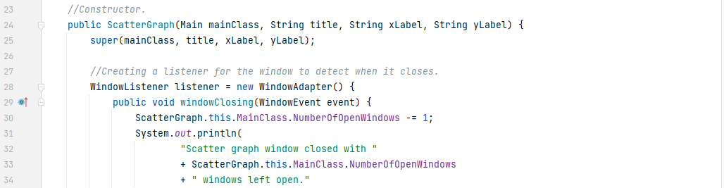

The window closing event in the ExtraReadingFrame class now prints when it closes.

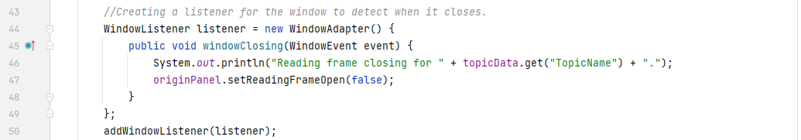

Now that the print statements were added/changed, the solution can be tested.

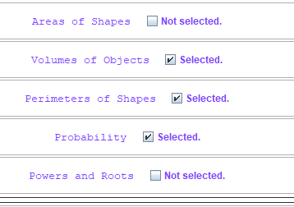

[Fig. 143] Evidence for test #1. 3 topics are selected.

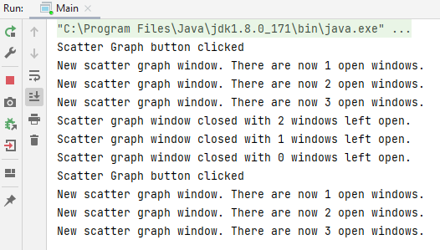

[Fig. 144] Evidence for test #1.

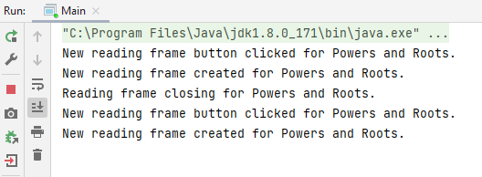

[Fig. 145] Evidence for test #2. The window is opened, closed, and reopened once again as required.

All tests are successful, therefore the remedies for the previous tests also worked for these tests. The solution is now more robust to users who click buttons rapidly and the print statements can be removed as they are no longer needed.

### Usability Testing

Finally, as part of post-development testing, it is necessary to test how *usable* solution is to the end-user and client.

#### Testing Session Results

I have arranged a testing session with the client and 3 stakeholders (year 7 students). I showed them how the solution worked, what its main features were and encouraged them to “play around with it and try it out”. During the session, I asked them to give scores from 0 to 10 for each of the following questions I asked them about their user experience. These are the results:

|  |  |  |  |  |  |
| --- | --- | --- | --- | --- | --- |
| Question | Tester 1 | Tester 2 | Tester 3 | Client | Total |
| 1. How preferable was the button size? | 8 | 9 | 9 | 8 | 34 |
| 2. How easy/hard was navigation? | 7 | 7 | 7 | 7 | 28 |
| 3. How readable were the fonts and their sizes? | 7 | 7 | 9 | 9 | 32 |
| 4. How reactive was the interface? | 9 | 9 | 9 | 9 | 36 |
| 5. How logical was the structure/layout? | 8 | 8 | 8 | 9 | 33 |
| 6. How understandable were the questions? | 8 | 8 | 9 | 8 | 33 |
| 7. How helpful were the model answers? | 8 | 8 | 7 | 6 | 29 |
| 8. How helpful were the extra reading? | 8 | 9 | 9 | 8 | 34 |
| 9. How logical was the colouring structure? | 8 | 8 | 8 | 8 | 32 |
| 10. How easy was the interface to understand? | 7 | 8 | 7 | 7 | 29 |
| Totals/Percentages | 78  78% | 81  81% | 82  82% | 79  79% | 320  80% |

The highest and lowest total score have been highlighted. The concerning scores below 30 have also been highlighted. As is clear from the data, the overall approval from the combined scores of the testers and client is 80%. At face value, this may seem like a good usability score. However, there were several extra comments the testers made, and these will be dealt with in the next section.

#### Addressing Usability Concerns

The comments were all features they dislike or find difficult to use/understand:

1. “The text in the questions is too close to the left edge of the screen which makes it difficult to read sometimes.”
2. “Points on the scatter graph are hard to see.”
3. “We don’t know what RGB is.”
4. “We don’t know what a scatter graph is.”
5. “.0 on the ends of all the numbers is weird and makes us get questions wrong.”
6. “Correct workings were sometimes unhelpful.”
7. “Checkboxes are too small.”
8. “Some symbols in the question wording were confusing. What does * or ^ mean?”

Each will be addressed. If it is applicable, I will fix the issue, and if not, I will justify how I would fix the issue in further development of the working solution.

*“The text in the questions is too close to the left edge of the screen which makes it difficult to read sometimes.”*

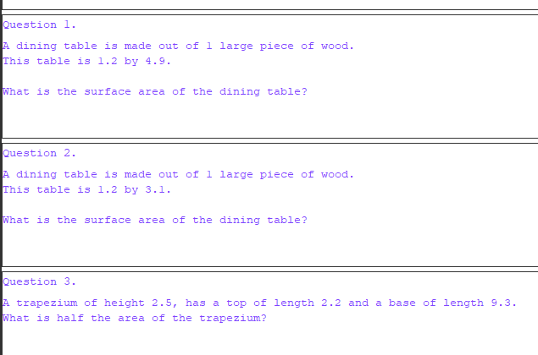

[Fig. 146] Showing how close to the edge of the screen the text is.

As can be seen from the figure above, there is a 0-pixel gap between the text and the edge of the screen which makes reading the text difficult – especially when the text can look relatively small from afar.

However, this is an easily fixable issue. By adding a 10-pixel gap at the start of the horizontal group for the GroupLayout for ModelAnswer and ListedQuestionBox, the whole of the contents of the JPanel are shifted right by 2 pixels. In ModelAnswer:

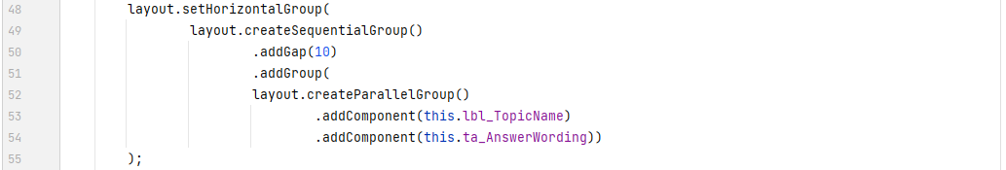

And in ListedQuestionBox:

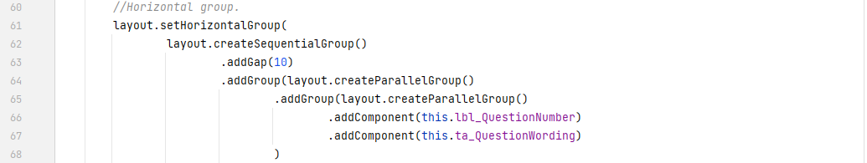

This yields the following result:

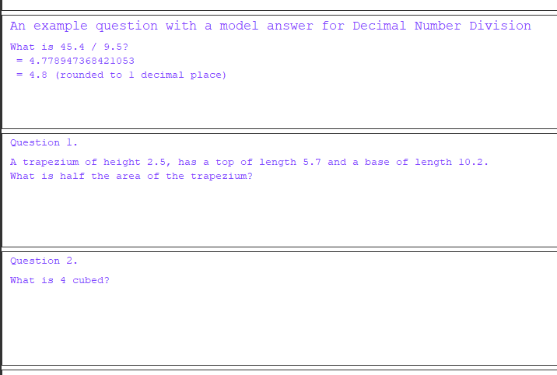

[Fig. 147] Demonstrating the improved readability achieved by adding a 10-pixel gap to the text.

As can be seen, the text has been shifted by 10 pixels and is now a lot more readable than previously.

*“Points on the scatter graph are hard to see.”*

The following figure illustrates this issue:

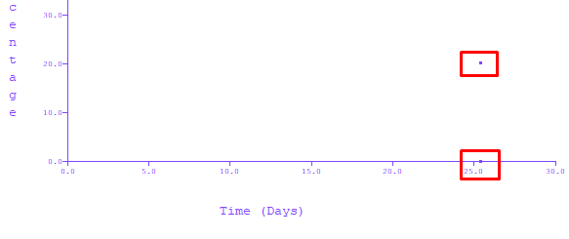

[Fig. 148] Demonstrating the difficulty of noticing the points on a scatter graph.

The top red box highlights a point on the graph that is clear to see because it is not obstructed by anything else. The bottom point, however, is more difficult to see. This is especially apparent when points are near the origin or y-axis of the graph because recent scores are what a typical user would like to check the most. A simple fix can be done for it.



By setting the component name “GraphPoint” to be non-colourable and then setting the name of each point to that name, the colouring algorithm will ignore that point.

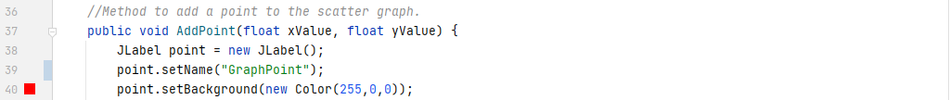

Then, the point can be coloured to an appropriate colour and it will stay that colour regardless of the user’s choice of interface colours. The result is below:

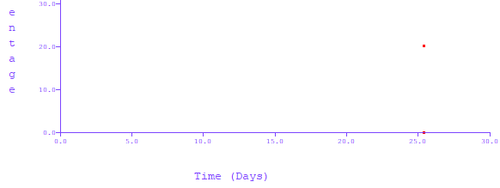

[Fig. 149] The points on a scatter graph are now much easier to identify.

*“We don’t know what RGB is.”*

This is unfortunately not an issue I can fix at this moment in time. However, in further development, I would use a *colour picker* – a visual frame with every possible shade of colour on it – as an alternative to just entering the RGB codes. I will keep the RGB parser because it is much quicker and easier for those who are familiar with it, but I will also include a colour picker for those who wish to visually pick their colours.

This is also an issue the client brought up at the end of iteration #5 – noting that younger users such as those from year 7 will likely not know what RGB is and will therefore not be able to insert codes to customise the interface. I acknowledged and agreed with their comment but did not act on it due to the schedule I had to keep to – implementing a colour picker is a lengthy time investment. Hence, the simpler and quicker solution of parsing user-entered RGB codes was chosen.

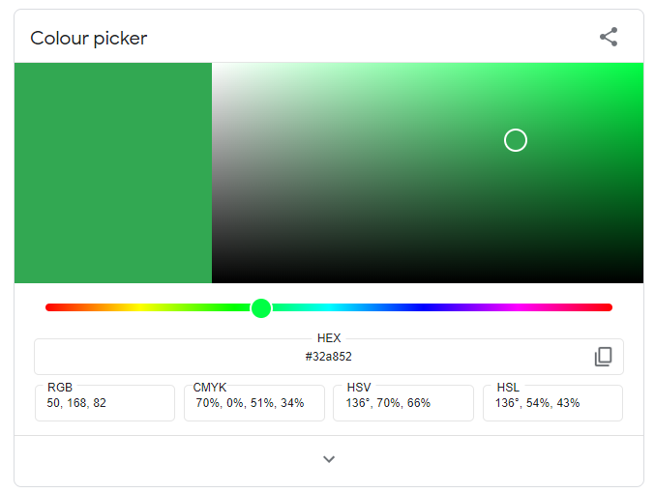

[Fig. 150] An example of a colour picker. This one is provided by the Google search engine.

For reference, the above figure shows what I *would* aim to implement if given the time. Note how easy it is to choose a colour. The user would have to simply move their mouse over the shade they want, and they’re done.

*“We don’t know what a scatter graph is.”*

Unfortunately, this is something that is partly out of my control. Scatter graphs are taught in year 8. However, for usability, there should be and will be varying types of graphs to display the historic performance data in further development. I did not include the other types because this is a prototype and including extra graphs adds little value to the proof-of-concept that this solution is supposed to be.

However, in further development, I wish to include a line chart which displays all the topics and their relative performance to each other. I wish to also include a pie chart which displays all the topics in bias ratio to show the user visually which topic they need to work on the most. Other graphs like cumulative frequency diagrams and bar charts can also be included.

For each graph, I would also like to include a *tooltip* to briefly explain what the graph displays and how it does it. This will increase the likelihood of the user understanding the visualisation that they’re seeing which betters the user experience. It also makes it more interactive.

As noted, these changes will only be made in further development since these are major implementations on their own.

*“.0 on the ends of all the numbers is weird and makes us get questions wrong.”*

This complaint is fully justified, because nowhere in the solution does it explain that numerical answers to questions need to be rounded to 1 decimal place even if the answer is a whole number. This makes the user experience confusing because they get questions wrong purely because they don’t know the correct format to answer in. There are 2 potential fixes for this: To make a small description box somewhere that explains the necessity to add it; to change the answer parsing algorithm to automatically add it in if it’s not there. I will go with the foremost due to the ease of implementation. The answer parsing algorithm would be better for the user experience because the solution would function more similarly to the expectation: 5 and 5.0 are equivalent so the user would expect to be able to answer with either and get it right on both occasions. However, due to the limited time, I will not be able to implement this.

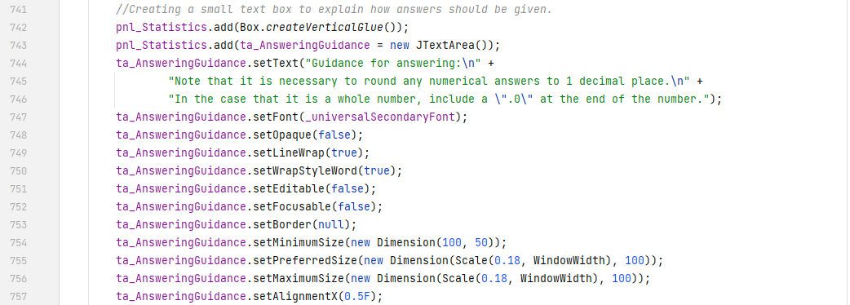

The code above adds a small text area to the statistics panel in a clear and obvious place.

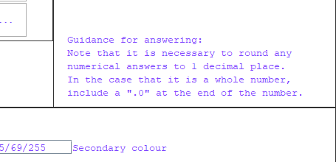

[Fig. 151] The description providing guidance for users on answering questions.

The user will now be able to better understand how to answer questions from the clear and concise guidance information provided at all times of the program’s run-time.

*“Correct workings were sometimes unhelpful.”*

This was noticed most prominently in the general arithmetic topic questions. Questions such as “What is 54 * 21?” would have workings that simply say “the answer is …”. While these are correct workings, given that the user is proficient at mental arithmetic, they are not helpful to those who are not. Better workings would look something like:

= 50 * 20 + 4 * 20 + 50 * 1 + 4 * 1

= 1,000 + 80 + 50 + 4

= 1,134

These follow a logical pattern and show the user how larger multiplication questions such as these can be done. Given more development time, a potential solution would be to either:

1. Further improve the specification file parsing to allow for arithmetic to be done within the workings. By this, I mean the same kind of arithmetic seen in the correct answers array, but allow it to be interpreted from the workings text too. To make the above example possible, digit selection would also have to be implemented.
   1. Instead of being:

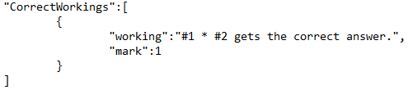

[Fig. 152] The current possibilities of the Specifications.json file.

* 1. It could instead be:

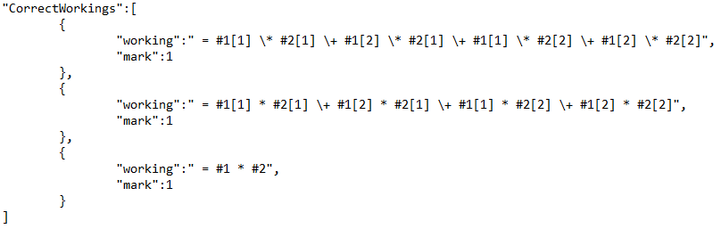

[Fig. 153] Potentially adding in digit selection and carrying out calculation embedded in text.

* 1. It should be noted that the backslash (“\”) characters in the figure above are there to symbolise to the parser to ignore the meaning of the succeeding character, and leave it written out as the intended character.
  2. These kinds of improvements would go a long way to making correct workings more powerful and informative for the user, but would also take a significant amount of time to properly implement and test – for this I will not implement it in this prototype.

1. Writing and training a *Machine Learning (ML)* algorithm to generate workings for any kind of question – given enough training data.
   1. This would mean training a machine learning model to suggest workings to maths questions that I would feed it. It would look at the question, look and the correct workings, and try to learn how to write correct workings for future questions.
   2. This idea is not applicable, however, because:
      1. It would take an unrealistic amount of training data and time to properly train.
      2. If it were properly trained, there is no guarantee that the workings will make grammatical or logical sense, since *Natural Language Processing (NLP)* is a notoriously difficult subsection of the ML field.
      3. The choice to even use AI may not even be applicable because there is - at least to my knowledge – no effective model in existence for this problem.

As is clear from the above summaries, potential solutions to this problem are out of the scope of this project’s timeframe and difficulty. For this, I will not be implementing any solutions. Given enough time, I would implement the first suggested idea, since that provides a good balance between flexibility and generalisation of the correct workings format.

*“Checkboxes are too small.”*

This would be a very simple fix, as most GUI libraries have size properties on all their elements and those side properties are usually very easily accessible. However, due to the way that Java Swing works, this is not the case for JCheckBox objects. In order to change the size of the checkbox, 2 custom images for the selected and unselected states have to be saved into the solution’s files. Then, the icon of the checkbox has to be manually set every time it’s toggled. I have achieved this with the following code:

The CustomInterfaceObject is the superclass of both the TopicPanel and the SpecificationPanel class. Both need the icons, so it makes sense to store the icon objects for them in there.



Then, within the TopicPanel class, the method that used to change the text in the JCheckBox got its name updated to match its new purpose. Line 104 and 107 show the icon now being set when the aesthetics of the check box get updated.

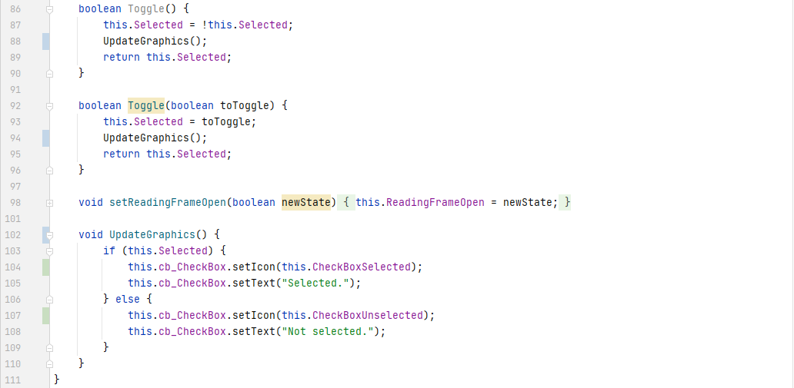

The same has been done in the SpecificationPanel class.

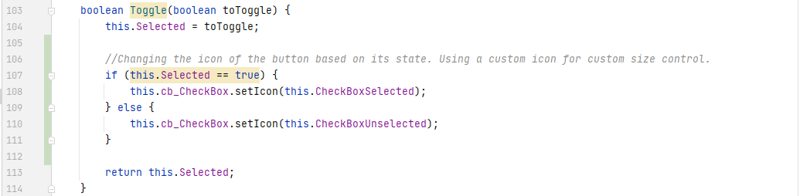

The result is the following look and feel.

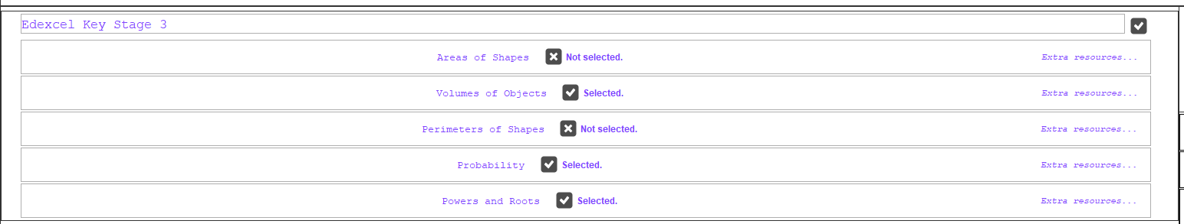

[Fig. 154] Showing the new icons being implemented into the topic screen.

The new icons were stock images I found on the open internet. These are here for prototyping purposes and can be changed freely at any time by editing the files of the project. The original ones I found were 512px by 512px in size, and filled the entire screen. Because of this, I had to edit them with image editing software and resize them to a more suitable 24px by 24px. This is about twice as big as the previous icons, and is much more prominent in the interface. The figure above also shows the toggling functionality working as intended. The user experience in the context of toggling check boxes should now be easier.

*“Some symbols in the question wording were confusing. What does * or ^ mean?”*

This is a problem caused by the difficulty of having real mathematical symbols in the text showed to the user. Unicode characters for mathematical operators do exist, and there are even typesetting systems like LaTeX [13] that display mathematical expressions with their corresponding formatting from markdown-like code. Replacing all mathematical operators with Unicode characters that better show their meaning is a potential fix for this problem. However, the x2 or *carat* operator (“^”) cannot use this, because it requires the proceeding numbers to be moved up and in a smaller font. For the sake of consistency, and time constraints, I will not implement an algorithm to do that. Something like LaTeX is also out of my range of expertise and time allowance to implement – let alone learn how to use.

However, given enough development time, I would implement something like LaTeX because it generalises to any mathematical expression (not just sequences of simple arithmetic operations), meaning any future changes to the rendering mathematics will not need to be made – should the need for more complex expressions arise.

This is also a usability problem for only the first few sets of questions. After that, the users (at least, the ones in the testing session) are able to figure out their meaning by simply inferring their meaning in the context of the question and show of correct workings.

## Analysis of Success

Now that testing is complete, an analysis of the successes and failures of the working solution can be documented.

### Successful Usability Features

In terms of the usability of the working solution, testing has been done with 3 stakeholders and the client on how much they felt the prototype was “usable”. Any problems that were identified have been fixed, minimised or explained as to how they would be fixed in further development. The Design phase outlined general usability features, and by combining those with stakeholder feedback, a list of successful usability features has been compiled below.

Note: *References such as “xx% approval from Qx” refer to questions answered in the usability testing session. The percentage is taken from the far-right column score out of 40. Evidence for the statements below comes from stakeholder feedback and numerous figures documented in above sections.*

1. ***Text at any point in the solution was, in general (80% approval from Q3), readable and easily understandable.***
   1. This means that the wording, font size, selection of font and any styling were appropriate and well received by stakeholders.
      1. Wording was concise, made sense for what it was describing, and had little to no ambiguity.
      2. Font type and font size were appropriate for what the text was (larger and bolder fonts for titles, Consolas font type for numbers, etc).
      3. Use of italics, underlining or boldening of characters and/or words was used minimally to provide emphasis.
2. ***The use of colour and iconography in the interface was conceptually known (80% approval from Q9).***
   1. Answer validity boxes were green for correct answers and red for incorrect answers.
      1. This is a common convention amongst the vast majority of applications when the meaning of validity is to be conveyed.
   2. Answer validity boxes also contained *ticks* for correct answers.
      1. This is another common convention that the vast majority of users are used to and therefore immediately understand when the solution shows it.
3. ***Menu buttons were the appropriate size for their use frequency (85% approval from Q1).***
   1. The 3 main menu buttons at the top were centred, sized to be relatively big (in comparison to the rest of the buttons in the application), and coloured with inverted colours (in comparison to the colour structure for the rest of the application components).
      1. This makes the user experience easier because those buttons can be toggled quicker and easier because they can be seen and navigated to much more easily.
   2. The button for creating graphical displays for performance data was relatively much smaller than the main buttons, because it is used with a smaller frequency than the others.
   3. As per the modifications to the prototype, the checkbox buttons are bigger than initially designed (because they were too small, according to some stakeholders), but they are still smaller than any other button in the main menu because there are a lot of them (making them even bigger would “crowd the window”, for lack of better phrasing).
4. ***Text in button labels was mostly concise and intuitive (as per 70% approval from Q2 and 72.5% approval from Q10).***
   1. The settings bar at the bottom of the screen in particular contained a number of labels with settings that have to be accurate to what they do, but also short enough to all fit on the screen.
      1. The bias setting got its label changed from “Enable Historic Bias” to “Smart Generation” to improve this usability feature.
   2. Main menu button labels were accurate to their functionality.
5. ***Topic grouping was logical and selection of topics was quick (82.5% approval from Q5).***
   1. The grouping of topics is technically down to whoever sets up the software, but in the case of this prototype and due to the ability of being able to group topics into “specifications”, this is a usability feature worth noting, because it makes the user experience better and more logical.
   2. Topic selection was also very granular.
      1. This means that the user has detailed control over which topics they would like to select, but they can also mass-select or mass-deselect topics based on specification. This makes the user experience quicker and easier.
6. ***Settings save when the application is restarted.***
   1. There was no explicit question in the usability testing session that addressed this, but it is a usability feature regardless.
   2. The user configures question generation to be how they would like, and the application saves their settings into a file. Those settings are then set in the next time that they open the application again.
      1. This makes the user experience quicker and easier because the user does not have to worry about remembering and resetting their settings every time that they want to revise mathematics the way they prefer.
7. ***The user can colour the interface to their liking (80% approval from Q9).***
   1. The user is given the ability to colour the interface to their liking, which means that the whole look and feel of the interface is customisable.
   2. However, there is a structure to the colouring.
      1. Borders of all kinds stay **black** regardless of colour choice. This is justified in the implementation phase.
      2. Colours for answer validity remain red or green. This is explained above.
      3. Colours for points on scatter graphs remain red.
         1. This is to highlight them when near the axes, but can be a problem if either the background (primary) or foreground (secondary) choice of colours is similar or the same as red.
8. ***The user interface design style is minimalistic.***
   1. This is also not directly addressed as one of the usability questions, but was outlined as a necessary usability feature in the design phase and it has also been met.
      1. While the term “minimalistic” is subject to opinion, a vast majority of people regard an interface to be minimalistic when there are very few buttons (there are only 3 main buttons), navigation does not require extra menus (there is only 1 main window), and windows are not bloated with “overly artistic” shapes or designs (there are no curved edges in the entire solution, and the only artistic iconography are the check boxes).
      2. Based upon this, the UI is minimalistic, and therefore easier to use for the user since they spend less cognitive effort trying to process how the UI looks, and more effort on trying to navigate. This is the intention.

### Limitations of the Working Solution

As is the case with any problem, there are limitations in the solution. This section details them, and for some, offers ways of minimising or removing them.

1. ***The algebra to calculate answers from the generated values do not support the use of braces.***
   1. This has been referenced and discussed previously in the implementation phase, but for the sake of summative organisation, it is being referenced here as well.
   2. This reduces the number of possible ways to generate answers and makes the algebra for some of the current topics more complex than it needs to be.
      1. This is because, in mathematics, braces are a vital way of controlling the order of operations for a given expression. Ways of implementing braces were spoken of in the implementation phase.
2. ***The algebraic parsing algorithm does not support more advanced mathematical notation or functionality.***
   1. This means that sigma notation for sums, the factorial function, integration or differentiation of expressions (to name a few) is simply not possible in the current state of the program.
   2. Like the previous point, this reduces the total number of possible ways an answer can be obtained programmatically – and for some cases, completely negates the possibility of writing an algebraic expression for the answer in the first place.
3. ***Question wording and model answers do not support the showcase or generation of diagrams.***
   1. This is a major limitation because a lot of questions rely on the use of diagrams to convey their ideas more clearly. Some even have diagrams as a necessity. This drastically reduces the potential range of topics that the solution can support given its current architecture.
4. ***As previously discussed in the analysis phase, there is no support or potential for support for network-based features.***
   1. This means there is no way for the user to interact with other users or services via the internet. Features such as:
      1. Saving scores to a webserver instead of a local file is not possible.
      2. Creating user accounts, allowing the user to access their performance data from multiple computers or machines is not possible.
      3. Leader boards with high scores per topic are not possible for multiple users.
5. ***Changing the finer details of the user interface is difficult from a software development perspective.***
   1. For example, the graphical icons for the check boxes required creating exceptions in more than 1 place.
      1. This is a violation of the don’t repeat yourself (DRY) principle and makes future maintenance or changes to the application more difficult.
   2. This is due to poor choices in inheritance structure during the beginning of the project.
      1. This could be avoided in future development by creating custom classes of each of the user interface objects and adding custom behaviour to each. Therefore, by changing the root class, every instance of that class will update to the new behaviour when the application is next run. This adheres to the DRY principle.
6. ***There is no way to run the application from a smartphone or tablet.***
   1. In the hypothetical scenario that this prototype receives further development and goes to market, it will not be usable to a wide audience of mobile or tablet users – cutting out potential users and customers.
   2. This is not good portability since the user is confined to the use of a desktop computer or laptop which cannot be displaced as easily as tablets and smartphones can.

### Maintenance of the Working Solution

Every piece of software also needs to be maintained in some way. This particular solution does not need a lot of maintenance when compared to other products of similar kind, however:

1. ***Difficult to maintain Specifications.json when trying to make changes.***
   1. The file gets very large, very quickly. At the time of writing, the Specifications.json file has 753 lines, which account for 14 topics. Given that the Edexcel GCSE mathematics higher specification has over 36 topics, the file has the potential to be thousands of lines long. This is just for 1 specification
      1. This will make maintaining the file very difficult, because fixing a simple spelling error may take whole minutes because of the time it takes to locate the information.
      2. Adding and removing topics will also take time because the file is long.
      3. As mentioned in the implementation phase, JSON parsers have no limit to how long the data has to be, but a limit for active memory use may eventually be reached, given that the file gets large enough.
2. ***Performance data more than 30 days old will become outdated and not necessary.***
   1. Since there are no features of the program that make use of performance data that is more than 30 days old, this data serves no purpose and therefore uses up unnecessary memory.
      1. This memory will never get cleaned up because the program does not delete this old data on its own. It has to be manually done. This was an oversight in the design phase.
      2. Given enough data, this may cause slow load times in future uses of the program, degrading the user experience.
3. ***If the specification changes, a lot of the data will have to be refactored.***
   1. This is a maintenance problem because the user themselves may not know how to update the data and their revision will eventually suffer because they’re practicing with outdated data.
      1. This is further justification to point 1.
      2. The specification data would have to be maintained actively by a 3rd party and new versions installed regularly. This can create unnecessary inconvenience to the user.

## Summary and Conclusion

In conclusion, the initial problem proposed in the start of the analysis phase has been *partly* solved by the prototype of the proposed solution to the problem. Every success criterion originally designated has been fully achieved and, in some cases, surpassed in requirements. The prototype scored an overall 80% approval for usability and received a number of improvements and changes during the robustness and usability testing phases.

That being said, the prototype has some obvious limitations and it is in my own professional opinion, that the core architecture of the working solution should be reworked from the ground up to be more general, more modular, and more easily changeable. Given more development time, a second prototype would be made with a fundamentally different approach to the problem, including the suggested fixes for many of the issues and limitations identified. I consider this a successful first attempt, none the less.

# Bibliography

1. N/A. (N/A). *Maths Revision Aids.* Available: https://www.elevenplusexams.co.uk/free-11-plus-practice-papers/elevenplusexams-maths-revision-aids. Last accessed 21st May 2021.
2. N/A. (2021). *Untitled.* Available: https://mathsbot.com/gcseQuestions. Last accessed 21st May 2021.
3. N/A. (2021). *Untitled.* Available: https://studymaths.co.uk/gcsequestions.html. Last accessed 26th May 2021.
4. Richard Parsons (2018). *GCSE Computer Science AQA Revision Guide - for assessments in 2021*. Newcastle: Coordination Group Publications (CGP). 40-41.
5. Deborah Cohen. (2013). *Revision techniques - the good, the OK and the useless.* Available: https://www.bbc.co.uk/news/health-22565912#:~:text=These%20include%20re%2Dreading%20notes,visual%20representations%20of%20the%20knowledge.. Last accessed 28th May 2021.
6. ############. ######@#########.net. Computer science project. 14th June 2021.
7. N/A. (2021). *GUI.* Available: https://www.computerhope.com/jargon/g/gui.htm. Last accessed 30th June 2021.
8. N/A. (2013). *Mathematics programmes of study: key stage 3.* Available: https://assets.publishing.service.gov.uk/government/uploads/system/uploads/attachment_data/file/239058/SECONDARY_national_curriculum_-_Mathematics.pdf. Last accessed 10th September 2021.
9. Whitney Quesenbery. (2001). *What Does Usability Mean: Looking Beyond ‘Ease of Use’.* Available: https://www.wqusability.com/articles/more-than-ease-of-use.html. Last accessed 17th September 2021.
10. N/A. (2021). *How to Use BorderLayout.* Available: https://docs.oracle.com/javase/tutorial/uiswing/layout/border.html. Last accessed 4th October 2021.
11. N/A. (2021). *The JSON Validator.* Available: https://jsonlint.com/. Last accessed 22nd October 2021.
12. ############. ######@#########.net. Computer Science Project. 24th January 2022.
13. N/A. (2022). *Home Page.* Available: https://www.latex-project.org/. Last accessed 15th February 2022.